The Calendar of Meetings (2H24)
Here is a snapshot of the TSG (bold) and WG meetings for June to September, with only the TSG meetings shown for Q424:
TITLE | START DATE | LOCATION
CT#104 | 17/06/2024 | Shanghai
RAN#104 | 17/06/2024 | Shanghai
SA#104 | 18/06/2024 | Shanghai
SA3#94-LI | 09/07/2024 | Amsterdam
CT1#150 | 19/08/2024 | Maastricht
CT3#136 | 19/08/2024 | Maastricht
CT4#124 | 19/08/2024 | Maastricht
RAN1#118 | 19/08/2024 | Maastricht
RAN2#127 | 19/08/2024 | Maastricht
RAN3#125 | 19/08/2024 | Maastricht
RAN4#112 | 19/08/2024 | Maastricht
RAN5#104 | 19/08/2024 | Maastricht
SA1#107 | 19/08/2024 | Maastricht
SA2#164 | 19/08/2024 | Maastricht
SA3#117 | 19/08/2024 | Maastricht
SA4#129-e | 19/08/2024 | Online
SA5#156 | 19/08/2024 | Maastricht
SA6#62 | 19/08/2024 | Maastricht
CT6#119-bis | 20/08/2024 | Maastricht
CT#105 | 09/09/2024 | Melbourne
RAN#105 | 09/09/2024 | Melbourne
SA#105 | 10/09/2024 | Melbourne
CT#106 | 09/12/2024 | Madrid, TBC
RAN#106 | 09/12/2024 | Madrid, TBC
SA#106 | 10/12/2024 | Madrid, TBC
CT#107 | 12/03/2025 | Korea
RAN#107 | 12/03/2025 | Korea
SA#107 | 12/03/2025 | Korea

The full calendar is online at https://portal.3gpp.org/

Hans on for 100!
In March, one of 3GPP’s most experienced delegates celebrated attending 100 consecutive Plenary meetings at the 103rd TSG meetings in Maastricht in the Netherlands. Hans van der Veen of NEC has attended uninterrupted TSG RAN meetings since June 1999 and TSG SA since October of that year.
For a time, Hans also served in the 3GPP Mobile Competence Centre in ETSI, as a seconded expert supporting (as Technical Officer) TSG RAN and RAN WG2.
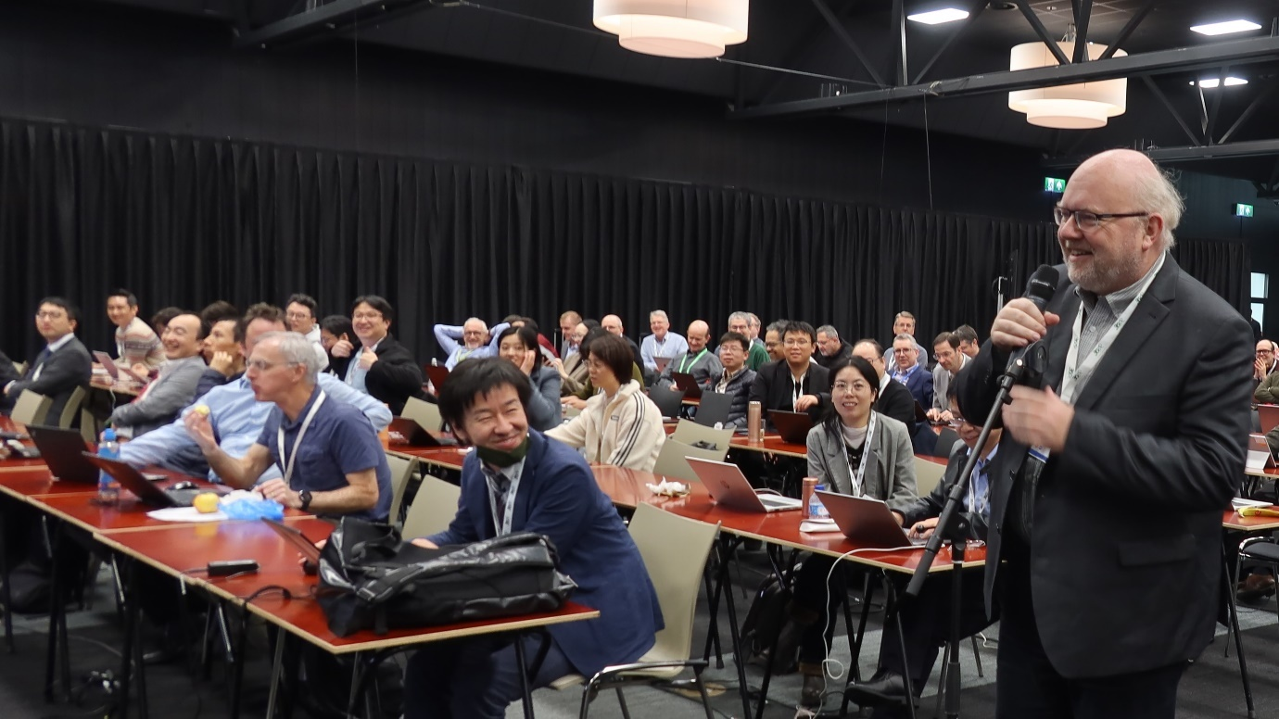

Awards for 2023 Excellence
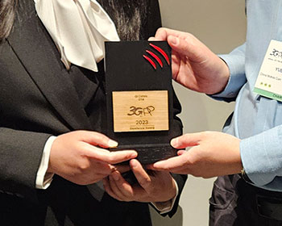
The annual Excellence Awards for delegates in 3GPP have been presented by the Working Group Chairs during the 1Q24 Working Group meetings in Seville and Athens.
Congratulations to Håkan Palm (RAN2), Yizhi Yao (SA5), Qi Caixia (CT4) and Jinguo Zhu (SA2).
See full details and the Awards roll of honour at www.3gpp.org/about-us/achievement-awards

6G planning
The Project Coordination Group (PCG) of 3GPP has approved a new logo for use on specifications for 6G, during their 52nd PCG meeting, hosted by ATIS in Reston, April 23, 2024.
The creation of this graphical mark is another step in 3GPP’s preparations for the next generation of mobile systems. In December 2023, the Organizational Partners: ARIB (Japan), ATIS (North America), CCSA (China), ETSI (Europe), TSDSI (India), TTA (Korea) and TTC (Japan) announced their joint commitment to make 6G happen in 3GPP. Now there is a graphical badge that can accompany the 3GPP work on the topic, on study cover sheets (TRs) and on future specifications (TSs).

5G-MAG in Maastricht
In its capacity as a 3GPP Market Representation Partner, 5G-MAG recently highlighted the achievements of its members to the broader 3GPP community gathered in Maastricht.
A key focus of the presentation was the demonstration of 5G-MAG Reference Tools, which provide tangible examples of how 5G-MAG facilitates the translation of 3GPP’s specifications into products. The 5G-MAG Reference Tools development programme effectively bridges the gap between technical specifications and practical applications.
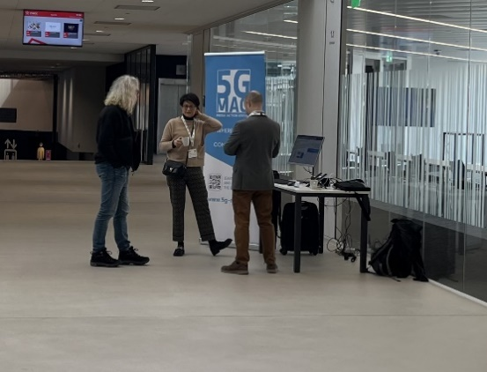
5G-MAG plays a key role in consensus-building efforts prior to standardization, it develops comprehensive profiles and guidelines, creates reference implementations and provides valuable feedback to Standards Development Organizations such as 3GPP.

