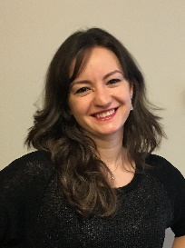
An interview with…
Diana Pani, RAN2 Chair, InterDigital Inc.
As VP and Head of Wireless Standards at InterDigital, overseeing the research and contributions to 3GPP 5G/NR RAN and Core Network (SA/CT) standards, Diana Pani is deeply entwined within the 3GPP ecosystem and standards process. Her broad expertise includes Technical Specification Group RAN, specifically Working Group RAN 2 - where she was elected Vice-Chair in 2013 and now serves as Chair, following her election in August 2023.
We met in Maastricht in March 2024, during the 103rd Technical Specification Group (TSG) plenaries.
Highlights: Having attended TSG RAN#103, could you give us a flavour of what is happening this week in the group?
Diana Pani: The primary focus of this week’s meetings was to define and finalize the Rel-19 work plan for topics led by WG RAN4. In December 2023 we defined the Rel-19 work plan for RAN1, RAN2, and RAN3-led topics, so at the conclusion of these meetings we will have a complete view of the scope of Rel-19 across all WGs and the work ahead of us for the next 18 months.
The 6G timeline was another major discussion topic across the TSGs.
H: You have the Rel-18 freeze, work on Rel-19 planning and then you are looking forward to 6G. How difficult is to do all of this at once?
DP: It’s quite difficult to handle everything at the same time, so the TSG and WG chairs must carefully plan how to allocate time for their WGs throughout the release, to balance the completion of one release with the start of a new release. Until now, RAN2 has concentrated 100% on finishing the Rel-18 work to ensure stability of the specifications. However, April and May will be much more challenging because we have to begin the Rel-19 work while also prioritizing completion of Rel-18 and a successful ASN.1 Rel-18 freeze.
The 6G timeline is very important and informative, but 6G doesn’t yet impact the RAN2 work. As decided in December, RAN working groups will start work for 6G in Rel-20.
H: Can we get an insight into your standards journey? What brought you to the standards field and to a career at InterDigital, in Canada?
DP: I started working at InterDigital right out of college, I had just completed my engineering degree and was really happy in Montreal. Prior to working there, I had actually interned at InterDigital as well, looking at smart access point Wi-Fi algorithm design and implementations. I found the environment welcoming and the work extremely interesting, so I was very happy to return after my graduation, and soon thereafter joined InterDigital’s Standards group. After two years of work in the back office, I was asked to go to 3GPP to represent our company as a replacement for a co-worker for just two meetings. Those two meetings quickly turned into 15 years of participation. I realized that I had fallen into the “new delegate trap”. After you’ve been to two meetings, you are hooked!
H: Can you tell us a little about how the standards work is organized within the company?
DP: At InterDigital, we have a dedicated wireless standards team that mainly focuses on 3GPP, Wi-Fi, ITU, and IETF standards. Our team is comprised of both researchers and experienced standards delegates that work very well together across all the different areas of the wireless systems. We also have an experienced team in our Video Lab that contributes research and holds leadership roles in various video standards.
I am extremely proud and grateful to work with such a committed, collaborative, and overall world class team of standards engineers.
H: Looking at the work of TSG RAN, could you help us demystify how the stages of a release come together? On the TSG/CT side of the house, the stage 1 requirements followed by the stage 2 architecture split is quite clearly divided between SA1 and SA2, while CT covers most of the stage 3 work. RAN work seems to be a little different; do you have all three stages in your groups?
DP: We do have similar stages of work in RAN, but the working groups splits are not determined by the stages of work but instead on areas of expertise and protocol layers within the RAN. Typically, the work happens in parallel across the RAN working groups. For many features there are dependencies between the groups, which requires cooperation and coordination between the RAN groups (see Rel-19 example below), and for some topics coordination between the SA/CT groups.
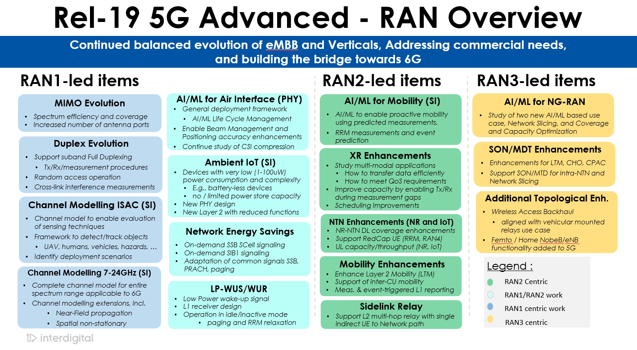
In my role as RAN2 Chair, I work with the other WG Chairs to identify areas of overlap and determine which group should begin the work. Coordination is sometimes difficult because the separation is not always very clear and both groups are busy, but by working closely with the WG and Session Chairs, we ensure that we make good progress on the features.
H: As Rel-19 gets fully underway, what are the major RAN2 projects for the release?
DP: Projects for Rel-19 primarily focus on continuing the balanced evolution of eMBB and verticals to address new commercial needs and build the bridge toward 6G.
For RAN2, some of the major projects include the evolution of Rel-18 5G-Advanced projects like, eXtended Reality, Non-Terrestrial Networks, Network Energy Saving, Mobility and SideLink Relays. RAN2 is also working on several new important 5G-Advanced projects like Ambient IoT and AI/ML for Mobility and Air Interface.

H: Once the focus on who does what is agreed, what is the dynamic in the RAN2 group? How do decisions get made?
DP: Reaching consensus and agreement takes a lot of time and discussions both during and between the meetings. In RAN2 we have roughly 350 delegates looking at 2000 documents per meeting.
While in RAN2 there are many offline discussions, most of the agreements are made online. For this reason, it is important to have our 3GPP experts participate in physical meetings to resolve disagreements face to face. The discussions are detailed and difficult, often because there are diverging views on what is important and how a problem should be solved. Achieving consensus requires a lot of cooperation from companies and a willingness to compromise to reach a common goal and complete the work on time so the industry can benefit.
RAN2 maintains a strong track record on compromise in the pursuit of solutions and deadlines.
H: How is it possible to deal with 2000 documents in the Working Group week?
DP: Indeed, 2000 documents are a lot to process and the chairs and delegates have a responsibility to review them before the meeting. Because of the very high workload and work being done in parallel for different projects, companies often send a large number of delegates. Delegates can then focus only on specific topics and read the subset of documents related to their topics, but even still that is a high volume of documents.
We have limited time at the meetings, so we can only address and present some of the documents. The chairs select a very limited number of contributions to present for each agenda item and these contributions sometime provide different perspectives on how to address a problem. Sometimes, we receive 50 documents for one agenda item but only have time to present 2 or 3 to ensure the remaining time can be dedicated to technical discussions.
H: Can this create stress around which contributions are chosen for discussion?
Even if only 2 or 3 documents are treated it doesn’t mean the remaining contributions are not important. Companies typically review all contributions before the meeting and are aware of the technical contents of the contributions. Companies bring their views directly to the discussion without needing to present their document. In these technical discussions, all ideas are considered equally, regardless of whether they come from a presented contribution.
H: Do the large-scale co-located ‘mega’ meetings help or hinder things, with the WGs gathering in the same place and the same time? I guess you can’t easily be in two WGs at the same time. Could we improve coordination efforts?
DP: Theoretically, co-hosted meetings can help, but in practice everyone is busy – So, coordination during the meeting itself is limited. We haven’t held joint sessions between WGs for some time, so meeting in a common place is useful, but it isn’t always necessary. For companies with small delegations, like some vertical companies, co-located meetings can be useful because it supports attendance at different WGs for the same features (considering there are no collisions, which are often difficult to avoid).
On coordination, the WG chairs don’t have much time to do that during the week, because they are consistently chairing meetings. Overall, the [TSG] plenaries are the place where the WG Chairs have time to talk to each other.
H: Looking towards future efforts on 6G, how much is that being shaped by the current focus on 5G-Advanced?
DP: Rel-19 and it’s 5G-Advanced features are building the bridge towards 6G, and in RAN2 we are doing work now that will prepare us and eventually become fundamental building blocks of 6G. Some of the work reflects ‘6G’ topics, for example RAN1’s channel modelling work for sensing and new spectrum, while other areas like AI/ML, Network Energy Savings, XR, etc represent 5G topics that will become important in 6G.
Each of these will evolve and I believe the lessons we learn in 5G will prove to be critically important for the design and implementation of 6G. Being ready for the transition of the G’s is a major purpose we share across the groups.
This is by design; each wireless generation evolves and builds upon itself. Looking historically, we saw that the later features of 4G LTE became fundamental building blocks of 5G. I think we can expect 5G-Advanced to contribute to the foundations of 6G in a similar way.

For more on WG RAN2: www.3gpp.org/3gpp-groups
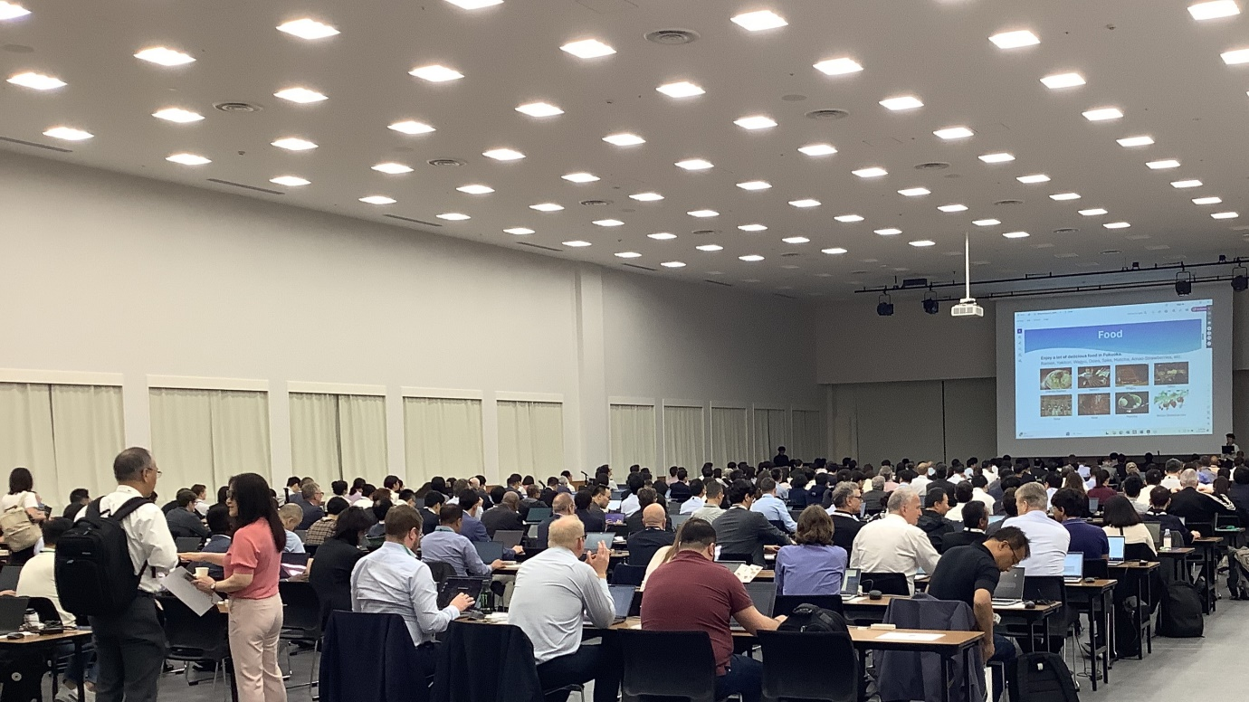
3GPP RAN2#126, Fukuoka City, May 2024.

