3GPP functionality for Energy Utilities
By Erik Guttman, Alberto Sendin, Vincent Audebert, Julian Stafford
5G standards aim in part to address specific requirements of different vertical business sectors. This is the first feature standardized in 3GPP that specifically addressing the needs of energy utilities. Most energy utilities rely heavily on private telecommunication networks, but also employ mobile telecommunications requiring a highly available service. At the same time, mobile telecommunications services rely upon energy services also. The features supported by 3GPP therefore benefit both energy utility and mobile telecommunications service providers and are instrumental for a higher penetration of mobile telecommunications in utilities.
Reliability is crucial for energy utilities, to satisfy regulatory, business and public health & safety requirements. To achieve this reliability, a range of 'smart energy services' are employed by the energy system. These services, largely standardized by IEC and IEEE, require communication. As greater degrees of efficiency, resiliency, responsiveness and other capabilities are sought in the delivery of energy to consumers, more and more communications services are required by the energy sector to build what the sector refers to as a Smart Grid ^{[C]}.
There are many options for delivery of communication services today – power line communications, fibre optics, fixed networks, microwave transmission, satellite communications and mobile telecommunications. The appropriate means, or rather mix of communications services, depends on several factors including the location, the possibility of leveraging existing assets (e.g. power lines,) and the 'total cost of operations,' and the properties of the communication service.
To the extent that the 3GPP system can provide services that meet the needs of the energy sector, telecommunications will be an increasingly prominent part of the technical ecosystem by which energy is delivered. Also, MNOs will benefit from improved electricity service availability.

Energy distribution service operators
Energy utilities benefits from smart energy services, not least for greater efficiency and reliability. By far the most complex aspect of energy utility operations, whose requirements for communication are increasing most rapidly, are distribution services - responsible for all aspects of energy delivery between long-range high voltage transmission and consumers. Activity in 3GPP has focussed on the requirements of distribution service operators (DSOs.)
The Network Services and Operations for Energy Utility (NSOEU) feature defines how energy utility service providers and MNOs can exchange information in a standardized format to improve the availability of communication services and facilitate rapid recovery in the case of energy system outage.
In the feasibility study on 5G Smart Energy and Infrastructure ^{[1]} use cases were investigated that motivated NSOEU. Corresponding functional requirements were added to specifications that capture service requirements of the 5G system ^{[2][3]}. A follow-up study on support for several of these requirements was undertaken in the telecom management working group of 3GPP, SA5 ^{[4]}. This led to normative specification of the NSOEU feature ^{[5]}.

Network performance monitoring for proactive response
Network performance monitoring is possible today, using a range of defined KPIs and an established set of services and interfaces. This capability is used by a mobile network operator. The NSOEU feature exposes a limited set of this functionality to third parties, as a service, to DSOs. The goal of exposure of this information is to enable the DSO to achieve higher energy service availability, as described below.
The highest possible availability of energy service is in the interest of mobile network operators. Within the power system, distribution networks are the origin of over 90% of end-consumer outages ^{[B]}. There is significant interest by energy distribution service operators to improve energy service availability. This can be achieved by smart energy services. Telecommunications enable these services in many situations (where fixed network access to distribution network equipment is not possible.) However, telecommunication service today itself is not, in practice, of sufficiently high availability to offer 5 or 6 '9s' of availability.
Distribution network substations (primary and secondary) have communication networks that communicate via routers to the DSO operation centres. These routers can employ UEs to obtain network access, and often support multiple USIMs.
Switching between two PLMNs effectively requires two or more minutes, as routers need to be rebooted. For 99.999% service reliability, we can only expect 5.26 minutes of down time per year. Thus, waiting for a service outage and responding to it reactively is not sufficient for services that require 99.999% reliability or more. If a critical event were to occur during this time, smart energy services could neither detect nor respond. This could result in very serious conditions that would render one or more energy distribution substations inoperable.
The DSO needs information regarding outages and performance degradation of the communication system, as it may be possible for the DSO to proactively establish and use an alternative means of communication. Instead of waiting for communication service failure to react, DSOs monitor the quality of the network service to identify service quality decline. This allows a proactive switch to another provider. Monitoring 'over the top' has several disadvantages: it has to be done at a very coarse granularity to avoid using significant resources, and as a result, it provides only sparse data to serve as an indication of approaching outages.
3GPP TS 28.318 ^{[5]} defines the exposure of PerfMetricJob and ThresholdMonitor ^{[6]}. These are included in procedures to be used in diverse deployment scenarios in informative annex A ^{[5]}. These procedures are indicative; there could be many other sequences of actions performed using the framework. Of principle interest to DSOs are ‘average delay’, ‘delay’ and ‘packet loss’ both for downlink and uplink traffic in a cell. In addition, cell and network availability can be monitored.
These network monitoring capabilities rely on the 3GPP standardized Network Resource Model (NRM), an extensive object-oriented system that corresponds in practice to the mobile network operator's network. The operator does not expose this NRM information to the DSO. Instead, a very simple subset of the NRM is assumed to be known to the DSO in advance, requiring off-line prior configuration in an implementation-specific manner. Using this model, performance monitoring of a limited set of cells can be initiated by the DSO.

Coordinated energy service recovery
The service-customer relationship is bi-directional: MNOs require energy services, and energy utilities require communication services. Power cuts were found to be the second most common cause of lack of availability of telecommunication service, a primary or secondary cause in over a fifth of major incidents. ^{[A]} The energy system, in turn, can rely on the telecommunication system to perform remote smart energy services.
Recovery from energy outages by a DSO can be performed in many cases in a small number of minutes by means of 'distribution automation,' a general term that expresses smart energy services that enable automated remote monitoring and control. When remote operations are not possible, e.g. when the mobile telecommunication network is not available as a result of the energy outage, recovery requires much longer.
When either a planned or unplanned power outage occurs, there is some time in which MNO sites continue to function, by means of autonomous energy capacity, either through generation or uninterruptable power supplies.
Today the DSO lacks knowledge of the constraints on recovery, and are affected by lack of sufficient autonomous energy capacity in the MNO network.
The NSOEU feature provides a means by which an MNO can provide information concerning the correspondence of energy supply and their essential sites to the DSO. Further, information concerning the location and timing outages and recovery times can be provided by the DSO to the MNO.
This exchanged information can greatly improve the coordination between the DSO and MNO and lead to more rapid recovery of energy service. One scenario supported by NSOEU is illustrated and summarized here, as an example of how improved information sharing can facilitate recovery.
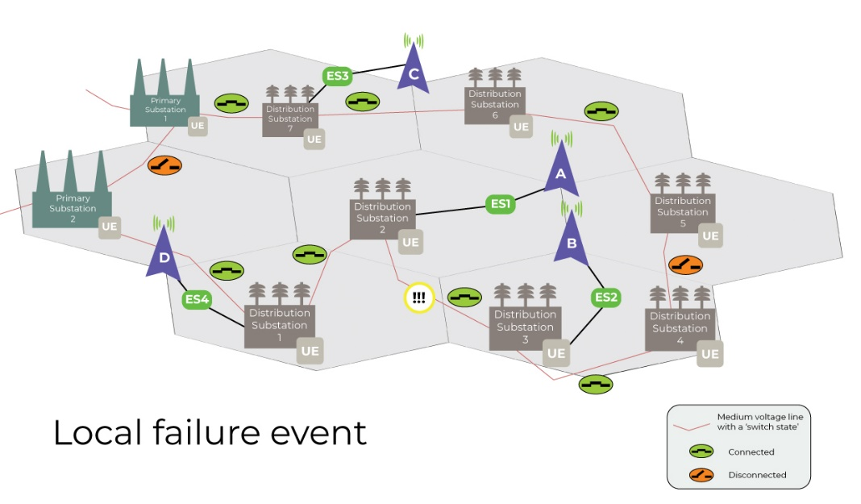
In the figure, different MNO infrastructure, represented by the elements A, B, C and D, are supplied with energy. MNO site B is supplied by Distribution Substation 3.
In this example, an outage occurs between Distribution Substation 2 and 3, e.g. due to an underground transmission line being accidentally cut by construction equipment. Distribution Substation 3 is no longer supplied with energy, and site B cannot be served. Site B provides mobile service to Distribution Substation 3 and 4, but only as long as site B has autonomous energy supply.
Fortunately, there is a redundant topology between Distribution Substations. In order to reestablish energy service, Distribution Substation 2 and 3 will disconnect the medium voltage line between them. Distribution Substation 5 and then 4 will connect the medium voltage line (currently shown as disconnected in the figure.) All of this can be accomplished remotely, within minutes, using smart energy mechanisms.
NSOEU enables the DSO to be aware of the autonomous operation duration possible of site B, and that site B serves Distribution Substations 3 and 4. The DSO will prioritize performing operations in Distribution Substations 3 and 4 before site B's autonomous energy supply is exhausted. This is in contrast to the current situation, without the NSOEU feature: DSOs must send technicians to Distribution Substation sites to manually connect and disconnect stations to recover from energy outages.

Conclusion
While significant progress has been made on enhancement of the 5G system to support requirements of energy utilities, there are more capabilities to add in the future. The functionality provided in Release 18, based on exposure of management services, needs to be further specified, as documented in 3GPP TS 28.318 Annex D ^{[5]}. Study has begun in Release 19 on how to standardize exposed management service interfaces, including their configuration and security. It is hoped that this development will benefit the NSOEU feature with support of standardized mechanisms.
There are two areas which have not yet been addressed that remain of high interest to the DSOs. These could be developed in a future 3GPP release. In Release 18, information exposure concerns service to a cell. To obtain detailed information concerning the communication status of a single UE, additional information exposure is needed. This would improve the ability of the energy utility operator to determine whether, due to a concerning trend or reduction in performance, to make use of an alternative communication service proactively.
References
[A] Connected Nations 2020, UK Report, Ofcom. https://www.ofcom.org.uk/__data/assets/pdf_file/0024/209373/connected-nations-2020.pdf (Access 20.4.22).
[B] A. Sendin, J. Stafford and Adrian Grilli, "Utilities and Telecommunications in a nutshell", Ediciones Experiencia, S.L., Barcelona, 2022.
[C] A. Sendin, M.A. Sanchez-Fornie, I. Berganza, J. Simon, I Urrutia, “Telecommunication Networks for the Smart Grid”, Artech House, Boston / London, 2016.

[1] 3GPP TR 22.867, "Study on 5G Smart Energy and Infrastructure".
[2] 3GPP TS 22.261, "Service requirements for the 5G system; Stage 1".
[3] 3GPP TS 22.104, "Service requirements for cyber-physical control applications in vertical domains; Stage 1".
[4] 3GPP TR 28.829, "Study on network and service operations for energy utilities".
[5] 3GPP TS 28.318, "Network and Service Operations for Energy Utilities (NSOEU)".
[6] 3GPP TS 28.622, "Telecommunication management; Generic Network Resource Model (NRM) Integration Reference Point (IRP); Information Service (IS)".

