<Content around the content listing>

6G Stage 1 Workshop
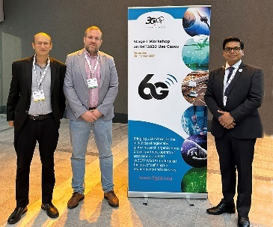
The jauntily named ‘3GPP Stage-1 Workshop on IMT2030 Use Cases’ attracted over 200 participants to the Dutch city of Rotterdam, 8 – 10 May 2024, to share beautiful spring weather and two and a half days of presentations from the emerging 6G initiatives, 3GPP market partners (MRPs) and the ITU.
3GPP WG SA1 now has the task to define the 6G stage 1 requirements to be met by future 3GPP specifications. The presentations from the workshop can be downloaded from the 3GPP website. See also Puneet Jain’s article about the event on page 25 of this issue of Highlights.
IMAGE: Left to right; Alain Sultan (MCC, SA1 Secretary), Jose Almodovar (SA1 Chair) and Puneet Jain (SA Chair)

Satellite technology of the year
On March 20, 2024 the work of the 3GPP members and delegates on NTN specifications has been recognised with ‘3GPP NTN Standards’ selection as satellite technology of the year in a ‘Via Satellite’ pole. The announcement was made during the SATELLITE 2024 conference in Washington in March, with the publication singling out the 3GPP NTN Standards nomination for its “proactive engagement of the satellite industry with 3GPP and other forums - to ensure that satellite technologies can be fully integrated into the 5G ecosystem.”
<trim photo if poss / needed – take tables out >
