**3GPP TSG-SA5 Meeting #150 S5-235zzz**

**Goteborg, Sweden, August 21-25, 2023 was S5-235zzz**

**Source: Samsung, ...**

**Title: Rel-18 pCR 28.318 5.X Energy utility and telecommunciations coordinated recovery with redundent topology**

**Document for: Approval**

**Agenda Item: 6.6.4.3 (NSOEU_WoP#3) Support energy system recovery through communication of management information between the energy utility service operator and site operator**

# 1 Decision/action requested

***The group is asked to discuss and approve the proposals.***

# 2 References

[1] 3GPP TR 28.829 "Study on network and service operations for energy utilities".

[2] SP-230632, "Network and Service Operations for Energy Utilities", NSOEU WID approved at SA#100.

# 3 Rationale

This pCR provides a normative clause of the requirements agreed in [1] with respect to coordination of energy system recovery, and pursues the objectives in the agreed WID [2].

# 4 Detailed proposal

It is proposed to agree to the following change to TS 28.318, 0.0.0.

|  |
| --- |
| **Begin Change** |

## 5.Z Energy utility and telecommunications coordinated recovery with redundant topology

### 5.Z.1 Description

The general motivation for the functionality whose requirements are specified in clause 5.Z.2 is described in clause 4.4.

This use case concentrates on the distribution aspects, which is depicted above as a single level in a hierarchy, but in fact may have a series of sub-stations between high voltage transmission and the final distribution to energy consumers.

Interruptions occur in the distribution system, as at some level, the medium voltage network may require local reconfigurations or suffer unplanned loss of distribution service (e.g. due to distribution cable damage, etc.) The resulting energy service interruptions last a variable amount of time (from minutes to hours.)

The normal situation is that a utility may need to disconnect a certain Medium Voltage feeder. As the grid does not automatically re-connect this feeder to an active one, there will be a power outage in all points of supply connected to it while the power is being restored. The procedures and times to reconnect the affected feeder would be the same if for any reason this has been caused by a planned operation, an unexpected incident, or if it is a major grid problem.

In the recovery procedures, the DSO network operations centre needs to restore power in a certain order often for regulatory compliance: the order includes prioritizing the more important energy consumers (e.g., Hospitals, government sites).

This prioritization may also include major MNOs' sites, such as base stations and core network sites to restore communication services, which is in the interest of both MNO and DSO stakeholders. This prioritized recovery of MNO sites is enabled by this use case.

It is here where a standardized mechanism connecting DSOs and MNOs would be beneficial. This use case describes the information and operations that would be required on that interface.

Part of the information may have a more static nature.

This is the point of Energy Supply ID. The DSO is aware of each point of supply (to an energy consumer), by means of the Energy Supply ID. The MNO needs to let the DSO know the relevant Energy Supply IDs, so that the utility can know where they connect to its feeders. Another critical information element is the power back up installed by the MNO in each site (including 'back up' base stations), and its current expected duration. In addition, for each Energy Supply ID, base station, e.g. eNB, IDs (serving the cell IDs) served by the base station as shown in figure 6.2.1-2 below.

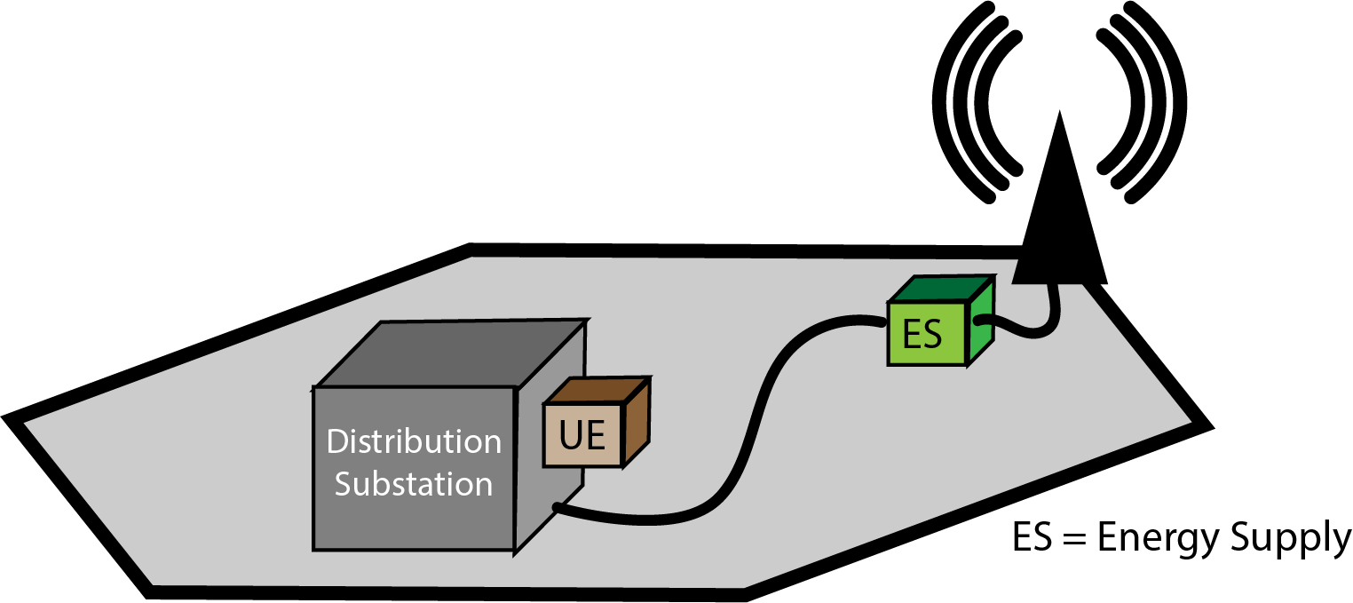

Figure 5.Z.1-1: Local recovery scenario

NOTE 1: The representation of the ID above corresponds to the Energy Supply termination of the base station site.

Editor's Note: Replace this figure with an editable version.

The correspondence between the communication system serving the distribution substation by means of a UE (camped in the depicted cell), the Energy Supply ID of the base station and the ID of the base station enables the DSO to identify important operational aspects, such as:

(a) the impact of the distribution substation interrupting service: specifically the base station that the distribution substation relies on will have its power supply interrupted;

(b) upon recovery of the distribution substation, which substations may be high priority for resumption of service.

As implied in Figure 5.Z.1-1, there is a dependency that the DSO has on the MNO in that the DSO relies upon data connectivity to smart energy equipment in the distribution system. Through the use of smart energy services, restoration of energy service is rapid and reliable. If the energy substation lacks data connectivity, it is sometimes necessary to send a technician to the site to restore service, which is time consuming.

The DSO monitors and controls the systems within the Distribution Substation as part of normal operations, especially in the event of a service outage.

Other information exposed by the new mechanism is dynamic.

Distirbution Substations are deployed with medium voltage transmission feeders in a redundant topology so that if a given feeder is interrupted (either due to planned maintenance or unexpected service disruption such as a severed distribution line), it is possible to restore energy distribution. The redundant topology is necessary but not sufficient for such a restoration. In order to restore distribution successfully through an intact path in the redundant topology, energy service has to be **switched** **on and off** at corresponding distribution substations. This action can either be done manually (which is slow, can take as long as hours, as service technicians must be 'on site'). It is preferable to perform these operations remotely by means of smart energy services (principally Distribution Automation,) which is rapid - i.e. can be concluded in minutes. As service is switched on and off, energy service is interrupted, and this can occur throughout the energy distribution topology.

Taking into account (a) which mobile network infrastructure sites (i.e. base stations) are critical to service and which cells they serve, (b) the corresponding Energy Supply ID, (c) the distribution substation (UEs) that rely on these base stations, (d) the remaining UPS capacity available in the sites, it is possible for the DSO to plan the 'switch on / switch off process' to avoid any interruption of service. This is done by **selective ordering**of the switch on / switch off activity, to avoid exhausting any mobile network infrastructure UPS - especially where this base station (etc.) serves to enable communication services to a distribution substation.

In order to support the process described above, another example of dynamic real-time information is the 'real' current back up power available at the base station, at any moment in time; the intention is to see how much time the DSO has to restore the power before service interruption compromises the MNO's operation.

The use case supported is one that has two actors.

- The management service consumer, the authorized third party, is operated by the DSO.

- The management service producer, which selectively exposes specific functionality of the 3GPP managmeent system, operated by a site operator.

In this use case, the management service consumer requests, subscribes to and provides information. Responses and notifications are provided containing the information as expressed in the requirements in clause 5.Z.2.

Preconditions:

There is a distribution sub station that acts as a feeder, whose operation requires smart energy services. The smart energy services are available through DSO equipment in the DSO site. The equipment can communicate over an IP network by means of a router that supports a mobile telecommunications interface, a UE.

The DSO can obtain information from each UE in the DSO network. The DSO-MS is aware of the Base station ID of the serving base station for each UE.

On a regular basis, e.g. daily, the DSO-MS obtains 'static information' from the MNO-MS. The DSO-MS is aware which sites (including both base stations and other critical infrastructure of the mobile network operator) each of the DSO's UE camp on. The DSO-MS is also aware of which sites (here designated as A, B, C, D) rely on which Distribution Substation .

Each mobile site is equipped with some form of Uninterruptable Power Supply (UPS) which enables a time-limited capacity of operation for the site when energy supply is interrupted. Figure 5.Z.1-2 shows such an example distribution of times for different sites.

**!**

**Outage incident**

**occurs (or**

**is planned)**

**Times at which**

**specific mobile**

**site UPS**

**will be exhausted.**

***time***

***a***

***b***

***c***

***d***

Figure 5.Z.1-2: Timeline for Restoration of a Distribution Substation

Service Flow:

1. The DSO-MS uses the standardized mechanism to identify an energy service outage at a particular Distribution Substation (or set of Distribution Substations).

This is shown in Figure 5.Z.1-2 as the time the outage incident occurs.

2. The DSO-MS uses the standardized mechanism to request information from the MNO-MS, to identify the UPS capacity of the base stations in the vicinity of the outage, where the distribution substations will need to be switched on and off. This is shown in Figure 5.Z.1-2 as a, b, c, d which correspond to sites A, B, C and D.   
  
This request can be done repeatedly, over time, so that the DSO-MS can track the status of the MNO-MS. The MNO-MS may inform the DSO-MS of the total and current UPS status for a specific Energy Supply ID.

3. The DSO-MS uses the standardized mechanism to inform the MNO-MS of which sites (using the Energy Supply ID known by both the MNO and the DSO) will experience an outage. The DSO can inform the MNO in advance of a planned outage, e.g. when switching on and off will take place.

4. The DSO actively switches on and off the medium voltage topology (transmission feeder lines) for the different distribution stations seeking to establish a stable and sufficient topology. The DSO prioritizes switching involving DS1 so that the UPS of site A is not exhausted, because 'a' will expire first as shown in Figure 5.Z.1-2.

5. A stable and sufficient medium voltage distribution topology is established without exhausting any of the UPS capacity of the base stations and other critical mobile infrastructure sites.

Post-conditions:

The DSO-MS has informed about the outage to the MNO-MS before, during and after an energy service outage.

The DSO-MS has been able to obtain dynamic UPS information corresponding to mobile infrastructure sites throughout the recovery process.

Service Result:

### Energy service is restored to the MNO sites and to the rest of the DSO's energy service customers efficiently, without requiring mobile manual intervention.5.Z.2 Requirements

|  |  |  |
| --- | --- | --- |
| Requirement label | Description | Related use cases |
| REQ-5.Z-1 | The 3GPP management system should support, subject to operator policy, regulatory requirements and contractual obligations, the for the DSO to obtain the following information from the site operator.  For each 'site' for which energy service is critical to the site operator:  - Energy Supply ID  - UPS Capacity of the site (total or at the time at which this information is obtained);  - Base Station ID (if applicable. The site may not be a base station, e.g. it could be data centre or other facility.) | 5.Y [NOTE 1] |
| REQ-5.Z-2 | The 3GPP management system should support, subject to operator policy, regulatory requirements and contractual obligations, the capability to enable the DSO to provide the site operator with information concerning the beginning of an energy service outage and the effected sites (e.g., Energy Supply IDs, Base Station IDs). | 5.Y |
| REQ-5.Z-3 | The 3GPP management system should support, subject to operator policy, regulatory requirements and contractual obligations, the capability to enable the DSO to obtain information from the site operator concerning the UPS capacity corresponding to a specific site (e.g., Energy Supply IDs, Base Station IDs). | 5.Y |
| REQ-5.Z-4 | The 3GPP management system should support, subject to operator policy, regulatory requirements and contractual obligations, the capability to enable the DSO to inform the site operator concerning the end of an energy service outage and the related sites (e.g., Energy Supply IDs, Base Station IDs). | 5.Y |
| REQ-5.Z-5 | The 3GPP management system should support, subject to operator policy, regulatory requirements and contractual obligations, the capability to inform the DSO of any energy service outage to specific sites (e.g., Energy Supply IDs, Base Station IDs). | 5.Y |
| REQ-5.Z-6 | Authentication of the consumer (3rd party) by the producer (3GPP management system) shall be possible. | 5.Y |
| REQ-5.Z-7 | Authentication of the producer (3GPP management system) by the consumer (3rd party) shall be possible. | 5.Y |
| REQ-5.Z-8 | Authorization of the consumer (3rd party) by the producer (3GPP management system) shall be possible. | 5.Y |
| REQ-5.Z-9 | Communication between the consumer (3rd party) and the producer (3GPP management system) shall be confidentially protected. | 5.Y |
| REQ-5.Z-10 | Communication between the consumer (3rd party) and the producer (3GPP management system) shall be integrity protected. | 5.Y |
| [NOTE 1]: The relation between the use case in clause 5.Z and clause 5.Y is that both support recovery procedures between DSO and MNO, and have similar aspects, especially regarding security requirements. Clause 5.Z specifies coordination procedures in a scenario in which the energy supply has a redundant topology and can be restored relatively rapidly. Clause 5.Y specifies coordination procedures in a scenario in which the energy supply does not have a redundant topology and therefore could entail significant delays before service recovery is possible. | | |

|  |
| --- |
| **End of Changes** |