3GPPSA3-e(AH) for Rel-19 SID/WID workshop S3-******

Online 26-27 September 2023 (revision of S3-yyxxxx)

Source: China Telecom

Title: Discussion on security for PLMN hosting a NPN

Document for: Discussion and endorsement
Agenda Item: 3

1 Decision/action requested
This contribution proposes to discuss security for PLMN hosting a NPN.

2 References
[1] 3GPP TS 22.261: "Service requirements for the 5G system; Phase 1"
[2] 3GPP TS 33.501: "Security architecture and procedures for 5G system"

3 Rationale
SA1 has captured the scenario in WID:NPN security considerations (SecNPN) (SP-230523/S1-231781) and added requirements on NPN security considerations (S1-231782) in clause 8.2 of TS 22.261[1], which is:
“The 5G system shall enable a PLMN to host an NPN without compromising the security of that PLMN.
NOTE: Dedicated network entities of NPN can be deployed in customer premises that are outside the control of the PLMN operator.”
NPN can be hosted by a PLMN. NPN customers can request dedicated NFs to be deployed in customer premises for performance and privacy reasons. Figure1 and Figure2 demonstrates two specific PNI-NPNs with dedicated NFs deployed in customer premises.
- For scenario 1, as depicted in Figure1, dedicated UPF is deployed in customer premises, all CP functions rely on NFs deployed in the operator premises. The interface between customer premises and operator premises is N4, which is non-SBA interface.
- For scenario 2, as depicted in Figure2, dedicated UPF and part of CP functions are deployed in customer premises. The interface between customer premises and operator premises is SBA interface.
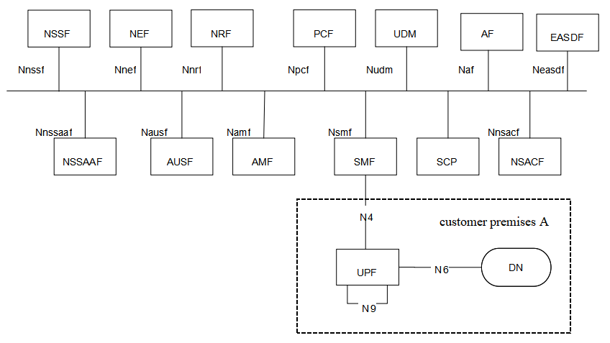
Figure 1 PNI-NPN with dedicated UPF deployed in customer premises
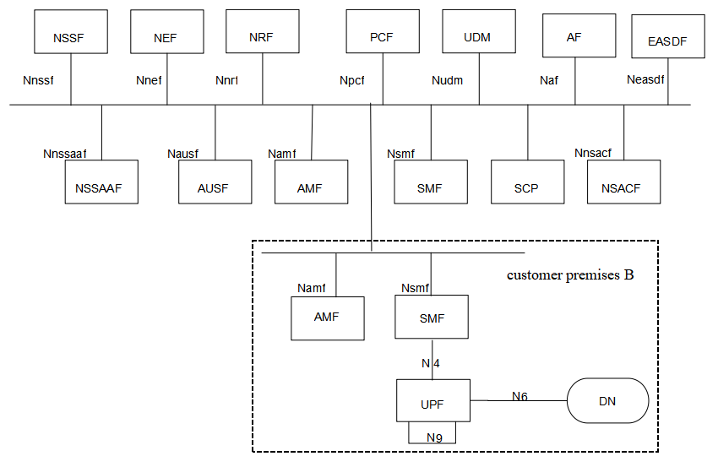
Figure 2 PNI-NPN with dedicated UPF and part of CP functions deployed in customer premises
Compared to operators, customers may have limited resources for security. Therefore, the physical security of customer premises might be weaker than that of operator’s core network. Moreover, if NPN customers do not succeed to provide a secure O&M procedure, there is a risk of unauthorized control to the dedicated NFs by attackers. Attackers may utilize compromised dedicated NFs to collect PLMN’s topology, send malformed messages or launch DDoS attacks to PLMN etc.
For scenario 1, NDS/IP shall be supported to ensure confidentiality, integrity and replay protection as described in clause 9.9 in TS 33.501 [2].
For scenario 2, SBA security shall be supported to ensure confidentiality, integrity and replay protection as described in clause 13 in TS 33.501 [2].
However, existing NDS/IP or SBA security cannot protect PLMN from attacks that attackers exploit compromised dedicated NFs to launch, such as DDoS, malformed signaling messages, topology information exposure etc.

4 Detailed proposal
Considering the security risks, SA3 needs to study the security when a PLMN hosts a NPN with dedicated NFs deployed in customer premises. Therefore a SID is proposed in a parallel contribution.

