Company | RIL Number | Comment
Xiaomi | X002 | 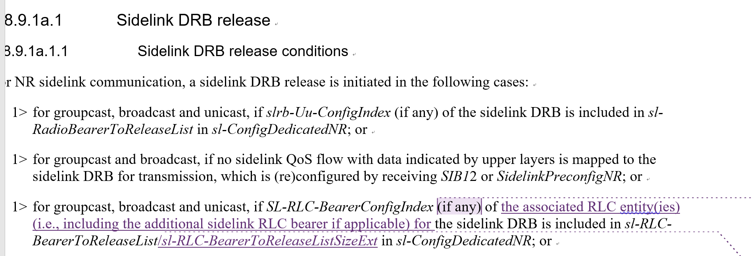  In our understanding if the SL-RLC-BearerConfigIndex indicates the release of the original RLC bearer for the SL DRB, the additional RLC bearer should be released as well. See below. There is no need to emphasize in DRB release procedure that when both RLC legs are released, the SL DRB is released.  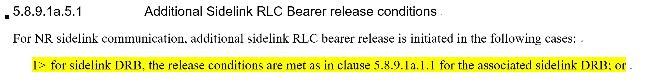
Xiaomi | X004 | If the “and…backwardsincompatible” condition is kept, then how to handle the case when dedicated RRC indicates UE to release the additional RLC bearer but the Tx profile of the QoS flows indicates backwardscompatible? Shall the UE still keep the additional RLC bearer? To us, tx UE needs to follow NW configuration no matter of the tx profile. Please note for SL DRB, even it is backwards compatible, UE can enable PDCP duplication only when there is additional RLC bearer configuration in dedicated RRC/SIB/preconfig.  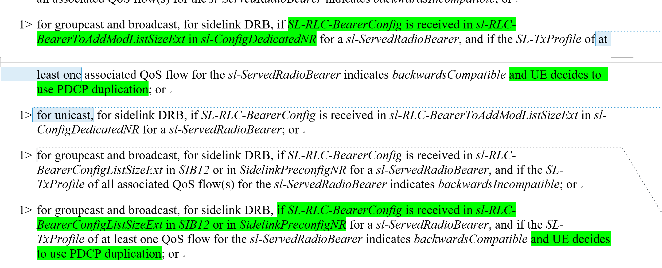
Xiaomi | X006 | According to RAN2 agreement, the case mentioned in this bullet only applies to RRC idle/inactive, for RRC connected, there should be no mixed tx profiles within the same RB since tx profile to qos flow mapping is reported to gNB via SUI. Considering this issue is not critical clear for connected case, we propose RAN2 to further discuss and clarify whether NW ensures no mixed case based on the reported qos flow to tx profile mapping or mixed case is allowed, UE follows the same solution as idle/inactive. Suggest rapporteur to change to ToDo.  If at least one QoS flow having Tx profile with value set to backwards compatible is mapped to the radio bearer, legacy carrier is used for transmission for this radio bearer, for RRC_IDLE/RRC_INACTIVE/OOC case.
Xiaomi | X012/X013 | Based on the updated running CR, we think our RILs should be “propagree”

