 Stockholm 30th of January 2001

TO MEMBERS OF 3GPP TSG T3

Invitation to the 3GPP TSG T3 SIM Interpreter Ad Hoc meeting to be held
on 5-7 February 2001 in Stockholm, Sweden.

Dear Colleagues,

On behalf of SmartTrust, I have the pleasure to inform you of the arrangements for the SIM Interpreter Ad Hoc meeting.

The venue of this meeting will be:
Foresta Hotell & Konferens
Herserudsvägen 22
Lidingö-Stockholm
Sweden

The meeting will start 5th of February 2001 at 9.00 and will end 7th of February 2001 at latest 16.00.

The on-line registration is available at:
http://webapp.etsi.org/3GPPRegistration/home.asp?mid=21164

The automatic document number allocation is available at:
http://www.3gpp.org/ftp/TSG_T/WG3_USIM/www/DocNumberAllocation.htm

After number allocation the documents will be uploaded on the server in the FTP directory at:
ftp://ftp.3gpp.org/TSG_T/WG3_USIM/adhocs/25-0102-Stockholm/

Annexed to this invitation you will find information about booking the hotel and a registration form.

I look forward to seeing you in Stockholm!

Best regards,

Susanna Eskola
SmartTrust

THE MEETING VENUE

The meeting hotel is 6 km north-east from the Stockholm downtown. Please look at the map below to see the exact situation.

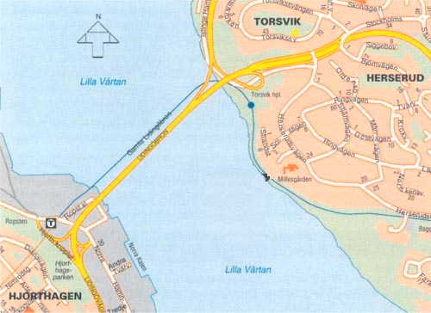

Hotel
Centrum

How to reach Foresta Hotell & Konferens FROM THE AIRPORT

Arlanda Airport is Stockholm's International Airport. It is situated 45 km north of Stockholm city.
There is two alternatives to reach the meeting venue: With taxi or with train and taxi.

Taxi:
Taxi to meeting venue is about SEK 400-500, always ask the price before leaving. The trip will take about 40-60 minutes depending of the traffic.

Train and taxi:
There is frequent train service (Arlanda Express) from Arlanda airport to the Stockholm Central railway station. The trip takes 20 minutes and cost SEK 120.. In central railway station you can find taxi on the left hand side on a way to the central railway station. The taxi trip from the Central railway station to the meeting venue takes about 15 minutes depending of the traffic and cost about 150 SEK.

HOTEL RESERVATION FORM

To: Susanna Eskola
Fax.+ 46 8 685 6530
Tel. + 46 70 350 2753
E-mail. susanna.eskola@smarttrust.com

For the 3GPP T3 SIM Interpreter Ad Hoc Meeting.
Please complete ALL sections in BLOCK CAPITALS and send the reservation form
as soon as possible to: Susanna Eskola (latest on Wednesday 31st of January 16.00)

The special conference rate is SEK 1350.- per person per night, including breakfast.

I will arrive on ____________ at __________
I will leave on ____________ at __________

Name: _________________________________________
Company: __________________________________________________
Address: __________________________________________________
__________________________________________________
Fax*: __________________________________________________
Tel*: __________________________________________________
(* = including country code)

Signature: __________________________________________________

