Invitation to the 3GPP T1#23,SA5#38, RAN4#31 meetings to be held in May 2004 in Beijing, China
3GPP T WG1 #23,10~14 May 2004
3GPP SA WG5 #38,10~14 May 2004
3GPP RAN WG4 #31,10~14 May 2004
Dear Delegate,
On behalf of CATT we have the pleasure to invite you to attend the above-mentioned meetings taking place in Beijing from May 10th – 14th, 2004. Registration will start on the first day of the meetings at 8.30 am.
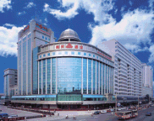

The meetings will take place at STATE GUEST HOTELS. Please use the enclosed registration form for hotel reservations ASAP. The hotel has a block booking on the “first come first served”-basis. Deadline for the block booking is April 10th, 2004. After that date room availability and discount rates cannot be guaranteed. May is a very high season for tourism in Beijing, so please take into account of this deadline.
NOTE: During the meetings all documents will be distributed via wireless LAN. Please remember to bring your wireless LAN card.
The Meeting chairmen will distribute meeting agendas separately.
We are looking forward to seeing you in Beijing.
Sincerely,

Dr. XIE, yongbin
vice-president
Datang Mobile Telecommunication Equipment Co. Ltd
Hotel Reservation Form
Cut-off Date: April 10, 2004
Room Rate per night: 100 USD for single and 110 USD for double and $120 USD for Deluxe (including tax , breakfast and lunch)
Cancellation Policy: Reservations must be cancelled before April 15, 2004 to avoid a penalty of one night’s room Rate.
Name of Meeting:
3GPP T1 3GPP RAN4 3GPP SA5
Meeting Date: 10th~14th, May, 2004

Guest Information(* = including country code)
Title: | Ms Mr
Family Name:
Fore name:
Company:
Mailing address:
Guest Address
Telephone*:
Fax*:
E-mail:
Accompanied by:
Reservation: | Single Double Deluxe Smoking No smoking
Date and time of arrival:
Date and time of departure:
Any special arrangements:

Billing information to be used as a guarantee
Credit Card Type: | AMEX DINERS MASTER VISA others （ ）
Number of Credit Card:
Expiry date:
Billing Address of Credit Card Holder:
Cardholder’s Name:
NOTE:
Please fax the above-cited forms to Ms. Dong Bing at +86-10-62303127 before April 10, 2004，so that she can book the room and prepare the representative card for you. Please note that without your credit card number, reservation is not guaranteed.
General Meeting Information
Dates:
3GPP T WG1 #23, 10~14 May 2004
3GPP SA WG5 #38, 10~14 May 2004
3GPP RAN WG4 #31, 10~14 May 2004
Hotel Address:
STATE GUEST HOTELS
9 Fuchengmenwai Road, Xicheng District, Beijing, China
Submission of documents:
Please contact the Secretary of the relevant group to obtain a Tdoc template and an allocated Tdoc number:
Please Note:
This will be a paperless meeting. A wireless LAN will be set up for document distribution. Please be sure to bring your wireless LAN card to the meeting.
Airport:
Beijing International Airport (PEK). A number of major European, North American, and Australian airlines fly directly into Beijing International Airport (PEK)
Voltage:
220 Volts. Please be sure you have the correct adapter. Voltage converters or adapters will not be provided at the meeting.
Taxi Information:
Metered taxis are located in front of the terminal and reach the city in 40-60 minutes. The cost to the hotel is in the range of RMB100 (or USD 15) depending on the type of taxi, plus RMB10 for the highway toll. The trip will take you around 40-60 minutes. It is not necessary to tip taxi drivers in Beijing unless they render extra assistance with bags, etc. Please consider the heavy traffic in Beijing.
However, most taxi drivers do not speak English, so make sure you have the name of your hotel or address written in Chinese.
The following is the address of the hotel in Chinese:
Directions to Hotel:
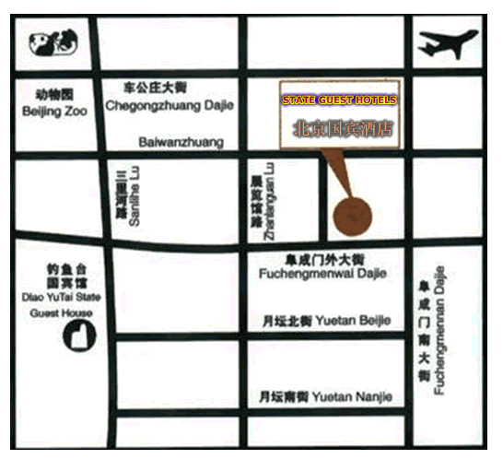

Visa Information:
In case you need a personal invitation for your visa application to China, Please fill the following visa request form and email to Ms. Dong Bing at dongbing@datangmobile.cn.
Invitation letters will be sent via fax. If you need an original copy please send a request to Ms. Dong Bing. Your request will be processed within 10 working days from receiving. If you do not receive your invitation within certain days or have any changes after receiving your letter, please contact Ms. Gong Ge or Ms. Dong Bing.
In order to be processed, your email must include the following information.
VISA REQUEST FORM

Family name

Fore name

Gender

Birth date (dd/mm/yy)

Passport number

Passport expired date

Nationality

Profession

Entry date

Visiting place

Reason of visit

Single entry/multi entry

Duration of staying

Company/Employer

Company/Employer’s Address

Telephone number

E-mail address

Fax number
In which way would you like  the invitation to be sent | Fax only Fax and EMS

Note:

If you have been in China before, please list here all the places you have visited. Otherwise, just fill in ‘No’.

Where will you apply for the traditional visa? (country)

Contact person for invitation letter:

Name | MS. Dong, Bing
Fax | +86-10-62303127
Mail | dongbing@datangmobile.cn

Name | MS. Gong, Ge
Tel | +86-10-82029090 ext.6757

Related web pages:

http://www.chinabig.com/en/travel/bj_guide/
http://weather.yahoo.com/forecast/CHXX0008_c.html?force_units=1

