3GPP TSG-SA WG6 Meeting #43 S6-211256
e-meeting, 24th May – 2nd June 2021 (revision of S6-21xxxx)

Source: Samsung, Convida, Ericsson, AT&T, Qualcomm, Apple, Motorola Solutions, Intel, Deutsche Telekom, Nokia, Nokia Shanghai Bell, Sony, Lenovo, Motorola Mobility
Title: Pseudo-CR on Clause 6
Spec: 3GPP TS 23.558 v2.1.0
Agenda item: 7.6
Document for: Approval
Contact: Nishant Gupta <nishant.gup@samsung.com>

1. Introduction
The contribution cleans up clause 6 Application architecture, and resolves related ENs.
2. Reason for Change
Editor's note: Whether the meaning of the term SBA in this clause needs to be modified based upon the above representation is FFS.
The above EN can be closed as the SBA terminology is just a representative of an architecture that is described from a “service provider” point of view, i.e. independently from the consumer and does not preclude representation of UE applications on the service based architecture.
Editor's note: How the possible deployment models of the ECS affect the above representation is FFS.
The above EN can be closed as the description of the ECS in clause 6.3.4 mentions that the ECS can be deployed in both MNO and 3rd party domains as required. No change in the representation is required as in either deployment the ECS exposes the Eecs interface to provide services to the EEC and the EES.
Excerpt from clause 6.3.4:

6.3.4 Edge Configuration Server (ECS)
ECS provides supporting functions needed for the EEC to connect with an EES.
Functionalities of ECS are:
a) provisioning of Edge configuration information to the EEC. The Edge configuration information includes the following:
1) the information for the EEC to connect to the EES (e.g. EDN service area); and
2) the information for establishing a connection with EESs (such as URI);
NOTE: The ECS can be deployed in the MNO domain or can be deployed in 3rd party domain by service provider.
b) supporting the functionalities of registration (i.e., registration, update, and de-registration) for the EES(s);
c) supporting the functionalities of API invoker and API exposing function as specified in 3GPP TS 23.222 [6]; and
d) interacting with 3GPP Core Network for accessing the capabilities of network functions either directly (e.g. via PCF) or indirectly (e.g. via SCEF/NEF/SCEF+NEF).

3. Proposal
It is proposed to agree the following changes to 3GPP TS 23.558 v2.1.0.

* * * First Change * * * *

3.3 Abbreviations
For the purposes of the present document, the abbreviations given in 3GPP TR 21.905 [1] and the following apply. An abbreviation defined in the present document takes precedence over the definition of the same abbreviation, if any, in 3GPP TR 21.905 [1].
AC Application Client
ACID Application Client Identification
ACR Application Context Relocation
ACT Application Context Transfer
AF Application Function
ASP Application Service Provider
DN Data Network
DNAI Data Network Access Identifier
DNN Data Network Name
EAS Edge Application Server
EASID Edge Application Server Identification
ECS Edge Configuration Server
ECSP Edge Computing Service Provider
EDN Edge Data Network
EEC Edge Enabler Client
EECID Edge Enabler Client Identification
EES Edge Enabler Server
EESID Edge Enabler Server Identification
FQDN Fully Qualified Domain Name
GPSI Generic Public Subscription Identifier
GSM Global System for Mobile Communications
GSMA GSM Association
LADN Local Area Data Network
NEF Network Exposure Function
OP Operator Platform
OPG Operator Platform Group
S-EAS Source Edge Application Server
S-EES Source Edge Enabler Server
SBA Service Based Architecture
SCEF Service Capability Exposure Function
SSID Service Set Identifier
T-EAS Target Edge Application Server
T-EES Target Edge Enabler Server
TAI Tracking Area Identity

6.2 Architecture
This clause describes the architecture for enabling edge applications in the following representations:
- A service-based representation, where the Edge Enabler Layer functions (e.g. ECS) enable other authorized Edge Enabler Layer functions (e.g. EES) to access their services. This representation also includes point-to-point reference points where necessary;
- A service-based representation as specified in 3GPP TS 23.501 [2], where the Network Functions (e.g. NEF) enable authorized Edge Enabler Layer functions (e.g. ECS) i.e. Application Functions, to access their services;
- A service-based representation, where the Core Network Northbound APIs as specified in 3GPP TS 23.501 [2] and 3GPP TS 23.502 [3], are utilized by authorized Edge Enabler Layer functions via CAPIF core function specified in 3GPP TS 23.222 [6]; and
- A reference point representation, where existing interactions between any two functions (e.g. EES, ECS) is shown by an appropriate point-to-point reference point (e.g. EDGE-6, EDGE-7).
Edge Enabler Layer functions of the edge architecture shall only use service-based interfaces for their interactions.
Figure 6.2-1 illustrates the service based representation of architecture for enabling edge applications.
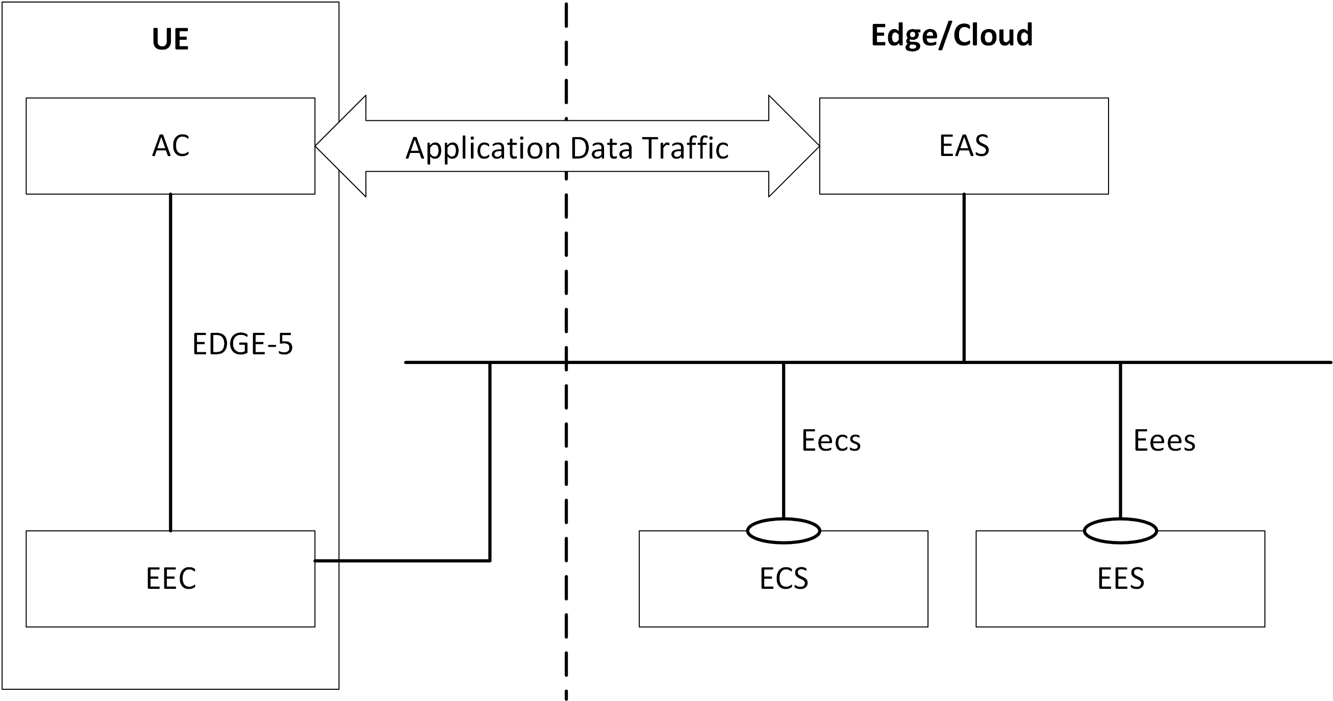
Figure 6.2-1: Architecture for enabling edge applications - service-based representation
NOTE: The EEC function and EAS function in figure 6.2-1 do not expose any service to the other functions.

The mechanisms for service discovery in the SBA represented by figure 6.2-1 are as follows:
- The EES discovers the ECS via pre-configuration or by using CAPIF as specified in 3GPP TS 23.222 [6];
- The EAS discovers the EES via pre-configuration or by using CAPIF as specified in 3GPP TS 23.222 [6];
- The EAS discovers the other EAS(s) as specified in clause 8.8.3.2;
- The EEC discovers the ECS as specified in clause 8.3.2; and
- The EEC discovers the EES via service provisioning as specified in clause 8.3.3.
Figure 6.2-2 illustrates the service-based representation for utilization of the 5GS network services based on 5GS SBA specified in 3GPP TS 23.501 [2].
Figure 6.2-2: Utilization of 5GS network services based on 5GS SBA – service based representation
The ECS, EES and EAS acts as AFs for consuming network services directly from the 3GPP 5G Core Network entities over the service based architecture specified in 3GPP TS 23.501 [7].
The ECS, EES and EAS can consume network services from the 5GS SBA as represented in the figure 6.2-2 and interact in the SBA represented in figure 6.2-1.
Figure 6.2-3 illustrates the service-based representation for utilization of the Core Network (5GC, EPC) northbound APIs via CAPIF.
Figure 6.2-3: Utilization of Core Network Northbound APIs via CAPIF – service based representation
The ECS, EES and EAS act as authorized API invoker to consume services from the Core Network (5GC, EPC) northbound API entities like SCEF, NEF, SCEF+NEF which act as API Exposing Function as specified in 3GPP TS 23.222 [6].
The mechanism for northbound APIs discovery in the SBA represented by figure 6.2-3 is as specified in 3GPP TS 23.222 [6].
The ECS, EES and EAS can consume Core Network northbound APIs via CAPIF as represented in the figure 6.2-3 and interact in the SBA represented in figure 6.2-1.
Figure 6.2-4 illustrates the reference point representation of the architecture for edge enabling applications.
Figure 6.2-4: Architecture for enabling edge applications - reference points representation
The EDN is a local Data Network. EAS(s) and the EES are contained within the EDN. The ECS provides configurations related to the EES, including details of the EDN hosting the EES. The UE contains AC(s) and the EEC. The EAS(s), the EES and the ECS can interact with the 3GPP Core Network.

* * * Next Change * * * *

6.5 Reference Points

6.5.1 General
This clause describes the reference points of the architecture for enabling edge applications. The reference points show the interactions that exist amongst the Edge Enabler Layer functions and between the Edge Enabler Layer functions and the 3GPP Core Network. These reference points are realized using the corresponding service-based interfaces.

