3GPP TSG-SA WG6 Meeting #38-e S6-201501
e-meeting, 31st August – 8th September 2020 (revision of S6-20xxxx)

Source: Huawei, Hisilicon, China Mobile, CATT
Title: S-EAS decided application context relocation
Spec: 3GPP TS 23.558 0.4.0
Agenda item: 7.5
Document for: Approval
Contact: Cuili Ge (gecuili@huawe.com), Niranth (namogh@huawei.com)

1. Introduction
This contribution is proposed to introduce the S-EAS decided appliction context relocation.
2. Reason for Change
It is proposed to make the S-EAS to be the decision-maker of application context relocation as:
1) only the AC and AS be aware of the service running status to make decision whether and when to start the excution of application context relocation.
2) it helps the ECSP to avoid the business risk in case of the EES decides and starts the application context relocation at a wrong moment which cause the service collapse or unacceptable degradation to the ASP.
This procedure provide a overall and high level of application context relocation decided by S-EAS as follows:
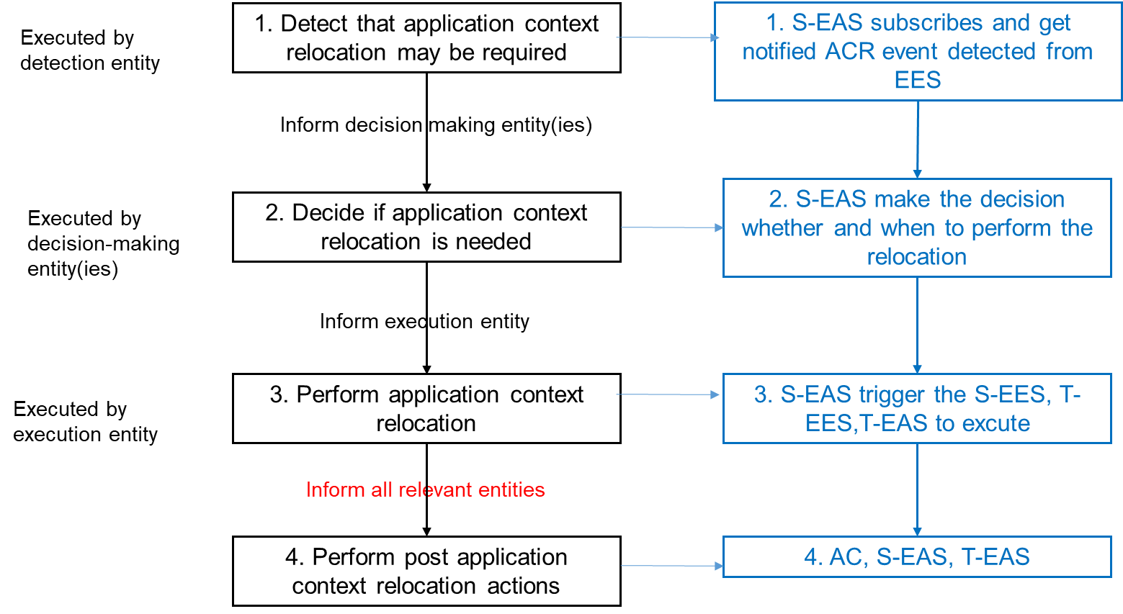
From EES perspective, it can provide one or all of the following services, which can be invoked by EAS:
-Relocation detection;
-Application Context tranfering service from source EAS to target EAS
Although it is not clearly addressed by above, the target EAS address shall be discovered to enable the tranfering of application context relocation. It can be implemented as a separated services or combined with Relocation Detection or Context Transfering by EES.
3. Conclusions
4. Proposal
It is proposed to agree the following changes to 3GPP TS 23.558 v0.4.0.

* * * First Change * * * *

8.8.2.x Application context relocation procedures

8.8.2.x.1 General
The procedure in this clause illustrates the high level procedure of application context relocation in inter-EDN mobility, EAS overload, or EDN overload scanarios.
In this procedure, the EAS may detect the need of application context relocation locally or is notified by the source Edge Enabler Server due to UE inter-EDN mobility, EDN overload etc. The EAS make the decision about whether to perform the application context relocation, and starts the application context relocation at a proper time.

8.8.2.x.2 Source EAS based application context relocation
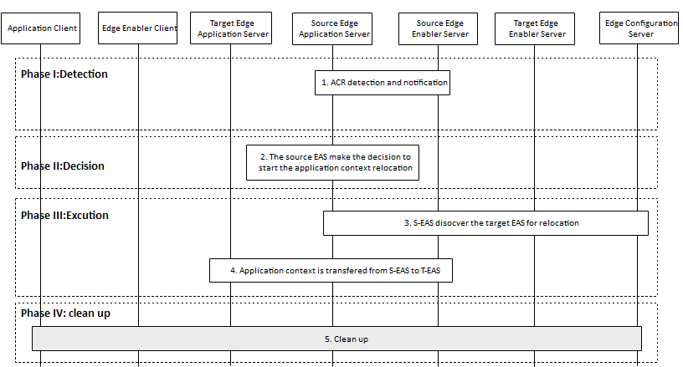
Figure 8.8.2.x.2-1: Source EAS based application context relocation
The source Edge Application Server based application context relocation is outlined with four main phases: detection, decision, c and clean up.
Phase I: Application context relocation detection
1. The source Edge Application Server either receives notifications from source Edge Enabler Sever indicating that application context relocation may be required, or self detects the need for application context relocation. The notification may contain the target Edge Application Server information.
NOTE 1: How the source Edge Application Server self detects the application context relocation is needed locally is outside the scope of this specification.
Editor’s Note: Whether and what kind of EEC detection can be provided to EAS via EES is FFS.

Phase II: Application context relocation decision
2. The source Edge Application Server makes the decision to perform the application context relocation e.g., for one or more users and when to start.
NOTE 2: It is outside of the scope of this specification how the source Edge Application server determines when to start the application context relocation.
Phase III: Application context relocation execution
3. If no target Edge Application Server is available at the source Edge Application Server, the source Edge Application Server discovers the target Edge Application Server as described in clause 8.8.2.
4. The application context is transferred from source Edge Application Server to the target Edge Application Server via the application layer. The Edge Enabler Client is informed of the application context transfer completion.
NOTE 3: Step 3 and step 4 can be merged into a single step.
Editor's Note: It is FFS whether application context can be transferred via the edge enabler layer.
Phase IV: Post clean up after application context relocation
5. All required entities perform cleanup
Editor’s note: Whether to inform the EEC as post-ACR action at phase IV is FFS.
Editor's Note: Detailed operation for cleaning up at each entity is FFS.

