3GPP TSG-SA WG6 Meeting #38-e S6-201501
e-meeting, 31st August – 8th September 2020 (revision of S6-20xxxx)

Source: Huawei, Hisilicon
Title: S-EAS decided application context relocation
Spec: 3GPP TS 23.558 0.4.0
Agenda item: 7.5
Document for: Approval
Contact: Cuili Ge (gecuili@huawe.com), Niranth (namogh@huawei.com)

1. Introduction
This contribution is proposed to introduce the S-EAS decided appliction context relocation.
2. Reason for Change
It is proposed to make the S-EAS to be the decision-maker of application context relocation as:
1) only the AC and AS be aware of the service running status to make decision whether and when to start the excution of application context relocation.
2) it helps the ECSP to avoid the business risk in case of the EES decides and starts the application context relocation at a wrong moment which cause the service collapse or unacceptable degradation to the ASP.
This procedure provide a overall and high level of application context relocation decided by S-EAS as follows:
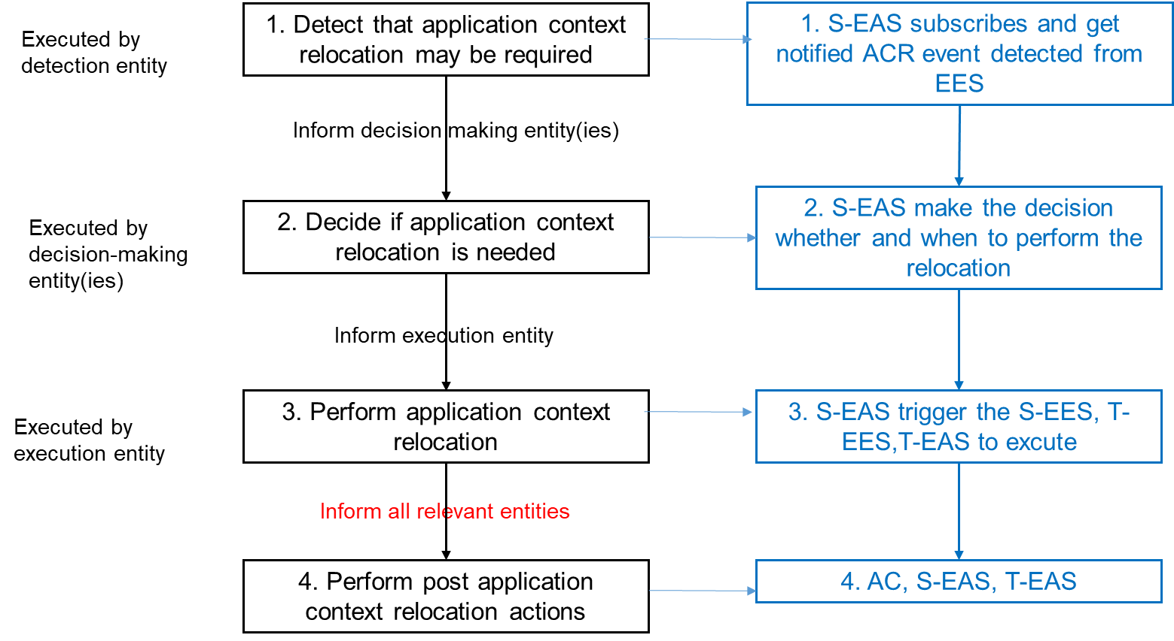
From EES perspective, it can provide one or all of the following services, which can be invoked by EAS:
-Relocation detection;
-Application Context tranfering service from source EAS to target EAS
Although it is not clearly addressed by above, the target EAS address shall be discovered to enable the tranfering of application context relocation. It can be implemented as a separated services or combined with Relocation Detection or Context Transfering by EES.
3. Conclusions
4. Proposal
It is proposed to agree the following changes to 3GPP TS 23.558 v0.4.0.

* * * First Change * * * *

8.8.2.x Application context relocation procedures

8.8.2.x.1 General
The procedures in this clause illustrates the high level procedure of application context relocation in inter-EDN mobility, EAS overload, or EDN overload scanarios.
In this procedures, the EAS may get application context relocation event notification or application context relocation event with target EAS notification from the EES about inter-EDN mobility, EAS overload, or EDN overload, the EAS make the decision about whether and when to migirate the user to a better EAS. If migirated, the EAS starts the application context transfer at a proper time.

8.8.2.x.2 Source EAS based application context relocation

Figure 8.8.2.x.2-1: Source EAS based application context relocation
The source Edge Application Server based application context relocation is outlined with four main phases: detection, decision, excution and clean up.
Phase I: Application context relocation detection
The source Edge Application Server either receives notifications from source Edge Enabler Sever (Option#a with step 1a) indicating that application context relocation may be required, or application context relocation may be required to be relocated to the target Edge Application Server (Option#1b with step 1b), or self detects the need for application context relocation (Option#c with step 1c).
1a. The source Edge Application Server subscribes and gets the application context relocation event notification from source Edge Enabler Server as described in clause 8.8.2.x.
1b. The source Edge Application Server subscribes and gets the application context relocation event with target Edge Application Server notification from source Edge Enabler Server as described in clause 8.8.2.y.
NOTE 1: When Option#1b (i.e., step 1b) is selected by the EAS, the phase IV of application context relocation execution may be preformed via the application layer which is outside the scope of this specification.
1c. The source Edge Application Server detects the application context relocation event locally.
NOTE 2: How the source Edge Application Server detects the application context relocation event locally is outside the scope of this specification.
Phase II: Application context relocation decision
2. Based on application context relocation detections in Phase I, the source Edge Application Server makes the decision whether the application context relocation for one or more user is required and when to start. If the source Edge Application Server determines it is not the moment to start the application context relocation, the source Edge Application Server may record the event and delay the decision at a proper moment.
NOTE 3: How the source Edge Application Server make the decision is outside the scope of this specification.
Phase III: Application context relocation excution
When the source Edge Application Server makes the decision to start the application context relocation, the application context relocation excution is triggered. The application context relocation excution contains several actions (i.e., traget Edge Application Server discovery, application context transfer, notifying the application relocation information to 3GPP core network ) which may be selectively or fully excuted with the utilization of edge enabler layer capabilities. In the selectively excution option, any of the actions 3a-1, 3a-2 and 3a-3 can be replaced by the application mechanism. In the fully excution option, all the actions are excuted with the edge enabler layer capabilities as a whole.
3a-1. The source Edge Application Server discovers the target Edge Application Server as described in clause 8.8.2.1.
NOTE 4: If Option#1b (i.e., step 1b) is selected by the EAS in Phase I of application context relocation detection, the step 3a-1 is skipped.
3a-2. The source Edge Application Server delivers the application context to the target Edge Application Server as described in 8.8.2.z.
3a-3. The source Edge Application Server notifies the 3GPP core network about the application context relocation information as described in 8.6.2.a if necessary.
3b. The source Edge Application Server starts the application context relocation as described in clause 8.8.2.1.
Phase IV: Post clean up after application context relocation
The application client, the source Edge Application Server and the target Edge Application Server may perform post application context relocation clean ups if required.

