3GPP TSG-SA WG6 Meeting #38-e S6-201500
e-meeting, 31st August – 8th September 2020 (revision of S6-20xxxx)

Source: Huawei, Hisilicon
Title: DNAI clarification
Spec: 3GPP TS 23.558 0.4.0
Agenda item: 7.5
Document for: Approval
Contact: Cuili Ge (gecuili@huawe.com), Niranth (namogh@huawei.com)

1. Introduction
This pCR is proposed to solve the editor’s note about DNAI.
2. Reason for Change
As discussed in SA6#38e, two issues are raised in regard of the above ENs. The 1st issue is the relationship among DNAI associated with EAS, DNAI associated with EES, DNAI associated with EDN. The second one is about whether DNAI can be used as UE location.
For the 1st issue, there are several ENs about the DNAI in TS 23.558 as follows:
1st EN is in 8.2.4 Edge Application Server Profile:
Editor's Note: Detailed relation with EAS DNAI and DNAIs associated with EES or EDN is FFS.
2nd EN is in 8.8.2.2 Retrieve Target Edge Enabler Server procedure:
Editor's Note: Detailed description of Target DNAI information is FFS. Also, the relationship of DNAI associated with EAS and the DNAI(s) associated with EDN is FFS.
3rd EN is in 8.8.3.1 Edge Application Server discovery request
Editor's Note: Detailed description of Target DNAI information is FFS. Also, the relationship of DNAI associated with EAS and the DNAI(s) associated with EDN is FFS.
The relationship is analyzed and illustrated in the figure below. For a single EAS registered at the EES in the same EDN, the EAS, the EES share the same DNAI associated with the EDN. While for the specific application, the DNAI list associated with this application maybe different with the DNAI list associated with the EES or other application (which can be see as another application)
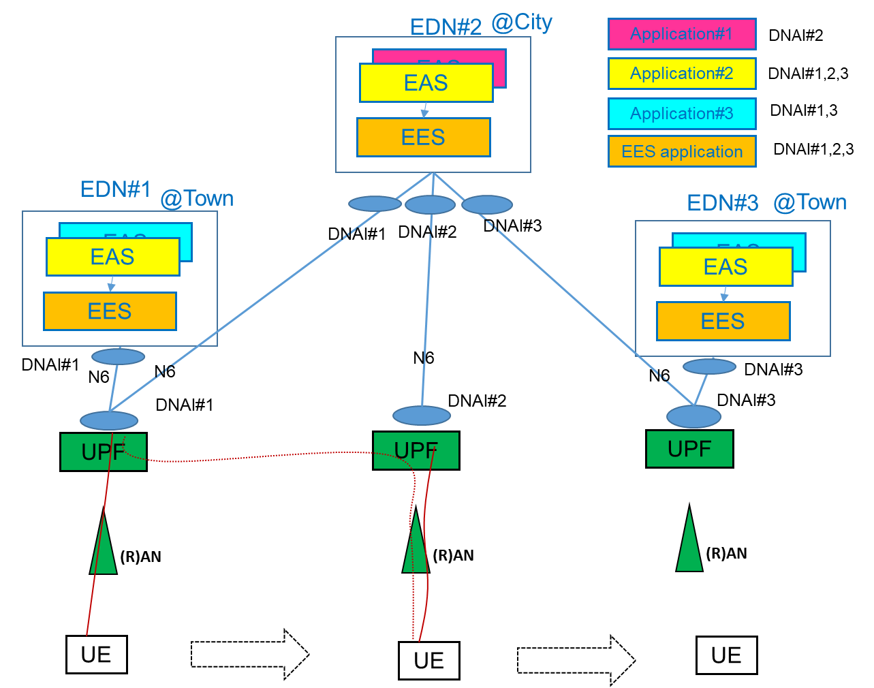

For the 2nd issue, the definition of DNAI in TS 23.502 indicates that the DNAI is a kind of network topology location just like cell and TA, but in another bigger granularity. So the DNAI can reflect the UE location in the network and can be used as UE location.
“DN Access Identifier (DNAI): Identifier of a user plane access to one or more DN(s) where applications are deployed.”
3. Conclusions
The changes are summaried as follows :
To resolve the 3 ENs, the clause 8.2.4 EAS profile, clause 8.2.6 EES profile, clause 8.8.2.2 and clause 8.8.3.1 is updated and the ENs are removed.
To resolve the DNAI being the UE location, the clause 7.3.2 is updated to include the DNAI as a kind of UE location, and clause 8.8.2.2 and clause 8.8.3.1 is updated to relfect that the DNAI can be one kind of UE location.
4. Proposal
It is proposed to agree the following changes to 3GPP TS 23.558 v0.4.0.

* * * First Change * * * *

7.3.2 UE Location
The UE location identifies where the UE is connected to the network. It provides consistent definition of the UE's location across the UE and network entities. Following values are examples that can be used:
a) Cell Identity or Tracking Area Identity, as defined in 3GPP TS 23.502 [3] clause 5.15.3.
b) DNAI, as defined in 3GPP TS 23.501 [2].
Editor's Note: It is for FFS if we need two different UE Location definitions. One is the physical location of the UE to any EAS specific usage and the second is the network topology location (e.g. Cell ID/TAI/DNAI) that is used to find the best user plane routing or most nearby EAS to the UE.
* * * Next Change * * * *

8.2.4 Edge Application Server Profile
Table 8.2.4-1: Edge Application Server Profile
Information element | Status | Description
EAS ID | M | The identifier of the EAS
EAS Endpoint | M | Endpoint information (e.g. URI, FQDN, IP address) used to communicate with the EAS. This information maybe discovered by EEC and exposed to Application Clients so that application clients can establish contact with the EAS.
Application Client ID(s) | O | Identifies the Application Client(s) that can be served by the EAS
EAS Provider Identifier | O | The identifier of the EAS Provider
EAS Type | O | The category or type of EAS (e.g. V2X)
EAS description | O | Human-readable description of the EAS
EAS Schedule | O | The availability schedule of the EAS (e.g. time windows)
EAS Service Area | O | The geographical service area that the EAS serves
EAS Service KPIs | O | Service characteristics provided by EAS, detailed in Table 8.2.5-1
EAS service permission level | O | Level of service permissions e.g. trial, gold-class supported by the EAS
EAS Feature(s) | O | Service features e.g. single vs. multi-player gaming service supported by the EAS
Service continuity support | O | Indicates if the EAS supports service continuity or not. This IE may also indicate whether the EAS supports Application Context Transfer.
EAS DNAI (NOTE) | O | DNAI associated to the EAS. This IE may be used as Potential Locations of Applications in clause 5.6.7 of 3GPP TS 23.501 [2].
EAS Availability Reporting Period | O | The availability reporting period (i.e. heart beat period) that indicates to the EES how often it needs to check the EAS's availability after a successful registration.
EAS Required Service APIs | O | A list of the Service APIs that are required by the EAS
EAS Status | O | The status of the EAS (e.g. enabled, disabled, etc.)
NOTE: The value of EAS DNAI, the DNAI(s) associated with the EES and the DNAI with the EDN are the same

* * * Next Change * * * *

8.2.6 Edge Enabler Server Profile
The Edge Enabler Server profile includes information about the EES and the services it provides.
Table 8.2.6-1: Edge Enabler Server Profile
Information element | Status | Description
EES ID | M | The identifier of the EES
EES Endpoint | M | Endpoint information (e.g. URI, FQDN, IP address) used to communicate with the EES. This information is provided to the EEC to connect to the EES.
Edge Application Server IDs | M | List of Edge Application Server IDs registered with the EES.
EES Provider Identifier | O | The identifier of the EES Provider (such as ECSP)
EES DNAI(s) (NOTE) | M | The DNAI(s) associated with the EES
NOTE: The value of EES DNAI(s), the DNAI(s) associated with the EDN and the DNAI(s) associated with the EAS are the same.

Editor's Note: Whether there is a need to specify a Service Area for the EES is FFS.

* * * Next Change * * * *

8.8.2.1 Discover target Edge Application Server
Figure 8.8.2.1-1 illustrates the interactions between the source Edge Application Server and the source Edge Enabler Server and optionally between the source Edge Enabler Server and the Edge Configuration Server and between the source Edge Enabler Server and target Edge Enabler Server for fetching target Edge Application Server information. This procedure may be utilized by a source Edge Application Server which undertakes the transfer of application context information to a target Edge Application Server directly.
Pre-conditions:
1. Information related to the Edge Enabler Server is available with the source Edge Application Server.
Figure 8.8.2.1-1: Discover target Edge Application Server
1. The Edge Application Server invokes the Edge Application Server Discovery request on the source Edge Enabler Server. If potential target EAS DNAI is available at the source Edge Application Server via UP path management event notification, the source Edge Application Server provides the source Edge Enabler Server with the potential target EAS DNAI.
NOTE: The trigger condition to invoke the Discover target Edge Application Server API is up to application service logic, which is out of scope of this specification.
2. Upon receiving the request, the source Edge Enabler Server checks if the requesting Edge Application Server is authorized to perform the discovery operation. If it is authorized, the source Edge Enabler Server checks if there exists a target Edge Application Server information (registered or cached) that can satisfy the requesting Edge Application Server information and additional query filters. If the source Edge Enable Server discovers the target Edge Application Server(s), the flow continues with step 5, else the source Edge Enabler Server retrieves the target Edge Enabler Server address from the Edge Configuration Server as specified in clause 8.8.2.2.
3. The source Edge Enabler Server invokes the Edge Application Server Discovery request on the target Edge Enabler Server.
4. The target Edge Enabler Server discovers the target Edge Application Server(s) and responds with the discovered target Edge Application Server information to the source Edge Enabler Server. The source Edge Enabler Server may cache the target Edge Application Server information.
Editor’s Note: How the target Edge Application Server is selected from the list of Edge Application Servers received in step 4 is for further study.
5. The source Edge Enabler Server responds to the Edge Application Server with the target Edge Application Server Information.

8.8.2.2 Retrieve Target Edge Enabler Server procedure
Figure 8.8.2.2-1 illustrates the procedure for the source Edge Enabler Server to retrieve the target Edge Enabler Server information from the Edge Configuration Server.
Pre-condition:
1. The source Edge Enabler Server has been pre-configured with the address of the Edge Configuration Server.
2. The Application Client at the UE already has on-going application traffic with the source Edge Application Server.
Figure 8.8.2.2-1: Retrieve target Edge Enabler Server procedure
1. The source Edge Enabler Server sends the Retrieve Edge Enabler Server request (UE location information (e.g., potential target EAS DNAI, potential target EES DNAI(s)) or UE identity, EAS ID of the source Edge Application Server) to the Edge Configuration Server in order to identify the target Edge Enabler Server which has an Edge Application Server available to serve the given Application Client in the UE. Potential target EAS DNAI is included if provided the the source Edge Application Server as specified in the clause 8.8.2.1. If potential target EES DNAI is available at the source Edge Enabler Server via UP path management event notification, the source Edge Enabler Server includes the potential target EAS DNAI.
2. If the request contains the UE identity (e.g. GPSI) but the UE location is not known to the Edge Configuration Server, then the Edge Configuration Server interacts with 3GPP core network to retrieve the UE location. The Edge Configuration Server determines target Edge Enabler Server(s) as per the parameters (e.g. EAS ID) in the request and the UE location information (e.g., potential target EAS DNAI, potential target EES DNAI(s)).
3. The Edge Configuration Server sends the Retrieve Edge Enabler Server response (EAS ID of the source Edge Application Server, list of target Edge Enabler Server(s) information) to the source Edge Enabler Server. The list of target Edge Enabler Server(s) information includes the endpoint for each of the target Edge Enabler Server(s), e.g. IP address determined in step 2.
Editor's note: It is FFS whether and what additional info is included in the Retrieve EES Request.
Editor's note: How to handle the case of multiple ECS(s) configured at the UE is FFS.

* * * Next Change * * * *

8.8.3.1 Edge Application Server discovery request
Table 8.8.3.1-1 describes information elements for the Edge Application Server Discovery Request from the EAS to the Edge Enabler Server. Table 8.8.3.1-2 provides further detail about the Query Filter information element.
Table 8.8.3.1-1: Edge Application Server discovery request
Information element | Status | Description
EAS ID | M | EAS ID of the source EAS to discover the target EAS information that matches with the source EAS.
Application Service Provider ID | O | The ASP identifier.
UE identifier | O | The identifier of the UE (i.e. GPSI or identity token).
UE location | O | Location of the UE (e.g. geographical area, civic address, potential target EAS DNAI).
Discovery Reason | O | Discovery reason (e.g. maintenance, UP path change).
Security credentials | M | Security credentials resulting from a successful authorization for the edge computing service.
Query Filter | O | List of characteristics for discovery purposes, as detailed in Table 8.8.3.1-2.

