3GPP TSG-SA WG6 Meeting #38-e S6-201499
e-meeting, 31st August – 8th September 2020 (revision of S6-20xxxx)

Source: Huawei, Hisilicon
Title: Application context relocation at edge enabler layer
Spec: 3GPP TS 23.558 0.4.0
Agenda item: 7.5
Document for: Approval
Contact: Cuili Ge (gecuili@huawe.com), Niranth (namogh@huawei.com)

1. Introduction
This contribution is proposed to introduce the procedure about fully excution of application context relocation with utilization of Edge Enabler layer capability.
2. Reason for Change
In order to shorten the time of application context relocation, the target EAS discovery, application context transfer can be executed in the same signalling flow via the Edge Enabler layer. And the application relocation information will be notified to the 3GPP Core network by the source Edge Enabler Server afther the context transfer is completed.
During this procedure, the following work is achieved:
1) The S-EAS and T-EAS can negotiate the handlings of application context e.g., application context format, compression formation etc.
2) The T-EAS is confirmed to accept the migrated user with its application context.
3) The application context can be directly delivered to the target EAS within the signallings. Or a separate media plane via the source EES and target EES is established to deliver the application context. A separate media plane (different with the signalling plane) is created between the S-EES and the T-EES to deliver the application context.
3. Proposal
It is proposed to agree the following changes to 3GPP TS 23.558 v0.4.0.

* * * First Change * * * *

8.8.2.z Application context relocation procedures
The procedures in this clause illustrates the high level procedure of source Edge Application Server requesting the source Edge Enabler Server to start and execute the application context relocation to transfer the user application context to the target Edge Application Server.
In this procedures, when receiving the application context relocation request from source Edge Application Server, the source Edge Enabler Server discovers the target Edge Application Server which accepts the incoming user with its application context, establishes the tunnel for transferring the user application context, and notify the application relocation information to the 3GPP core network if required.
Pre-conditions:
1. Information related to the Edge Enabler Server is available with the source Edge Application Server.
2. The source Edge Application Server has determined to start the application context relocation.
3. The target Edge Application Server has subscribed the application context relocation event from the target Edge Enabler Server.
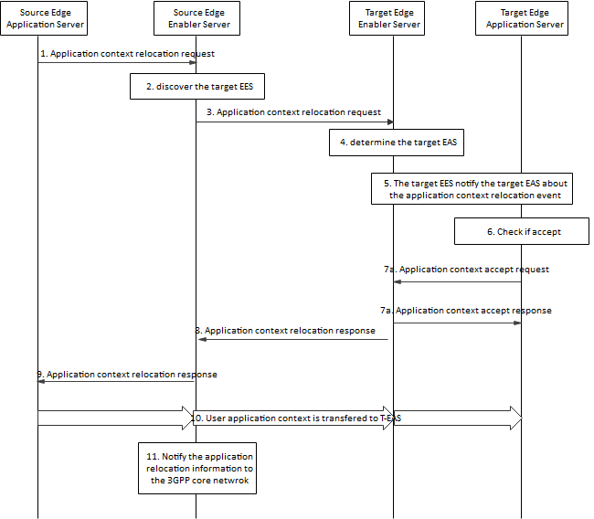
Figure 8.8.2.z-1: Application context relocation procedure
1. The source Edge Application Server sends an application context relocation request (UE identifier, Security credentials, UE location information, EAS ID, Application context handling parameters supported, Query Filter, 3GPP core network subscription context if any, application context container) to the source Edge Enabler Server. The application context container conveys the application context being transferred if the application context is of small size. Application context handling parameters supported is included if using a separate media plane to deliver the application context.
2. The source Enabler Server checks if the requesting Edge Application Server is authorized to perform the operation. If it is authorized, the source Edge Enabler Server checks if there exists a target Edge Application Server information (registered or cached) that can satisfy the requesting Edge Application Server information and additional query filters. If the source Edge Enable Server discovers the target Edge Application Server(s), the step 3 and step 8 is skipped, else the source Edge Enabler Server retrieves the target Edge Enabler Server address from the Edge Configuration Server as specified in clause 8.8.2.2.
3. The source Edge Enabler Server sends the application context relocation request (UE identifier, Security credentials, UE location information, EAS ID, Query Filter, Application context handling parameters supported at source EAS, 3GPP core network subscription context if any, application context container, media plane parameters supported at EES for the application context transfer) to the target Edge Enabler Server retrieved in step 2. The media plane parameters supported at EES such as the protocol, compression format etc. is provide to establish the separate media plane for the application context transfer between the source Edge Enabler Server and the target Edge Enabler Server.
4. The target Edge Enabler Server determines the target Edge Application Server as per the request received in step 3.
5. The target Edge Enabler Server sends the application context relocation event notification as specified in clause 8.8.2.x.
6. The target Edge Application Server checks whether to accept this request.
7a. If accepted, the target Edge Application Server sends an application context accept request. The address to receive the application context and the selected Application context handling parameters may be included when no application context container is received in step 5. If not accept, a rejection or failure indication with the cause is included.
7b. The target Edge Enabler Server responds the application context accept response. Then the target Edge Application Server starts to listen the application context packet.
8. The target Edge Enabler Server sends the application context relocation response to the source Edge Enabler Server. The target Enabler Server may provide the selected media plane parameters and the media plane address to receive the application context delivery from source Edge Enabler Server if necessary.
9. The source Edge Enabler Server sends the application context relocation response to the source Edge Application Server. The address for the source Edge Application Server to deliver the application context to EES, the selected application context handling parameter by the target Edge Application Server are returned if no application context container is included in step 1.
10. [Conditional] if the source Edge Application Server utilizes the separate media plane to deliver the application context, the source Edge Application Server processes the application context with the negotiated application context handling parameters, delivers the application context to the source Edge Enabler Server. The source Edge Enabler Server further delivers the application context to the target Edge Enabler Server via the established media plane tunnel. The target Edge Enabler Server delivers the application context to the target Edge Application Server
11. The source Edge Enabler Server, acting as the AF to invoke the Nnef_TrafficInfluence_AppRelocationInfo, or Nsmf_EventExposure_AppRelocationInfo, notifies the 3GPP core network about the application relocation information as specified in clause 4.3.6.3 in 3GPP TS 23.502 [3].

* * * Next Change * * * *

8.8.3.z1 Application context relocation request (EAS – EES)
Table 8.8.3.z1-1 describes information elements for the application context relocation request from the EAS to the Edge Enabler Server.
Table 8.8.3.z1-1: Application context relocation request
Information element | Status | Description
UE identifier | M | Identifies the UE for which application context relocation is requested
Security credentials | M | Security credentials of the source Edge Application Server
EAS ID | M | Unique identifier of the application
UE location | O | Location of the UE (e.g. geographical area, civic address, target DNAI)
Application context handling parameters supported (NOTE) | O | Indicates the application context handling parameters supported by the source EAS (e.g., compression format of context)
Query Filter | O | List of characteristics for discovery purposes, as detailed in Table 8.8.3.1-2.
3GPP core network subscription context | O | The 3GPP core network related subscriptions of the UE
Application context container (NOTE) | O | The application context of to be transfer
NOTE: Either one of them is present

8.8.3.z2 Application context relocation request (EES – EES)
Table 8.8.3.z2-1 describes information elements for the application context relocation request from the Edge Enabler Server to the Edge Enabler Server.
Table 8.8.3.z2-1: Application context relocation request
Information element | Status | Description
UE identifier | M | Identifies the UE for which application context relocation is requested
Security credentials | M | Security credentials of the requesting Edge Enabler Server
EAS ID | M | Unique identifier of the application
UE location | O | Location of the UE (e.g. geographical area, civic address, target DNAI)
Application context container (NOTE 1) | O | Indicates the application context of to be transfer
Application context handling parameters supported at source EAS (NOTE 1) | O | Indicates the application context handling parameters supported by the source EAS (e.g., compression format of context)
Query Filter | O | List of characteristics for discovery purposes, as detailed in Table 8.8.3.1-2.
3GPP core network subscription context | O | Indicates the 3GPP core network related subscriptions of the UE
Media plan parameters supported at source EES (NOTE 1) | O | Indicates the capability supported by the requesting EES to establish the media plane for application context transfer.
NOTE 1: Application context handling parameters supported at source EAS and media plan parameters supported at source EES are not present if Application context container is present

8.8.3.z3 Application context accept request (EAS – EES)
Table 8.8.3.z3-1 describes information elements for the application context accept request from the Edge Application Server to the Edge Enabler Server.
Table 8.8.3.z3-1: Application context accept request
Information element | Status | Description
UE identifier | M | Identifies the UE for which application context is requested
Reception address | O | Indicates the media plane address for receiving application context at the EAS
Application context handling parameters selected | O | Indicates the application context handling parameters (e.g., compression format of context) selected by the target EAS

8.8.3.z4 Application context accept response (EAS – EES)
Table 8.8.3.z4-1 describes information elements for the application context accept response from the Edge Application Server to the Edge Enabler Server.
Table 8.8.3.z4-1: Application context accept response
Information element | Status | Description
Successful response | O | Indicates that the subscription request was successful.
Failure response | O | Indicates that the subscription request failed.
> Cause | O | Indicates the cause of request failure

8.8.3.z5 Application context relocation response (EES – EES)
Table 8.8.3.z5-1 describes information elements for the application context relocation response from the Edge Enabler Server to the Edge Enabler Server.
Table 8.8.3.z5-1: Application context relocation response
Information element | Status | Description
Successful response | O | Indicates that the subscription request was successful.
> Application context handling parameters selected | O | Indicates the application context handling parameters (e.g., compression format of context) selected by the target EAS
> Media plane info for EES
>> Target media plane address | O | Indicates the media plane address for receiving application context at target EES
>> Media plan parameters selected by target EES |  | Indicates the parameters selected by the target EES to establish the media plane for application context transfer
Failure response | O | Indicates that the subscription request failed.
> Cause | O | Indicates the cause of request failure

8.8.3.z6 Application context relocation request (EES – EAS)
Table 8.8.3.z6-1 describes information elements for the application context relocation response from the Edge Enabler Server to the Edge Application Server.
Table 8.8.3.z6-1: Application context relocation response
Information element | Status | Description
Successful response | O | Indicates that the subscription request was successful.
> Application context handling parameters selected | O | Indicates the application context handling parameters (e.g., compression format of context) selected by the target EAS
> Target media plane address | O | Indicates the media plane address to deliver the application context to EES
Failure response | O | Indicates that the subscription request failed.
> Cause | O | Indicates the cause of request failure

