3GPP TSG-SA WG6 Meeting #39-e S6-201387
e-meeting, 31st August – 8th September 2020 ()

Source: Intel, Apple
Title: Application Context Relocation involving the AC
Spec: 3GPP TS 23.558 v0.4.0
Agenda item: 7.5
Document for: Approval
Contact: Danny Moses <danny.moses@intel.com>

1. Introduction
This contribution proposes a new procedure for Application Context Transfer as a result of a UE mobility event. This procedure relies on existing Service Provisioning and EAS discovery procedures for discovering the target EAS(s). It also relies on AC(s) being triggered to initiate and supervise the transfer of application context.
The concept was presented in previous meetings and a contribution was generated and presented in SA6# 38-e but was postponed. The concept was presented during the Application Context Relocation drafting session between SA6 #38-e and SA6 #39-e and received feedback from some companies indicating it is a viable solution. So it is presented once more with some improvements to the text.
During the drafting sessions, we have agreed on some definitions that defined various entities that may be involved in Application Context Relocation : Detection Entities, Decision-making Entities and Excution Entities. It is not clear if the WG expects these to be identified in each ACR procedure, so an Editor’s Note was inserted until a decision is made.
Following are the mapping of this solution to these entities :
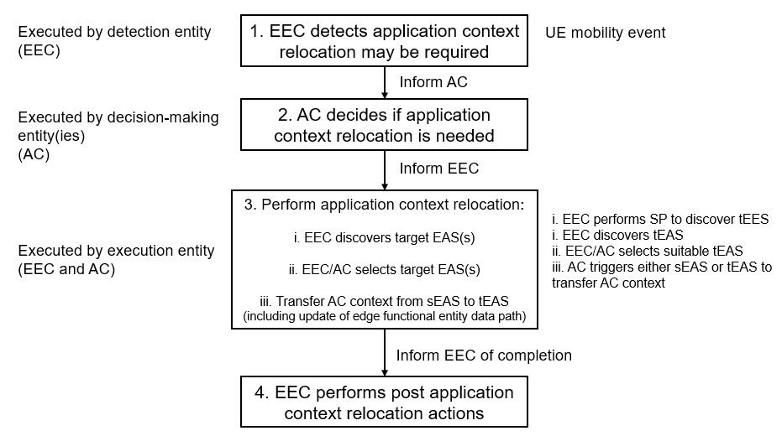

2. Reason for Change
This solution has several advantages: (1) It re-uses existing procedures; (2) it minimizes core NW involvement and overhead; (3) it provides a solution for some missing needs in other proposals such as: Ensuring the TCP/IP connection with the T-EAS, synchronization of application contiguous activity while context is being transferred and an identification of the appliaction context that needs to be transferred, using application-level identity.
3. Conclusions
<Conclusion part (optional)>
4. Proposal
It is proposed to agree the following changes:

* * * Next Change * * * *

8.8.2.X Initiation by Edge Enabler Client using regular EAS Discovery

8.8.2.X.1 General
This procedure handles Application Context Relocation as a result of the UE moving to a new location which is outside the service area of the serving EAS. It further relies on the EEC being triggered as a result of the UE’s movement.
This procedure is based on Service Provisioning (as specified in subclause 8.3) and EAS Discovery (as specified in subclause 8.5) procedures to discover the target EESs and EASs that shall serve the ACs as a result of the UE’s new location, and that will receive the Application Context from the serving EASs.
The procedure in the following subclause describes the relocation of a single application context to a new EAS. It should be repeated for each active AC in the UE
This procedure relies on an interface between the EEC and ACs over EDGE-5, which is out of the scope of this specification.

8.8.2.X.2 Procedure
Pre-conditions:
1. The Application Client in the UE already has a connection to a corresponding source Edge Application Server.
2. The preconditions listed in subclause 8.3.2.3 with regards to the Edge Enabler Client are fulfilled.
3. The Edge Enabler Client is triggered when it obtains the UE’s new location, or is triggered by another entity such as an ECS notification
NOTE 1: This procedure is applicable only for Edge-aware ACs and EASs.

Figure 8.8.2.x.2-1: Application Context Relocation initiated by the EEC and ACs
1. The EEC is triggered as a result of a UE mobility event, and provided with the UE’s new location
NOTE 2: If the EEC is triggered by an external entity such as by a notification from the ECS, a list of new EESs (that will be used as target EESs) is provided by that notification and STEP 2 below is skipped.
Editor’s Note: Whether and how the EEC knows the UE has moved out of the EDN service area is FFS
2. The EEC performs Service Provisioning (as specified in subclause 8.3) for all active applications. Since the location of the UE has changed, this procedure results in a list of T-EESs that are relevant to the supplied applications and the new location of the UE.
NOTE 3: If the change in UE’s location does not trigger a need to change the serving EAS, the subsequent steps will not take place. The EEC will remain connected to the serving EESs and the ACs will remain connected to their corresponding serving EASs.
3. Using the provisioned target EESs, the EEC performs EAS discovery (as specified in subclause 8.5) for the desired target EASs by querying the target EESs that were established in Step 2 (or provided in the notification from the ECS – if it was the trigger)
4. The AC is triggered by the EEC to start Application Context Transfer. The AC initiates the transfer of application context from the source EAS to the target EAS. There may be different ways of transferring context and they are all outside the scope of this specification. After the application context relocation is completed, the AC remains connected to the target EAS and disconnects from the source EAS; the EEC is informed of the completion.
NOTE 4: Whether and how the AC initiates the application context transfer is out of scope of the present document
5. All required entities perform cleanup

Editor’s note: Evaluate the need of an appropriate step for supporting EEC context transfer from S-EES(s) to T-EES(s)

* * * End of Change * * * *

