3GPP TSG-SA WG6 Meeting #38-e S6-201145
e-meeting, 20th – 31st July 2020 (revision of S6-20xxxx)

Source: Huawei, Hisilicon
Title: Considering UE location during EES provisioning
Spec: 3GPP TS 23.558 v0.3.0
Agenda item: 7.5
Document for: Approval
Contact: Cuili Ge (gecuili@huawei.com), Niranth (namogh@huawei.com)

1. Introduction
This pCR is propoded to consider the UE location when provisioning the EES information to the EEC.
2. Reason for Change
(a) UE location is not considered during EES provisioning yet.
As the concept of edge computing and the following statement in clause 8.3 service provisoning, UE location is an impartant factor for EES provisioning. While, the UE location is not considered during the EES selection in clause 8.3.
“Service Provisioning allows the Edge Enabler Clients to be configured with information about available edge computing services, based on the hosting UEs location, service requirements, service preferences and connectivity.”
(b) EES provisioning without network assistance may make the EES/AC suffer bad connectivity/downgraded connectivity and low service experience.
The following figure provides an example to illustrate the problem caused by lack of network assistance. The UPF may be overloaded or congested which is not known by the Edge enable layer. So the ECS may select the EDN/EES(s) with the UPF being overloaded or congested, which will further cause the AC/EEC to have a poor connectivity/or a even longer UP path connectivity which may not satisfied the service requirements.
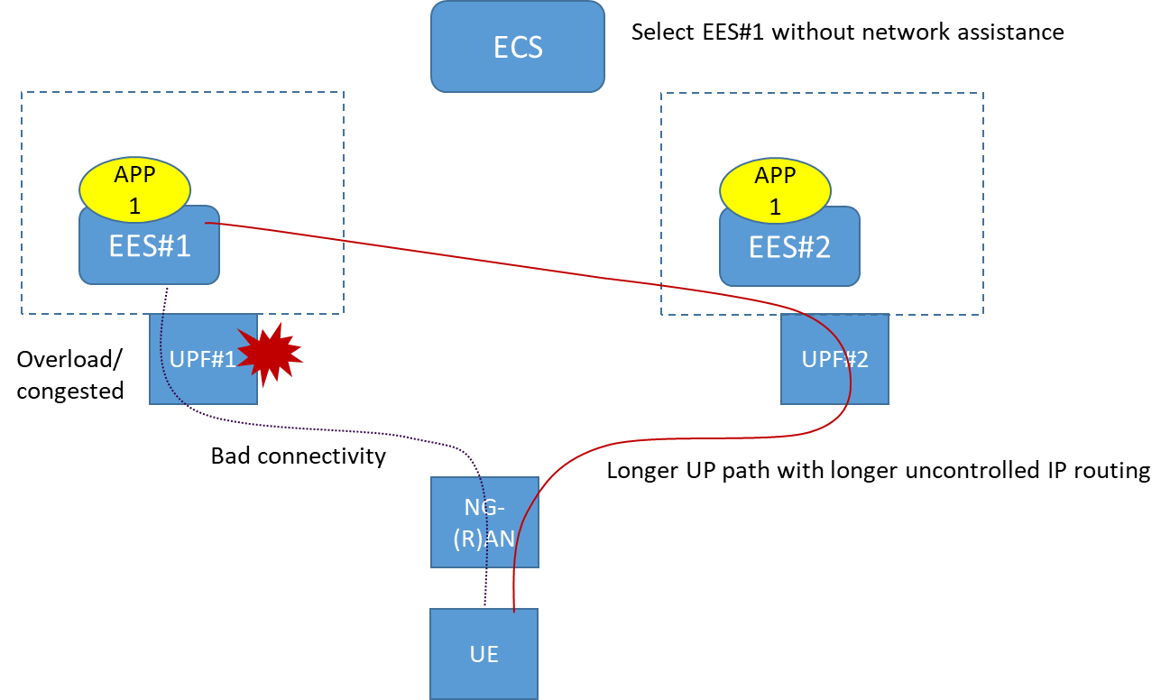
Thus, it is proposed to get the network assistance information during the provision to provide a better EES/EDN to the EES/AC.

3. Proposal
It is proposed to agree the following changes to 3GPP TS 23.558 v0.3.0.

* * * First Change * * * *

8.3.2 Procedure
Pre-conditions:
1. The Edge Enabler Client has been pre-configured or discovered the address (e.g. URI) of the Edge Configuration Server.
2. The Edge Enabler Client has been authorized to enable the communication with the Edge Configuration Server. The UE Identifier is either preconfigured or resulted from a successful authorization.
Editor's Note: The authorization procedure required to enable communication with the Edge Configuration Server is FFS.
Figure 8.3.2-1: Service provisioning
1. The Edge Enabler Client sends a provisioning request to the Edge Configuration Server. The request message may include the UE identifier such as GPSI and credentials received during EEC authorization procedure, UE location and Application Client Profile information.
2. Upon receiving the request from the Edge Enabler Client, the Edge Data Network Configuration Server performs an authorization check to verify whether the Edge Enabler Client has privileges to perform the operation. The Edge Configuration Server determines the Edge Enabler Servers matching Application Client Profiles (or Application Client Profile IDs) and UE location if provided in step 1. If the UE location is not provided, the ECS may get the UE location from the 5GC via the SCEF/NEF or LCS (Location Service) as specified in 3GPP TS 23.502 [3], 3GPP TS 23.271 [7]. The DNAI(s) if available is also considered by the Edge Configuration Server to determine the Edge Enabler Server. The Edge Enabler Server also determines other information that needs to be provisioned, e.g. identification of the Edge Data Network, service area information, Edge Enabler Server endpoints.
Editor's Note: How the ECS get the DNAIs associated with UE location with respect to the different deployment scenarios and potential coordination with SA2 are FFS.
3. The Edge Configuration Server responds to the Edge Enabler Client by sending Edge services configuration information, e.g. identification of the Edge Data Network, service area information (for LADN), and the information for establishing a connection to the Edge Enabler Server (e.g. URI, IP address).
If the Edge Data Network configuration information includes an LADN DNN as an identifier for the Edge Data Network, the Edge Enabler Client considers the LADN as the Edge Data Network. Therefore, the service area of Edge Data Network is the LADN Service Area which can be discovered using the UE Registration Procedure.

8.3.3 Information flows

8.3.3.1 Provisioning request
Table 8.3.3.1-1 describes the information elements for a Provisioning Request from the Edge Enabler Client to the provisioning server (i.e. Edge Configuration Server).
Table 8.3.3.1-1: Provisioning request
Information element | Status | Description
EEC ID | M | Unique identifier of the EEC.
Security credentials | M | Security credentials resulting from a successful authorization for the edge computing service.
Application Client Profile(s) | M | Information about services the EEC wants to connect to, as described in Table 8.2.2-1.
UE Identifier | O | The identifier of the UE (i.e. GPSI or identity token)
Connectivity Filter | O | List of connectivity information for the UE, e.g. PLMN ID, SSID.
UE location | O | The location information of the UE. The UE location is described as clause 7.3.1.

Editor's Note: It is FFS whether the EEC ID is mandatory or whether the UE ID should be included.
* * * End of Change * * * *

