3GPP TS 28.531 V18.5.0 (2024-03)
Technical Specification
3rd Generation Partnership Project;
Technical Specification Group Services and System Aspects;
Management and orchestration;
Provisioning;
(Release 18)

 | 

The present document has been developed within the 3rd Generation Partnership Project (3GPP TM) and may be further elaborated for the purposes of 3GPP.
The present document has not been subject to any approval process by the 3GPP Organizational Partners and shall not be implemented.
This Specification is provided for future development work within 3GPP only. The Organizational Partners accept no liability for any use of this Specification.
Specifications and Reports for implementation of the 3GPP TM system should be obtained via the 3GPP Organizational Partners' Publications Offices.

Keywords
5G, Network Slicing, Slice, Provisioning
3GPP
Postal address

3GPP support office address
650 Route des Lucioles - Sophia Antipolis
Valbonne - FRANCE
Tel.: +33 4 92 94 42 00 Fax: +33 4 93 65 47 16
Internet
http://www.3gpp.org
Copyright Notification
No part may be reproduced except as authorized by written permission.
The copyright and the foregoing restriction extend to reproduction in all media.

© 2024, 3GPP Organizational Partners (ARIB, ATIS, CCSA, ETSI, TSDSI, TTA, TTC).
All rights reserved.
UMTS™ is a Trade Mark of ETSI registered for the benefit of its members
3GPP™ is a Trade Mark of ETSI registered for the benefit of its Members and of the 3GPP Organizational Partners
LTE™ is a Trade Mark of ETSI registered for the benefit of its Members and of the 3GPP Organizational Partners
GSM® and the GSM logo are registered and owned by the GSM Association
Contents
Foreword 6
1 Scope 7
2 References 7
3 Definitions and abbreviations 8
3.1 Definitions 8
3.2 Abbreviations 8
4 General 8
4.1 Overview 8
4.2 Configuration information for the constituents of an NSI 10
4.3 General information for network slice instance 10
4.4 General information for network slice subnet instance 10
4.5 Void 10
4.6 Void 10
5 Specification level requirements 11
5.1 Use cases 11
5.1.1 Network slice instance allocation 11
5.1.2 Network slice subnet instance allocation 13
5.1.3 Network slice instance deallocation 14
5.1.4 Network slice subnet instance deallocation 15
5.1.5 Obtaining network slice subnet instance information 16
5.1.6 Network slice feasibility check 17
5.1.7 Network slice instance activation 18
5.1.8 Network slice instance deactivation 19
5.1.9 Network slice instance modification 20
5.1.10 Network slice subnet instance activation 21
5.1.11 Network slice subnet instance deactivation 22
5.1.12 Network slice subnet instance modification 23
5.1.13 Network slice subnet configuration 24
5.1.14 Obtaining network slice management data 25
5.1.15 Void 26
5.1.16 Void 26
5.1.17 Creation of a 3GPP NF 26
5.1.18 Configuration of a 3GPP NF instance 27
5.1.19 Creation of a 3GPP sub-network 28
5.1.20 Configuration of a 3GPP sub-network 29
5.1.21 Network slice subnet feasibility check 30
5.1.22 Void 31
5.1.23 Network slice subnet management with assigned priority 31
5.1.24 Management interaction with NFV MANO for network service priority 31
5.1.25 Void 32
5.1.26 Obtaining network slice subnet provider capability information 32
5.2 Requirements 32
5.2.1 Requirements for network slice provisioning service 32
5.2.2 Requirements for network slice subnet provisioning service 33
5.2.3 Requirements for NF provisioning service 34
5.2.4 Requirements for sub-network provisioning service 34
6 Management services for provisioning of networks and network slicing 34
6.1 Management services for network slice provisioning 34
6.2 Management services for network slice subnet provisioning 35
6.3 Management services for network function provisioning 36
6.4 Void 37
6.5. Operations of provisioning 37
6.5.1 AllocateNsi operation 37
6.5.1.1 Description 37
6.5.1.2 Input parameters 38
6.5.1.3 Output parameters 38
6.5.2 AllocateNssi operation 38
6.5.2.1 Description 38
6.5.2.2 Input parameters 38
6.5.2.3 Output parameters 38
6.5.3 DeallocateNsi operation 39
6.5.3.1 Description 39
6.5.3.2 Input parameters 39
6.5.3.3 Output parameters 39
6.5.4 DeallocateNssi operation 39
6.5.4.1 Description 39
6.5.4.2 Input parameters 39
6.5.4.3 Output parameters 39
6.5.5 Void 40
7 Provisioning procedures of networks and network slicing 40
7.1 General 40
7.2 Procedure of Network Slice Instance Allocation 40
7.3 Procedure of Network Slice Subnet Instance Allocation 43
7.4 Procedure of Network Slice Instance Deallocation 47
7.5 Procedure of network slice subnet instance deallocation 48
7.6 Procedure of Network Slice Instance Modification 51
7.7 Procedure of Network Slice Subnet Instance Modification 52
7.8 Procedure of Obtaining Network Slice Subnet Management Service Producer Capability 55
7.8.1 Introduction 55
7.8.2 Querying Network Slice Subnet Capability Information 55
7.8.3 Void 55
7.9 Procedure of TN coordination supporting network slicing 55
7.9.1 Introduction 55
7.9.2 Interaction with NFVO as TN Manager 55
7.10 Procedure of NF instance creation 56
7.11 Procedure of NF instance modification 58
7.12 Procedure of NF instance deletion 58
7.13 Procedure of feasibility check and reservation of NSI 60
7.14 Procedure of feasibility check and reservation of network slice subnet 62
7.15 Void 63
7.16 Void 63
7.17 Procedure of management interaction with NFV MANO for network service priority 63
7.18 Procedure for Network slice instance activation 64
7.19 Procedure for Network slice instance deactivation 65
7.20 Procedure for Network slice sunbet instance activation 65
7.21 Procedure for Network slice subnet instance deactivation 66
8 Void 68
9 RESTful HTTP-based solution set of provisioning 68
9.1 Network slice provisioning management service 68
9.1.1 Mapping of operations 68
9.1.1.1 Introduction 68
9.1.1.2 Operation allocateNsi 68
9.1.1.3 Operation deallocateNsi 69
9.1.2 Resources 69
9.1.2.1 Resource definitions 69
9.1.2.1.1 Resource “…/ServiceProfile 69
9.2 Network slice subnet provisioning management service 71
9.2.1 Mapping of operations 71
9.2.1.1 Introduction 71
9.2.1.2 Operation allocateNssi 71
9.2.1.3 Operation deallocateNssi 72
9.2.2 Resources 72
9.2.2.1 Resource definitions 72
9.2.2.1.1 Resource “.../SliceProfile 72
Annex A (informative): A network slice journey example 75
Annex B (informative): General information for network slice related identifiers 78
Annex C (informative): Plant UML source code 79
C.1 General 79
C.2 Procedure of network slice instance allocation 79
C.3 Procedure of Network Slice Subnet Instance Allocation 80
C.4 Procedure of Network Slice Instance Deallocation 81
C.5 Procedure of network slice subnet instance deallocation 82
C.6 Procedure of Network Slice Instance Modification 83
C.7 Procedure of Network Slice Subnet Instance Modification 84
Annex D (informative): Change history 86

Foreword
This Technical Specification has been produced by the 3rd Generation Partnership Project (3GPP).
The contents of the present document are subject to continuing work within the TSG and may change following formal TSG approval. Should the TSG modify the contents of the present document, it will be re-released by the TSG with an identifying change of release date and an increase in version number as follows:
Version x.y.z
where:
x the first digit:
1 presented to TSG for information;
2 presented to TSG for approval;
3 or greater indicates TSG approved document under change control.
y the second digit is incremented for all changes of substance, i.e. technical enhancements, corrections, updates, etc.
z the third digit is incremented when editorial only changes have been incorporated in the document.

1 Scope
The present document specifies use cases, requirements, management services and procedures for provisioning of 5G networks. For the cases when a NF taking part in these networks contains virtualized parts, interactions with ETSI NFV MANO system are described.

2 References
The following documents contain provisions which, through reference in this text, constitute provisions of the present document.
- References are either specific (identified by date of publication, edition number, version number, etc.) or non-specific.
- For a specific reference, subsequent revisions do not apply.
- For a non-specific reference, the latest version applies. In the case of a reference to a 3GPP document (including a GSM document), a non-specific reference implicitly refers to the latest version of that document in the same Release as the present document.
[1] 3GPP TR 21.905: "Vocabulary for 3GPP Specifications".
[2] 3GPP TS 28.525: "Telecommunication management; Life Cycle Management (LCM) for mobile networks that include virtualized network functions; Requirements".
[3] ETSI GS NFV-IFA 013 (V4.5.1) (2023-09): "Network Function Virtualisation (NFV); Release 4; Management and Orchestration; Os-Ma-nfvo reference point - Interface and Information Model Specification".
[4] 3GPP TS 28.530: "Management and orchestration; Concepts, use cases and requirements".
[5] 3GPP TS 22.261 "Service requirements for next generation new services and markets".
[6] 3GPP TS 28.541: "Management and orchestration; 5G Network Resource Model (NRM); Stage 2 and stage 3".
[7] Void.
[8] 3GPP TS 28.532: "Management and orchestration; Generic management services".
[9] GSMA NG.116 Generic Network Slice Template v9.0 (2023-04-27) - NG.116-v9.0.pdf (gsma.com).
[10] 3GPP TS 23.501: "Technical Specification Group Services and System Aspects;System Architecture for the 5G System;Stage 2".
[11] 3GPP TS 38.300: "Technical Specification Group Radio Access Network;NR; NR and NG-RAN Overall Description;Stage 2".
[12] ETSI GS NFV-IFA 014 (V4.2.1) (2021-05): "Network Function Virtualisation (NFV); Release 4; Management and Orchestration; Network Service Templates Specification".
[13] 3GPP TS 28.622: "Telecommunication management; Generic Network Resource Model (NRM) Integration Reference Point (IRP); Information Service (IS)".
[14] ETSI GS NFV-IFA 011 (V4.3.1) (2022-06): "Network Function Virtualisation (NFV); Release 4; Management and Orchestration; VNF Descriptor and Packaging Specification".
[15] ETSI GS NFV-IFA 008 (V4.3.1) (2022-05): "Network Function Virtualisation (NFV); Release 4; Management and Orchestration; Ve-Vnfm reference point - Interface and Information Model Specification".

3 Definitions and abbreviations

3.1 Definitions
For the purposes of the present document, the terms and definitions given in TR 21.905 [1], TS 28.530 [4] and the following apply. A term defined in the present document takes precedence over the definition of the same term, if any, in TR 21.905 [1] and TS 28.530 [4].

3.2 Abbreviations
For the purposes of the present document, the abbreviations given in TR 21.905 [1], TS 28.530 [4] and the following apply. An abbreviation defined in the present document takes precedence over the definition of the same abbreviation, if any, in TR 21.905 [1].
5GAA 5G Automative Association
5G-ACIA 5G Association for Connected Industries and Automation
5GC 5G Core Network
AMF Access and Mobility Management Function
CSC Communication Service Customer
CSP Communication Service Provider
CP Control Plane
GST Generic Slice Template
IOC Information Object Class
MANO Management and Orchestration
MnS Management Service
NEST Network Slice Type
NF Network Function
NFV Network Functions Virtualisation
NRM Network Resource Model
NSaaS Network Slice as a Service
NSC Network Slice Customer
NSI Network Slice Instance
NSP Network Slice Provider
NSSI Network Slice Subnet Instance
P-NEST Private NEST
S-NEST Standardized NEST
TN Transport Network
VNF Virtualized Network Function
UP User Plane

4 General

4.1 Overview
A 5G system consists of a 5G Access Network (AN), and a 5G Core Network (5GC). Network slicing is one of the key 5G features.
The management aspects of a Network Slice Instance (NSI) are described by the four phases shown in Figure 4.3.1.1 of TS 28.530 [4].
The provisioning of network slicing includes the four phases which are preparation, commissioning, operation and decommissioning:
- In the preparation phase the NSI does not exist. The preparation phase includes network slice design, on-boarding, evaluation of the network slice requirements, preparing the network environment and other necessary preparations required to be done before the creation of an NSI.
- During the NSI lifecycle stage which include commissioning phase, operation phase and decommissioning phase, the NSI provisioning operations include:
- Create an NSI;
- Activate an NSI;
- Deactivate an NSI;
- Modify an NSI;
- Terminate an NSI.
The operations of the provisioning of an NSI occurs during different phases of a NSI:
a) During the commissioning phase:
- Create an NSI.
During NSI creation all resources to the NSI have been created and configured to satisfy the network slice requirements. NSI creation may trigger NSSI(s) creation or using existing NSSI(s) and setting up the corresponding associations.
b) During the operation phase:
- Activate an NSI;
- Modify an NSI;
- Deactivate an NSI.
NSI activation includes any actions that make the NSI active to provide communication services. NSI activation may trigger NSSI activation.
NSI modification in operation phase could map to several workflows, e.g. changes of NSI capacity, changes of NSI topology, NSI reconfiguration. NSI modification can be triggered by receiving new network slice related requirements, new communication service requirements, or the result of NSI supervision automatically. NSI modification may trigger NSSI modification.
The NSI deactivation operation may be needed before NSI modification operation and the NSI activation operation may be needed after the NSI modification operation. NSI deactivation includes any actions that make the NSI inactive and not providing any communication services. NSI deactivation trigger NSSI deactivation to deactivate constituent NSSI(s) which is not used by other NSI(s). Operator may decide to keep the NSI without termination after deactivation and reactivate it when receives new communication service request.
c) During the decommissioning phase:
- Terminate an NSI.
NSI termination step includes any action that make the NSI does not exist anymore and release resources that are not used by other NSI(s). NSI termination may trigger NSSI termination to terminate constituent NSSI(s) which is not used by other NSI(s).
Similarly, provisioning for network slice subnet instance includes the following operations:
- Create an NSSI;
- Activate an NSSI and associate it with certain NSI to be used by the NSI;
- Disassociate the NSSI with certain NSI and deactivate the NSSI if it’s not associated with any NSI;
- Modify an NSSI;
- Terminate an NSSI.

4.2 Configuration information for the constituents of an NSI
To use network slice to support communication service or deliver a network slice as a service, the 3GPP defined constituents of the NSI should be configured by 3GPP management system according to the types and requirements of the network slice so that the NSI can be operated and maintained.
The configuration information of these components may include:
- Information on the requirements to be applied to every NSI constituent to satisfy the requirements of multiple NSIs if the constituent is shared by multiple NSIs;
- Network function selection information: Information on the selection of the NFs (e.g., AMF) according to the requirements of this NSI;
- Connection information: The information of the logical links to carry the NSI’s CP and UP data between the component and other NFs and NSSIs belonging to the NSI.
NOTE 1: The list of information above is not exhaustive.
NOTE 2: The list of information above is not all necessary for an NSI.

4.3 General information for network slice instance
The general information used to describe a network slice instance may include:
- Resource model information, which describes the static parameters and functional components of network slice, includes service profile, network slice type (e.g. eMBB), additional system feature (e.g. multicast, Edge Computing), priority.
- Management model information, which describes the information model that is used for network slice lifecycle management, includes configuration profile (e.g. application configuration parameters).
- Capability model information, which describes the capability including supported communication service characteristic information (e.g. service type, UE mobility level, density of users, traffic density), QoS attributes (e.g. bandwidth, latency, throughput and so on) and capacity (e.g. maximum number of UEs), can be exposed to CSC .

4.4 General information for network slice subnet instance
The general information used to describe a network slice subnet instance may include:
- Resource model information, which describes the static parameters and functional component of network slice subnet, includes slice profile, network slice subnet type (e.g. RAN eMBB, CN eMBB), additional system feature (e.g. multicast, Edge Computing), priority, QoS attributes (e.g. bandwidth, latency, number of subscribers and so on), NSD ID.
- Management model information, which describes the information model that is used for network slice subnet lifecycle management, includes configuration profile (e.g. application configuration parameters).
- Capability model information, which describes the capability including supported communication service characteristic information (e.g. service type, UE mobility level, density of users, traffic density), QoS attributes (e.g. bandwidth, latency, throughput and so on) and capacity (e.g. maximum number of UEs).

4.5 Void

4.6 Void

5 Specification level requirements

5.1 Use cases

5.1.1 Network slice instance allocation
Use case stage | Evolution/Specification | <<Uses>>  Related use
Goal | To satisfy request for allocation of a network slice instance with certain characteristics, by creating a new or using an existing network slice instance.
Actors and Roles | A network slice provisioning management service consumer.
Telecom resources | Network slice instance  Network slice subnet instance  Transport network  A network slice provisioning management service provider.  A network slice subnet provisioning management service provider.
Assumptions | N/A
Pre-conditions | N/A
Begins when | The network slice provisioning management service provider receives the request for allocation of the network slice instance with network slice related requirements.  The network slice provisioning management service provider has the capability to process the network slice related requirements (e.g., SLA information from GSMA GST) which are represented by service profile parameters [6]. The service profile can be translated to the corresponding requirements for dedicated domains and NSSIs.
Step 1 (M) | If the requested NSI can be shared and if an existing NSI can be used, the network slice provisioning management service provider decides to use the existing NSI.  Modification of the existing NSI may be needed to satisfy the network slice instance related requirements. Use case is completed go to "Step 8".  Otherwise, the network slice provisioning management service provider triggers to create a new NSI, for which the following steps 2 – 8 are needed.
Step 2 (M) | The network slice provisioning management service provider decides on the constituent NSSIs and the topology of the NSI to be created using the information from service profile [6] and if applicable isolation profiles are selected. For the constituent NSSIs, the network slice provisioning management service provider derives network slice subnet related requirements from the network slice related requirements. If reconfiguration of the transport network is needed, the network slice provisioning management service provider derives transport network related requirements (e.g., latency, bandwidth) from the network slice related requirements.
Step 3 (M) | For the required NSSI(s), the network slice provisioning management service provider sends network slice subnet related requirements to the network slice subnet provisioning management service provider to request allocation of the required NSSI(s). | Network slice subnet instance allocation use case
Step 4 (M) | The network slice provisioning management service provider receives the information of the allocated NSSI(s) (e.g., the management identifier of NSSI, service access point information of NSSI, external connection point information of NSSI) from NSSMF.
Step 5 (M) | The network slice provisioning management service provider, via the network slice subnet provisioning management service provider, sends the transport network related requirements (e.g., external connection point, latency and bandwidth) to the TN Manager. The TN manager reconfigures the TN accordingly and responds to the network slice provisioning management service provider via the network slice subnet provisioning management service provider.
Step 6 (M) | The network slice provisioning management service provider receives the response from TN Manager via the network slice subnet provisioning management service provider.
Step 7 (M) | The network slice provisioning management service provider associates the NSSI(s) with the corresponding NSI (e.g., allocation of the management identifier of NSI and mapping the management identifier of NSI with the received management Identifier of NSSI(s)), if applicable with the isolation profiles are associated with the NSI and NSSI(s), and triggers to establish the links between the service access points of the NSSI(s).
Step 8 (M) | The network slice provisioning management service provider notifies the network slice instance information of NSI (e.g., the management identifier of NSI).
Ends when | All the steps identified above are successfully completed.
Exceptions | One of the steps identified above fails.
Post-conditions | An NSI is ready to satisfy the network slice related requirements.
Traceability | REQ-PRO_NSSI-FUN-1, REQ-PRO_NSI-FUN-3, REQ-PRO_NSI-FUN-9.

5.1.2 Network slice subnet instance allocation
Use case stage | Evolution/Specification | <<Uses>>  Related use
Goal | Create a new network slice subnet instance or use an existing network slice subnet instance to satisfy the network slice subnet related requirements; provide the provisioning service consumer with identity of the NFVO which the consumer can use for further access to the information of the involved VNFs, PNFs and NSs.
Actors and Roles | A network slice subnet provisioning management service consumer.
Telecom resources | Network Slice Subnet instance  Network Service instance  A network slice subnet provisioning management service provider.  The operator deployed NFVO to manage the lifecycle of VNFs and interconnection between the VNFs and PNFs in terms of the NS instances.
Assumptions | Network slice subnet instance may include network functions which are virtualized.
Pre-conditions | VNF Packages for virtualized network functions to be included in the network slice subnet instance have been already on-boarded.
Begins when | The network slice subnet provisioning management service consumer sends to the network slice subnet provisioning management service provider a request for an NSSI to be associated with the NSI; the request contains network slice subnet related in TS 28.541 [6].  The network slice subnet provisioning management service provider receives request for a network slice subnet instance. The request contains network slice subnet related requirements. The request may also include query of the identity of the NFVO to be used.
Step 1 (M) | Based on the network slice subnet related requirements received and if applicable the isolation profile is selected, the network slice subnet provisioning management service provider decides to create a new NSSI or use an existing NSSI.
Step 2 (M) | If an existing network slice subnet instance is decided to be used, the network slice subnet provisioning management service provider may trigger to modify the existing network slice subnet instance to satisfy the network slice subnet related requirements. Go to “Step 8”.  Otherwise, the network slice subnet provisioning management service provider triggers to create a new NSSI, the following steps are needed.
Step 3 (O) | If the required NSSI contains constituent NSSI(s) managed by other network slice subnet provisioning management service provider (s), the first network slice subnet provisioning management service provider derives the requirements for the constituent NSSI(s) and sends those requirements to the corresponding network slice subnet provisioning management service provider (s) which manages the constituent NSSI(s).  The first network slice subnet provisioning management service provider receives the constituent NSSI information from the other network slice subnet provisioning management service provider (s) and associates the constituent NSSI(s) with the required NSSI.
Step 4 (M) | Based on the network slice subnet related requirements received and SliceProfile [6], the network slice subnet provisioning management service provider decides that to satisfy the NSSI requirements, the part of the network controlled by certain NFVO should be involved. The network slice subnet provisioning management service provider determines the NS related requirements (i.e., information about the target NSD and additional parameterization for the specific NS to instantiate, see clause 7.3.3 in ETSI GS NFV-IFA013 [3]), and if applicable the associated isolation rules.
Step 5 (M) | Based on the NS related requirements, the network slice subnet provisioning management service provider triggers corresponding NS instantiation request to NFVO via Os-Ma-nfvo interface as described in clause 6.4.3 in TS 28.525 [2], and the NFVO performs NS instantiation. (see note) | TS 28.525 [2] Clause 6.4.3 NS instance use cases
Step 6 (M) | The network slice subnet provisioning management service provider associates the NS instance with corresponding network slice subnet instance (e.g., allocation of the management identifier of NSSI and mapping with the corresponding identifiers).
Step 7 (M) | The network slice subnet provisioning management service provider is using the NF provisioning service to configure the NSSI constituents.  In case of RAN NSSI, the configuration contains RRM policy information for individual Radio cells. In the cells shared by multiple NSSIs such policy includes guidance for split of Radio resources between the NSSIs. | NF provisioning service
Step 8 (M) | The network slice subnet provisioning management service provider notifies the provisioning service consumer with the NSSI information (e.g., the management identifier of NSSI). The network slice provisioning management service provider associates the NSSI with the NSI and if applicable the isolation profile.
Ends when | All the steps identified above are successfully completed.
Exceptions | One of the steps identified above fails.
Post-conditions | A NSSI is ready to satisfy the network slice subnet related requirements.
Traceability | REQ-PRO_NSSI-FUN-2, REQ-PRO_NSSI-FUN-3, REQ-PRO_NSSI-FUN-4, REQ-PRO_NSSI-FUN-5, REQ-PRO_NSSI-FUN-6, REQ-PRO_NSSI-FUN-14, REQ-PRO_NSSI-FUN-19.
NOTE: According to the TS 28.525 [2], for the PNFs, NS instantiation includes only establishment of interconnection with other NFs.

5.1.3 Network slice instance deallocation
Use case stage | Evolution/Specification | <<Uses>>  Related use
Goal | To deallocate a network slice instance..
Actors and Roles | A network slice provisioning management service consumer.
Telecom resources | Network slice instance  Network slice subnet instances  A network slice provisioning management service provider.  A network slice subnet provisioning management service provider.
Assumptions | N/A
Pre-conditions | N/A
Begins when | The network slice provisioning management service provider receives the request indicating that an existing NSI is no longer needed to support a particular service. (identified by service profile Id) The NSI identification is included in the request.
Step 1 (M) | Based on the request, the network slice provisioning management service provider deletes the corresponding slice profile and checks if there are other services to be supported by the NSI. If there are none the network slice provisioning management service provider may decide to terminate the NSI; then proceed to Step 2.  Otherwise, the network slice provisioning management service provider may decide to trigger to modify the NSI or to do nothing.  The use case is completed; go to step 5. | NSI modification use case
Step 2 (M) | If the NSI to be terminated is active, the network slice provisioning management service provider de-activates the NSI. Then, the NSI to be terminated is inactive. | NSI de-activation use case
Step 3 (M) | The network slice provisioning management service provider identifies the network slice subnet instances used by the NSI, and for every such NSSI sends the request to the corresponding network slice subnet provisioning management service provider (s) indicating that the NSSI(s) are no longer needed for the NSI. The network slice subnet provisioning management service provider (s) may decide to terminate or modify the NSSI(s) based on the request and disassociates them with the NSI.
Step 4 (M) | The network slice provisioning management service provider receives the response from the network slice subnet provisioning management service provider (s) and terminates the NSI.
Step 5 (M) | The network slice provisioning management service provider notifies its consumer of the NSI deallocation.
Ends when | All the steps identified above are successfully completed or skipped per condition in the Step 1.
Exceptions | One of the steps identified above fails.
Post-conditions | The NSI has been deallocated.
Traceability | REQ-PRO_NSI-FUN-3

5.1.4 Network slice subnet instance deallocation
Use case stage | Evolution/Specification | <<Uses>>  Related use
Goal | To deallocate a network slice subnet instance.
Actors and Roles | Network slice subnet provisioning management service consumer.
Telecom resources | Network slice subnet instance  Network slice subnet provisioning management service provider.
Assumptions | N/A
Pre-conditions | N/A
Begins when | The network slice subnet provisioning management service provider receives network slice subnet related request from its authorized consumer indicating that an existing NSSI is no longer needed to support a particular set of network slice subnet requirements identified by a slice profile id). The NSSI identification is included in the request.
Step 1 (M) | Based on the request, the network slice subnet provisioning management service provider decides whether the NSSI should be terminated.  If the decision is the NSSI should be terminated, go to the Step 2.  If the decision is that the NSSI should not be terminated (e.g., the NSSI is shared or the network slice subnet provisioning management service provider decides to keep the NSSI for later use), the network slice subnet provisioning management service provider disassociates the NSSI from its consumer and provides feedback to the authorized consumer, maybe with removing its consumer’s configuration or not. Go to Step 5.
Step 2 (M) | If the NSSI consists of constituent NSSIs that are not managed directly by the network slice subnet provisioning management service provider, the network slice subnet provisioning management service provider sends a request to other network slice subnet provisioning management service provider(s) indicating that the constituent NSSIs are no longer needed for the NSSI.
Step 3 (M) | If the NSSI is associated with NSI, the network slice subnet provisioning management service provider disassociates the NSI from the NSSI to be terminated, and the network slice subnet provisioning management service provider may trigger request to NFVO for terminating or updating (e.g. scaling-in) the NS instance. (see note).
Step 4 (M) | If there exists a transport network segment used by the NSSI, the network slice subnet provisioning management service provider may indicate that the transport network segment is no longer needed to support the NSSI.
Step 5 (M) | The network slice subnet provisioning management service provider sends response to its consumer.
Ends when | All the steps identified above are successfully completed.
Exceptions | One of the steps identified above fails.
Post-conditions | The NSSI has been deallocated.
Traceability | REQ-PRO_NSSI-FUN-8, REQ-PRO_NSSI-FUN-11
NOTE: In case where the NS instance is not dedicated for the NSSI, the network slice subnet provisioning management service provider does not terminate the NS instance.

5.1.5 Obtaining network slice subnet instance information
Use case stage | Evolution/Specification | <<Uses>>  Related use
Goal | Enable the network slice subnet provisioning management service consumer to obtain network slice subnet instance information (e.g. Slice/Service type).
Actors and Roles | Network slice subnet provisioning management service consumer.
Telecom resources | Network slice subnet instance  Network slice subnet provisioning management service provider.
Assumptions | The network slice subnet provisioning management service consumer is authorized to obtain the network slice subnet instance information from the network slice subnet provisioning management service provider.
Pre-conditions | NSSI is created.
Begins when | The network slice subnet provisioning management service consumer wants to obtain the network slice subnet instance information.
Step 1 (M) | The network slice subnet provisioning management service consumer sends a request to the network slice subnet provisioning management service provider to obtain the network slice subnet instance information.  The indication on which information needs to be obtained may be included in the request.
Step 2 (M) | The network slice subnet provisioning management service provider processes this request.
Step 3 (M) | The network slice subnet provisioning management service provider sends the result of network slice subnet instance information to the network slice subnet provisioning management service consumer.
Ends when | All the steps identified above are successfully completed.
Exceptions | One of the steps identified above fails.
Post-conditions | The network slice subnet provisioning management service consumer has obtained the network slice subnet instance information.
Traceability | REQ-PRO_NSSI-FUN-7.

5.1.6 Network slice feasibility check
Use case stage | Evolution/Specification | <<Uses>>  Related use
Goal | To check the feasibility of provisioning a network slice to determine whether the network slice requirements can be satisfied at a particular point in time (e.g., in terms of resources), and optionally reserve resources to satisfy the network slice requirements.
Actors and Roles | Network slice management service consumer. For example, CSP providing NSaaS plays the role of network slice management service consumer.
Telecom resources | Network slice management service provider.
Assumptions | Network slice management service consumer has decided to check the feasibility of provisioning a network slice based on, for example, internal decision or to facilitate an external service requests.  Network slice management service consumer has optionally decided to request reservation of the resources to satisfy the network slice requirements.
Pre-conditions | Network slice requirements have been derived or received by network slice management service consumer.
Begins when | Network slice management service provider receives the request to evaluate the feasibility of provisioning a network slice and optionally reserve resources, according to the network slice requirements at a particular point in time.
Step 1 (M) | Network slice management service provider identifies the network slice subnets according to the requirements.
Step 2 (M) | Network slice management service provider obtains the information necessary to evaluate the feasibility of provisioning a network slice by requesting the network slice subnet service provider(s) to evaluate the availability of resources under their control.  If the Network slice management service consumer has requested reservation of resources, then Network slice management service provider requests network slice subnet service provider(s) to reserve resources.
Step 3 (M) | Network slice subnet management service provider(s) checks the feasibility of provisioning a slice subnet(s) by analysing network constituents to ensure that their capabilities, e.g., resources, management services, etc. are (or will be) adequate to provision network slice subnet instance, satisfying all requirements without impacting existing services. For the purpose of checking the feasibility of provisioning a network slice subnet(s) of the network slice, network slice subnet management service provider(s) may obtain information from the network (e.g., current or predicted load level information from the NWDAF).  If the Network slice management service provider has requested reservation of resources, then Network slice subnet management service provider(s) reserves the resources necessary to provision the network slice subnet instance. | 5.1.21 Network slice subnet feasibility check
Ends when | Feasibility check results have been provided to network slice management service consumer.  If the Network slice management service consumer has requested reservation of resources, then resources to satisfy the network slice requirements are reserved.
Exceptions | One of the mandatory steps fails.
Post-conditions | N/A
Traceability | REQ-PRO_NSSI-FUN-12, REQ-PRO_NSSI-FUN-13, REQ-PRO_NSI-FUN-8.

5.1.7 Network slice instance activation
Use case stage | Evolution/Specification | <<Uses>>  Related use
Goal | To activate an existing network slice instance which is inactive
Actors and Roles | Network slice provisioning management service consumer. For example, CSP providing NSaaS plays the role of Network slice management service consumer.
Telecom resources | Network slice instance  Network slice provisioning management service provider.  Network slice subnet provisioning management service provider.
Assumptions | N/A
Pre-conditions | An NSI has already been created and it is inactive.
Begins when | The network slice provisioning management service provider decides to activate an NSI based on the received network slice related request from its authorized consumer.
Step 1 (M) | The network slice provisioning management service provider checks whether NSSIs associated with the NSI are all active, if there is an inactive NSSI, the network slice provisioning management service provider requests the network slice subnet provisioning management service provider to activate the corresponding NSSI. | Network slice subnet instance activation use case
Step 2 (M) | The network slice provisioning management service provider receives response from the network slice subnet provisioning management service provider indicating that the NSSI is active.
Step 3 (M) | The network slice provisioning management service provider activates the NSI and sends response to the requesting consumer.
Ends when | All the steps identified above are successfully completed.
Exceptions | One of the steps identified above fails.
Post-conditions | An NSI has been activated.
Traceability | REQ-PRO_NSI–FUN-4

5.1.8 Network slice instance deactivation
Use case stage | Evolution/Specification | <<Uses>>  Related use
Goal | To deactivate an existing network slice instance which is active.
Actors and Roles | Network slice provisioning management service consumer. For example, CSP providing NSaaS plays the role of network slice provisioning management service consumer.
Telecom resources | Network slice instance  Network slice provisioning management service provider.  Network slice subnet provisioning management service provider.
Assumptions | N/A
Pre-conditions | NSI has already been created and it is active.
Begins when | The network slice provisioning management service provider decides to deactivate an NSI based on the received network slice related request from its authorized consumer.
Step 1 (M) | The network slice provisioning management service provider stops the NSI serving its subscribers.
Step 2 (M) | The network slice provisioning management service provider checks whether NSSIs associated with the NSI are all inactive. If there is an active NSSI, the network slice provisioning management service provider requests the network slice subnet provisioning management service provider to deactivate the corresponding NSSI.  The network slice subnet provisioning management service provider receives the request and decides if the NSSI will be disassociated and deactivated. | Network slice subnet instance deactivation use case
Step 3 (M) | The network slice provisioning management service provider receives response from the network slice subnet provisioning management service provider that the NSSI deactivation request has been processed.
Step 4 (M) | The network slice provisioning management service provider deactivates the NSI and sends response to its authorized consumer.
Ends when | All the steps identified above are successfully completed.
Exceptions | One of the steps identified above fails.
Post-conditions | An NSI has been deactivated.
Traceability | REQ-PRO_NSI–FUN-5

5.1.9 Network slice instance modification
Use case stage | Evolution/Specification | <<Uses>>  Related use
Goal | To modify an existing network slice instance
Actors and Roles | Network slice provisioning management service consumer. See NOTE.
Telecom resources | Network slice instance  Network slice provisioning management service provider.
Assumptions | N/A
Pre-conditions | N/A.
Begins when | The network slice provisioning management service provider receives request from its authorized customer with new set of network slice related requirements and decides to modify an existing NSI.
Step 1 (M) | The network slice provisioning management service provider identifies the NSSI(s) associated with the NSI to be modified and generates network slice subnet related requirements for the NSSI(s).
Step 2 (M) | The network slice provisioning management service provider sends requests to the network slice subnet provisioning management service provider with new sets of network slice subnet related requirements.  The network slice provisioning management service provider receives request and decides whether the NSSI needs to be modified. | Network slice subnet instance modification use case
Step 3 (M) | The network slice provisioning management service provider receives the response from the network slice subnet provisioning management service provider. If the NSSI modification request cannot be satisfied by the network slice subnet provisioning management service provider, the network slice provisioning management service provider may re-generate the network slice subnet related requirements for the NSSI and go to step 2, or the network slice provisioning management service provider may decide the modification request cannot be satisfied.
Step 4 (M) | The network slice provisioning management service provider sends response to its authorized consumer.
Ends when | All the steps identified above are successfully completed.
Exceptions | One of the steps identified above fails.
Post-conditions | The NSI is modified.
Traceability | REQ-PRO_NSI-FUN-6
NOTE: Examples of roles and actors for this use case can be found in TS 28.530 [4].

5.1.10 Network slice subnet instance activation
Use case stage | Evolution/Specification | <<Uses>>  Related use
Goal | To activate an existing network slice subnet instance which is inactive.
Actors and Roles | Network slice subnet provisioning management service consumer.
Telecom resources | Network slice subnet instance  Network slice subnet provisioning management service provider.
Assumptions | N/A
Pre-conditions | An NSSI has already been created and it is inactive.
Begins when | The network slice subnet provisioning management service provider decides to activate an NSSI based on the received network slice subnet related request from its authorized consumer.
Step 1 (M) | The network slice subnet provisioning management service provider identifies inactive constituents (e.g. NSSI, NF) of the NSSI and decides to activate those constituents.
Step 2 (M) | If the constituent of NSSI is managed directly by the network slice subnet provisioning management service provider, the network slice subnet provisioning management service provider activates the NSSI constituent directly.
Step 3 (M) | If an NSSI constituent is managed by other network slice subnet provisioning management service provider, the network slice subnet provisioning management service provider requests other network slice subnet provisioning management service provider to activate the constituent NSSI.
Step 4 (M) | If an NSSI constituent is an NF managed by NF related provisioning management service provider, the network slice subnet provisioning management service provider request the NF related provisioning management service provider to activate the NF (e.g., activate the NF in sleep mode, turn on the ports).
Step 5 (M) | The network slice subnet provisioning management service provider receives response indicating that NSSI constituents are all activated.
Step 6 (M) | The network slice subnet provisioning management service provider activates the network slice subnet instance and sends response to its authorized consumer.
Ends when | All the steps identified above are successfully completed.
Exceptions | One of the steps identified above fails.
Post-conditions | An NSSI has been activated.
Traceability | REQ-PRO_NSSI–FUN-9

5.1.11 Network slice subnet instance deactivation
Use case stage | Evolution/Specification | <<Uses>>  Related use
Goal | To deactivate an existing network slice subnet instance which is active.
Actors and Roles | Network slice subnet provisioning management service consumer.
Telecom resources | Network slice subnet instance.  Network slice subnet provisioning management service provider.
Assumptions | N/A
Pre-conditions | An NSSI has already been created and is active.
Begins when | The network slice subnet provisioning management service provider decides to deactivate an NSSI based on the received network slice subnet related request from its authorized customer.
Step 1 (M) | The network slice subnet provisioning management service provider identifies the NSSI constituents that need to be deactivated.
Step 2 (M) | If the constituent of NSSI is managed directly by the network slice subnet provisioning management service provider, the network slice subnet provisioning management service provider deactivates the NSSI constituent directly.
Step 3 (M) | If an NSSI constituent is managed by other network slice subnet provisioning management service provider, the network slice subnet provisioning management service provider requests other network slice subnet provisioning management service provider to deactivate the constituent NSSI.
Step 4 (M) | If an NSSI constituent is managed by the NF related provisioning management service provider, the network slice subnet provisioning management service provider requests the NF related provisioning management service provider to either deactivate the NF (if it is dedicated for this NSSI and not being used by any other NSSI) or to modify the NF (if it is shared by other NSSI).
Step 5 (M) | The network slice subnet provisioning management service provider receives response indicating that corresponding NSSI constituents are deactivated or not deactivated (e.g., shared constituents cannot be deactivated).
Step 6 (M) | The network slice subnet provisioning management service provider deactivates the network slice subnet instance and send response to its authorized consumer.
Ends when | All the steps identified above are successfully completed.
Exceptions | One of the steps identified above fails.
Post-conditions | A network slice subnet instance has been deactivated.
Traceability | REQ-PRO_NSSI–FUN-10

5.1.12 Network slice subnet instance modification
Use case stage | Evolution/Specification | <<Uses>>  Related use
Goal | To modify an existing network slice subnet instance
Actors and Roles | Network slice subnet provisioning management service consumer.
Telecom resources | Network slice subnet instance  Network SliceSubnet slice subnet provisioning management service provider.
Assumptions | N/A
Pre-conditions | N/A
Begins when | The network slice subnet provisioning management service provider receives request from its authorized consumer with new sets of network slice subnet related requirements and decides to modify an existing NSSI.
Step 1 (M) | The network slice subnet provisioning management service provider identifies the NSSI constituents as well as the transport network (TN) part within the NSSI that needs to be modified, and generates new sets of requirements for the NSSI constituents and transport network if needed.
Step 2 (M) | The network slice subnet provisioning management service provider checks whether the requirements for the identified NSSI constituents managed by itself could be satisfied, and then triggers the modification of the corresponding NSSI constituents if needed.
Step 3 (M) | If the NSSI consists of constituent NSSI managed by other network slice subnet provisioning management service provider, and the constituent NSSI is identified to be modified, the network slice subnet provisioning management service provider sends modification request to other network slice subnet provisioning management service provider which manages the constituent NSSI with new sets of constituent NSSI requirements. | Network slice subnet instance modification use case
Step 4 (M) | If the NS instance associated with the NSSI needs to be modified, the network slice subnet provisioning management service provider derives the new sets of NS related requirements and triggers corresponding NS instance request to NFVO with Os-Ma-nfvo interface as described in clause 6.4.3 in TS 28.525 [2]. | TS 28.525 [2] Clause 6.4.3 NS instance use cases
Step 5 (M) | If the related TN part of the NSSI is identified to be modified, the network slice subnet provisioning management service provider derives new sets of requirements for the TN part and coordinates with the corresponding TN management system.
Step 6 (M) | The network slice subnet provisioning management service provider generates the modification result based on the received response and send response to its authorized consumer.
Ends when | All the steps identified above are successfully completed.
Exceptions | One of the steps identified above fails.
Post-conditions | The NSSI is modified.
Traceability | REQ-PRO_NSSI-FUN-11

5.1.13 Network slice subnet configuration
Use case stage | Evolution/Specification | <<Uses>>  Related use
Goal | To provide service for slice-specific (re)configuration of NSSI.
Actors and Roles | Network slice subnet provisioning management service consumer (e.g., the operator)
Telecom resources | Network slice subnet provisioning management service provider (e.g., NSSMF)  Network slice subnet instance  NF(s)
Assumptions | Authorized network slice subnet provisioning management service consumer provide slice operation information (see 4.2) for (re-)configuring NSSI constituents.
Pre-conditions | NSSI exists.
Begins when | The network slice subnet provisioning management service consumer wants to (re-)configure the constituents of a NSSI.
Step 1 (M) | The network slice subnet provisioning management service consumer sends requests to the network slice subnet provisioning NSS management service provider with slice operation information for (re-)configuring a network slice subnet.
Step 2 (M) | The network slice subnet provisioning management service provider (derives and) decomposes the received slice operation information, and then makes them as separate CM requests for each constituent if necessary and applicable. These (decomposed) requests may be delegated to other provisioning management service providers (e.g., other network slice subnet provisioning service providers, NF provisioning management service providers) with corresponding slice operation information.  These requests may contain configuration for specific NFs such as 1) Configuration of dedicated NFs (e.g., configure the SMF with the information of new instantiated UPFs, see 5.3.2, 5.3.3 in [6]) and 2) Configuration of shared NFs (see 4.2 so that this information can be accessed by other constituents of the NSS (e.g., NSSF, AMF, SMF).
Step 3 (M) | the network slice subnet provisioning management service provider sends the processing result to the network slice subnet provisioning management service consumer (might be based on applicable processing results from other CM service providers).
Ends when | All the steps identified above are successfully completed.
Exceptions | One of the steps identified above fails.
Post-conditions | The required (re)configuration is configured at the corresponding constituent(s).
Traceability | REQ-PRO_NSSI-FUN-16

5.1.14 Obtaining network slice management data
Use case stage | Evolution/Specification | <<Uses>>  Related use
Goal | Enable network slice management service consumer to obtain network slice management data (e.g. PM data, FM data).
Actors and Roles | Network slice management service consumer.  Network slice management service provider.
Telecom resources | Network slice instance
Assumptions | The network slice management service consumer is authorized to obtain the network slice management data from the network slice management service provider.
Pre-conditions | NSI is created.
Begins when | The network slice management service consumer wants to obtain the network slice management data.
Step 1 (M) | The network slice management service consumer sends a request to the network slice management service provider to obtain the network slice management data.
Step 2 (M) | The network slice management service provider provides the network slice management service consumer with the network slice management data .
Ends when | All the steps identified above are successfully completed.
Exceptions | One of the steps identified above fails.
Post-conditions | The network slice management service consumer obtained the network slice management data.
Traceability | REQ-PRO_NSI-FUN-7

5.1.15 Void

5.1.16 Void

5.1.17 Creation of a 3GPP NF
Use case stage | Evolution/Specification | <<Uses>>  Related use
Goal | To enable the authorized consumer to request creation of an instance of 3GPP NF.
Actors and Roles | An authorized consumer of the NF creation provisioning management service.
Telecom resources | VNF package(s) of the virtualized part of 3GPP NF;  ETSI NFV MANO system;  NF provisioning management service producer.
Assumptions | N/A
Pre-conditions | The VNF package(s) of the virtualized part of 3GPP NF have been on-boarded to ETSI NFV MANO system.
Begins when | The authorized consumer needs to create a new instance of 3GPP NF.
Step 1 (M) | The authorized consumer requests the NF provisioning management service producer to create a new instance of 3GPP NF.
Step 2 (M) | The NF provisioning management service producer checks the subject 3GPP NF contains virtualized part and/or non-virtualized part. If it contains virtualized part, then the NF instantiation service producer performs the step 3 and 4 to instantiate the virtualized part of the subject 3GPP NF.  How to instantiate the non-virtualized part of the subject 3GPP NF is out of scope of present specification.
Step 3 (M) | The NF provisioning management service producer interacts, or requests another NF provisioning management service producer to interact, with ETSI NFV MANO system to instantiate the VNF(s) that are realizing the virtualized part of subject 3GPP NF.
Step 4 (M) | If all of the contained parts (i.e., virtualized part and non-virtualized part if any) of the 3GPP NF have been successfully instantiated, the NF provisioning management service producer informs the consumer(s) (who have subscribed to the notifications for NF creation) that the instance of 3GPP NF has been created, and creates the MOI(s) for the subject 3GPP NF.
Step 5 (M) | Created MOI(s) may be maintained by a Management Function which has the NF provisioning management service or the 3GPP NF. When the MOI(s) is maintained by the 3GPP NF, the NF provisioning management service producer sends a request of creating the MOI(s) to the corresponding NF provisioning management service producers in the created NF.
Ends when | All the steps identified above are successfully completed.
Exceptions | One of the steps identified above fails.
Post-conditions | The instance of 3GPP NF has been created, and the MOI(s) of the 3GPP NF have been created.
Traceability | REQ-PRO_NF-FUN-1, REQ-PRO_NF-FUN-2, REQ-PRO_NF-FUN-7

5.1.18 Configuration of a 3GPP NF instance
Use case stage | Evolution/Specification | <<Uses>>  Related use
Goal | To enable the authorized consumer to request configuration of a 3GPP NF instance.
Actors and Roles | An authorized consumer of the NF provisioning management service.
Telecom resources | ETSI NFV MANO system;  NF provisioning management service producer.
Assumptions | N/A
Pre-conditions | The NF to be configured has been instantiated;  The MOI of the NF has been created.
Begins when | The authorized consumer needs to configure a 3GPP NF instance.
Step 1 (M) | The consumer requests the NF provisioning management service producer to modify the attribute(s) of the MOI of the 3GPP NF instance.
Step 2 (O) | If the 3GPP NF contains virtualized part and the corresponding VNF instance(s) need to be updated, the NF provisioning management service producer interacts, or requests another NF provisioning management service producer to interact, with ETSI NFV MANO system to update the corresponding VNF instance(s).
Step 3 (M) | The NF provisioning management service producer configures the 3GPP NF instance, per the MOI attribute modification request received from the consumer.
Step 4 (M) | The NF provisioning management service producer modifies the attributes of the MOI and informs the consumer that the 3GPP NF instance has been configured successfully.
Ends when | All the steps identified above are successfully completed.
Exceptions | One of the steps identified above fails.
Post-conditions | The 3GPP NF instance has been configured.
Traceability | REQ-PRO_NF-FUN-4, REQ-PRO_NF-FUN-5, REQ-PRO_NF-FUN-6, REQ-PRO_NF-FUN-3

5.1.19 Creation of a 3GPP sub-network
Use case stage | Evolution/Specification | <<Uses>>  Related use
Goal | To enable the authorized consumer to request creation of a 3GPP sub-network.
Actors and Roles | An authorized consumer of the sub-network provisioning management service.
Telecom resources | VNF package(s) of the virtualized part of 3GPP NF(s);  NSD(s) of the NS(s);  ETSI NFV MANO system;  Network provisioning service producer;  NF provisioning service producer.
Assumptions | N/A
Pre-conditions | The non-virtualized part of the NFs (including completely non-virtualized NFs) constituting the 3GPP sub-network have been deployed;  The VNF package(s) of the virtualized part of 3GPP NF(s) have been on-boarded to ETSI NFV MANO system;  The NSD(s) of the NS realizing the 3GPP sub-network have been on-boarded to ETSI NFV MANO system.
Begins when | The authorized consumer needs to create a 3GPP sub-network.
Step 1 (M) | The authorized consumer requests the sub-network provisioning management service producer to create a 3GPP sub-network. The request needs to indicate the network capacity (e.g., the number of instances of each kind of NFs, and the capacity of each NF instance, for example, number of flows with certain QoS attributes to be supported), network topology information (e.g., the connections between NF instances), and the network QoS requirements (e.g., bandwidth and latency requirements of the interface between two NF instances).
Step 2 (M) | The network provisioning management service producer interacts, or requests another network provisioning management service producer to interact, with ETSI NFV MANO system to instantiate the NS(s) realizing the sub-network.
Step 3 (M) | ETSI NFV MANO system informs the NF provisioning management service producer about the instantiation of the NSs and the new VNFs.
Step 4 (M) | The NF provisioning management configuration service producer creates the MOI(s) of the 3GPP NFs that are realized by the newly instantiated VNF(s); there may be MOI(s) that specify the topology of the instantiated NSs.
Step 5 (M) | The sub-network provisioning management service producer is using the NF provisioning management service to configure the 3GPP NF instance(s) that are constituting the subject 3GPP sub-network. | NF configuration service
Ends when | All the steps identified above are successfully completed.
Exceptions | One of the steps identified above fails.
Post-conditions | The 3GPP sub-network has been created.
Traceability | REQ-PRO_NW-FUN-1, REQ-PRO_NW-FUN-2

5.1.20 Configuration of a 3GPP sub-network
Use case stage | Evolution/Specification | <<Uses>>  Related use
Goal | To enable the authorized consumer to request configuration of a 3GPP sub-network.
Actors and Roles | An authorized consumer of the network provisioning management service.
Telecom resources | 3GPP network;  3GPP NFs;  ETSI NFG MANO system;  Network provisioning management service producer.
Assumptions | N/A
Pre-conditions | The 3GPP sub-network has been created;  The MOI(s) related to the sub-network has been created.
Begins when | The authorized consumer needs to configure a 3GPP sub-network.
Step 1 (M) | The authorized consumer requests to configure a 3GPP sub-network.
Step 2 (M) | The consumer requests the network provisioning management management service producer to modify the attribute of the MOI(s) related to the 3GPP sub-network.
Step 3 (O) | If the 3GPP network is realized by NS(s) (ETSI ISG NFV concept), the network provisioning management service producer requests (directly or indirectly via another) ETSI NFV MANO system to update the NS(s) realizing the 3GPP sub-network.
Step 4 (O) | If there are new VNFs instantiated by the NS update, ETSI NFV MANO system informs the NF provisioning management service producer about the instantiation of VNFs.
Step 5 (O) | The NF provisioning management service producer creates the MOI(s) of the 3GPP NFs that are realized by the newly instantiated VNF(s).
Step 6 (M) | The network provisioning management service producer consumes the NF provisioning management service to configure the impacted 3GPP NF instance(s). | NF configuration service
Step 7 (M) | The network provisioning management service producer configures the 3GPP sub-network, per the MOI attribute modification request received from the consumer.
Step 8 (M) | The NF provisioning management service producer modifies the attributes of the MOI(s) of the 3GPP network and informs the consumer that the 3GPP sub-network has been configured successfully.
Ends when | All the steps identified above are successfully completed.
Exceptions | One of the steps identified above fails.
Post-conditions | The 3GPP network has been configured.
Traceability | REQ-PRO_NW-FUN-3, REQ-PRO_NW-FUN-4

5.1.21 Network slice subnet feasibility check
Use case stage | Evolution/Specification | <<Uses>>  Related use
Goal | To check the feasibility of provisioning a network slice subnet to determine whether network slice subnet requirements can be satisfied at a particular point of time (e.g., in terms of resources)
Actors and Roles | Network slice subnet management service consumer. For example, when a network slice subnet instance is to be provided as a constituent of a network slice instance.
Telecom resources | Network slice subnet instance  Network slice management service provider. For example, a management function that plays the role of network slice management service provider.
Assumptions | Network slice subnet management service consumer has decided to check the feasibility of provisioning a network slice subnet based on, for example, internal decision or to facilitate an external service requests.
Pre-conditions | Network slice subnet requirements have been derived or received by network slice subnet management service consumer.
Begins when | Network slice subnet management service provider receives the request to evaluate the feasibility of provisioning a network slice subnet according to the network slice requirements at a particular point in time.
Step 1 (M) | Network slice subnet management service provider identifies the network slice subnets constituents according to the requirements, e.g., network services to be requested from MANO.
Step 2 (O) | For the purpose of checking the feasibility of provisioning a network slice subnet(s) of the network slice instance, network slice subnet management service provider(s) may obtain information from the network (e.g., current or predicted load level information, current or predicted resource usage information from management data analytics services).
Step 3 (M) | Network slice subnet management service provider sends enquiries with reservation requests to other management providers (e.g., MANO) to determine availability of network constituents, e.g., network services, network functions. If some of the responses are negative, network slice subnet management service provider may send enquiries to different management providers.
Ends when | Feasibility check results have been provided to network slice subnet management service consumer.
Exceptions | One of the mandatory steps fails.
Post-conditions | N/A
Traceability

5.1.22 Void

5.1.23 Network slice subnet management with assigned priority
Use case stage | Evolution/Specification | <<Uses>>  Related use
Goal | To assign priority on existing network slice subnet instance(s).
Actors and Roles | Network slice subnet provisioning management service consumer.  Network slice subnet provisioning management service provider (e.g. NSSMF)
Telecom resources | Network slice subnet instance (i.e. NSSI)  Network slice subnet provisioning management service provider
Assumptions | Network slice subnet instance is deployed to support a communication service with priority, set by the operator.
Pre-conditions | This use case is based on the condition that operator requires a priority assigned to network slice subnet.
Begins when | The NSSI(s) should have been assigned with priority set by the operator.
Step 1 (M) | The network slice provisioning management service provider identifies the NSSI(s) that needs to be associated with the priority, requested by authorized network slice subnet provisioning management service consumer.  The network slice provisioning management service provider assigns priority to the identified NSSI(s) | Network slice subnet instance modification use case
Step 2 (M) | The network slice provisioning management service provider sends response to its authorized consumer about assigned priority on identified NSSI(s).
Ends when | All the steps identified above are successfully completed. Network slice subnet priority was assigned by the network slice subnet management service provider.
Exceptions | One of the steps identified above fails.
Post-conditions
Traceability | REQ-PRO_NSI-FUN-9

5.1.24 Management interaction with NFV MANO for network service priority
Use case stage | Evolution/Specification | <<Uses>>  Related use
Goal | To enable the authorized consumer to request creation of a 3GPP sub-network, management interactions with NFV MANO is needed. This management interaction will assign priority on NFV NS(s).
Actors and Roles | An authorized consumer of 3GPP sub-network creation.
Telecom resources | VNF package(s) of the virtualized part of 3GPP NF(s);  NSD(s) of the NS(s);  ETSI NFV MANO system;
Assumptions | N/A
Pre-conditions | The ETSI NFV VNF package(s) of the virtualized part of 3GPP NF(s) have been on-boarded to ETSI NFV MANO system;  The ETSI NFV NSD(s) used to instantiate NS(s) for realizing the 3GPP sub-network have been on-boarded to ETSI NFV MANO system.
Begins when | The authorized consumer needs to create a 3GPP sub-network. This creation operation also needs to assign priority on 3GPP sub-network and on related ETSI NFV NS(s).
Step 1 (M) | The authorized consumer requests the 3GPP sub-network creation service producer to create a 3GPP sub-network.
Step 2 (M) | The sub-network creation service producer interacts, or requests another sub-network creation service producer to interact, with ETSI NFV MANO system to instantiate the NS(s) realizing the 3GPP sub-network.
Step 3 (M) | ETSI NFV MANO is informed about NS priority.
Ends when | All the steps identified above are successfully completed.
Exceptions | One of the steps identified above fails.
Post-conditions | The 3GPP sub-network has been created. Network service priority is identified by NFVO to support the 3GPP sub-network.
Traceability | REQ-PRO_NW-FUN-1, REQ-PRO_NW-FUN-2

5.1.25 Void

5.1.26 Obtaining network slice subnet provider capability information
Use case stage | Evolution/Specification | <<Uses>>  Related use
Goal | To satisfy the query for obtaining network slice subnet provider capability information.
Actors and Roles | Network slice subnet provisioning management service consumer.
Telecom resources | Network slice subnet provider capabilities
Assumptions | N/A
Pre-conditions | N/A
Begins when | A network slice subnet provisioning management service consumer wants to obtain the network slice subnet provider capability information
Step 1 (M) | The network slice subnet provisioning management service provider receives the request from its authorized consumer querying as to what the network slice subnet provisioning management service provider is capable of supporting.
Step 2 (M) | The network slice subnet provisioning management service provider processes the request.
Step 3 (M) | The network slice subnet provisioning management service provider sends the result of network slice subnet provider capability information request to the network slice subnet provisioning management service consumer.
Ends when | All the steps identified above are successfully completed.
Exceptions | One of the steps identified above fails.
Post-conditions | The query for obtaining network slice subnet capability information has been satisfied.
Traceability | REQ-PRO_NSSI-FUN-19

5.2 Requirements

5.2.1 Requirements for network slice provisioning service
REQ-PRO_NSI-FUN-1 The network slice provisioning service provider shall have the capability allowing its authorized consumer to request a network slice instance.
REQ-PRO_NSI-FUN-2 The network slice provisioning service provider shall have the capability allowing its authorized consumer to send the network slice related requirements.
NOTE 1: The network slice related requirements include requirements such as area traffic capacity, coverage area, isolation/sharing, end-to-end latency, mobility, overall user density, priority, service availability, service reliability, UE speed; see TS 22.261 [5] where these parameters are defined for end user services.
NOTE 2: The network slice related requirements also include requirements derived from the Generic network Slice Template (GST) defined by GSMA in [9].
NOTE 3: The SLA requirements can be translated to service profile which can be used to decides on the constituent NSSIs and the topology of the NSI.
NOTE 4: Void
REQ-PRO_NSI-FUN-3 The network slice provisioning service provider shall have the capability allowing its authorized consumer to request the deallocation of a network slice instance.
REQ-PRO_NSI–FUN-4 The network slice provisioning service provider shall have the capability allowing its authorized consumer to request activation of a network slice instance.
REQ-PRO_NSI–FUN-5 The network slice provisioning service provider shall have the capability allowing its authorized consumer to request deactivation of a network slice instance.
REQ-PRO_NSI-FUN-6 The network slice provisioning service provider shall have the capability allowing its authorized consumer to request the modification of a network slice instance.
REQ-PRO_NSI-FUN-7 The network slice provisioning service provider shall have the capability allowing its consumer to obtain the network slice management data.
REQ-PRO_NSI-FUN-8 The network slice provisioning service provider shall have the capability allowing its authorized consumer to obtain the feasibility of provisioning the requested network slice instance at a particular point of time.
REQ-PRO_NSI-FUN-9 The network slice provisioning service provider shall have the capability to satisfy the requirements using shared or dedicated managed resources for a network slice instance.

5.2.2 Requirements for network slice subnet provisioning service
REQ-PRO_NSSI-FUN-1 The network slice subnet provisioning service provider shall have the capability allowing its authorized consumer to request a network slice subnet instance.
REQ-PRO_NSSI-FUN-2 The network slice subnet provisioning service provider shall have the capability of interaction with NFVO via the NS lifecycle management interface.
REQ-PRO_NSSI-FUN-3 The network slice subnet provisioning service provider shall have the capability allowing its authorized consumer to send network slice subnet related requirements.
REQ-PRO_NSSI-FUN-4 The network slice subnet provisioning service provider shall have the capability allowing its authorized consumer to request to create a new NSSI or use an existing NSSI based on the network slice subnet related requirements.
REQ-PRO_NSSI-FUN-5 The network slice subnet provisioning service provider shall have the capability allowing its authorized consumer to request to associate the NS instance with corresponding NSSI.
REQ-PRO_NSSI-FUN-6 The network slice subnet provisioning service provider shall have the capability allowing its authorized consumer to request the configuration of the RAN NSSI constituents with the RRM policy information for simultaneous support of multiple NSIs.
REQ-PRO_NSSI-FUN-7 The network slice subnet provisioning service provider shall have the capability allowing its authorized consumer to obtain network slice subnet instance information.
REQ-PRO_NSSI-FUN-8 The network slice subnet provisioning service provider shall have the capability of allowing its authorized consumer to request the deallocation of a network slice subnet instance.
REQ-PRO_NSSI-FUN-9 The network slice subnet provisioning service provider shall have the capability allowing its authorized consumer to request activation of a network slice subnet instance.
REQ-PRO_NSSI-FUN-10 The network slice subnet provisioning service provider shall have the capability allowing its authorized consumer to request deactivation of a network slice subnet instance.
REQ-PRO_NSSI-FUN-11 The network slice subnet provisioning service provider shall have the capability allowing its authorized consumer to request modification of a network slice subnet instance.
REQ-PRO_NSSI-FUN-12 The network slice subnet provisioning service provider shall have the capability allowing its consumer to obtain information regarding available network slice subnet resources.
REQ-PRO_NSSI-FUN-13 The network slice subnet provisioning service provider shall have the capability allowing its authorized consumer to obtain the feasibility of provisioning a network slice subnet instance at a particular point of time.
REQ-PRO_NSSI-FUN-14 The network slice subnet provisioning service provider shall have the capability to satisfy the request to consume the NF provisioning service.
REQ-PRO_NSSI-FUN-16 The network slice subnet provisioning service provider shall have the capability allowing its consumer to provide slice specific operation information for the (re)configuration to a NSSI.
REQ-PRO_NSI-FUN-17 The network slice subnet provisioning service provider shall have the capability allowing its authorized consumer to assign priority of a network slice subnet.
REQ-PRO_NSSI-FUN-18 The network slice subnet provisioning service provider shall have the capability allowing its authorized consumer to obtain network slice subnet provider capability information.
REQ-PRO_NSSI-FUN-19 The network slice subnet provisioning service provider shall have the capability to satisfy the requirements using shared or dedicated managed resources for a network slice subnet instance.

5.2.3 Requirements for NF provisioning service
REQ-PRO_NF-FUN-1 The NF provisioning service producer shall have the capability allowing its authorized consumer to request creation of an instance of 3GPP NF.
REQ-PRO_NF-FUN-2 The NF provisioning service producer shall have the capability to fulfill the consumer’s request to create an instance of 3GPP NF.
REQ-PRO_NF-FUN-3 The NF provisioning service producer shall have the capability to provide the VNF and VNFC related information of the NF instance to its authorized consumer.
REQ-PRO_NF-FUN-4 The NF provisioning service producer shall have the capability allowing its authorized consumer to request configuration of a 3GPP NF instance.
REQ-PRO_NF-FUN-5 The NF provisioning service producer shall have the capability to request updating the VNF(s) that are realizing the virtualized part of a 3GPP NF.
REQ-PRO_NF-FUN-6 The NF provisioning service producer shall have the capability to fulfill the consumer’s request to configure a 3GPP NF instance.
REQ-PRO_NF-FUN-7 The NF provisioning service producer shall have the capability to request NF management service producers working in the concerned NF instance to create and maintain the MOI(s) for it.

5.2.4 Requirements for sub-network provisioning service
REQ-PRO_NW-FUN-1 The sub-network provisioning service producer shall have the capability allowing its authorized consumer to request creation of a 3GPP sub-network.
REQ-PRO_NW-FUN-2 The sub-network provisioning service producer shall have the capability to fulfil the consumer’s request to create a 3GPP sub-network.
REQ-PRO_NW-FUN-3 The sub-network provisioning service producer shall have the capability allowing its authorized consumer to request configuration of a 3GPP sub-network.
REQ-PRO_NW-FUN-4 The sub-network provisioning service producer shall have the capability to fulfil the consumer’s request to configure a 3GPP sub-network.

6 Management services for provisioning of networks and network slicing

6.1 Management services for network slice provisioning
The management services for network slice provisioning are listed in table 6.1-1.
Table 6.1-1: Management services for network slice provisioning
MnS Name | MnS Component Type A  (operations and notifications) | MnS Component Type B  (information model) | Note
Network Slice Provisioning | Operations defined in clause 11 of TS 28.532 [8]:  - createMOI operation  - deleteMOI operation  - getMOIAttributes operation  - modifyMOIAttributes operation  Operations defined in clause 6.5:  - allocateNsi operation  - deallocateNsi operation | Network Slice NRM related information models defined in clause 6.3 of TS 28.541 [6] | This management service enables its consumer to request allocating, deallocating, or modifying an NSI.  The typical scenario is "Network Slices as NOP internals" model where this MnS is consumed by operators.
Network Slice Provisioning data reporting | Operations defined in TS 28.532 [8]:  - createMOI operation  - deleteMOI operation  - getMOIAttributes operation  - modifyMOIAttributes operation  Notifications defined in clause 11 of TS 28.532 [8]:  - notifyMOICreation notification  - notifyMOIDeletion notification  - notifyMOIAttributeValueChanges notification | NtfSubscriptionControl defined in TS 28.622 [13].  Network Slice NRM related information models defined in clause 6.3 of TS 28.541 [6] | This management service enables its consumer to obtain notifications about Network Slice NRM related information Information model data.  The typical scenario is "Network Slices as NOP internals" model where this MnS is consumed by operators

6.2 Management services for network slice subnet provisioning
The management services for network slice subnet provisioning are listed in table 6.2-1.
Table 6.2-1: Management services for NSS provisioning
MnS Name | MnS Component of type A (Operations and notifications) | MnS Component of type B (information model)
Network Slice Subnet Provisioning | Operations defined in clause 11 of TS 28.532 [8]:  - createMOI operation  - modifyMOIAttributes operation  - getMOIAttributes operation  - deleteMOI operation  Operations defined in clause 6.5:  - allocateNssi operation  - deallocateNssi operation | Network slice subnet NRM related information models defined in clause 6.3 of TS 28.541 [6]
Network Slice Subnet Provisioning data reporting | Operations defined in TS 28.532 [8]:  - createMOI operation  - deleteMOI operation  - getMOIAttributes operation  - modifyMOIAttributes operation  Notifications defined in clause 11 of TS 28.532 [8]:  - notifyMOICreation notification  - notifyMOIDeletion notification  - notifyMOIAttributeValueChanges notification | NtfSubscriptionControl defined in TS 28.622 [13].  Network slice subnet NRM related information models defined in clause 6.3 of TS 28.541 [6]

6.3 Management services for network function provisioning
The management services for network function provisioning are listed in table 6.3-1.
Table 6.3-1: Management services for NF provisioning
MnS Name | MnS Component of type A (Operations and notifications) | MnS Component of type B (information model)
Network Function Provisioning | Operations defined in clause 11 of TS 28.532 [8]:  - createMOI operation  - modifyMOIAttributes operation  - getMOIAttributes operation  - deleteMOI operation | NF(s)/ME(s) information model defined in TS 28.541 [6].
Network Function Provisioning data reporting | Operations defined in TS 28.532 [8]:  - createMOI operation  - deleteMOI operation  - getMOIAttributes operation  - modifyMOIAttributes operationNotifications defined in clause 11 of TS 28.532 [8]:  - notifyMOICreation notification  - notifyMOIDeletion notification  - notifyMOIAttributeValueChanges notification | NtfSubscriptionControl defined in clause 4.3.22 of TS 28.622 [13].  NF(s)/ME(s) information model defined in TS 28.541 [6].

6.4 Void

6.5. Operations of provisioning

6.5.1 AllocateNsi operation

6.5.1.1 Description
This operation is invoked by network slice provisioning MnS consumer to request the provider to allocate a network slice instance to satisfy network slice related requirements. The provider may create a new NSI or using existing NSI to satisfy the request. The requirements in the request are compared/matched against the actual capabilitites of all candidate NSIs by the provider. If an existing NSI can be found it is eligible for allocation, or else a new NSI is created, provided that required NSSIs can be created.

6.5.1.2 Input parameters
Parameter Name | Support Qualifier | Information Type / Legal Values | Comment
attributeListIn | M | LIST OF SEQUENCE< attribute name, attribute value> | This parameter specifies the network slice related requirements defined in ServiceProfile in Clause 6.3.3 in TS 28.541 [6].

6.5.1.3 Output parameters
Parameter name | Support Qualifier | Matching Information / Legal Values | Comment
attributeListOut | M | LIST OF SEQUENCE< attribute name, attribute value> | This list of name/value pairs contains the attributes of the ServiceProfile [6] which has been allocated and the actual value assigned to each.
status | M | ENUM (OperationSucceeded, OperationFailed) | An operation may fail because of a specified or unspecified reason.
networkSliceDN | M | The DN of NetworkSlice MOI uniquely identifying the network slice instance.

6.5.2 AllocateNssi operation

6.5.2.1 Description
This operation is invoked by network slice subnet provisioning MnS consumer to request the provider to allocate a network slice subnet instance to satisfy the network slice subnet related requirements. The provider may create a new NSSI or using existing NSSI to satisfy the request. The requirements in the request are compared/matched against the actual capabilitites of all candidate NSSIs by the provider. If an existing NSSI can be found then it is eligible for allocation, or else a new NSSI is created, provided that resoures are available.

6.5.2.2 Input parameters
Parameter Name | Support Qualifier | Information Type / Legal Values | Comment
attributeListIn | M | LIST OF SEQUENCE< attribute name, attribute value> | This parameter specifies the network slice subnet related requirements defined in SliceProfile in Clause 6.3.4 in TS 28.541 [6].

6.5.2.3 Output parameters
Parameter name | Support Qualifier | Matching Information / Legal Values | Comment
attributeListOut | M | LIST OF SEQUENCE< attribute name, attribute value> | This list of name/value pairs contains the attributes of the SliceProfile [6] which has been allocated and the actual value assigned to each.
status | M | ENUM (OperationSucceeded, OperationFailed) | An operation may fail because of a specified or unspecified reason.
networkSliceSubnetDN | M | The DN of NetworkSliceSubnet MOI uniquely identifying the network slice subnet instance.

6.5.3 DeallocateNsi operation

6.5.3.1 Description
This operation is invoked by network slice provisioning MnS consumer to request the provider to deallocate a service profile in an NSI. The provider may terminate the requested NSI or modify the requested NSI without termination to satisfy the request.

6.5.3.2 Input parameters
Parameter Name | Support Qualifier | Information Type / Legal Values | Comment
networkSliceDN | M | The DN of NetworkSlice MOI uniquely identifying the network slice instance.
serviceProfileId | M | An attribute that globally uniquely identifies the service profile in an NSI. | It specifies the global unifique identifier of the service profile in the NSI which is to be deallocated.

6.5.3.3 Output parameters
Parameter name | Support Qualifier | Matching Information / Legal Values | Comment
status | M | ENUM (OperationSucceeded, OperationFailed) | An operation may fail because of a specified or unspecified reason.

6.5.4 DeallocateNssi operation

6.5.4.1 Description
This operation is invoked by network slice subnet provisioning MnS consumer to request the provider to deallocate a slice profile in an NSSI. The provider may terminate the requested NSSI or modify the requested NSSI without termination to satisfy the request.

6.5.4.2 Input parameters
Parameter Name | Support Qualifier | Information Type / Legal Values | Comment
networkSliceSubnetDN | M | The DN of NetworkSliceSubnet MOI identifying the network slice subnet instance.
sliceProfileId | M | An attribute uniquely identifies the slice profile in an NSSI. | It specifies the unifique identifier of the slice profile in the NSSI which is to be deallocated.

6.5.4.3 Output parameters
Parameter name | Support Qualifier | Matching Information / Legal Values | Comment
status | M | ENUM (OperationSucceeded, OperationFailed) | An operation may fail because of a specified or unspecified reason.

6.5.5 Void

7 Provisioning procedures of networks and network slicing

7.1 General
The procedures of provisioning of 5G networks are listed in this following subclauses.

7.2 Procedure of Network Slice Instance Allocation
The Figure 7.2-1 illustrates the procedure of creating a new NSI or using an existing NSI to satisfy the required network slice related requirements.
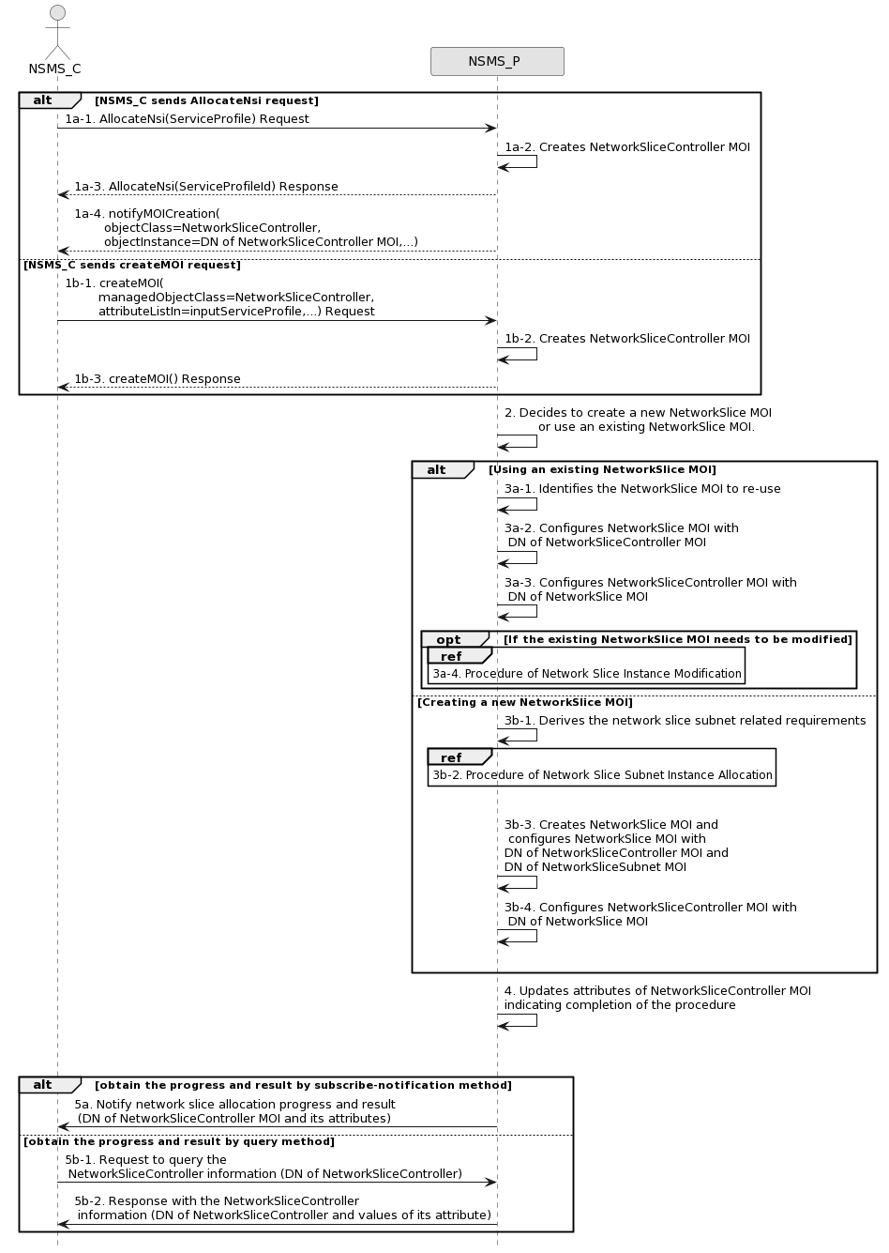
Figure 7.2-1: Network Slice Instance Allocation Request procedure
1a-1) Network Slice Management Service Provider (NSMS_P) receives an AllocateNsi request (see AllocateNsi operation defined in clause 6.5.1) from Network Slice Management Service Consumer (NSMS_C) with network slice related requirements (the network slice related requirements are defined as the attributes in the ServiceProfile see clause 6.3.3 in TS 28.541 [6]).
1a-2) The NSMS_P creates a NetworkSliceController MOI and configures attribute serviceProfileId to control and monitor network slice allocation process. NSMS_P starts to perform the network slice allocation process.
1a-3) The NSMS_P sends AllocateNsi response to the NSMS_C. The serviceProfileId is included in the AllocateNsi response.
1a-4) NSMS_P sends notification (see notifyMOICreation defined in TS 28.532 [8]) to NSMS_C to notify the DN of the created NetworkSliceController instance.
1b-1) NSMS_P receives a createMOI request (see createMOI operation defined in TS 28.532 [8]) from NSMS_C with network slice controller (see NetworkSliceController IOC and its attributes defined in TS 28.541[6]) including the network slice related requirements in attribute inputServiceProfile.
1b-2) The NSMS_P creates an MOI of NetworkSliceController.
1b-3) The NSMS_P sends the response to NSMS_C for the createMOI request.
NOTE: Network slice allocation may be initiated using AllocateNsi operation as described in steps 1a or createMOI operation as described in steps 1b.
2) Based on the network slice related requirements and the knowledge of the capabilities of existing deployed network slices, the NSMS_P may compare/match the provided requirements against all the candidate NetworkSlice MOIs, and then decides whether to use an existing NetworkSlice MOI or create a new NetworkSlice MOI. If the network slice related requirements allow the requested NetworkSlice MOI to be shared and if an existing suitable NetworkSlice MOI can be reused, the NSMS_P may decide to use the existing NetworkSlice MOI.
3a-1) If using an existing NetworkSlice MOI, the NSMS_ P identifies the NetworkSlice MOI to be re-used.
3a-2) The NSMS_P configures the attribute networkSliceControllerRef of the NetworkSlice MOI with the DN of NetworkSliceController MOI.
3a-3) NSMS_P configures the NetworkSliceController MOI attribute networkSliceRef with the DN of NetworkSlice MOI (identified in step 3a-1).
3a-4) If the existing NetworkSlice MOI needs to be modified to satisfy the network slice related requirements, the NSMS_P invokes the procedure of network slice instance modification as described in clause 7.6.
3b-1) If creating a new NetworkSlice MOI, the NSMS_P derives the network slice subnet related requirements from the received network slice related requirements. Before NSMS_P derives the network slice subnet related requirements, NSMS_P may invoke corresponding network slice subnet capability information querying procedure as described in clause 7.8.
3b-2) The NSMS_P invokes the procedure of network slice subnet instance allocation as described in clause 7.3. Before NSMS_P invokes the procedure, NSMS_P may invoke corresponding procedure of feasibility check and reservation of network slice subnet as described in clause 7.14.
3b-3) The NSMS_P creates the NetworkSlice MOI and configures the attribute networkSliceSubnetRef with the DN of NetworkSliceSubnet MOI and the attribute networkSliceControllerRef with the DN of NetworkSliceController MOI. Other configuration information may be configured for the created NetworkSlice MOI.

Note: The detailed configuration information is described in network slice NRM (see NetworkSlice IOC defined in clause 6.3.1 in TS 28.541 [6]).
3a-5) NSMS_P configures the NetworkSliceController MOI attribute networkSliceRef with the DN of NetworkSlice MOI (created in step 3b-3).
4) NSMS_P configures NetworkSliceController MOI attributes operationalState, administrativeState, availabilityStatus and processMonitor to indicate completion of the procedure.
The NSMS_C may check the status and completion of the network slice allocation procedure any time by monitoring the values of NetworkSliceController MOI attributes operationalState, administrativeState, availabilityStatus and processMonitor by querying the values or by subscribing to notifications.
The following step 5 describes the procedures for NSMS_C to monitor network slice allocation progress and result. These steps can happen anytime after the NetworkSliceController MOI is created and its DN is notified to the NSMS_C (step 1a-4 or step 1b-3).
5a) The NSMS_P sends notification (see notifyMOIAttributeValueChanges defined in TS 28.532 [8]) to NSMS_C to notify the progress and result for network slice allocation process (see attributes in NetworkSliceController IOC).
5b-1) The NSMS_C sends query request to NSMS_P to query the attribute values of NetworkSliceController MOI (see getMOIAttributes operation defined in TS 28.532 [8]) to obtain the progress and result (including DN of the NetworkSlice MOI) for network slice allocation process.
5b-2) The NSMS_P sends the response to NSMS_C with the NetworkSliceController information

7.3 Procedure of Network Slice Subnet Instance Allocation
The Figure 7.3-1 illustrates the procedure of creating a new network slice subnet instance or using an existing network slice subnet instance to satisfy the required network slice subnet related requirements.
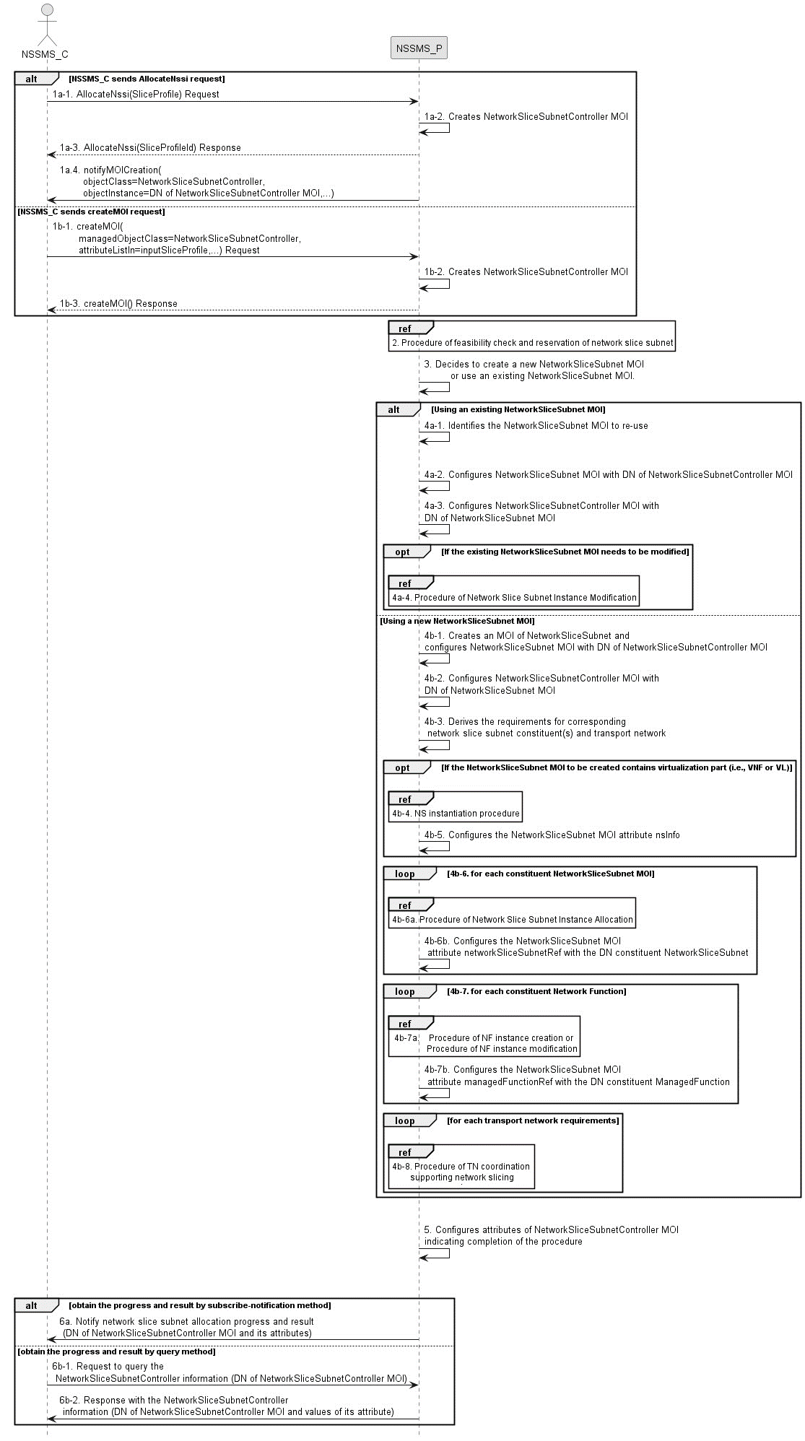
Figure 7.3-1: Network Slice Subnet Instance Allocation Request procedure
1a-1) Network Slice Subnet Management Service Provider (NSSMS_P) receives an AllocateNssi request (see AllocateNssi operation defined in clause 6.5.2) from Network Slice Subnet Management Service Consumer NSSMS_C with network slice subnet related requirements (network slice subnet related requirements defined in SliceProfile see clause 6.3.4 in TS 28.541 [6]).
1a-2) The NSSMS_P creates an MOI of NetworkSliceSubnetController and configures attribute sliceProfileId to control and monitor network slice subnetallocation process. NSSMS_P starts to perform the network slice subnet allocation process.
1a-3) The NSSMS_P sends AllocateNssi response to the NSSMS_C. The sliceProfileId is included in the AllocateNssi response.
1a-4) NSSMS_P sends notification (see notifyMOICreation defined in TS 28.532 [8]) to NSSMS_C to notify the DN of the created NetworkSliceSubnetController instance.
1b-1) NSSMS_P receives a createMOI request (see createMOI operation defined in TS 28.532 [8]) from NSSMS_C with network slice subnet controller (see NetworkSliceSubnetController IOC and its attributes defined in TS 28.541[6])) including the network slice subnet related requirements in attribute inputSliceProfile.
1b-2) The NSSMS_P creates an MOI of NetworkSliceSubnetController.
1b-3) The NSSMS_P sends the response to NSSMS_C for the createMOI request.
NOTE: Network slice subnet allocation may be initiated using AllocateNssi operation as described in steps 1a or createMOI operation as described in steps 1b.
2) NSSMS_P may invoke corresponding procedure of feasibility check and reservation of network slice subnet as described in clause 7.14. If the network slice subnet related requirements can be satisfied, the following step 3) to step 5) are needed, else go to step 6).
3) Based on the network slice subnet related requirements and the existing NetworkSliceSubnet MOI capabilities, NSSMS_P decides whether to use an existing NetworkSliceSubnet MOI or create a new NetworkSliceSubnet MOI. If the network slice subnet related requirements allow the requested NetworkSliceSubnet MOI to be shared and if an existing suitable NetworkSliceSubnet MOI can be reused, the NSSMS_P decides to use the existing NetworkSliceSubnet MOI.
4a-1) If using an existing NetworkSliceSubnet MOI, the NSSMS_ P identifies the NetworkSliceSubnet MOI to be reused.
4a-2) The NSSMS_P configures NetworkSliceSubnet MOI (attribute networkSliceSubnetControllerRef) with the DN of NetworkSliceSubnetController MOI.
4a-3) NSSMS_P configures the NetworkSliceSubnetController MOI (attribute networkSliceSubnetRef) with DN of NetworkSliceSubnet MOI (identified in step 4a-1).
4a-4) If the existing NetworkSliceSubnet MOI needs to be modified to satisfy the network slice subnet related requirements, the NSSMS_P invokes the procedure of network slice subnet instance modification as described in clause 7.7.
4b-1) If creating a new NetworkSliceSubnet MOI, the NSSMS_P creates an MOI of NetworkSliceSubnet. The NSSMS_P configures NetworkSliceSubnet MOI (attribute networkSliceSubnetControllerRef) with DN of NetworkSliceSubnetController MOI.
4b-2) NSSMS_P configures the NetworkSliceSubnetController MOI (attribute networkSliceSubnetRef) with DN of NetworkSliceSubnet MOI (identified in step 4b-1).
4b-3) NSSMS_P derives the corresponding network slice subnet constituent (i.e., NF, constituent NetworkSliceSubnet) related requirements and transport network related requirements (e.g., 3GPP endpoint information, latency requirements, bandwidth requirements and isolation requirements) from the received network slice subnet related requirements. Part of these requirements may be referenced by attribute epTransportRef as defined in clause 6.3.2.2 in TS 28.541[6]. Before NSSMS_P derives the constituent network slice subnet related requirements, NSSMS_Provider may invoke corresponding network slice subnet capability information querying procedure as described in clause 7.8.2.
4b-4) If the NetworkSliceSubnet MOI contains virtualisation part (i.e. VNF or VL), NSSMS_P derives the NS instance instantiation information (the NS instance instantiation information is described in clause 7.3.2.2 and clause 7.3.3.2 [3]) based on network slice subnet related requirements. NSSMS_P determines new VNF instance(s) that need to be deployed and the existing VNF instance(s) that need to be reused according to the necessary network function(s) and then derives the profile of virtual link(s) according to the connection requirements between the network functions. NSSMS_P chooses a proper NSD deployment flavour and creates data concerning the SAPs of the NS instance. NSSMS_P invokes the NS instantiation procedures to create a NS instance.

Note: For the interaction with ETSI NFV MANO, NS instantiation procedure is described in clause 7.3.3 in ETSI GS NFV-IFA 013 [3].
4b-5) NSSMS_P configures NetworkSliceSubnet MOI attribute nsInfo with NS instance information.
4b-6) For each required constituent network slice subnet (NetworkSliceSubnet MOIs), the following step 4b-6a) and 4b-6b) are needed:
4b-6a) NSSMS_P invokes procedure of network slice subnet instance allocation.
4b-6b) NSSMS_P configures NetworkSliceSubnet MOI attribute networkSliceSubnetRef with DN of NetworkSliceSubnet MOI.
4b-7) For each required constituent NF instance (ManagedFunction MOI), the following step 4b-7a) and 4b-7b) are needed:
4b-7a) NSSMS_P invokes procedure of NF instance creation described in clause 7.10 or procedure of NF instance modification described in clause 7.11.
4b-7b) NSSMS_P configures NetworkSliceSubnet MOI attribute managedFunctionRef with DN of ManagedFunction MOI.
4b-8) For each required transport network related requirements, NSSMS_P invokes corresponding procedure of coordination with relevant TN Manager to handle the TN part as described in clause 7.9.
5) NSSMS_P configures NetworkSliceSubnetController MOI attributes operationalState, administrativeState, availabilityStatus and processMonitor to indicate completion of the procedure.
The NSSMS_C may check the status and completion of the network slice subnet allocation procedure any time by monitoring the values of NetworkSliceSubnetController MOI attributes operationalState, administrativeState, availabilityStatus and processMonitor by querying the values or by subscribing to notifications.
Following step 6) describes the procedures for NSSMS_C to monitor network slice subnet allocation progress and result. These steps can happen anytime after the NetworkSliceSubnetController MOI is created and its DN is notified to the NSSMS_C (step 1a-4 or step 1b-3).
6a) The NSSMS_P sends notification (see notifyMOIAttributeValueChanges defined in TS 28.532 [8]) to NSSMS_C to notify the progress and result for network slice subnet allocation process (see attributes in NetworkSliceSubnetController IOC).
6b-1) The NSSMS_C sends query request to NSSMS_P to query the attribute value of NetworkSliceSubnetController MOI (see getMOIAttributes operation defined in TS 28.532 [8]) to obtain the progress and result (including DN of theNetworkSliceSubnet MOI) for network slice subnet allocation process.
6b-2) The NSMS_P sends the response to NSMS_C with the NetworkSliceSubnetController information

7.4 Procedure of Network Slice Instance Deallocation
Figure 7.4-1 depicts the procedure of deallocating a network slice instance by the network slice management service provider to satisfy the NSI deallocation request received from an authorized consumer.
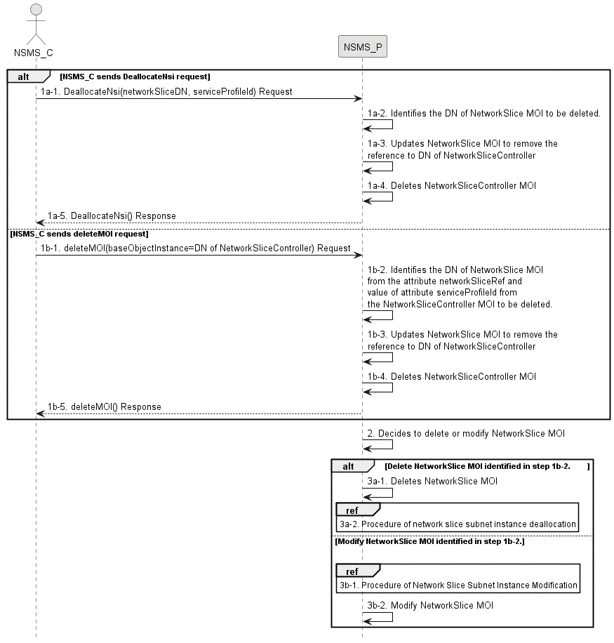
Figure 7.4-1: Network slice instance deallocation procedure
1a-1) Network Slice Management Service Provider (NSMS_P) receives a DeallocateNsi request (see DeallocateNsi operation defined in clause 6.5.3) from Network Slice Management Service Consumer (NSMS_C) indicating that the NetworkSlice MOI is no longer needed for the given requirements i.e ServiceProfile.
1a-2) NSMS_P identifies the DN of NetworkSlice MOI from the attribute networkSliceRef and value of attribute serviceProfileId of the NetworkSliceController MOI to be deleted.
1a-3) NSMS_P updates attribute networkSliceControllerRef of NetworkSlice MOI (identified in step 1b-2) attribute to remove the DN of NetworkSliceController MOI to be deleted.
1a-4) NSMS_P deletes NetworkSliceController MOI.
1a-5) The NSMS_P sends the DeallocateNsi response (see DeallocateNsi operation defined in clause 6.5.3) to NSMS_C.
1b-1) NSMS_P receives a deleteMOI request (see deleteMOI operation defined in TS 28.532 [8]) from NSMS_C with network slice controller (see NetworkSliceController IOC and its attribute defined in TS 28.541[6])).
1b-2) NSMS_P identifies the DN of NetworkSlice MOI from the attribute networkSliceRef and value of attribute serviceProfileId of the NetworkSliceController MOI to be deleted.
1b-3) NSMS_P updates attribute networkSliceControllerRef of NetworkSlice MOI (identified in step 1b-2) attribute to remove the DN of NetworkSliceController MOI to be deleted.
1b-4) NSMS_P deletes NetworkSliceController MOI.
1b-5) NSMS_P sends the response to NSMS_C for the deleteMOI request.
NOTE: Network slice deallocation may be initiated using DeallocateNsi operation as described in steps 1a or using deleteMOI operation as described in steps 1b.
2) The NSMS_P may decide to delete or modify the NetworkSlice MOI (identified in step 1b-2).
3a-1) If NSMS_P decides to delete the NetworkSlice MOI, then it deletes the NetworkSlice MOI.
3a-2) NSMS_P invokes the procedure of network slice subnet instance deallocation as described in clause 7.5.
3b-1) If NSMS_P decides to modify the NetworkSlice MOI, procedure of network slice subnet instance modification procedure as described in clause 7.6.
3b-2) NSMS_P modifies the NetworkSlice MOI to update the serviceProfileList (using the serviceProfileId identified in step 1a-2) or 1b-2) and may update other attributes.
If the NSMS_C has subscribed for the notification, then NSMS_P sends notification for deletion (see notifyMOIDeletion operation defined in TS 28.532 [8]) and notification for the attribute value changes (see notifyMOIAttributeValueChanges operation defined in TS 28.532 [8]) of NetworkSliceController MOI and NetworkSlice MOI.

7.5 Procedure of network slice subnet instance deallocation
Figure 7.5-1 depicts the procedure of deallocating a network slice subnet instance by the network slice subnet management service provider to satisfy the NSSI deallocation request received from an authorized consumer.
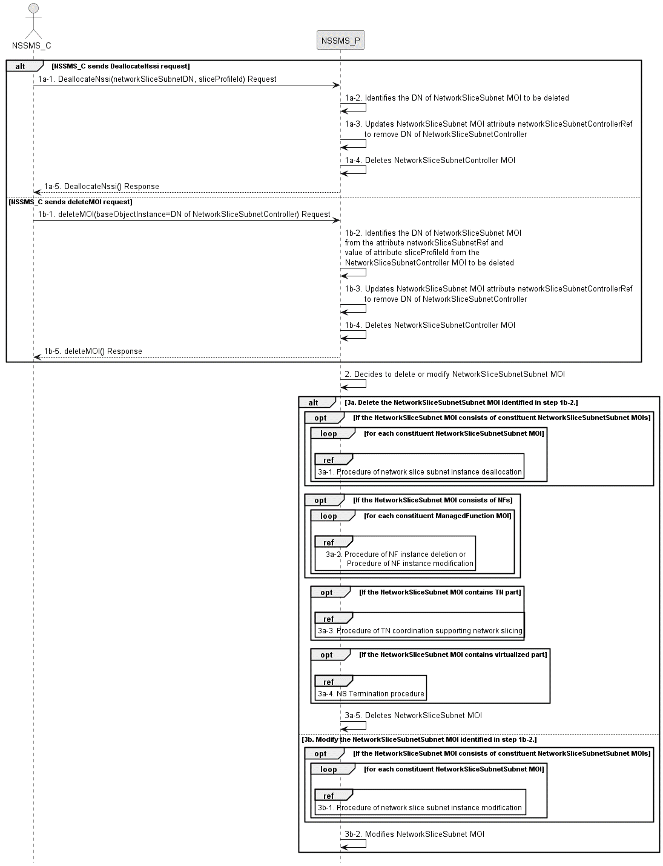
Figure 7.5-1: Network slice subnet instance deallocation procedure
1a-1) The network slice subnet management service provider (NSSMS_P) receives DeallocateNssi request (see DeallocateNssi operation defined in clause 6.5.4) from network slice subnet management service consumer (NSSMS_C) indicating that the NetworkSliceSubnet MOI is no longer needed for the given requirements i.e SliceProfile.
1a-2) NSSMS_P identifies the DN of NetworkSliceSubnet MOI from the attribute networkSliceSubnetRef and value of attribute sliceProfileId from the NetworkSliceSubnetController MOI to be deleted.
1a-3) NSSMS_P updates NetworkSliceSubnet MOI (identified in step 1b-2) attribute networkSliceSubnetControllerRef to remove the DN of NetworkSliceSubnetController MOI to be deleted.
1a-4) NSSMS_P deletes NetworkSliceSubnetController MOI.
1a-5) NSSMS_P sends response (see DeallocateNssi operation defined in clause 6.5.4) of NSSI deallocation service to NSSMS_C.
1b-1) NSSMS_P receives a deleteMOI request (see deleteMOI operation defined in TS 28.532 [8]) from NSSMS_C with network slice controller (see NetworkSliceSubnetController IOC and its attribute defined in TS 28.541[6])).
1b-2) NSSMS_P identifies the DN of NetworkSliceSubnet MOI from the attribute networkSliceSubnetRef and value of attribute sliceProfileId from the NetworkSliceSubnetController MOI to be deleted.
1b-3) NSSMS_P updates NetworkSliceSubnet MOI (identified in step 1b-2) attribute networkSliceSubnetControllerRef to remove the DN of NetworkSliceSubnetController MOI to be deleted.
1b-4) NSSMS_P deletes NetworkSliceSubnetController MOI.
1b-5) NSSMS_P sends the response to NSSMS_C for the deleteMOI request.
NOTE: Network slice subnet deallocation may be initiated using DeallocateNssi operation as described in steps 1a or using deleteMOI operation as described in steps 1b.
2) The NSSMS_P may decide to delete or modify the NetworkSliceSubnet MOI (identified in step 1b-2).
3a) If NSSMS_P decides to delete the NetworkSliceSubnet MOI, then it performs the following steps:
3a-1) NSSMS_P invokes procedure of network slice subnet instance deallocation as described in clause 7.5 for each constituent NetworkSliceSubnet MOI(s) that is configured in attribute networkSliceSubnetRef of NetworkSliceSubnet MOI (identified in step 1b-2).
3a-2) For each constituent NF instance (ManagedFunction MOI DN that is configured in attribute of managedFunctionRef of NetworkSliceSubnet MOI identified in step 1b-2), NSSMS_P invokes procedure of NF instance deletion as described in clause 7.12 only if the NF is dedicated for the NetworkSliceSubnet MOI (identified in step 1b-2) and not being used by any other NetworkSliceSubnet MOIs in the network, otherwise, NSSMS_P procedure of NF instance modification as described in clause 7.11.
3a-3) NSSMS_P invokes TN related coordination procedure with responsible manager as described in clause 7.9 if the NetworkSliceSubnet MOI consists of TN part.
3a-4) NSSMS_P invokes NS termination procedure if the NetworkSliceSubnet MOI contains virtualized part.

Note: For the interaction with ETSI NFV MANO, NS termination procedure is described in clause 7.3.7 in ETSI GS NFV-IFA 013 [3]..
3a-5) NSSMS_P deletes the NetworkSliceSubnet MOI.
3b) If NSSMS_P decides to modify the NetworkSliceSubnet MOI, then it performs the following sub steps:
3b-1) For each constituent NetworkSliceSubnet MOI, NSSMS_P invokes the procedure of network slice subnet instance modificationas described in clause 7.6.
3b-2) NSSMS_P modifies the NetworkSliceSubnet MOI to update the sliceProfileList (using the sliceProfileId identified in step 1b-2) and may update other attributes.
If the NSSMS_C has subscribed for the notification, then NSSMS_P sends notification for deletion (see notifyMOIDeletion operation defined in TS 28.532 [8]) and notification for the attribute value changes (see notifyMOIAttributeValueChanges operation defined in TS 28.532 [8]) of NetworkSliceSubnetController MOI and NetworkSliceSubnet MOI.

7.6 Procedure of Network Slice Instance Modification
The Figure 7.6-1 illustrates the procedure of modifying an existing NSI.
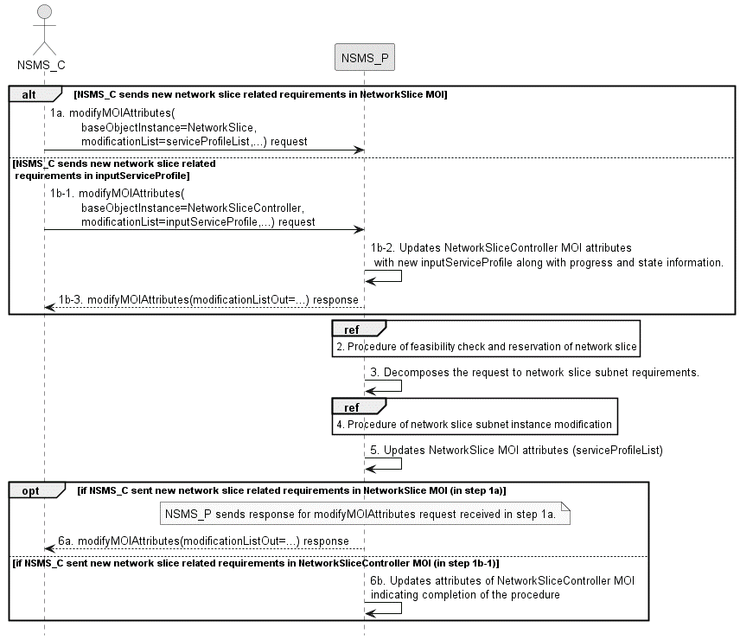
Figure 7.6-1: Network Slice Instance Modification Request procedure
1a) Network Slice Management Service Provider (NSMS_P) receives a modifyMOIAttributes request (defined in TS 28.532 [8]) from Network Slice Management Service Consumer (NSMS_C) with the DN of NetworkSlice MOI and the new network slice related requirements (see ServiceProfile defined in clause 6.3.3 in TS 28.541[6]).
1b-1) Network Slice Management Service Provider (NSMS_P) receives a modifyMOIAttributes request (defined in TS 28.532 [8]) from Network Slice Management Service Consumer (NSMS_C) with the DN of NetworkSliceController MOI (see NetworkSliceController IOC and its attribute defined in TS 28.541[6]) and the new requirements for the network slice in attribute inputServiceProfile. The NSMS_C may check the status and completion of the network slice instance modification procedure any time by monitoring the values of NetworkSliceController MOI attributes operationalState, administrativeState, availabilityStatus and processMonitor by querying the values or by subscribing to notifications.
1b-2) The NSMS_P updates NetworkSliceController MOI attributes inputServiceProfile, and may update attributes operationalState, availabilityStatus and processMonitor to indicate progress.
1b-3) The NSMS_P sends the response to NSMS_C for the modifyMOIAttributes request.
NOTE: Network slice modification may be initiated using DN of NetworkSlice MOI in the modifyMOIAttributes operation as described in steps 1a or using DN of NetworkSliceController MOI in the modifyMOIAttributes operation as described in steps 1b.
2) Based on the new network slice related requirements, NSMS_P invokes the procedure of feasibility check and reservation of network slice as described in clause 7.13. If the modification requirements can be satisfied, go to step 3), else go to step 6).
3) NSMS_P decomposes the modification request into the new requirements for the network slice subnet related.
4) NSMS_P, as the role of Network Slice Subnet Management Service Consumer (NSSMS_C), invokes the procedure of network slice subnet instance modification as described in clause 7.7.
5) NSMS_P updates NetworkSlice MOI attributes.
6a) If NSMS_C sent new network slice related requirements in NetworkSlice MOI (in step 1a), then NSMS_P sends response for modifyMOIAttributes.
6b) If NSMS_C sent the new network slice related requirements in NetworkSliceController MOI (in step 1b-1), then NSMS_P updates NetworkSliceController MOI attributes operationalState, administrativeState, availabilityStatus and processMonitor to indicate completion of the procedure.

7.7 Procedure of Network Slice Subnet Instance Modification
The Figure 7.7-1 illustrates the procedure of modifying an existing NSSI.

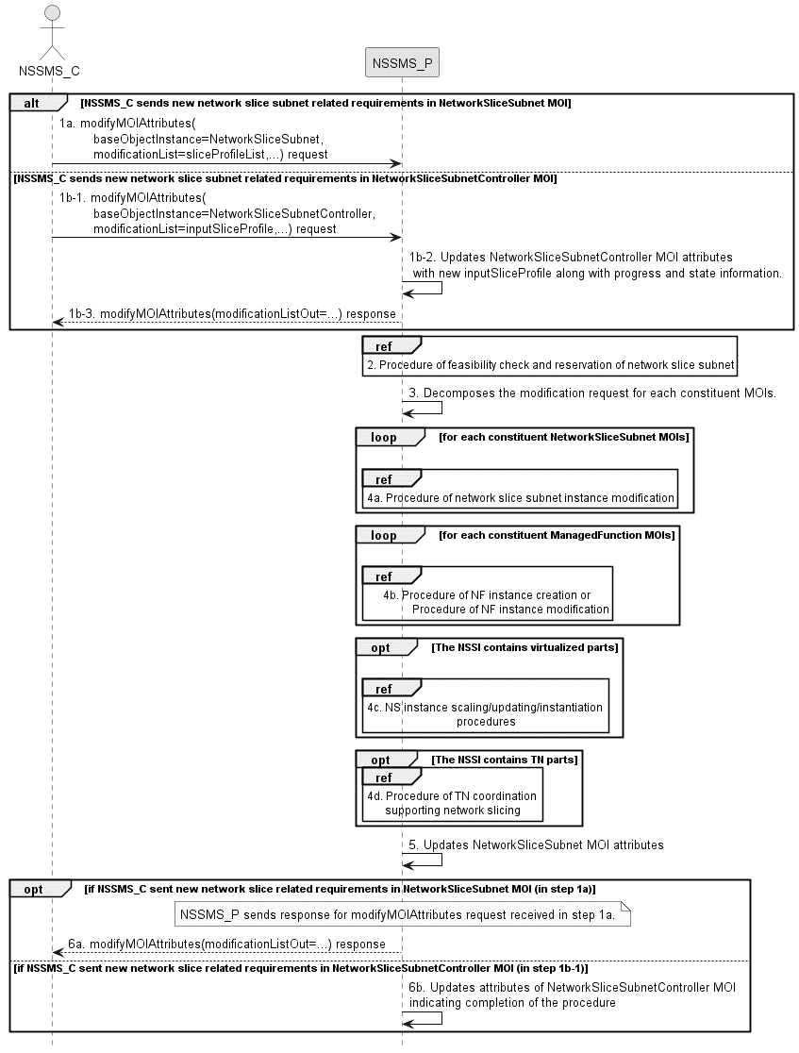
Figure 7.7-1: Network Slice Subnet Instance Modification Request procedure

1a) Network Slice Subnet Management Service Provider (NSSMS_P) receives a modifyMOIAttributes request (defined in TS 28.532 [8]) from Network Slice Subnet Management Service Consumer (NSSMS_C) with the DN of NetworkSliceSubnet MOI and the new network slice subnet related requirements (see SliceProfile defined in clause 6.3.3 in TS 28.541[6]).
1b-1) Network Slice Subnet Management Service Provider (NSSMS_P) receives a modifyMOIAttributes request (defined in TS 28.532 [8]) from Network Slice Subnet Management Service Consumer (NSSMS_C) with the DN of NetworkSliceSubnetController MOI (see NetworkSliceSubnetController IOC and its attribute defined in TS 28.541[6]) and the new network slice subnet related requirements in attribute inputSliceProfile. The NSSMS_C may check the status and completion of the network slice instance modification procedure any time by monitoring the values of NetworkSliceSubnetController MOI attributes operationalState, administrativeState, availabilityStatus and processMonitor by querying the values or by subscribing to notifications.
1b-2) The NSSMS_P updates NetworkSliceSubnetController MOI attributes inputSliceProfile, and may update attributes operationalState, availabilityStatus and processMonitor to indicate progress.
1b-3) The NSSMS_P sends the response to NSSMS_C for the modifyMOIAttributes request.
NOTE: Network subnet slice modification may be initiated using DN of NetworkSliceSubnet MOI in the modifyMOIAttributes operation as described in step 1a or using DN of NetworkSliceSubnetController MOI in the modifyMOIAttributes operation as described in step 1b.
2) Based on the new network slice subnet related requirements, NSSMS_P invokes the procedure of feasibility check and reservation of network slice subnet as described in clause 7.14. If the modification requirements can be satisfied, go to step 3), else go to step 6).
3) NSSMS_P decomposes the NetworkSliceSubnet MOI modification request into modification requests for each constituent MOIs.
4a) NSSMS_P invokes procedure of network slice subnet instance modification for each constituent NetworkSliceSubnet MOI(s) that is configured in attribute networkSliceSubnetRef of the NetworkSliceSubnet MOI.
4b) For each constituent NF instance (ManagedFunction MOI DN that is configured in attribute of managedFunctionRef of NetworkSliceSubnet MOI), NSSMS_P invokes procedure of NF instance creation as described in clause 7.10 or procedure of NF instance modification as described in clause 7.11.
4c) If the NetworkSliceSubnet MOI contains the virtualized part, NSSMS_P invokes the NS instance scaling and/or NS instance updating and/or NS instance instantiation procedures. For the interaction with ETSI NFV MANO the procedures are described in ETSI GS NFV-IFA 013 [3].
4d) If the NetworkSliceSubnet MOI contains the TN part, NSSMS_P invokes the corresponding procedure of coordination with relevant TN Manager to handle the TN part as described in clause 7.9.
5) NSSMS_P updates NetworkSliceSubnet MOI attributes.
6a) If NSSMS_P sent new network slice subnet related requirements in NetworkSliceSubnet MOI (in step 1a), then NSMS_P sends response for modifyMOIAttributes.
6b) If NSSMS_C sent the new network slice subnet related requirements in NetworkSliceSubnetController MOI (in step 1b-1), then NSSMS_P updates NetworkSliceSubnetController MOI attributes operationalState, administrativeState, availabilityStatus and processMonitor to indicate completion of the procedure.

7.8 Procedure of Obtaining Network Slice Subnet Management Service Producer Capability

7.8.1 Introduction
The clause illustrates possible procedures of obtaining network slice subnet capability information (e.g. supported maximum latency, supported capacity (e.g. maximum user number)) of network slice subnet instance(s) which can be provided by network slice subnet management service provider.

7.8.2 Querying Network Slice Subnet Capability Information
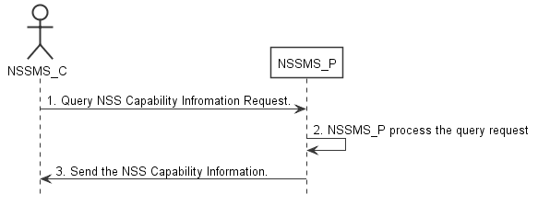
Figure 7.8-2: Procedure of querying network slice subnet capability information
1) Network Slice Subnet Management Service Consumer (NSSMS_C) wants to query the NSS capability information of the NSSI(s) which can be provided by corresponding Network Slice Subnet Management Service Producer (NSSMS_P) NSSMS_C sends getMOIAttributes operation (defined in TS 28.532 [8]) , for NetworkSliceSubnetProviderCapabilities IOC, to NSSMS_P to obtain the NSS capability information of the NSSI(s) which can be provided by corresponding NSSMS_P.
2) NSSMS_P processes the NSS capability information querying request.
3) NSSMS_P sends the NSS capability information (e.g. supported maximum latency, supported capacity (e.g. user number)) of NSSI(s) that can be provided by itself, as a response to getMOIAttributes operation (as defined in TS 28.532 [8]), to NSSMS_C.

7.8.3 Void

7.9 Procedure of TN coordination supporting network slicing

7.9.1 Introduction
This clause describes procedures of coordination with TN Manager to handle TN part supporting network slicing.
NOTE: The present document: addresses interactions with NFVO as TN manager,. interactions with other types of TN Manager (e.g. Optical, IP bearer transport network, etc.) have not been addressed.

7.9.2 Interaction with NFVO as TN Manager
This clause considers the procedure of interaction between the 3GPP management system and the NFVO, which behaves as TN Manager, to satisfy the TN related requirements for the virtual links used in NSSI. The procedure is applicable to creation and modification of the NSSI.
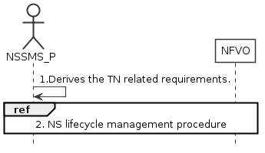
Figure 7.9.2-1: Interaction with NFVO as TN manager to support network slicing
1) Network Slice Subnet Management Service Provider (NSSMS_P) derives the TN related requirements (e.g. 3GPP endpoint information, latency requirements, bandwidth requirements, isolation requirements) for the TN part to be used in the NSSI.
2) To satisfy the TN related requirements NSSMS_P invokes the corresponding NS instance lifecycle management procedures as described in ETSI GS NFV-IFA 013 [3].
3) After the NFVO executes the requested operation, it sends the corresponding notification to the NSSMS_P as described in ETSI GS NFV-IFA 013 [3].

7.10 Procedure of NF instance creation
The Figure 7.10-1 illustrates the procedure of creating a new network function instance to satisfy the required network function related requirements.
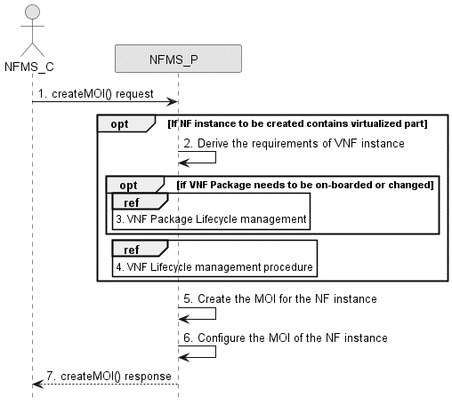
Figure 7.10-1: Network Function Instance Creation procedure
1) Network Function Management Service Provider (NFMS_P) receives a createMOI, for ManagedFunction IOC, request from Network Function Management Service Consumer (NFMS_C) with network function related requirements.
Note: The network function related requirements see information model definition for NR NRM in clause 4 and information model definition for 5GC NRM in clause 5 in TS 28.541[6].
2) If NF instance to be created contains virtualized part, NFMS_P derives the requirements for VNF instance based on the network function related requirements.
3) If corresponding VNF Package needs to be on-boarded or changed, the NFMS_P invoke corresponding VNF Package management. For the interaction with ETSI NFV MANO, the procedure is described in clause 7.7 in ETSI GS NFV-IFA013 [3]. The VNF package is compliant with ETSI GS NFV-IFA011 [14].
4) The NFMS_P invokes VNF lifecycle management. For the interaction with ETSI NFV MANO, the procedure is as described in clause 7.3.5 (Update NS operation) in ETSI GS NFV-IFA013 [3] or clause 7.2.2 (Create VNF Identifier operation) and clause 7.2.3 (Instantiate VNF operation) in ETSI GS NFV-IFA008 [15]..
5) The NFMS_P creates the MOI for the ManagedFunction to be created. If the ManagedFunction contains virtualized part, the NFMS_P may send the request of creating the MOI to the NFMS_P in the ManagedFunction.
6) The NFMS_P configures the new created MOI with corresponding configuration information (see information model definition for NR NRM in clause 4 and information model definition for 5GC NRM in clause 5 in TS 28.541[6]).
7) The NFMS_P sends the createMOI response to NFMS_C with DN of MOI for ManagedFunction.

7.11 Procedure of NF instance modification
The Figure 7.11-1 illustrates the procedure of modify NF instance.
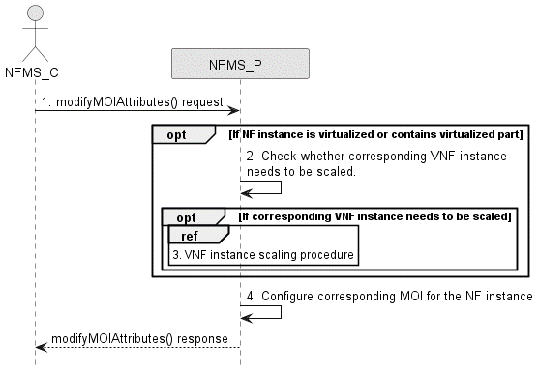
Figure 7.11-1: Network Function Instance Modify procedure
1) Network Function Management Service Provider (NFMS_P) receives a modifyMOIAttributes operation defined in TS 28.532 [8] from Network Function Management Service Consumer (NFMS_C) with DN of MOI for ManagedFunction and network function related requirements.
Note: The network funcation related requirements see information model definition for NR NRM in clause 4 and information model definition for 5GC NRM in clause 5 in TS 28.541[6].
2) If ManagedFunction instance contains virtualized part, NFMS_P checks whether corresponding VNF instance needs to be scaled to satisfy the network function related requirements.
3) If corresponding VNF instance needs to be scaled, NFMS_P invokes corresponding VNF instance scaling procedure. For the interaction with ETSI NFV MANO, the procedure is described in clause 7.2.4 in ETSI GS NFV-IFA008 [15] or clause 7.3.4 in ETSI GS NFV-IFA013 [3].
4) NFMS_P reconfigures corresponding ManagedFunction MOI.
5) The NFMS_P sends the response (see modifyMOIAttributes operation defined in TS 28.532 [8]) to NFMS_C.

7.12 Procedure of NF instance deletion
The Figure 7.12-1 illustrates the procedure of deleting NF instance.
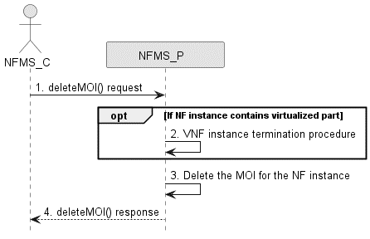
Figure 7.12-1: Network Function Instance Deletion procedure
1) Network Function Management Service Provider (NFMS_P) receives deletetMOI from Network Function Management Service Consumer (NFMS_C) with DN of ManagedFunction MOI.
2) If the ManagedFunction instance contains virtualized part, NFMS_P invokes VNF instance termination procedure. For the interaction with ETSI NFV MANO, the procedure is with ETSI NFV MANO as described in clause 7.2.7 (Terminate VNF operation) and clause 7.2.8 (Delete VNF Identifier operation) in ETSI GS NFV-IFA008 [15] or clause 7.3.5 (Update NS operation) in ETSI GS NFV-IFA013 [3].
3) NFMS_P deletes the ManagedFunction MOI.
4) NFMS_P sends the response (see deleteMOI operation defined in TS 28.532 [8]) to NFMS_C.

7.13 Procedure of feasibility check and reservation of NSI
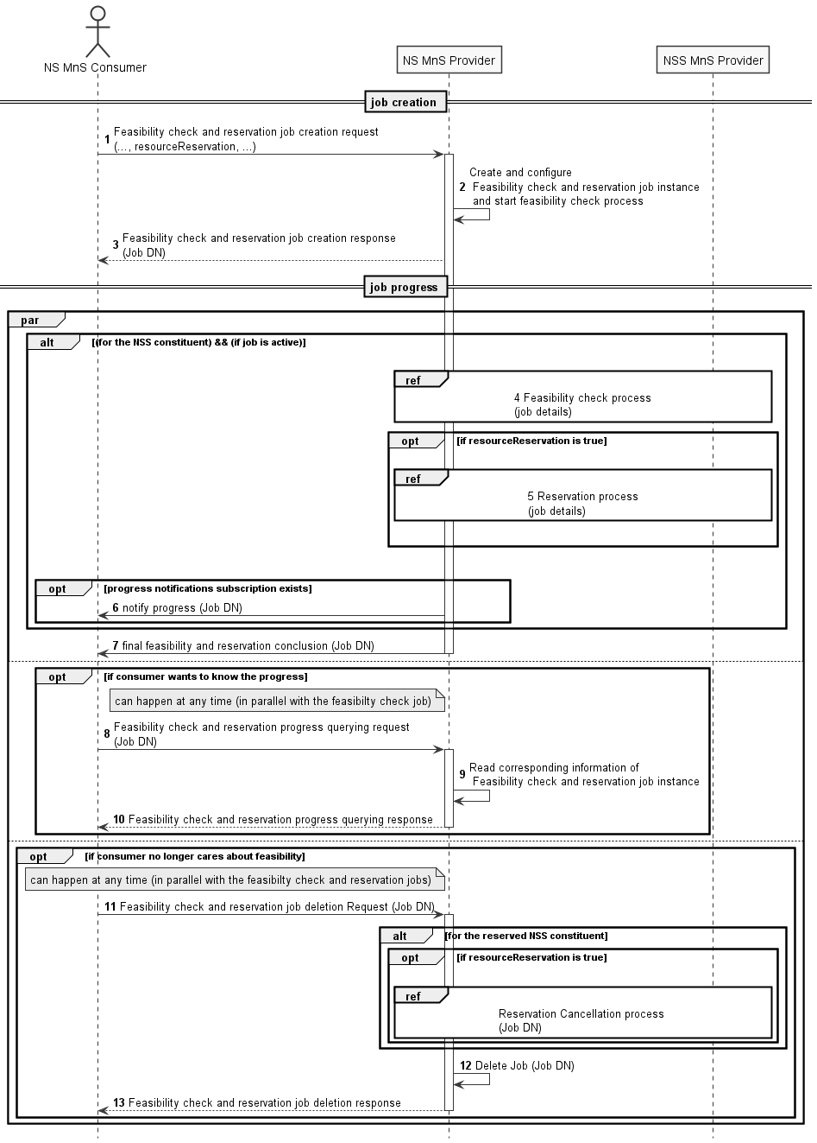
Figure 7.13-1 Network slice feasibility check and reservation procedure
1) Network Slice Management Service Provider (NS MnS Provider) receives a feasibility check with or without reservation job creation request (see createMOI operation defined in TS 28.532 [8]) from Network Slice Management Service Consumer (NS MnS Consumer) with feasibility check and reservation requirements (including serviceProfile, resourceReservation,recommendationRequest, requestedReservationExpiration and feasibilityTimeWindow of FeasibilityCheckAndReservationJob IOC defined in TS 28.541 [6]). The request is to check whether the network slice related requirements (i.e., ServiceProfile) can be satisfied and optionally be requested to be reserved. The resourceReservation attribute in the request may indicate whether reservation is also requested or not.
2) NS MnS Provider creates the FeasibilityCheckAndReservationJob instance and configures the attribute "ServiceProfile" and other attributes received from the request and NS MnS Provider starts executing the feasibility check process.
3) NS MnS Provider sends the feasibility check and reservation job creation response with the DN of the FeasibilityCheckAndReservationJob instance (see createMOI operation defined in TS 28.532 [8]) to NS MnS Consumer.
4) NS MnS Provider performs feasibility check locally on whether the resources are available.
NS MnS Provider may invoke the feasibility check and reservation procedure for the constituent network slice subnet as described in clause 7.14
5) NS MnS Provider performs resource reservation process when resourceReservation is True and feasibilityResult is feasible.
6) The NS MnS Consumer may subscribe for the attribute value change notifications for this specific job or for any of the job(s) created by it to receive any asynchronous job progress notifications for those job(s). NS MnS Provider then sends the asynchronous job progress notification for feasibility check and reservation process with processMonitor attributes.
7) NS MnS Provider sends the final notification with the feasibility check and reservation status (including feasibilityResult, inFeasibleReason, resourceReservationStatus, reservationFailureReason, reservationExpiration and recommendedRequirements of FeasibilityCheckAndReservationJob IOC in TS 28.541 [6]).
8-10) Once after step 3, NS MnS Consumer can send query request to NS MnS Provider any time, to know the feasibility check and reservation job status and receive the feasibility check and reservation job status.
11-13) NS MnS consumer can request to delete the feasibility check and reservation job any time and the NS MnS Provider deletes the Job and sends the Job deletion response. NS MnS Provider will cancel the resource reservation when the feasibility check and reservation job is deleted.

7.14 Procedure of feasibility check and reservation of network slice subnet
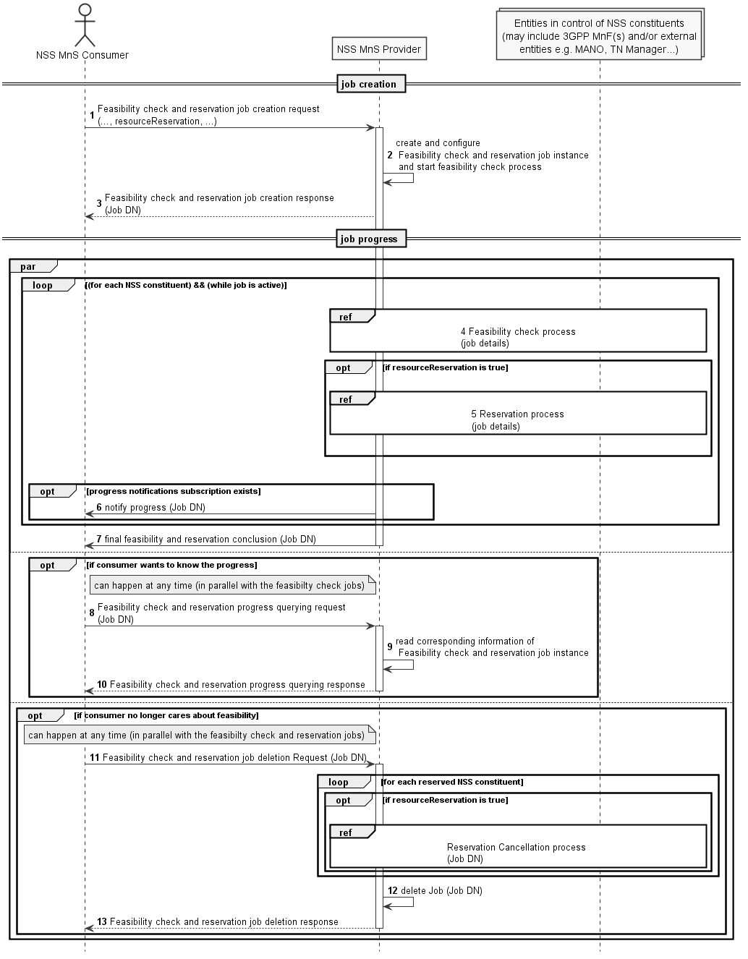
Figure 7.14-2 Network slice subnet feasibility check and reservation procedure
1) Network Slice Subnet Management Service Provider (NSS MnS Provider) receives a feasibility check with or without reservation job creation request (see createMOI operation defined in TS 28.532 [8]) from Network Slice Subnet Management Service Consumer (NSS MnS Consumer) with feasibility check and reservation requirements (including sliceProfile, resourceReservation, recommendationRequest, requestedReservationExpiration and feasibilityTimeWindow defined in FeasibilityCheckAndReservationJob IOC defined in TS 28.541 [6]). The request is to check whether the network slice subnet related requirements (i.e. SliceProfile) can be satisfied and optionally be requested to be reserved. The resourceReservation attribute in the request may indicate whether reservation is also requested or not.
2) NSS MnS Provider creates the FeasibilityCheckAndReservationJob instance and configures the attribute "SliceProfile" and other attributes received from the request and NSS MnS Provider starts executing the feasibility check process.
3) NSS MnS Provider sends the feasibility check and reservation job creation response for the received DN of theFeasibilityCheckAndReservationJob (see createMOI operation defined in TS 28.532 [8]) requests to NSS MnS Consumer.
4) NSS MnS Provider performs feasibility check locally (e.g 3GPP MnFs) on whether the resources are available.
NSS MnS Provider may optionally perform feasibility check with other entities in control of the network slice subnet constituents (e.g., MANO, TN Manager) of the network slice subnet.
5) NSS MnS Provider performs resource reservation process when resourceReservation is True and feasibilityResult is feasible.
6) The NSS MnS Consumer may subscribe for the attribute value change notifications for this specific job or for any of the job(s) created by it to receive any asynchronous job progress notifications for those job(s). NSS MnS Provider then sends the asynchronous job progress notification for feasibility check and reservation process with processMonitor attributes.
7) NSS MnS Provider sends the final notification with the feasibility check and reservation status (including feasibilityResult, inFeasibleReason, resourceReservationStatus, reservationFailureReason, reservationExpiration and recommendedRequirements defined in FeasibilityCheckAndReservationJob IOC in TS 28.541 [6]).
8-10) Once after step 3, NSS MnS Consumer can send query request to NSS MnS Provider any time, to know the feasibility check and reservation job status and receive the feasibility check and reservation job status.
11-13) NSS MnS consumer can request to delete the feasibility check and reservation job any time and the NSS MnS Provider deletes the Job and sends the Job deletion response. NSS MnS Provider will cancel the resource reservation when the feasibility check and reservation job is deleted.

7.15 Void

7.16 Void

7.17 Procedure of management interaction with NFV MANO for network service priority
The Figure 7.17-1 illustrates the procedure of management interaction with NFV MANO for network service priority.
Figure 17.1-1: Management interaction with NFV MANO
1. Network provisioning management service provider receives a CreateMOI requrest for SubNetwork IOC from a consumer. In the request, the priority is assigned by providing the value to the priorityLabel attribute.
2. If the sub-network to be created contains virtualisation part (i.e. VNF or VL), Network provisioning management service provider chooses a proper NSD deployment flavour with appropriate priority (see clause 6.3.2.2 in ETSI GS NFV-IFA 014 [12] ) according to the value of priorityLabel attribute in the CreateMOI requrest. Network provisioning management service provider invokes the NS instantiation procedures to create a NS instance.
Note: NS instantiation procedure is described in clause 7.3.3 in ETSI GS NFV-IFA 013 [3].
3. For each constituent NF, Network provisioning management service provider invokes NF Creation Procedure as described in clause 7.10.
4. The Network provisioning management service provider sends the response to the consumer with DN of MOI for the created sub-network.

7.18 Procedure for Network slice instance activation
The Figure 7.18-1 illustrates the procedure for network slice instance activation.

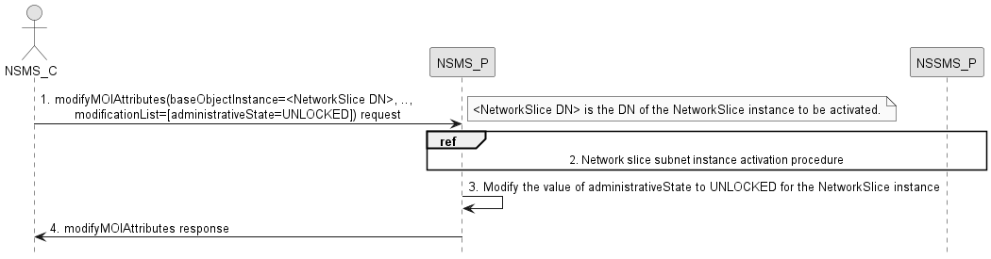
Figure 7.18-1: Network slice instance activation
1. Network Slice Management Service Provider (NSMS_P) receives a modifyMOIAttributes operation (defined in TS 28.532 [8]) from Network Slice Management Service Consumer (NSMS_C) with the DN of NetworkSlice instance and the new value of UNLOCKED for the administrative state (see NetworkSlice IOC and administrativeState attribute defined in clause 6.3.1 in TS 28.541[6]).
2. NSMS_P, as the role of etwork Slice Subnet Management Service Consumer (NSSMS_C), invokes the network slice subnet instance activation procedure.
3. NSMS_P modifies the value of the administrative state attribute of the NetworkSlice instance.
4. NSMS_P sends network slice instance administrative state attribute modification result (see modifyMOIAttributes operation defined in TS 28.532 [8]) to NSMS_C.

7.19 Procedure for Network slice instance deactivation
The Figure 7.19-1 illustrates the procedure for network slice instance deactivation.
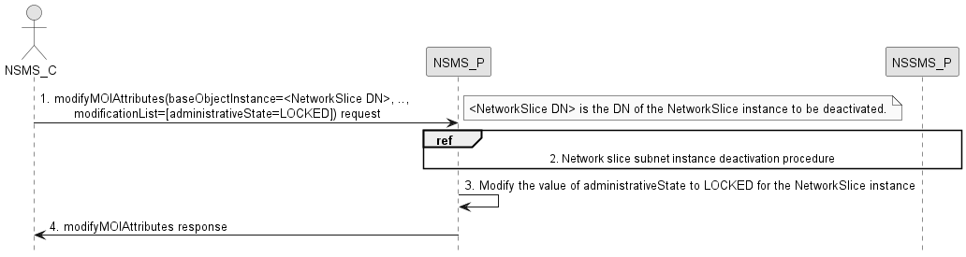
Figure 7.19-1: Network slice instance deactivation
1. Network Slice Management Service Provider (NSMS_P) receives a modifyMOIAttributes operation (defined in TS 28.532 [8]) from Network Slice Management Service Consumer (NSMS_C) with the DN of NetworkSlice instance and the new value of LOCKED for the administrative state (see NetworkSlice IOC and administrativeState attribute defined in clause 6.3.1 in TS 28.541[6]).
2. NSMS_P, as the role of Network Slice Subnet Management Service Consumer (NSSMS_C), invokes the Network slice subnet instance deactivation procedure.
3. NSMS_P modifies the value of the administrative state attribute of the NetworkSlice instance.
4. NSMS_P sends network slice instance administrative state attribute modification result (see modifyMOIAttributes operation defined in TS 28.532 [8]) to NSMS_C.

7.20 Procedure for Network slice sunbet instance activation
The Figure 7.20-1 illustrates the procedure for network slice subnet instance activation.
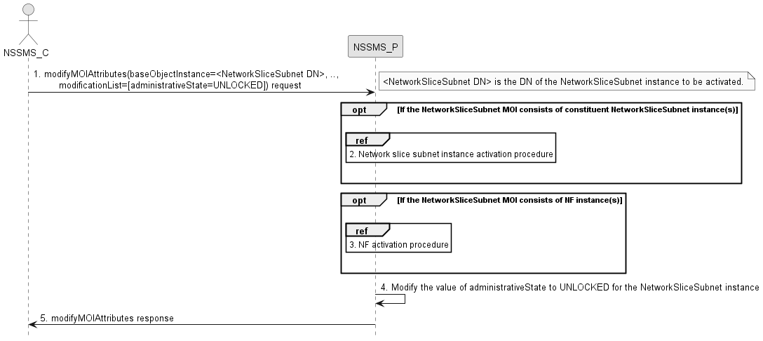
Figure 7.20-1: Network slice subnet instance activation
1. Network Slice Subnet Management Service Provider (NSSMS_P) receives a modifyMOIAttributes operation (defined in TS 28.532 [8]) from Network Slice Subnet Management Service Consumer (NSSMS_C) with the DN of NetworkSliceSubnet instance and the new value of UNLOCKED for the administrative state (see NetworkSliceSubnet IOC and administrativeState attribute defined in clause 6.3.2 in TS 28.541[6]).
2. If the network slice subnet instance consists of constituent network slice subnet instance(s), then NSSMS_P, as the role of Network Slice Subnet Management Service Consumer (NSSMS_C), invokes the network slice subnet instance activation procedure for the constituent network slice subnet instance(s).
3. If the network slice subnet instance consists of constituent is NF instance, then NSSMS_P request the NF related provisioning management service provider to activate the NF (e.g., activate the NF in sleep mode, turn on the ports).
4. NSSMS_P modifies the value of the administrative state attribute of the NetworkSliceSubnet instance.
5. NSSMS_P sends network slice subnet instance administrative state attribute modification result (see modifyMOIAttributes operation defined in TS 28.532 [8]) to NSMS_C.

7.21 Procedure for Network slice subnet instance deactivation
The Figure 7.21-1 illustrates the procedure for network slice subnet instance deactivation.

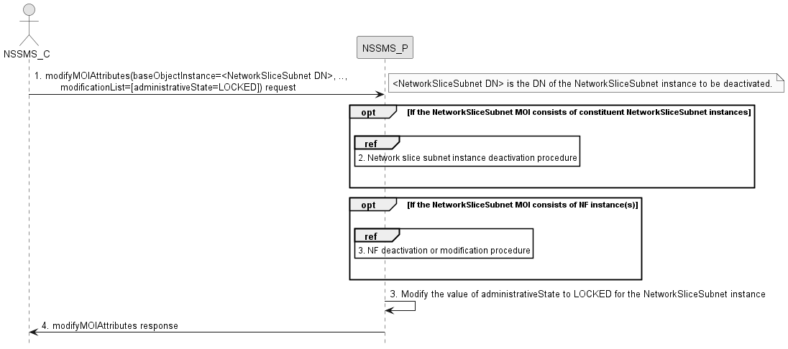
Figure 7.21-1: Network slice subnet instance deactivation
1. Network Slice Subnet Management Service Provider (NSSMS_P) receives a modifyMOIAttributes operation (defined in TS 28.532 [8]) from Network Slice Subnet Management Service Consumer (NSSMS_C) with the DN of NetworkSliceSubnet instance and the new value of LOCKED for the administrative state (see NetworkSliceSubnet IOC and administrativeState attribute defined in clause 6.3.2 in TS 28.541[6]).
2. If the network slice subnet instance consists of constituent network slice subnet instance(s), then NSSMS_P, as the role of Network Slice Subnet Management Service Consumer (NSSMS_C), invokes the network slice subnet instance deactivation procedure for the constituent network slice subnet instance(s).
3. If the network slice subnet instance consists of constituent is NF instance, then NSSMS_P requests the NF related provisioning management service provider to either deactivate the NF (if it is dedicated for this network slice subnet instance and not being used by any other network slice subnet instance) or to modify the NF (if it is shared by other network slice subnet instance).
4. NSSMS_P modifies the value of the administrative state attribute of the NetworkSliceSubnet instance.
5. NSSMS_P sends network slice subnet instance administrative state attribute modification result (see modifyMOIAttributes operation defined in TS 28.532 [8]) to NSMS_C.

8 Void

9 RESTful HTTP-based solution set of provisioning

9.1 Network slice provisioning management service

9.1.1 Mapping of operations

9.1.1.1 Introduction
Table 9.1.1-1: Mapping of IS operations to SS equivalents
IS operation | HTTP Method | Resource URI | Qualifier
allocateNsi | POST | {MnSRoot}/NSProvMnS/{MnSVersion}/ServiceProfile | M
deallocateNsi | DELETE | {MnSRoot}/NSProvMnS/{MnSVersion}/ServiceProfile={ServiceProfileId} | M

9.1.1.2 Operation allocateNsi
This operation is to allocate a network slice instance provided by the service provider, the network slice instance may be new or existing.
Table 9.1.2-1: Mapping of IS operation input parameters to SS equivalents (HTTP POST)
IS operation parameter name | SS parameter location | SS parameter name | SS parameter type | Qualifier
attributeListIn | request body | n/a | n/a | M

Table 9.1.2-2: Mapping of IS operation output parameters to SS equivalents (HTTP POST)
IS operation parameter name | SS parameter location | SS parameter name | SS parameter type | Qualifier
attributeListOut | response body | n/a | n/a | M
status | response status codes | n/a | n/a | M
status | response body | error | ErrorResponse | O
networkSliceDN | response body | n/a | Resource | M

The message flow for allocation is as follows:
1. The MnS consumer sends a HTTP POST request to the MnS producer.
- The target URI is equal to the concatenation of URI of the parent resource of resource to be created, and the resource (in this case ServiceProfile) to be created.
- The message body shall carry the complete representation of the resource to be created. The resource identifier shall be absent or carry null semantics.
2. The MnS producer sends a HTTP POST response to the MnS consumer.
- On success, "201 Created" shall be returned. The Location header shall carry the URI of the new resource (in this case ServiceProfile) and the message body shall contain the complete complete representation of the ServiceProfile and networkSliceDN identifying the NetworkSlice MOI created.
- On failure, an appropriate error code shall be returned. The response message body may provide additional error information.

9.1.1.3 Operation deallocateNsi
This operation deallocate a service profile in an NSI. The provider may terminate the requested NSI or modify the requested NSI without termination to satisfy the request.
Table 9.1.1.3-1: Mapping of IS operation input parameters to SS equivalents (HTTP DELETE)
IS operation parameter name | SS parameter location | SS parameter name | SS parameter type | Qualifier
networkSliceDN | request body | n/a | Resource | M
serviceProfileId | Request body | n/a | Resource | M

Table 9.1.1.3-2: Mapping of IS operation output parameters to SS equivalents (HTTP DELETE)
IS operation parameter name | SS parameter location | SS parameter name | SS parameter type | Qualifier
status | response status codes | n/a | n/a | M
status | response body | error | ErrorResponse | O

The message flow for deallocation is as follows:
1. The MnS consumer sends a HTTP DELETE request to the MnS producer.
- The target URI is equal to the concatenation of URI of the parent resource and the resource (in this case ServiceProfile) to be deleted.
- The message body shall contain the networkSliceDN identifying the NetworkSlice MOI.
2. The MnS producer sends a HTTP DELETE response to the MnS consumer.
- On success, "204 No content" shall be returned.
- On failure, an appropriate error code shall be returned. The response message body may provide additional error information.

9.1.2 Resources

9.1.2.1 Resource definitions

9.1.2.1.1 Resource “…/ServiceProfile
9.1.2.1.1.1 Description
This resource represents collects of network slice related requirement (i.e. ServiceProfiles).
9.1.2.1.1.2 URI
Resource URI: {MnSRoot}/NSProvMnS/{MnSVersion}/ServiceProfile
9.1.2.1.1.3 HTTP methods
9.1.2.1.1.3.1 POST
The POST method create a serviceProfile, the provider may create a NSI or using existing NSI to satisfy the serviceProfile.
This method shall support the request data structures, and the response data structures and response codes specified in the following tables.
Table 9.1.2.1.1.3.1-1: Data structures supported by the POST Request Body on this resource
Name | DATA TYPE | P | Cardinality | Description
attributeListIn | LIST OF SEQUENCE< attribute name, attribute value> | M | 1 | This parameter specifies the network slice related requirements or network related requirements defined in ServiceProfile in Clause 6.3.3 in TS 28.541 [6].

Table 9.1.2.1.1.3.1-2: Data structures supported by the POST Request Body on this resource
Name | DATA TYPE | P | Cardinality | Description
attributeListOut | LIST OF SEQUENCE< attribute name, attribute value> | M | 1 | This list of name/value pairs contains the attributes of the SliceProfile[6] which has been allocated and the actual value assigned to each.
status | HTTP response code | M | 1 | HTTP response code 200 indicates “OperationSucceeded”.  All other HTTP response codes indicate “OperationFailed”.
networkSliceDN | Resource | M | 1 | The DN of NetworkSlice MOI uniquely identifying the network slice instance.

9.1.2.1.1.3.2 DELETE
The DELETE method deletes a ServiceProfile.
This method shall support the request data structures, and the response data structures and response codes specified in the following tables.
Table 9.1.2.1.1.3.2-1: Data structures supported by the DELETE Request Body on this resource
Name | DATA TYPE | P | Cardinality | Description
networkSliceDN | Resource | M | 1 | The DN of NetworkSlice MOI uniquely identifying the network slice instance.
serviceProfileId | Resource | M | 1 | It specifies the global unifique identifier of the service profile in the NSI which is to be deallocated.

Table 9.1.2.1.1.3.2-2: Data structures supported by the DELETE Request Body on this resource
Name | DATA TYPE | P | Cardinality | Description
status | HTTP response code | M | 1 | HTTP response code 200 indicates “OperationSucceeded”.  All other HTTP response codes indicate “OperationFailed”.

9.2 Network slice subnet provisioning management service

9.2.1 Mapping of operations

9.2.1.1 Introduction
Table 9.2.1.1-1: Mapping of IS operations to SS equivalents
IS operation | HTTP Method | Resource URI | Qualifier
allocateNssi | POST | {MnSRoot}/NSSProvMnS/{MnSVersion}/SliceSubnetMgmt/SliceProfile | M
deallocateNssi | DELETE | {MnSRoot}/NSSProvMnS/{MnSVersion}/SliceSubnetMgmt/SliceProfile={id} | M

9.2.1.2 Operation allocateNssi
This operation is to allocate a network slice subnet instance provided by the service provider, the network slice subnet instance may be new or existing.
Table 9.2.1.2-1: Mapping of IS operation input parameters to SS equivalents (HTTP POST)
IS operation parameter name | SS parameter location | SS parameter name | SS parameter type | Qualifier
attributeListIn | request body | n/a | Resource | M

Table 9.2.1.2-2: Mapping of IS operation output parameters to SS equivalents (HTTP POST)
IS operation parameter name | SS parameter location | SS parameter name | SS parameter type | Qualifier
attributeListOut | response body | n/a | Resource | M
status | response status codes | n/a | n/a | M
status | Response body | error | ErrorResponse | O
networkSliceSubnetDN | response body | n/a | Resource | M

The message flow for allocation is as follows:
1. The MnS consumer sends a HTTP POST request to the MnS producer.
- The target URI is equal to the concatenation of URI of the parent resource of resource to be created, and the resource (in this case SliceProfile) to be created.
- The message body shall carry the complete representation of the resource to be created. The resource identifier shall be absent or carry null semantics.
2. The MnS producer sends a HTTP POST response to the MnS consumer.
- On success, "201 Created" shall be returned. The Location header shall carry the URI of the new resource (in this case SliceProfile) and the message body shall contain the complete complete representation of the SliceProfile and networkSliceSubnetDN identifying the NetworkSliceSubnet MOI created.
- On failure, an appropriate error code shall be returned. The response message body may provide additional error information.

9.2.1.3 Operation deallocateNssi
This operation deallocate a slice profile in an NSSI. The provider may terminate the requested NSSI or modify the requested NSSI without termination to satisfy the request.
Table 9.2.1.3-1: Mapping of IS operation input parameters to SS equivalents (HTTP DELETE)
IS operation parameter name | SS parameter location | SS parameter name | SS parameter type | Qualifier
networkSliceSubnetDN | request body | n/a | Resource | M
sliceProfileId | request body | n/a | Resource | M

Table 9.2.1.3-2: Mapping of IS operation output parameters to SS equivalents (HTTP DELETE)
IS operation parameter name | SS parameter location | SS parameter name | SS parameter type | Qualifier
status | response status codes | n/a | n/a | M
status | response body | error | ErrorResponse | O

The message flow for deallocation is as follows:
1. The MnS consumer sends a HTTP DELETE request to the MnS producer.
- The target URI is equal to the concatenation of URI of the parent resource and the resource (in this case SliceProfile) to be deleted.
- The message body shall contain the networkSliceSubnetDN identifying the NetworkSliceSubnet MOI.
2. The MnS producer sends a HTTP DELETE response to the MnS consumer.
- On success, "204 No content" shall be returned.
- On failure, an appropriate error code shall be returned. The response message body may provide additional error information.

9.2.2 Resources

9.2.2.1 Resource definitions

9.2.2.1.1 Resource “.../SliceProfile
9.2.2.1.1.1 Description
This resource represents collects of network slice subnet related requirements (i.e. SliceProfile).
9.2.2.1.1.2 URI
Resource URI: {MnSRoot}/NSSProvMnS/{MnSVersion}/SliceSubnetMgmt/SliceProfile
9.2.2.1.1.3 HTTP methods
9.2.2.1.1.3.1 POST
The POST method create a SliceProfile, the provider may create a new NSSI or using existing NSSI to support the SliceProfile.
This method shall support the request data structures, and the response data structures and response codes specified in the following tables.
Table 9.2.2.1.1.3.1-1: Data structures supported by the POST Request Body on this resource
Name | DATA TYPE | P | Cardinality | Description
attributeListIn | LIST OF SEQUENCE< attribute name, attribute value> | M | 1 | This parameter specifies the network slice subnet related requirements defined in SliceProfile in Clause 6.3.4 in TS 28.541 [6].

Table 9.2.2.1.1.3.1-2: Data structures supported by the POST Request Body on this resource
Name | DATA TYPE | P | Cardinality | Description
attributeListOut | LIST OF SEQUENCE< attribute name, attribute value> | M | 1 | This list of name/value pairs contains the attributes of the SliceProfile[6] which has been allocated and the actual value assigned to each.
status | HTTP response code | M | 1 | HTTP response code 200 indicates “OperationSucceeded”.  All other HTTP response codes indicate “OperationFailed”.
networkSliceSubnetDN | Resource | M | 1 | The DN of NetworkSliceSubnet MOI uniquely identifying the network slice subnet instance.

9.2.2.1.1.3.2 DELETE
The DELETE method deletes a SliceProfile.
This method shall support the request data structures, and the response data structures and response codes specified in the following tables.
Table 9.2.2.1.1.3.2-1: Data structures supported by the DELETE Request Body on this resource
Name | DATA TYPE | P | Cardinality | Description
networkSliceSubnetDN | Resource | M | 1 | The DN of NetworkSliceSubnet MOI uniquely identifying the network slice subnet instance.
sliceProfileId | Resource | M | 1 | It specifies the unifique identifier of the slice profile in the NSSI which is to be deallocated.

Table 9.2.2.1.1.3.2-2: Data structures supported by the DELETE Request Body on this resource
Name | DATA TYPE | P | Cardinality | Description
status | HTTP response code | M | 1 | HTTP response code 200 indicates “OperationSucceeded”.  All other HTTP response codes indicate “OperationFailed”.

Annex A (informative):
A network slice journey example
The Generic Slice Template (GST) ([9]) provides a standardized list of attributes that can be used to characterise different types of network slice. GST is generic and is not tied to any:
- Type of network slice
- Agreement between a Network Slice Customer (NSC) and a Network Slice Provider (NSP).
A Network Slice Type (NEST) is a GST filled with (ranges of) values. There may be two kinds of NESTs:
- Standardized NESTs (S-NEST), i.e. NESTs which character attributes are assigned (ranges of) values by SDOs, working groups, foras, etc. such as e.g. 3GPP, GSMA, 5GAA, 5G-ACIA, etc.;
- Private NESTs (P-NEST), i.e. NESTs which character attributes are assigned (ranges of) values by the Network Slice Providers, which are different from those assigned in S-NESTs.
Network Slice Providers can build their network slice product offering based on S-NESTs and/or their P-NESTs. For example, a Standardized Network Slice Type (S-NEST) NST-A, for which the attribute ‘Packet delay budget’ (see [x] – clause 3.4.26) value range is between 1 ms and 100 ms, is specified by 3GPP. Netwok Slice Provider Y may offer e.g. 3 products based on NST-A:
- Platinum NST-A based network slice product, where the attribute ‘Packet delay budget’ (see [x] – clause 3.4.26) value range is between 1 ms and 10 ms;
- Gold NST-A based network slice product, where the attribute ‘Packet delay budget’ (see [x] – clause 3.4.26) value range is between 11 ms and 50 ms;
- Silver NST-A based network slice product, where the attribute ‘Packet delay budget’ (see [x] – clause 3.4.26) value range is between 51 ms and 100 ms.
NSP Y’s customers can then order network slice instances from Y’s product catalog, as depicted by Figure A.1.
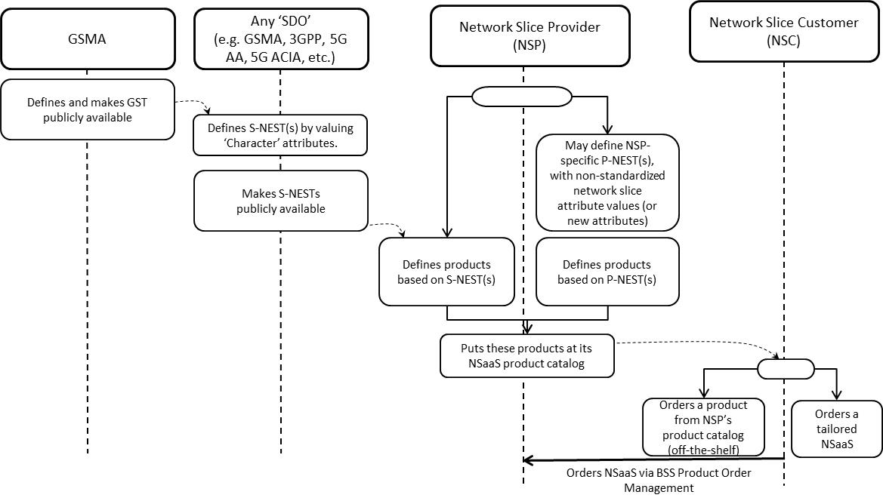
Figure A.1: From GST to S-(/P-)NEST based product ordering
1) A Network Slice Customer orders network slice instance to a Network Slice Provider, based on NSP’s product offering, by sending a request to NSP’ BSS
2) NSP’s BSS receives the request from NSC and translates NSC requirements into NSP technical parameter values
3) NSP’s BSS sends a request to NSP’s OSS to provide a network slice instance which fits NSC’s requirements (see Table 6.1-1)
4) NSP’s Network Slice Provisioning MnS either creates a new network slice instance or assigns an already existing network slice instance to NSC’s request
5) NSP’s Network Slice Provisioning MnS may have to request the Network Slice Subnet Provisioning MnS to provide a network slice subnet instance corresponding to the network slice instance (see Table 6.2-1)
6) NSP’s Network Slice Subnet Provisioning MnS may have to create one or more inner network slice subnet instances
7) NSP’s Network Function Provisioning MnS configures VNFs and/or PNFs (see Table 6.3-1).
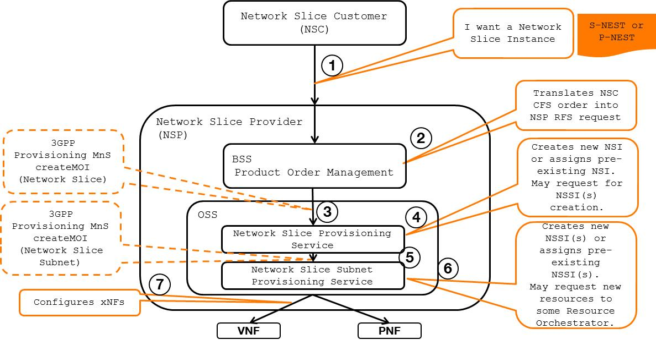
Figure A.2: Network Slice journey (NSaaS model) – high-level call flow
Depending on NSP’s product offering, NSC can order network slice instances spanning one or more network domains, e.g.:
- network slice instances composed of a RAN-only network slice subnet instance
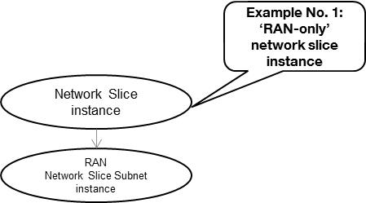
Figure A.3: RAN-only network slice subnet exposed as network slice
- network slice instances composed of a CN-only network slice subnet instance
- network slice instances composed of a RAN network slice subnet instance + Transport network slice subnet + CN network slice subnet instance
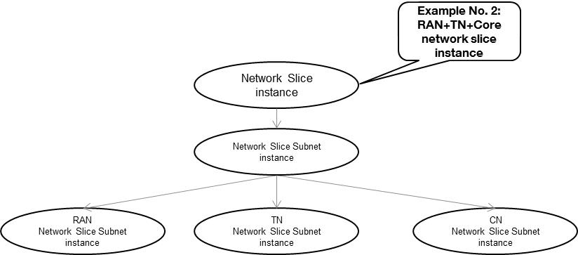
Figure A.4: RAN+TN+CN network slice subnets exposed as network slice
- network slice instances composed of a RAN network slice subnet instance + CN network slice subnet instance + IMS network slice subnet instance
- or more, as shown below..
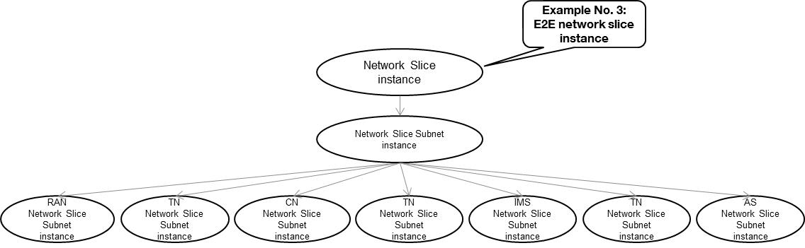
Figure A.5: RAN+TN+CN+TN+IMS+TN+AS network slice subnets exposed as network slice

Annex B (informative):
General information for network slice related identifiers
The following network slice related identifiers serve different purposes:
Identifier | Description
Identifiers for network slice management purpose
NetworkSlice identifier | To identify a NetworkSlice instance defined in TS 28.530 (see [4]), it is DN of a managed object instance of NetworkSlice IOC, see TS 28.541 [6]
NetworkSliceSubnet identifier | To identify a NetworkSliceSubnet instance defined in TS 28.530 (see [4]), it is DN of a managed object instance of NetworkSliceSubnet IOC, see TS 28.541 [6]
Identifiers for network slice signaling purpose
NSI ID | NSI ID is only for 5GC signaling use, i.e. to identify Core Network part of a Network Slice instance when multiple Network Slice instances of the same Network Slice are deployed, and there is a need to differentiate between them in the 5GC, see clause 3.1 of TS 23.501 [10]. The NRM attribute cNSIIdList of NRFFunction and NSSFFunction, see TS 28.541 [6], is a list for NSI ID(s).
S-NSSAI | To identify Network Slice defined in TS 23.501. Referred to TS 23.501 [10] and TS 38.300 [11]. NRM attribute sNSSAIList defines the S-NSSAI(s) supported by the corresponding managed object, see TS 28.541 [6].
PLMN ID | Represent PLMN identifier.

The NSI ID and S-NSSAI are configuration parameters of the management system.

Annex C (informative):
Plant UML source code

C.1 General
This annex contains the PlantUML source code for procedures defined in clause 7 of the present document.

C.2 Procedure of network slice instance allocation

@startuml

skinparam shadowing false
skinparam monochrome true
hide footbox

actor "NSMS_C" as NSMS_Consumer
participant "\tNSMS_P\t\t" as NSMS_Provider

alt NSMS_C sends AllocateNsi request
NSMS_Consumer -> NSMS_Provider: 1a-1. AllocateNsi(ServiceProfile) Request
NSMS_Provider -> NSMS_Provider: 1a-2. Creates NetworkSliceController MOI
NSMS_Provider --> NSMS_Consumer: 1a-3. AllocateNsi(ServiceProfileId) Response
NSMS_Provider --> NSMS_Consumer: 1a-4. notifyMOICreation(\n\tobjectClass=NetworkSliceController, \n\tobjectInstance=DN of NetworkSliceController MOI,...)
else NSMS_C sends createMOI request
NSMS_Consumer -> NSMS_Provider: 1b-1. createMOI(\n\t managedObjectClass=NetworkSliceController, \n\t attributeListIn=inputServiceProfile,...) Request
NSMS_Provider -> NSMS_Provider: 1b-2. Creates NetworkSliceController MOI
NSMS_Provider --> NSMS_Consumer: 1b-3. createMOI() Response
end alt

NSMS_Provider -> NSMS_Provider: 2. Decides to create a new NetworkSlice MOI\
\n\t or use an existing NetworkSlice MOI.

alt Using an existing NetworkSlice MOI
NSMS_Provider -> NSMS_Provider: 3a-1. Identifies the NetworkSlice MOI to re-use
NSMS_Provider -> NSMS_Provider: 3a-2. Configures NetworkSlice MOI with \n DN of NetworkSliceController MOI
NSMS_Provider -> NSMS_Provider: 3a-3. Configures NetworkSliceController MOI with \n DN of NetworkSlice MOI
opt If the existing NetworkSlice MOI needs to be modified
ref over NSMS_Provider
3a-4. Procedure of Network Slice Instance Modification
end ref
end opt

else Creating a new NetworkSlice MOI
NSMS_Provider -> NSMS_Provider: 3b-1. Derives the network slice subnet related requirements
ref over NSMS_Provider
3b-2. Procedure of Network Slice Subnet Instance Allocation
end ref
|||
NSMS_Provider -> NSMS_Provider: 3b-3. Creates NetworkSlice MOI and \n configures NetworkSlice MOI with \nDN of NetworkSliceController MOI and \nDN of NetworkSliceSubnet MOI
NSMS_Provider -> NSMS_Provider: 3b-4. Configures NetworkSliceController MOI with \n DN of NetworkSlice MOI

|||
end alt

NSMS_Provider -> NSMS_Provider: 4. Updates attributes of NetworkSliceController MOI\nindicating completion of the procedure

group Monitoring network slice allocation progress and result. \nThis can be happened anytime after step NetworkSliceController is created (i.e., step 1a-2 or step 1b-2)
alt obtain the progress and result by subscribe-notification method
NSMS_Provider -> NSMS_Consumer: 5a. Notify network slice allocation progress and result \n (DN of NetworkSliceController MOI and its attributes)
else obtain the progress and result by query method
NSMS_Consumer -> NSMS_Provider: 5b-1. Request to query the \n NetworkSliceController information (DN of NetworkSliceController)
NSMS_Provider -> NSMS_Consumer: 5b-2. Response with the NetworkSliceController \n information (DN of NetworkSliceController and values of its attribute)
end alt

@enduml

C.3 Procedure of Network Slice Subnet Instance Allocation
@startuml

skinparam shadowing false
skinparam monochrome true
hide footbox

actor "NSSMS_C" as NSSMS_Consumer
participant "NSSMS_P" as NSSMS_Provider

'alt CRUD operations not visible to the consumer
alt NSSMS_C sends AllocateNssi request
NSSMS_Consumer -> NSSMS_Provider: 1a-1. AllocateNssi(SliceProfile) Request
NSSMS_Provider -> NSSMS_Provider: 1a-2. Creates NetworkSliceSubnetController MOI
NSSMS_Provider --> NSSMS_Consumer: 1a-3. AllocateNssi(SliceProfileId) Response
NSSMS_Provider -> NSSMS_Consumer: 1a.4. notifyMOICreation(\n\tobjectClass=NetworkSliceSubnetController, \n\tobjectInstance=DN of NetworkSliceSubnetController MOI,...)
else NSSMS_C sends createMOI request
NSSMS_Consumer -> NSSMS_Provider: 1b-1. createMOI(\n\t managedObjectClass=NetworkSliceSubnetController, \n\t attributeListIn=inputSliceProfile,...) Request
NSSMS_Provider -> NSSMS_Provider: 1b-2. Creates NetworkSliceSubnetController MOI
NSSMS_Provider --> NSSMS_Consumer: 1b-3. createMOI() Response
end

ref over NSSMS_Provider
2. Procedure of feasibility check and reservation of network slice subnet
end ref

NSSMS_Provider -> NSSMS_Provider: 3. Decides to create a new NetworkSliceSubnet MOI\
\n\t or use an existing NetworkSliceSubnet MOI.

alt Using an existing NetworkSliceSubnet MOI
NSSMS_Provider -> NSSMS_Provider: 4a-1. Identifies the NetworkSliceSubnet MOI to re-use
|||
NSSMS_Provider -> NSSMS_Provider: 4a-2. Configures NetworkSliceSubnet MOI with DN of NetworkSliceSubnetController MOI
NSSMS_Provider -> NSSMS_Provider: 4a-3. Configures NetworkSliceSubnetController MOI with\nDN of NetworkSliceSubnet MOI

opt If the existing NetworkSliceSubnet MOI needs to be modified
|||
ref over NSSMS_Provider
4a-4. Procedure of Network Slice Subnet Instance Modification
end ref
end opt

else Using a new NetworkSliceSubnet MOI

NSSMS_Provider -> NSSMS_Provider: 4b-1. Creates an MOI of NetworkSliceSubnet and \nconfigures NetworkSliceSubnet MOI with DN of NetworkSliceSubnetController MOI

NSSMS_Provider -> NSSMS_Provider: 4b-2. Configures NetworkSliceSubnetController MOI with\nDN of NetworkSliceSubnet MOI

NSSMS_Provider -> NSSMS_Provider: 4b-3. Derives the requirements for corresponding\n network slice subnet constituent(s) and transport network
opt If the NetworkSliceSubnet MOI to be created contains virtualization part (i.e., VNF or VL)
|||
ref over NSSMS_Provider
4b-4. NS instantiation procedure
end ref
NSSMS_Provider -> NSSMS_Provider: 4b-5. Configures the NetworkSliceSubnet MOI attribute nsInfo
end opt
loop 4b-6. for each constituent NetworkSliceSubnet MOI
|||
ref over NSSMS_Provider
4b-6a. Procedure of Network Slice Subnet Instance Allocation
end ref
NSSMS_Provider -> NSSMS_Provider: 4b-6b. Configures the NetworkSliceSubnet MOI \n attribute networkSliceSubnetRef with the DN constituent NetworkSliceSubnet
end loop

loop 4b-7. for each constituent Network Function
|||
ref over NSSMS_Provider
4b-7a. \tProcedure of NF instance creation or
\t\tProcedure of NF instance modification
end ref
NSSMS_Provider -> NSSMS_Provider: 4b-7b. Configures the NetworkSliceSubnet MOI \n attribute managedFunctionRef with the DN constituent ManagedFunction
end loop

loop for each transport network requirements
|||
ref over NSSMS_Provider
4b-8. Procedure of TN coordination
supporting network slicing
|||
end ref
end loop
end alt

|||
NSSMS_Provider -> NSSMS_Provider: 5. Configures attributes of NetworkSliceSubnetController MOI\nindicating completion of the procedure

group Monitoring network slice subnet allocation progress and result. \nThis can be happened anytime after step NetworkSliceSubnetController is created (i.e., step 1a-2 or step 1b-2)
alt obtain the progress and result by subscribe-notification method
NSSMS_Provider -> NSSMS_Consumer: 6a. Notify network slice subnet allocation progress and result \n (DN of NetworkSliceSubnetController MOI and its attributes)
else obtain the progress and result by query method
NSSMS_Consumer -> NSSMS_Provider: 6b-1. Request to query the \n NetworkSliceSubnetController information (DN of NetworkSliceSubnetController MOI)
NSSMS_Provider -> NSSMS_Consumer: 6b-2. Response with the NetworkSliceSubnetController \n information (DN of NetworkSliceSubnetController MOI and values of its attribute)
end alt

@enduml

C.4 Procedure of Network Slice Instance Deallocation
@startuml

skinparam shadowing false
skinparam monochrome true
hide footbox

actor "NSMS_C" as NSMS_Consumer
participant "NSMS_P" as NSMS_Provider

alt NSMS_C sends DeallocateNsi request
NSMS_Consumer -> NSMS_Provider: 1a-1. DeallocateNsi(networkSliceDN, serviceProfileId) Request
NSMS_Provider -> NSMS_Provider: 1a-2. Identifies the DN of NetworkSlice MOI to be deleted.
NSMS_Provider -> NSMS_Provider: 1a-3. Updates NetworkSlice MOI to remove the \nreference to DN of NetworkSliceController
NSMS_Provider -> NSMS_Provider: 1a-4. Deletes NetworkSliceController MOI
NSMS_Provider --> NSMS_Consumer: 1a-5. DeallocateNsi() Response
else NSMS_C sends deleteMOI request
NSMS_Consumer -> NSMS_Provider: 1b-1. deleteMOI(baseObjectInstance=DN of NetworkSliceController) Request
NSMS_Provider -> NSMS_Provider: 1b-2. Identifies the DN of NetworkSlice MOI \nfrom the attribute networkSliceRef and \nvalue of attribute serviceProfileId from \nthe NetworkSliceController MOI to be deleted.
NSMS_Provider -> NSMS_Provider: 1b-3. Updates NetworkSlice MOI to remove the \nreference to DN of NetworkSliceController
NSMS_Provider -> NSMS_Provider: 1b-4. Deletes NetworkSliceController MOI
NSMS_Provider --> NSMS_Consumer: 1b-5. deleteMOI() Response
end

NSMS_Provider -> NSMS_Provider: 2. Decides to delete or modify NetworkSlice MOI

alt Delete NetworkSlice MOI identified in step 1b-2. \t

NSMS_Provider -> NSMS_Provider: 3a-1. Deletes NetworkSlice MOI
ref over NSMS_Provider
3a-2. Procedure of network slice subnet instance deallocation
end ref

else Modify NetworkSlice MOI identified in step 1b-2.
|||
ref over NSMS_Provider
3b-1. Procedure of Network Slice Subnet Instance Modification
end ref

NSMS_Provider -> NSMS_Provider: 3b-2. Modify NetworkSlice MOI
end

@enduml

C.5 Procedure of network slice subnet instance deallocation
@startuml

skinparam shadowing false
skinparam monochrome true
hide footbox

actor "NSSMS_C" as NSSMS_Consumer
participant "NSSMS_P" as NSSMS_Provider
'participant "NSSMS_Provider" as NSSMS_Consumer

alt NSSMS_C sends DeallocateNssi request
NSSMS_Consumer -> NSSMS_Provider: 1a-1. DeallocateNssi(networkSliceSubnetDN, sliceProfileId) Request
NSSMS_Provider -> NSSMS_Provider: 1a-2. Identifies the DN of NetworkSliceSubnet MOI to be deleted
NSSMS_Provider -> NSSMS_Provider: 1a-3. Updates NetworkSliceSubnet MOI attribute networkSliceSubnetControllerRef \n\tto remove DN of NetworkSliceSubnetController
NSSMS_Provider -> NSSMS_Provider: 1a-4. Deletes NetworkSliceSubnetController MOI
NSSMS_Provider --> NSSMS_Consumer: 1a-5. DeallocateNssi() Response
else NSSMS_C sends deleteMOI request
NSSMS_Consumer -> NSSMS_Provider: 1b-1. deleteMOI(baseObjectInstance=DN of NetworkSliceSubnetController) Request
NSSMS_Provider -> NSSMS_Provider: 1b-2. Identifies the DN of NetworkSliceSubnet MOI \nfrom the attribute networkSliceSubnetRef and \nvalue of attribute sliceProfileId from the \nNetworkSliceSubnetController MOI to be deleted
NSSMS_Provider -> NSSMS_Provider: 1b-3. Updates NetworkSliceSubnet MOI attribute networkSliceSubnetControllerRef \n\tto remove DN of NetworkSliceSubnetController
NSSMS_Provider -> NSSMS_Provider: 1b-4. Deletes NetworkSliceSubnetController MOI
NSSMS_Provider --> NSSMS_Consumer: 1b-5. deleteMOI() Response

end

NSSMS_Provider -> NSSMS_Provider: 2. Decides to delete or modify NetworkSliceSubnetSubnet MOI

alt 3a. Delete the NetworkSliceSubnetSubnet MOI identified in step 1b-2.
opt If the NetworkSliceSubnet MOI consists of constituent NetworkSliceSubnetSubnet MOIs
loop for each constituent NetworkSliceSubnetSubnet MOI
|||
ref over NSSMS_Provider
3a-1. Procedure of network slice subnet instance deallocation
end ref
end loop
end opt

opt If the NetworkSliceSubnet MOI consists of NFs
loop for each constituent ManagedFunction MOI
|||
ref over NSSMS_Provider
3a-2. Procedure of NF instance deletion or
\t\tProcedure of NF instance modification
end ref
end loop
end opt

opt If the NetworkSliceSubnet MOI contains TN part
|||
ref over NSSMS_Provider
3a-3. Procedure of TN coordination supporting network slicing
end ref
end opt

opt If the NetworkSliceSubnet MOI contains virtualized part
|||
ref over NSSMS_Provider
3a-4. NS Termination procedure
end ref
end opt

NSSMS_Provider -> NSSMS_Provider: 3a-5. Deletes NetworkSliceSubnet MOI
else 3b. Modify the NetworkSliceSubnetSubnet MOI identified in step 1b-2.
opt If the NetworkSliceSubnet MOI consists of constituent NetworkSliceSubnetSubnet MOIs
loop for each constituent NetworkSliceSubnetSubnet MOI
|||
ref over NSSMS_Provider
3b-1. Procedure of network slice subnet instance modification
end ref
end loop
end opt

NSSMS_Provider -> NSSMS_Provider: 3b-2. Modifies NetworkSliceSubnet MOI
end

@enduml

C.6 Procedure of Network Slice Instance Modification
@startuml

skinparam shadowing false
skinparam monochrome true
hide footbox

actor "NSMS_C" as NSMS_Consumer
participant "NSMS_P" as NSMS_Provider

alt NSMS_C sends new network slice related requirements in NetworkSlice MOI
NSMS_Consumer -> NSMS_Provider: 1a. modifyMOIAttributes(\n\t baseObjectInstance=NetworkSlice, \n\t modificationList=serviceProfileList,...) request
else NSMS_C sends new network slice related \n requirements in inputServiceProfile
NSMS_Consumer -> NSMS_Provider: 1b-1. modifyMOIAttributes(\n\t baseObjectInstance=NetworkSliceController, \n\t modificationList=inputServiceProfile,...) request
NSMS_Provider -> NSMS_Provider: 1b-2. Updates NetworkSliceController MOI attributes\n with new inputServiceProfile along with progress and state information.
NSMS_Consumer <-- NSMS_Provider: 1b-3. modifyMOIAttributes(modificationListOut=...) response
end alt

ref over NSMS_Provider
2. Procedure of feasibility check and reservation of network slice
end ref

NSMS_Provider -> NSMS_Provider: 3. Decomposes the request to network slice subnet requirements.
ref over NSMS_Provider
4. Procedure of network slice subnet instance modification
end ref

NSMS_Provider -> NSMS_Provider: 5. Updates NetworkSlice MOI attributes (serviceProfileList)
opt if NSMS_C sent new network slice related requirements in NetworkSlice MOI (in step 1a)
Note over NSMS_Provider: NSMS_P sends response for modifyMOIAttributes request received in step 1a.
NSMS_Consumer <-- NSMS_Provider: 6a. modifyMOIAttributes(modificationListOut=...) response
else if NSMS_C sent new network slice related requirements in NetworkSliceController MOI (in step 1b-1)
NSMS_Provider -> NSMS_Provider: 6b. Updates attributes of NetworkSliceController MOI \nindicating completion of the procedure
end opt
@enduml

C.7 Procedure of Network Slice Subnet Instance Modification
@startuml

skinparam shadowing false
skinparam monochrome true
hide footbox

actor "NSSMS_C" as NSSMS_Consumer
participant "NSSMS_P" as NSSMS_Provider

alt NSSMS_C sends new network slice subnet related requirements in NetworkSliceSubnet MOI
NSSMS_Consumer -> NSSMS_Provider: 1a. modifyMOIAttributes(\n\t baseObjectInstance=NetworkSliceSubnet, \n\t modificationList=sliceProfileList,...) request
else NSSMS_C sends new network slice subnet related requirements in NetworkSliceSubnetController MOI
NSSMS_Consumer -> NSSMS_Provider: 1b-1. modifyMOIAttributes(\n\t baseObjectInstance=NetworkSliceSubnetController, \n\t modificationList=inputSliceProfile,...) request
NSSMS_Provider -> NSSMS_Provider: 1b-2. Updates NetworkSliceSubnetController MOI attributes\n with new inputSliceProfile along with progress and state information.
NSSMS_Consumer <-- NSSMS_Provider: 1b-3. modifyMOIAttributes(modificationListOut=...) response
end alt

ref over NSSMS_Provider
2. Procedure of feasibility check and reservation of network slice subnet
end ref

NSSMS_Provider -> NSSMS_Provider: 3. Decomposes the modification request for each constituent MOIs.

loop for each constituent NetworkSliceSubnet MOIs
|||
ref over NSSMS_Provider
4a. Procedure of network slice subnet instance modification
end ref
end loop
loop for each constituent ManagedFunction MOIs
|||
ref over NSSMS_Provider
4b. Procedure of NF instance creation or
\t\tProcedure of NF instance modification
end ref
end loop
opt The NSSI contains virtualized parts
|||
ref over NSSMS_Provider
4c. NS instance scaling/updating/instantiation
procedures
end ref
end opt
opt The NSSI contains TN parts
'|||
ref over NSSMS_Provider
4d. Procedure of TN coordination
supporting network slicing
end ref
end opt

NSSMS_Provider -> NSSMS_Provider: 5. Updates NetworkSliceSubnet MOI attributes

opt if NSSMS_C sent new network slice related requirements in NetworkSliceSubnet MOI (in step 1a)
Note over NSSMS_Provider: NSSMS_P sends response for modifyMOIAttributes request received in step 1a.
NSSMS_Consumer <-- NSSMS_Provider: 6a. modifyMOIAttributes(modificationListOut=...) response
else if NSSMS_C sent new network slice related requirements in NetworkSliceSubnetController MOI (in step 1b-1)
NSSMS_Provider -> NSSMS_Provider: 6b. Updates attributes of NetworkSliceSubnetController MOI \nindicating completion of the procedure
end opt

@enduml

Annex D (informative):
Change history
Change history
Date | Meeting | TDoc | CR | Rev | Cat | Subject/Comment | New version
2018-09 | SA#81 |  |  |  |  | Upgrade to change control version | 15.0.0
2018-12 | SA#82 | SP-181043 | 0001 | 1 | F | Complete the reference information and reword the note | 15.1.0
2018-12 | SA#82 | SP-181043 | 0002 | - | F | Update operation names in the procedures of NSI provisioning | 15.1.0
2018-12 | SA#82 | SP-181043 | 0003 | - | F | Update operation names in the procedures of NSSI provisioning | 15.1.0
2018-12 | SA#82 | SP-181043 | 0004 | 1 | F | Update operation names in the procedures of NF provisioning | 15.1.0
2018-12 | SA#82 | SP-181043 | 0005 | 1 | F | Remove release specific information from clause 7.9.1 | 15.1.0
2018-12 | SA#82 | SP-181043 | 0006 | 1 | F | Correct procedures with reference to TS 28.541 | 15.1.0
2018-12 | SA#82 | SP-181043 | 0009 | 1 | B | Add Network slice subnet management use case with assigned priority | 15.1.0
2018-12 | SA#82 | SP-181043 | 0010 | 2 | B | Add network slice management interactions with NFV MANO for network service priority | 15.1.0
2018-12 | SA#82 | SP-181044 | 0011 | 2 | D | Implement minor corrections | 16.0.0
2019-03 | SA#83 | SP-190123 | 0013 | - | A | Update management services tables | 16.1.0
2019-03 | SA#83 | SP-190123 | 0015 | - | A | Correction on procedure of Network Slice Subnet Instance Deallocation | 16.1.0
2019-03 | SA#83 | SP-190123 | 0017 | 1 | A | Correct management service term | 16.1.0
2019-05 | SA#84 | SP-190370 | 0019 | 1 | A | Editor's change for configuration management service | 16.2.0
2019-09 | SA#85 | SP-190754 | 0022 | - | A | Update the incorrect reference | 16.3.0
2019-09 | SA#85 | SP-190750 | 0024 | 1 | B | Add informative annex to describe a network slice journey | 16.3.0
2019-09 | SA#85 | SP-190754 | 0026 | 1 | A | Add the identifier description | 16.3.0
2019-09 | SA#85 | SP-190742 | 0028 | 1 | A | Fix inconsistencies related to service requirements | 16.3.0
2019-12 | SA#86 | SP-191175 | 0032 | 1 | A | Fix inconsistencies in feasibility check use cases and requirements | 16.4.0
2019-12 | SA#86 | SP-191159 | 0033 | 1 | F | Clean up for incosistence | 16.4.0
2020-03 | SA#87E | SP-200166 | 0039 | - | F | Replace occurences of Management Function by Management Service | 16.5.0
2020-07 | SA#88-e | SP-200498 | 0044 | 1 | A | Fix Network Slice subnet termination use case | 16.6.0
2020-07 | SA#88-e | SP-200484 | 0045 | 1 | F | Fix NSI activation and deactivation use cases | 16.6.0
2020-07 | SA#88-e | SP-200484 | 0047 | 1 | F | Clarification on network slice related identifiers | 16.6.0
2020-09 | SA#89-e | SP-200724 | 0053 | 1 | F | Editorial corrections to remove redundant text from use cases | 16.7.0
2020-09 | SA#89-e | SP-200735 | 0056 | - | A | Add clarifying note to ServiceProfile | 16.7.0
2020-09 | SA#89-e | SP-200724 | 0057 | - | F | Fix general information of network slice related identifiers | 16.7.0
2020-12 | SA#90e | SP-201053 | 0058 | 1 | F | Move service profile definition to 28530 | 16.8.0
2020-12 | SA#90e | SP-201050 | 0059 | 1 | F | Correction of allocateNsi operations and procedures | 16.8.0
2021-03 | SA#91e | SP-210146 | 0060 | - | F | Correction of URI of Resource | 16.9.0
2021-03 | SA#91e | SP-210146 | 0061 | 1 | F | Correction of NSI and NSSI Operations | 16.9.0
2021-06 | SA#92e | SP-210417 | 0064 | 1 | A | Clarify misleading information in network slicing use cases | 16.10.0
2021-06 | SA#92e | SP-210401 | 0065 | 1 | F | Add reference to EP_transport for transport network requirements | 17.0.0
2021-06 | SA#92e | SP-210410 | 0066 | 1 | B | Add the SLA management related requirements and procedure | 17.0.0
2021-09 | SA#93e | SP-210881 | 0069 | 1 | A | Correction of network slice subnet configuration | 17.1.0
2021-09 | SA#93e | SP-210885 | 0071 | 1 | A | Updating NSSI deallocation | 17.1.0
2021-09 | SA#93e | SP-210885 | 0074 | 1 | A | Updating NSSI deactivation | 17.1.0
2021-09 | SA#93e | SP-210881 | 0076 | - | A | Removing network slice capacity planning | 17.1.0
2021-09 | SA#93e | SP-210881 | 0079 | - | A | Removing Notify Network Slice Subnet Capability Information | 17.1.0
2021-09 | SA#93e | SP-210885 | 0080 | 1 | A | Updating NSSI allocation | 17.1.0
2021-12 | SA#94e | SP-211454 | 0087 | 1 | A | Technical errors in use case descriptions | 17.2.0
2021-12 | SA#94e | SP-211455 | 0088 | 1 | C | Fixing NetworkSlice and NetworkSliceSubnet Allocation and Deallocation Stage 2 | 17.2.0
2021-12 | SA#94e | SP-211466 | 0098 | 1 | B | Modification of network slice related requirements | 17.2.0
2022-03 | SA#95e | SP-220178 | 0099 | - | F | Update procedure of network slice subnet instance allocation | 17.3.0
2022-03 | SA#95e | SP-220178 | 0104 | 1 | F | Fixing Network slice and network slice subnet provisioning management service - profiles not convert to IOC - Stage 3 | 17.3.0
2022-06 | SA#96 | SP-220499 | 0106 | - | B | Update procedure of reservation and checking feasibility of network slice subnet | 17.4.0
2022-06 | SA#96 | SP-220499 | 0107 | 1 | B | Update procedure of reservation and checking feasibility of network slice | 17.4.0
2022-06 | SA#96 | SP-220499 | 0108 | - | F | Deleting network slice capability exposure | 17.4.0
2022-06 | SA#96 | SP-220499 | 0110 | 1 | C | Network slice subnet capabilities | 17.4.0
2022-06 | SA#96 | SP-220499 | 0113 | 1 | B | Adding procedure for network service priority management | 17.4.0
2022-06 | SA#96 | SP-220499 | 0114 | - | B | Update procedure of reservation and checking feasibility of network slice subnet | 17.4.0
2022-06 | SA#96 | SP-220499 | 0115 | 1 | B | Update operations of deallocateNsi, deallocateNssi | 17.4.0
2022-09 | SA#97e | SP-220849 | 0122 | 1 | F | Deleting capacity planning use case | 17.5.0
2022-09 | SA#97e | SP-220849 | 0125 | 1 | F | Update feasibility check procedure to align with FeasibilityCheckAndReservationJob | 17.5.0
2022-09 | SA#97e | SP-220857 | 0131 | 1 | A | Remove example from network slice subnet instance modification | 17.5.0
2022-09 | SA#97e | SP-220857 | 0133 | 1 | A | Remove example from network slice instance modification | 17.5.0
2022-09 | SA#97e | SP-2220853 | 0135 | 1 | A | Correct roles in network slice subnet allocation use case | 17.5.0
2022-09 | SA#97e | SP-220849 | 0139 | 1 | F | Clarify translation in network slice allocation use case | 17.5.0
2022-09 | SA#97e | SP-220856 | 0118 | 1 | F | Update procedures for modification of Network Slice and Network Slice Subnet MOIs | 18.0.0
2022-09 | SA#97e | SP-220856 | 0120 | - | F | Removal of redundant network slice modification use case | 18.0.0
2022-09 | SA#97e | SP-220856 | 0121 | - | B | Add provisioning procedure for slice activation and deactivation using adminsitrative state | 18.0.0
2022-09 | SA#97e | SP-220856 | 0124 | 1 | C | Fixing provisioning data reporting service | 18.0.0
2022-12 | SA#98e | SP-221173 | 0149 | 1 | A | Correct vocabulary | 18.1.0
2022-12 | SA#98e | SP-221177 | 0150 | 2 | F | Fixing provisioning data reporting service | 18.1.0
2022-12 | SA#98e | SP-221177 | 0153 | 1 | C | Deleting allocate network | 18.1.0
2022-12 | SA#98e | SP-221167 | 0154 | 1 | A | Add missing use case and requirement for capability class | 18.1.0
2022-12 | SA#98e | SP-221178 | 0159 | 1 | A | Clarification and update of deallocation use case | 18.1.0
2023-06 | SA#100 | SP-230671 | 0170 | 3 | A | Clarify network slicing provisioning use case | 18.2.0
2023-06 | SA#100 | SP-230653 | 0173 | 1 | B | Update Procedure of Network Slice Instance Allocation to support asynchronous operations | 18.2.0
2023-06 | SA#100 | SP-230653 | 0174 | 1 | B | Update Procedure of Network Slice Instance Deallocation to support asynchronous operations | 18.2.0
2023-06 | SA#100 | SP-230653 | 0175 | 1 | B | Update Procedure of Network Slice Instance Modification to support asynchronous operations | 18.2.0
2023-06 | SA#100 | SP-230653 | 0176 | 1 | B | Update Procedure of Network Slice Subnet Instance Allocation to support asynchronous operations | 18.2.0
2023-06 | SA#100 | SP-230653 | 0177 | 1 | B | Update Procedure of network slice subnet instance deallocation to support asynchronous operations | 18.2.0
2023-06 | SA#100 | SP-230653 | 0178 | 1 | B | Update Procedure of Network Slice Subnet Instance Modification to support asynchronous operations | 18.2.0
2023-06 | SA#100 | SP-230649 | 0180 | 1 | A | Align figure with description in Procedure of NF instance creation | 18.2.0
2023-06 | SA#100 | SP-230649 | 0182 | - | A | Align figure with description in Procedure of NF instance deletion | 18.2.0
2023-06 | SA#100 | SP-230649 | 0184 | - | A | Align figure with description in Procedure of NF instance modification | 18.2.0
2023-06 | SA#100 | SP-230651 | 0188 | - | F | Several editorial Corrections | 18.2.0
2023-09 | SA#101 | SP-230953 | 0190 | - | A | Update reference to GST | 18.3.0
2023-09 | SA#101 | SP-230956 | 0191 | - | B | Add UML source code for Network Slice LCM procedures | 18.3.0
2023-09 | SA#101 | SP-230956 | 0192 | 1 | B | Fix MnS for network slice provisioning information | 18.3.0
2023-09 | SA#101 | SP-230956 | 0193 | 1 | B | Fix MnS for network slice subnet provisioning information | 18.3.0
2023-09 | SA#101 | SP-230944 | 0199 | - | A | Correct the description of network slice subnet instance | 18.3.0
2023-09 | SA#101 | SP-230940 | 0208 | - | A | Fix wrong clause reference | 18.3.0
2023-09 | SA#101 | SP-230968 | 0209 | 1 | F | Add the interactions with NFV-MANO in NF instance creation procedure | 18.3.0
2023-09 | SA#101 | SP-230968 | 0210 | 1 | F | Add the interactions with NFV-MANO in NF instance deletion procedure | 18.3.0
2023-09 | SA#101 | SP-230968 | 0211 | 1 | F | Update the reference information in clause 7.17 | 18.3.0
2023-12 | SA#102 | SP-231494 | 0218 | 1 | F | Update procedure of feasibility check and reservation of NSI and NSSI to align with FeasibilityCheckAndReservationJob | 18.4.0
2023-12 | SA#102 | SP-231494 | 0219 | 1 | F | Clarify initiation of Procedure of Network Slice Instance Deallocation | 18.4.0
2023-12 | SA#102 | SP-231494 | 0220 | 1 | F | Clarify initiation of Procedure of network slice subnet instance deallocation | 18.4.0
2023-12 | SA#102 | SP-231494 | 0221 | 1 | F | Clarify initiation of Procedure of Network Slice Instance Modification | 18.4.0
2023-12 | SA#102 | SP-231494 | 0222 | 1 | F | Clarify initiation of Procedure of Network Slice Subnet Instance Modification | 18.4.0
2023-12 | SA#102 | SP-231494 | 0223 | - | F | Corrections to description of Procedure of Network Slice Instance and Network Slice Subnet Instance allocations | 18.4.0
2023-12 | SA#102 | SP-231479 | 0224 | 1 | F | Update the scope of TS 28.531 | 18.4.0
2023-12 | SA#102 | SP-231479 | 0225 | 4 | F | Update the description about the procedure of NF instance creation | 18.4.0
2023-12 | SA#102 | SP-231479 | 0227 | 2 | F | Add the introduction for the procedure of NF instance modification | 18.4.0
2023-12 | SA#102 | SP-231469 | 0228 | 1 | F | Correct the description of Procedure of Network Slice Instance allocation | 18.4.0
2023-12 | SA#102 | SP-231481 | 0230 | 1 | B | Update use case and allocate for network slice isolation | 18.4.0
2023-12 | SA#102 | SP-231479 | 0231 | 1 | F | Update references from TS 28.526 to ETSI NFV IFA 013 | 18.4.0
2024-03 | SA#103 | SP-240186 | 0232 | 1 | F | Rel-18 CR TS 28.531 Add references to component table 6.3 | 18.5.0

