3GPP TSG-SA5 Meeting #136e S5-212244

e-meeting, 1 – 10 March 2021

Source: Nokia, Nokia Shanghai Bell, TELEFONICA S.A.

Title: TD clarify roles related to network slice management

Document for: Discussion and Endorsement
Agenda Item: 6.3

1 Decision/action requested
Please discuss and endorse

2 References
[1] 3GPP TS 28.530: "Management and orchestration; Concepts, use cases and requirements".

3 Rationale
There are a bounch of services and roles defined and used in existing specificaiton, but the difference of the services and demarcation point/boundary of the roles are very unclear that caused confusion and misleading.
Observation 1:
There are many services defined and used in the TS 28.530 and other specificaitons, e.g. communication service, connectivity service, network service, network slice as a service, etc., however, the differnece and relationship between those services is still unclear, especially between communication service and network slice as a service. Some delegates thought Network Slice as a Service is a type of Communication Service, and some thought NSaaS is different to Communication Service. Further discussion and agreement are needed.
Observation 2:
There’s no defintion for actor, neither reference for actor defintion but use in use cases. In addition in the use cases and other clauses. e.g. in sentence “A Network Operator (NOP) plays the role of a Network Slice Provider (NSP)” extracted from use cases ( clause 5.4 of TS 28.530), it’s described as “one role” plays another role, that was confusion in either pure english perspective or based on role definition in some wellknow specification. E.g. as extracted below from UML:
An Actor specifies a role played by a user or any other system that interacts with the subject
An actor is behaviored classifier which specifies a role played by an external entity that interacts with the subject.
The term "role" is used informally as some type, group or particular facet of users that require specific services from the subject modeled with associated use cases. When an external entity interacts with the subject, it plays the role of a specific actor. That single physical entity may play several different roles, and a specific role may be played by single or multiple different instances.
It’s always user or any other system or external entity or stakehoder plays role instead of one role plays another role

Observation 3:
There are a plenty of roles defined and used in TS 28.530 and 28.531, but the demarcation point/boundary between roles are not clear. E.g. in clause 4.8 of TS 28.530, it clear described NOP role Designs, builds and operates networks and provides related services, including network services and network slices, while CSP role Provides communication services. Designs, builds and operates its communication services. However, in other clauses of TS 28.530, e.g. clause 4.1.6, it’s CSP role provides network slice as a service.
Observation 4:
NOP role is a bit confusion. All other roles defined in 4.8 of 28.530 were named as “xSP” (e.g. DCSP, VISP, CSP) except for NOP, although all other xSP also have function/purpose of “operating”. E.g. CSP could also Designs, builds and operates its communication services, VISP could Designs, builds and operates its virtualization infrastructure(s), DSP could Designs, builds and operates its data centres

4 Detailed proposal
- Proposal 1: Based on observation 4, to align with other role defintions, rename Network Operator (NOP) role to Network Service/Slice Provider (NSP) role which could design, build and operate networks and provides related services, including network services and network slices. Optionally, explicitly add Network Service/Slice Customer (NSC) role in the definition and figure .
Note: CSP and NSP can be client of NSP, so maybe explicitly definition of NSC role is not needed. This can be decided in conrecte CR for role definition update.
Note: the impacted part of Figure 4.8.1: High-level model of roles of 28.530 will be looked as following (only show the impacted part in conceptual view for simplicity):
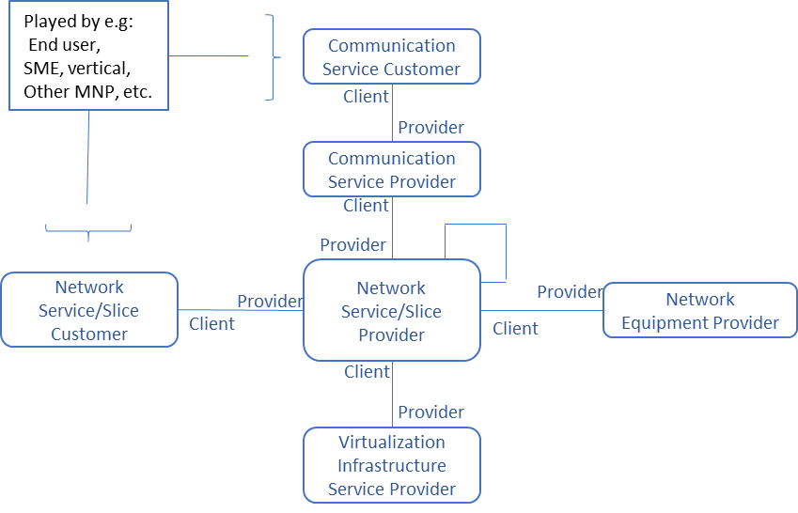
- Proposal 2: Based on observation 2&3, clearly separate resposbilities/functinaliies of each role and avoid any overlapping between roles, while a single enity or user or system or stakehoder could play multiple roles.
Note 1: role can be defined as:
Role represents responsibilities and capabilities of an organization (or legal enity) or person.
The roles related to 5G networks and network slicing management include CSC, CSP, NSSP, NSSC (optional), VISP, NEP, DCSP, etc.
Note 2: suggest to add some informative examples of entity (or user, system stakehoder), and example roles the enity could play

e.g. the entity could be (Mobile) Network Operator (MNP/NOP) who can play roles of CSP, NSP, NSC, etc., or the enitty could be vertical/enterprise who can play role of CSP, CSC, etc.
- Proposal 3: Based on obeservation 2, fix sentences described as “one role plays another role” in 28.530, e.g. in the table of use cases (e.g. 5.4 of 28.530),
Please endorse the proposals 1-3

