3GPP TSG SA WG5 Meeting 136-e S5-212206

electronic meeting, online, 1 - 9 March 2021

Source: Huawei, China Mobile, China Telecom，China Unicom

Title: Add autonomous network level for RAN UE throughput optimization

Document for: Approval
Agenda Item: 6.4.9

1 Decision/action requested
The group is asked to discuss and approval.

2 References
[1] 3GPP draft TS 28.100: “Levels of autonomous network v0.3.0”.

3 Rationale
This contribution proposes to add use case of autonomous network level for the RAN UE throughput optimization

4 Detailed proposal
It proposes to make the following changes to TS 28.100[1].
1st Change

6.4.X Autonomous network level for RAN UE throughput optimization

6.4.X.1 Introduction
RAN UE throughput is a key performance for radio network, and, numerous radio feature parameters with broad value ranges affect the RAN UE throughput. There are many radio feature parameters of RAN NE level or cell level, for examples, MLB related parameters, resource schedule related parameters, cell reselection related parameters, handover related parameters, different radio feature parameters affect each other and the combination number of various parameter values is large. cTherefore, it’s complex to adjust radio feature configuration parameters to achieve the optimized RAN UE throughput. So introducing the autonomous network level for RAN UE throughput optimization will be benefit for operator to achieve the full autonomy goal step by step and have clear view on which typical issues can be addressed by utilizing autonomy mechanism in corresponding steps. The requirements for each autonomous level for RAN UE throughput optimization are different.

6.4.X.2 Workflow
Following are the entire workflow for the RAN UE throughput optimization:
Intent handling:
- Task A: RAN UE throughput optimization policies generation and determination. The tasks of generating and determining the RAN UE throughput optimization related policies (e.g., RAN UE throughput issue identification policies, RAN UE throughput analysis policies and RAN UE throughput parameters adjustment policies) based on received RAN UE throughput optimization intent (e.g. RAN UE throughput targets(e.g. low RAN UE throughput ratio, target average RAN UE throughput) for the specified areas).
- Task B: RAN UE throughput optimization intent fulfilment evaluation. The tasks of evaluating RAN UE throughput optimization intent fulfilment information (e.g. corresponding RAN UE throughput targets are satisfied or not).
Awareness:
- Task C: RAN UE throughput related information collection. The tasks of collecting RAN UE throughput related data, including RAN UE throughput performance data (e.g., AverageUL/ DL UE throughput in gNB, Distribution of UL/DL UE throughput in gNB ), RAN UE throughput configuration data (e.g., cellIndividualOffset, isHOAllowed and isMLBAllowed of corresponding NRCellRelation(s)) and environment data (e.g. electronic map)).
Analysis:
- Task D: RAN UE throughput issues identification. The tasks of analysing the RAN UE throughput performance (e.g. geographical grid based RAN UE throughput performance) and identifying the RAN UE throughput issues (e.g. low average RAN UE throughput, large number of UEs with low RAN UE throughput) and corresponding location.
- Task E: RAN UE throughput deterioration prediction. The tasks of analysing current RAN UE performance and historical RAN UE throughput performance, predicting the RAN UE throughput performance trend in the future and identifying potential RAN UE throughput performance deterioration in advance.
- Task F: RAN UE throughput issue analysis. The tasks of analysing the root cause (e.g. unbalanced load between different cells, frequently handover among several cells) of the identified or predicted RAN UE throughput issues.
- Task G: RAN UE throughput adjustment solutions generation. The tasks of generating the recommended RAN UE throughput adjustment solution (e.g. reconfigure the NRCellRelation IOC and DMROFunction IOC of corresponding RAN NEs) which can address the identified or predicted RAN UE throughput issues.
Decision:
- Task H: RAN UE throughput adjustment solutions evaluation and determination. The tasks of evaluating the recommended RAN UE throughput adjustment solutions, and deciding the RAN UE throughput adjustment solutions to be executed.
Execution:
- Task I: RAN UE throughput adjustment solutions execution. The tasks of adjusting and configuring the RAN UE throughput related parameters (e.g. cellIndividualOffset, isHOAllowed and isMLBAllowed of corresponding NRCellRelation(s), maximumDeviationHoTrigger of corresponding DMROFunction).

6.4.X.3 Classification of autonomous network level
Editor’s note: following classification of autonomous network level needs to be revised based on the discussion of the framework approach for evaluating autonomous network level in clause 5.
Level 0:
- All the tasks in the RAN UE throughput optimization workflow (Task A, Task B, Task C, Task D, Task E, Task F, Task G, Task H, Task I) are accomplished by human.
Level 1:
- Telecom system executes the tasks of RAN UE throughput adjustment solutions execution based on the specified RAN UE throughput related parameters (Task I). Telecom system also can execute the tasks of RAN UE throughput related information collection based on the specified collection rule (Task C). At this level, telecom system can assist human to improve the execution and awareness efficiency for RAN UE throughput optimization.
- All the other tasks in the RAN UE throughput optimization workflow (Task A, Task B, Task D, Task E, Task F, Task G, Task H) are accomplished by human.
Level 2:
- Compared to Level 1, telecom system additionally executes the tasks of RAN UE throughput issues identification, RAN UE throughput issue analysis based on the specified RAN UE throughput issue identification and analysis rule (Task D, Task F). At this level, telecom system can assist human to achieve the closed loop for RAN UE throughput optimization based on human defined rules.
- All the other tasks in the RAN UE throughput optimization workflow (Task A, Task B, Task E, Task G, Task H) are accomplished by human.
Level 3:
- Compared to Level 2, telecom system additionally executes the tasks of RAN UE throughput adjustment solutions generation (Task G) and RAN UE throughput adjustment solutions evaluation and determination (Task H) based on the specified RAN UE throughput adjustment policies and evaluation policies. At this level, the telecom system can achieve the closed loop automation for RAN UE throughput optimization based on the human defined optimization policies.
- All the other tasks in the RAN UE throughput optimization workflow (Task A, Task B, Task E) are accomplished by human.
Level 4:
- Compared to Level 3, the telecom system additionally executes the tasks of RAN UE throughput deterioration prediction (Task E), RAN UE throughput optimization policies determination (Task A), and RAN UE throughput optimization intent evaluation (Task B) based on received RAN UE throughput optimization intent and intent translation/evaluation policies. At this level, telecom system can achieve the intent driven closed loop automation for RAN UE throughput optimization based on human defined intent translation and evaluation policies
- The intent translation and evaluation policies maybe pre-defined and specified by human to assist the telecom system.
Level 5:
- Telecom system can autonomously execute the entire workflow of RAN UE throughput optimization for all scenarios, which means the telecom system can achieve the full autonomy for RAN UE throughput optimization for full scenarios.
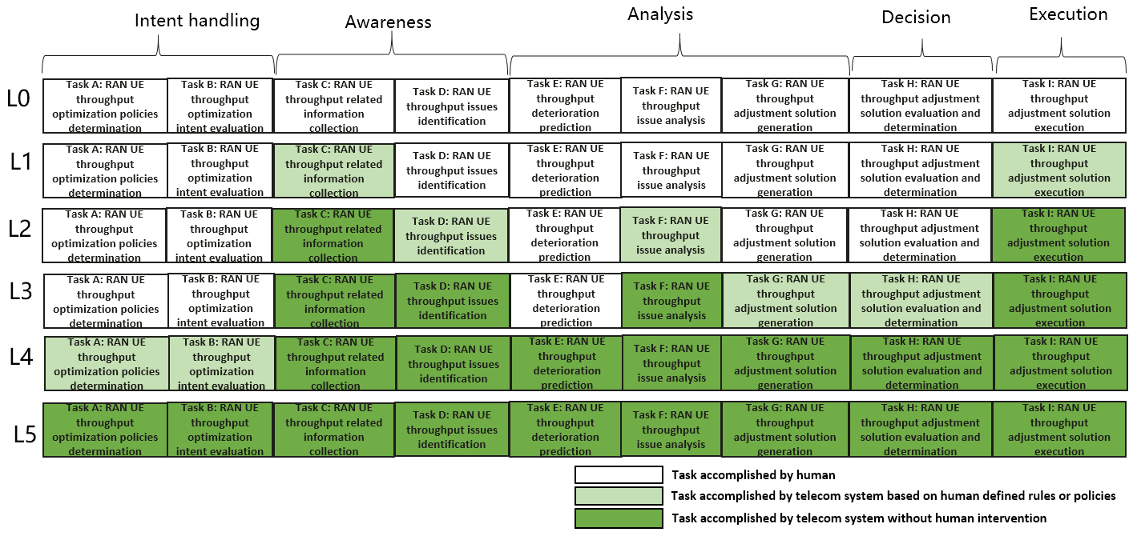
Figure 6.4.X.3-1 Classification of autonomous network level for RAN UE throughput optimization

End of changes

