3GPP TSG SA WG5 Meeting 136-e S5-212205

electronic meeting, online, 1 - 9 March 2021

Source: Huawei, China Mobile, China Telecom，China Unicom

Title: Add autonomous network level for RAN NE deployment

Document for: Approval
Agenda Item: 6.4.9

1 Decision/action requested
The group is asked to discuss and approval.

2 References
[1] 3GPP draft TS 28.100: “Levels of autonomous network v0.3.0”.
[2] 3GPP TR 28.810: “Study on concept, requirements and solutions for levels of autonomous network v17.0.0”

3 Rationale
RAN NE provisioning use case example for classification of network autonomy is described in TS 28.810[2], this contribution proposes to add autonomous network level for the RAN NE deployment.

4 Detailed proposal
It proposes to make the following changes to TS 28.100[1].
1st Change

6.2.X Autonomous network level for RAN NE deployment

6.2.X.1 Introduction
RAN NE deployment use case refers to the entire workflow of deploying an RAN NE, full autonomy of RAN NE deployment can help the network operator to reduce OPEX by reducing manual involvement in such tasks. However, full autonomy of RAN NE deployment is a long term goal, it will be beneficial for operator to achieve this goal step by step and have clear view on which typical issues can be addressed by utilizing network autonomy mechanisms in corresponding steps. The requirements for each autonomous level for RAN NE deployment are different.

6.2.X.2 Workflow
Following are the entire workflow for RAN NE deployment:
Intent handling:
- Task A: RAN NE deployment policy generation based on received RAN NE deployment intent. The tasks of generating and determining the RAN NE deployment related policies (e.g. RAN NE configuration data generation policies, RAN NE commissioning polices, RAN NE dialling test policies)
- Task B: RAN NE deployment intent evaluation, the tasks of evaluating RAN NE deployment fulfilment information (e.g. satisfied or not)
Awareness:
- Task C: RAN NE connection and hardware information collection, the tasks of connecting the RAN NE to the management system (including NE acquire its IP address and corresponding management system IP address) and collecting the RAN NE information (e.g. hardware information).
Analysis:
- Task D: RAN NE configuration data analysis, the tasks of analysing and generating the recommended network configuration data for the RAN NE based on the network planning data for the RAN NE and hardware information collected.
- Task E: RAN NE commissioning test, the tasks of performing the RAN NE commissioning test to put RAN NE into service (e.g. ensure the software and configuration (including radio configuration and transport configuration) is correct, and alarms are cleared).
- Task F: RAN NE dialing test, the tasks of performing the RAN NE dialing test to check whether RAN NE services are normal by testing whether the communication can be established between two subscribers.
Decision:
- Task G: RAN NE configuration data determination, the tasks of evaluating and determining the RAN NE configuration data to be download and activiated.
Execution:
- Task H: RAN NE configuration data and software download and activation, the tasks of downloading and activating network configuration data and software in RAN NE.

6.2.X.3 Classification of autonomous network level
Editor’s note: following classification of autonomous network level needs to be revised based on the discussion of the framework approach for evaluating autonomous network level in clause 5.
Level 0:
- All the tasks in the RAN NE deployment workflow (Task A, Task B, Task C, Task D, Task E, Task F, Task G, Task H) are accomplished by human.
Level 1:
- Telecom system executes tasks of downloading and activating the available RAN NE network configuration data and software prepared by human (Task H).
- All the other tasks in the RAN NE deployment workflow (Task A, Task B, Task C, Task D, Task E, Task F, Task G) are accomplished by human.
Level 2:
- Compared to Level 1, telecom system additionally executes the tasks of RAN NE connection and hardware information collection (Task C). Telecom system also can execute the tasks of analysing the network configuration data for the RAN NE based on the network configuration data generation rules (e.g. configuration template) specified by human(Task D).
- All the other tasks in the RAN NE deployment workflow (Task A, Task B, Task E, Task F, Task G) are accomplished by human.
Level 3:
- Compared to Level 2, the telecom system additionally executes tasks of analysing and determining the network configuration data for the RAN NE based on the network configuration data generation policies specified by human (Task D, Task G). Telecom system also can executes tasks of performing the RAN NE commissioning test based on commissioning policies specified by human (Task E), and tasks of performing the RAN NE dialing test based on dialing test policies specified by human(Task F).
- All the other tasks in the RAN NE deployment workflow (Task A, Task B) are accomplished by human.
Level 4:
- Compared to Level 3, the telecom system can additionally execute the tasks of RAN NE deployment policy generation (Task A) and RAN NE deployment intent evaluation (Task B) based on intent handling policies specified by human.
- The intent handling policies maybe pre-defined and specified by human.
Level 5:
- Telecom system can autonomously execute the entire workflow of RAN NE deployment for all scenarios,

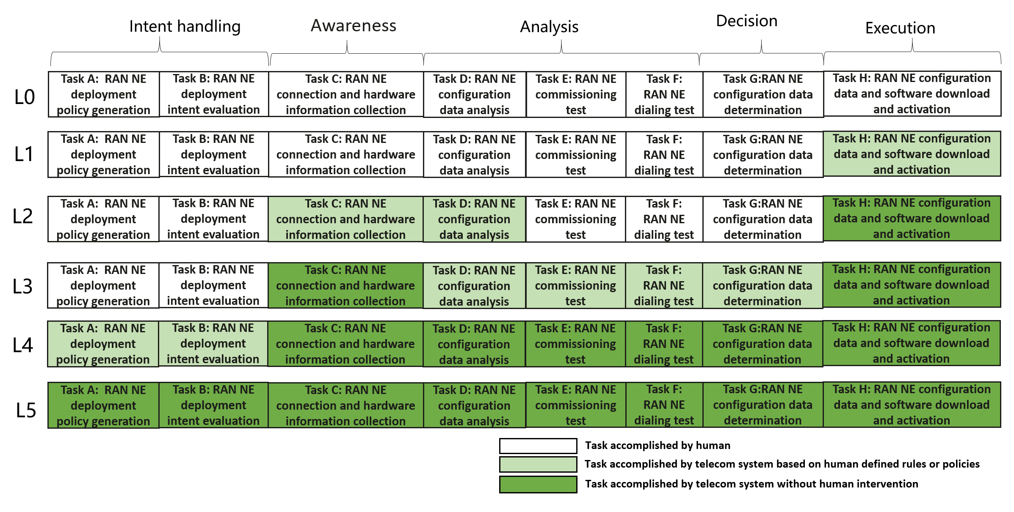
Figure 6.2.X.3-1 Classification of autonomous network level for RAN NE deployment

6.2.X.4 Requirements
Editor’s Note the detailed requirements is FFS.

End of changes

