3GPP TSG-SA5 Meeting #136e S5-212127rev3

e-meeting, 1 - 9 March 2021

Source: Orange, Intel, AT&T, Nokia, Deutsche Telekom, Telefonica

Title: Potential solution for KI#5 (5GC NF Energy Consumption)

Document for: Approval
Agenda Item: 6.5.2

1 Decision/action requested
The group is asked to discuss and agree on the proposal.

2 References
[1] TR 28.813 0.4.0: Study on new aspects of Energy Efficiency (EE) for 5G

3 Rationale
This contribution proposes a potential solution for KI#5 (5GC NF Energy Consumption).

4 Detailed proposal
This document proposes the following changes in TR 28.813 [1].

1st Change

2 References
The following documents contain provisions which, through reference in this text, constitute provisions of the present document.
- References are either specific (identified by date of publication, edition number, version number, etc.) or non-specific.
- For a specific reference, subsequent revisions do not apply.
- For a non-specific reference, the latest version applies. In the case of a reference to a 3GPP document (including a GSM document), a non-specific reference implicitly refers to the latest version of that document in the same Release as the present document.
[1] 3GPP TR 21.905: "Vocabulary for 3GPP Specifications".
[2] 3GPP TS 23.501: "5G; System Architecture for the 5G System".
[3] 3GPP TS 32.130: "Telecommunication management; Network sharing; Concepts and requirements".
[4] 3GPP TS 28.552: "Management and orchestration; 5G performance measurements".
[5] 3GPP TS 28.554: "Management and orchestration; 5G end to end Key Performance Indicators (KPI)".
[6] ETSI ES 203 228 v1.2.1: "Environmental Engineering (EE); Assessment of mobile network energy efficiency".
[7] S5-201169/S2-1912770: LS on analytics support for energy saving
[8] 3GPP TS 28.622: "Telecommunication management; Generic Network Resource Model (NRM) Integration Reference Point (IRP); Information Service (IS)".
[9] Draft ETSI GR NFV-IFA 015 V3.4.1 (2020-05): "Network Functions Virtualisation (NFV) Release 3; Management and Orchestration; Report on NFV Information Model".
[10] ETSI GR NFV 003 V1.5.1 (2020-01): "Network Functions Virtualisation (NFV); Terminology for Main Concepts in NFV".[11] 3GPP TS 28.809: "Management and orchestration; Study on enhancement of Management Data Analytics (MDA)".
[12] 3GPP TS 28.310: "Management and orchestration; Energy efficiency of 5G".
[13] IETF RFC 5136: "Defining Network Capacity".
[14] ETSI GS NFV-TST 008 V3.3.1: "Network Functions Virtualisation (NFV) Release 3; Testing; NFVI Compute and Network Metrics Specification".
[15] S5-206370: "Rel-17 CR TS 28.554 Add EE KPI definitions for network slices".
[16] 3GPP TR 21.866: "Study on Energy Efficiency Aspects of 3GPP Standards".
[17] 3GPP TS 28.313: "Management and orchestration; Self-Organizing Networks (SON) for 5G networks".
[18] 3GPP TS 28.555: "Management and orchestration; Network policy management for 5G mobile networks; Stage 1".
[A] ETSI GS NFV-IFA 027 V4.0.2 (2020-11): "Network Functions Virtualisation (NFV) Release 4; Management and Orchestration; Performance Measurements Specification".
[B] ETSI ES 202 336-12 V1.2.1 (2019-02): "Environmental Engineering (EE); Monitoring and control interface for infrastructure equipment (power, cooling and building environment systems used in telecommunication networks); Part 12: ICT equipment power, energy and environmental parameters monitoring information model".
[C] ETSI GS NFV-IFA 006 V3.4.1 (2020-06): "Network Functions Virtualisation (NFV) Release 3;Management and Orchestration; Vi-Vnfm reference point - Interface and Information Model Specification".

Next Change

4.5 Key Issue #5: 5GC NF Energy Consumption estimation

4.5.1 Description
In Release 16, the Energy Consumption (EC), as defined in TS 28.552 [4] clause 5.1.1.19, is defined for Physical Network Functions (PNF) only, and associated to corresponding ManagedElement IOC instances.
In case of 5GC Network Functions (NF) composed of Virtualized Network Functions (VNF) running on a Network Function Virtualization Infrastructure (NFVI), it is expected to be able to measure the energy consumption of each VNF separately, aggregate it at the Network Function level and associate it to corresponding ManagedFunction IOC instances.
However, in a NFVI, the finest grain at which Energy Consumption can be measured is the NFVI Node, making it impossible to measure the energy consumed by each and every VNF separately given that a) a VNF can run on more than one NFVI node and b) a NFVI node can support more than one VNF.
As a workaround, it is proposed to estimate the Energy Consumption of each and every VNF instance composing Network Functions, aggregate it at the Network Function level and associate it to the ManagedFunction IOC instance representing the management view of the Network Function.

4.5.2 Potential solutions

4.5.2.1 Potential solution #1: 5GC NF EC estimation based on relative vCPU usage

4.5.2.1.1 Introduction
In TS 28.622 [8] clause 4.3.4.2, the ManagedFunction IOC attribute ‘vnfParametersList’ lists the VNF instance(s) forming the ManagedFunction. This ManagedFunction IOC relation to VNF class is also represented in [9] as follows:
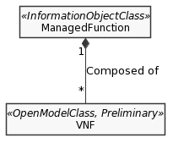
Figure 4.5.2.1.1-1: Managed Function-VNF relationship

ETSI GR NFV-IFA 015 [9] states that:
- a VNF is composed of 1-to-many VNF Component(s) (VNFC) – see diagram below.
- a VNFC runs over a single VirtualisationContainer – see diagram below.
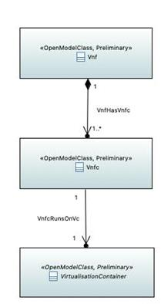
Figure 4.5.2.1.1-2: VNF-VNFC-Virtualisation Container relationship

, where a Virtualisation Container is defined in ETSI GR NFV 003 [10] as follows:
“
partition of a compute node that provides an isolated virtualised computation environment.
NOTE: Examples of virtualisation container includes virtual machine and OS container.
”.
Hence, a Virtualisation Container runs on a single NFVI Compute Node. A NFVI Compute Node may support 1-to-many Virtualisation Container(s).
To summarize:
- A network function (e.g. SMF in 5GC), represented from the management point of view by a ManagedFunction IOC instance, when realized by software running on NFVI, is composed of 1-to-many VNF instances, where each VNF instance pertains to one and only one Network Function (see NOTE 1);
- Each VNF instance may be composed of 1-to-many VNFC instances, where each VNFC instance pertains to one and only one VNF instance;
- Each VNFC instance runs on one and only one Virtualisation Container, which is a partition of a NFVI Compute Node;
- Each VNFC instance utilizes virtual CPUs of one single NFVI Compute Node;
- Each NFVI Compute Node hosts zero-to-many VNFC instances.
NOTE 1: How a 5GC NF is composed of VNFs is implementation specific. In particular, whether a VNF instance is shared or not between more than one NF is implementation specific. Hence, the case where a VNF instance is shared between multiple NFs is out of scope of the present potential solution.

Given that it is impossible to measure the energy consumed by each and every VNFC instance separately, aggregate it at the VNF instance level and then at the network function (e.g. SMF) level, it is proposed here to estimate VNFC instance energy consumption relatively to the NFVI Compute Node (on which it runs) energy consumption, in the same proportion as the VNFC instance virtual CPU usage relatively to the NFVI Compute Node (on which it runs) CPU usage during the same measurement period. This proposed solution does not consider NFVI Storage Nodes.
Here below is an illustration of the proposed solution on a virtualized SMF instance:
1. Consider SMF-1 is a 5GC Network Function instance;
2. Consider SMF-1 is composed of 2 VNF instances:
- VNF-11 (e.g. a load balancer), and
- VNF-12 (e.g. where the SMF logic is running);
3. Consider VNF-11 is composed of 2 VNFC instances (output from network planning):
- VNFC-111 (running on NVFI Node X), and
- VNFC-112 (running on NFVI Node Y);
4. Consider VNF-12 is composed of 2 VNFC instances (e.g. output from network dimensioning):
- VNFC-121 (running on NFVI Node Z), and
- VNFC-122 (running on NFVI Node T);
5. Consider NFVI Node X hosts 3 vCPU instances:
- X-1,
- X-2, and
- X-3;
6. Consider NFVI Node Y hosts 4 vCPU instances:
- Y-1,
- Y-2,
- Y-3, and
- Y-4;
7. Suppose that, during a given time period:
7.1 VNFC-111 has used 30% of the vCPU X-1 of NFVI Node X (calculated by VNFM based on input data from the VIM in charge of NFVI Node X),
7.2. VNFC-112 has used 35% of the vCPU Y-1 of NFVI Node Y (calculated by VNFM based on input data from the VIM in charge of NFVI Node Y),
7.3. VNFC-121 has used 20% of the vCPU X-2 of NFVI Node X (calculated by VNFM based on input data from the VIM in charge of NFVI Node X),
7.4. VNFC-122 has used 60% of the vCPU Y-2 of NFVI Node Y (calculated by VNFM based on input data from the VIM in charge of NFVI Node Y);
7.5. vCPU instance X-3 has been used by a VNFC instance from another NF (vCPU usage = 50%),
7.6 vCPU instances Y-3 and Y-4 have been used by a VNFC instance from yet another NF (vCPU usage = 25% and 45% respectively);
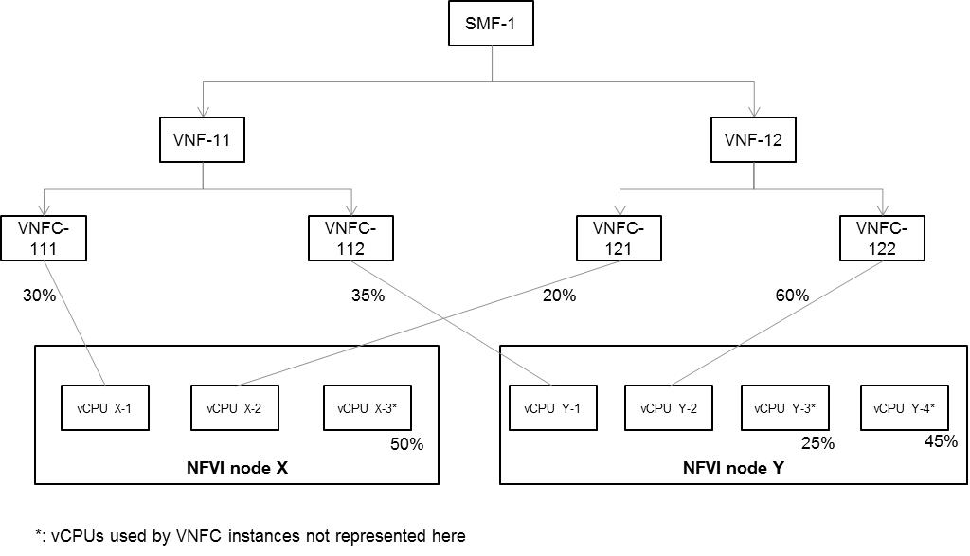
Figure 4.5.2.1.1-3: SMF energy consumption estimation

8. Based on the measurement obtained at step 7.1, it can be estimated that VNFC-111 has consumed 30% (= 30 / (30 + 20 + 50)) of the energy consumed by NFVI Node X during the same time period;
9. Based on the measurement obtained at step 7.2, it can be estimated that VNFC-112 has consumed 21% (= 35 / (35 + 60 + 25 + 45)) of the energy consumed by NFVI Node Y during the same time period;
10. Based on the measurement obtained at step 7.3, it can be estimated that VNFC-121 has consumed 20% (= 20 / (30 + 20 + 50)) of the energy consumed by NFVI Node X during the same time period;
11. Based on the measurement obtained at step 7.4, it can be estimated that VNFC-122 has consumed 55% (= 60 / (35 + 60 + 25 + 45)) of the energy consumed by NFVI Node Y during the same time period;
12. The energy consumed by NFVI Nodes X and Y during the same time period is measured separately. Let’s name these measurements as EC-X and EC-Y respectively;
13. Finally, the energy consumed by SMF-1 can be estimated by the sum of:
a. 50% (= 30 + 20) of EC-X,
b. 76% (= 21 + 55) of EC-Y.
14. End.

NOTE 2: In the above procedure, it is assumed that the multiple vCPUs located within the same NVFI Node are identical.

4.5.2.1.2 Description
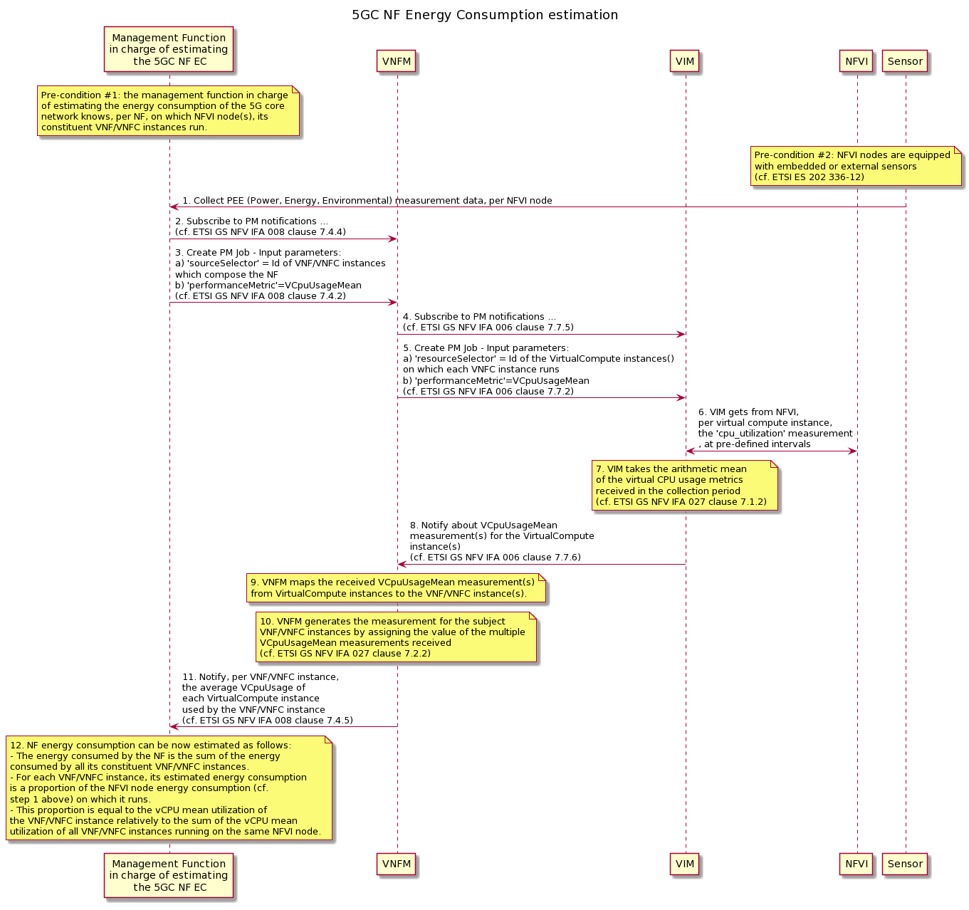

Pre-condition #1: the management function in charge of estimating the energy consumption of the 5G core network knows, per NF, on which NFVI node(s), its constituent VNF/VNFC instances run.

Pre-condition #2: NFVI nodes are equipped with embedded or external sensors (cf. ETSI ES 202 336-12).

1. The management function in charge of estimating the energy consumption of the 5G core network collects Power, Energy and Environmental (PEE) measurements from NFVI nodes (cf. ETSI ES 202 336-12), during a given period of time. The procedure described here is independent from whether the NFVI nodes are equipped with embedded sensors or external sensors (cf. ETSI ES 202 336-12);
2. The management function in charge of estimating the energy consumption of the 5G core network subscribes to PM notifications towards the VNFM, so as to receive notifications about the vCPU mean usage of each VNF/VNFC instance of the 5GC NF (cf. ETSI GS NFV IFA 008 [14] clause 7.4.4) for a given period of time;
3. The management function in charge of estimating the energy consumption of the 5G core network requests the VNFM to create a PM job to collect the vCPU usage of each VNF/VNFC instance of the 5GC NF (cf. ETSI GS NFV IFA 008 [14] clause 7.4.2);
4. The VNFM subscribes to PM notifications towards the VIM, so as to receive notifications about the vCPU usage of the virtual compute instances on which each VNF/VNFC instance runs (cf. ETSI GS NFV IFA 006 [C] clause 7.7.5);
5. The VNFM requests the VIM to create a PM job to collect the vCPU usage of the virtual compute instances on which each VNF/VNFC instance runs and whose id’s are provided as input parameters of the CreatePMJob request (cf. ETSI GS NFV IFA 006 [C] clause 7.7.2);
6. The VIM gets, at pre-defined intervals, the process utilization compute metric values from all CPU Cores of the NFVI (cf. ETSI NFV TST 008 [14] – clause 6.6). Whether the VIM gets this data in pull mode or in push mode is out of scope of the present document;
7. The VIM aggregates them per virtual compute resource and calculates their arithmetic mean per virtual compute resource; this per virtual compute resource arithmetic mean of process utilization compute metric values is called VCpuUsageMean (cf. ETSI GS NFV IFA 027 [A] clause 7.1.2);
8. The VIM notifies the VNFM about VCpuUsageMean measurement(s) for the virtual compute instance(s) (cf. ETSI GS NFV IFA 006 [C] clause 7.7.6);
9. The VNFM maps the received VCpuUsageMean measurement(s) from virtual compute instances to the VNF/VNFC instance(s);
10. The VNFM generates the measurement for the subject VNF/VNFC instances by assigning the value of the multiple VCpuUsageMean measurements received (cf. ETSI GS NFV IFA 027 [A] clause 7.2.2);
11. The VNFM notifies the Management Function in charge of estimating the 5GC NF EC, about the average VCpuUsageMean of each virtual compute instance used by the VNF/VNFC instance(s) which constitute the NF (cf. ETSI GS NFV IFA 008 [14] clause 7.4.5);
12. NF energy consumption can be now estimated as follows:
The energy consumed by the NF is the sum of the energy consumed by all its constituent VNF/VNFC instances.
For each VNF/VNFC instance, its estimated energy consumption is a proportion of the NFVI node energy consumption (cf. step 1 above) on which it runs.
This proportion is equal to the vCPU mean usage of the VNF/VNFC instance relatively to the sum of the vCPU mean usage of all VNF/VNFC instances running on the same NFVI node.

In this potential solution #1, the Energy Consumption (EC) of a 5G Network Function (NF) is a KPI obtained by summing up the EC of PNF(s) and VNF instance(s) that compose the NF. The energy consumption of a PNF is measured at the corresponding ManagedElement level (cf. TS 28.552 clause 5.1.1.19). The energy consumption of a VNF instance is the sum of the energy consumption of all its constituent VNF Component instance(s) (VNFC). The energy consumption of a VNFC instance is equal to the energy consumption of the virtual compute resource on which it runs.
The energy consumption of a virtual compute resource X is estimated as a proportion of the energy consumption of the NFVI node on which the virtual compute resource runs, this proportion being obtained by dividing the vCPU mean usage of the virtual compute resource X, by the sum of the vCPU mean usage of all virtual compute resources running on the same NFVI Node as X, as defined by the equation below:
, where:
- VCpuUsageMean is the mean vCPU usage of the virtual compute resource during the observation period, provided by NFV MANO,
- is sum of the vCPU mean usage of all virtual compute resources running on the same NFVI Node during the same observation period, all separately provided by NFV MANO (see clause 7.1.2 of [A],
- EC_{NFVINode,measured} is the measured energy consumption of the NFVI node on which the virtual compute resource runs, during the same observation period, as per ETSI ES 202 336-12 [B].

NOTE: the above definition of EC_{virtualCompute,estimated} offers a coarse-grained estimation of the energy consumed by a virtual compute resource, based on its vCPU mean usage (provided by VIM to VNFM) only. For a more accurate estimation, more factors need to be considered such as e.g. (this list is not exhaustive) the number of vCPUs used by the virtual compute resource, the type/architecture of physical CPUs of the NFVI Node, CPU clock rate, etc. A more accurate estimation could be obtained if the NFV MANO system could provide 3GPP management system with such information. In addition, the percentage of physical CPU allocated to each virtual compute resource would be needed; however, this measurement is not defined yet in ETSI NFV IFA 027 v4.0.2 [A].

As each VNFC instance is hosted by a single virtual compute resource, the estimated energy consumption of a VNF instance is equal to the estimated energy consumption of the virtual compute resource on which it runs, as defined here below:
Based on this, the estimated energy consumption of a VNF instance is equal to the sum of the energy consumption of all constituent VNFC instances, as defined by the equation below:
And the estimated energy consumption of a Network Function is defined as the sum of the measured energy consumption of all its constituent PNF instances and the estimated energy consumption of all its constituent VNF instances, as defined by the equation below:

The unit of this KPI is J.

In this potential solution #1, it is assumed that:
- the energy consumption of each NFVI node can be measured (see ETSI ES 202 336-12 [B]),
- the energy consumption of VNF / VNFC instances is not measurable hence it should be estimated,
- each VNFC instance pertains to one and only one VNF instance (see ETSI GR NFV-IFA 015 [9]),
- each VNF instance pertains to one and only one Network Function (see TS 28.622 [8] clause 4.3.4.2),
- there is a 1-to-1 relationship between VNFC instance and virtual compute resource (see ETSI GR NFV-IFA 015 [9]),
- there is a 1-to-many relationship between virtual compute resource and vCPU,
- there is a 1-to-many relationship between vCPU and CPU Core,
- there is a 1-to-many relationship between NFVI Node and Physical CPU,
- there is a 1-to-many relationship between Physical CPU and CPU Core,
- all CPU cores allocated to a vCPU run on the same Physical CPU,
- VNF / VNFC instances are not containerized
, as illustrated in the figure below.

End of changes

