3GPP TSG-SA5 Meeting #136e S5-212120rev1

e-meeting 1st - 9th March 2021

Source: Huawei

Title: Discussion on assurance report for closed control loop

Document for: Approval
Agenda Item: 6.4.12

1 Decision/action requested
The group is asked to discuss and agree on the proposal.

2 References
[1] 3GPP TS 28.535: “Management and orchestration; Management services for communication service assurance; Requirements”, Rel-17 v17.0.0
[2] 3GPP TS 28.536: “Management and orchestration; Management services for communication service assurance; Stage 2 and stage 3”, Rel-17 v16.2.1
[3] 3GPP TS 28.311: “Management and orchestration; Network policy management for mobile networks based on Network Function Virtualization (NFV) scenarios”, Rel-16 v16.0.0
[4] 3GPP TS 28.532: “Management and orchestration; Generic management services”, Rel-16 v16.5.1

3 Rationale
In this contribution, some characteristics, applicability and NRM aspects of assurance report for assurance closed control loop (ACCL) are discussed.

3.1 Characteristics and NRM aspects of assurance report
The ACCL MnS producer may need to allow the consumer to configure the reporting of some important abstractions of ACCL operations, e.g. actions, related reasons (e.g. root causes of KPI anomaly) for actions, applied policies and the resulted assurance goal fulfilment status etc. Based on the information, the ACCL MnS consumer may be aware of how the assurance goal is satisfied. With more hints on what have happened in the ACCL, the consumer may take further actions to improve the ACCL performance, e.g. optimizing the configurations or adjusting the ACCL policies etc. The report can be used as additional information to the assurance goal fulfilment status.
In TS 28.532 [4], there are some general notification related APIs for CM, PM and FM etc. However the service aspects of the ACCL still need to be addressed. By using an assurance report, the ACCL MnS producer could aggregate the correlated information for the MnS consumer for more convenient monitoring or analysis. It is beneficial for flexibility and more optimal network operations.
There are some use cases and requirements in TS 28.535 [1] related to ACCL reporting. Report type may be classified according to different purposes or scenarios, for example:
- Report type related to ACCL Goal fulfilment;
- Report type related to ACCL governance;
- Report type related to ACCL coordination;
- Report type related to ACCL operation;
Report content may be defined as actions, related reasons and/or policy, related assurance goal etc according to different report types.

Assuance goal fulfilment:
REQ-CSA_CSA-FUN-02 The 5GS shall have the capabilities to monitor, and report to CSP the fulfilment of committed CS requirements and actions taken to adjust for deviations.
REQ-CSA_CSA-FUN-03 The 5GS shall have the capabilities to monitor and report to CSP actions taken to adjust deviations on committed CS requirements.
REQ-CSA-CON-13 The 3GPP management system shall have the capability to allow its authorized consumer to obtain the SLS assurance progress information and fulfil information.
The above requirements could be handled as report actions related to goal fulfilment.
Report content related to reportType of ACCL goal fulfilment: The actions of the ACCL goal deviation adjustment;
It could be discussed whether the assurance goal fulfilment information should be moved into the assurance report, or some references could be made between the assurance report and the assurance goal.
could be defined like the following table:

ACCL governance:
REQ-CSA-CON-17 The 3GPP management system shall allow an authorized consumer to set a condition to enable/disable an ACCL.
This requirement could be handled as report for ACCL governance.
Report content related to reportType of ACCL governance: The actions of the ACCL state change;
could be defined like the following table:

ACCL coordination:
REQ-CSA-CON-16 The 3GPP management system shall have the capability to allow its authorized consumer to limit the set of action capabilities executable by an assurance closed loop.
The above requirement could be handled as report actions related to ACCL coordination.
Report content related to reportType of ACCL coordination: limit the set of action capabilities in case of ACCL conflict;
could be defined like the following table:

ACCL operation:
In clause 5.1.4 Use case for interaction with core network for service assurance
REQ-CSA_RR-CON-01 The 3GPP management system shall be able to configure the 5GC functions to make them report of a potential service load increase beyond a certain threshold so that the 3GPP management system can do scaling up of resources in time without impacting the SLA.
REQ-CSA_RR-CON-02 The 3GPP management system shall be able to determine the service load thresholds that need to be used by the 5GC functions to report, so that a potential resource overprovisioning situation can be ascertained.
In clause 6.2 Requirements
REQ-CSA-CON-15 The 3GPP management system shall have the capability to take actions such as network configuration and perform network resource reallocation according to the network prediction results.
The above requirements could be handled as report actions related to ACCL operation.
Report content related to reportType of ACCL operation: actions of scaling up of resources upon potential service load increase beyond a certain threshold;
could be defined like the following table:

Some existing requirements and use cases may be classified into one of the above report types, or new report types need to be defined for them. There may be other means of report type definitions, e.g. report type defined according to scenarios, and a report type may consist of attributes of actions, analysis information, applied policies, goal fulfilment etc. It could be left for futher study.
The intention to classify different types of action report according to ACCL scenarios or purposes is mainly for flexibility and future extention.

Relation of assurance goal, assurance report and assurance policy:
The actions in the assurance report may be for the support of a certain assurance goal. Its effects may result in the assurance goal fulfilment status. The actions may be triggered according to a certain assurance policy. By evaluation of the correlations, the ACCL MnS consumer may take more appropriate actions to optimize the ACCL performance, e.g. by updating or reselection of more optimal assurance policy.
The report may also be independent of the assurance goal, e.g. just to report actions that may not directly contribute to the goal fulfilment, e.g. the state transitions actions. The report may also be independent of the assurance policy, e.g., not to convey internal policy but just report the analytical result.
Observation 1: There may be some relations between the assurance report and the assurance goal, e.g. effects of the actions on assurance goal fulfilment;
Observation 2: There may be some relations between the assurance report and the assurance policy, e.g. actions and the applied policy which trigger the actions;
Observation 3: The assurance report may also be independent of assurance goal or assurance policy.
Proposal 1: It is proposed to introduce AssuranceReport IOC for ACCL, some of its attributes are reportId <<string>>, reportStatus<<ENUM>>, timestamp<<string>>, reportType<<ENUM>> and reportContent<<IOC>>. Additional attributes and allowed values could be FFS currently.

3.2 UML diagram
There may be relations between AssuranceReport, AssuranceGoal and AssurancePolicy, they are correlated or independent according to different policy types and report types.. For example, the mapping may be 0..1 to * between AssuranceReport and AssuranceGoal, and the mapping may be 0..1 to * between AssuranceReport and AssurancePolicy.
When AssuranceReport is introduced, the NRM diagram is depicted as in Figure 1.
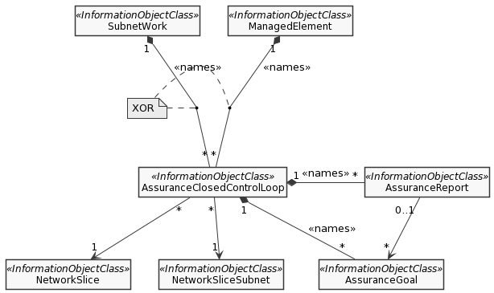
Figure 1: Assurance management NRM fragment
The Figure 2 below reflects relations when both AssuranceReport and AssurancePolicy are intruduced.
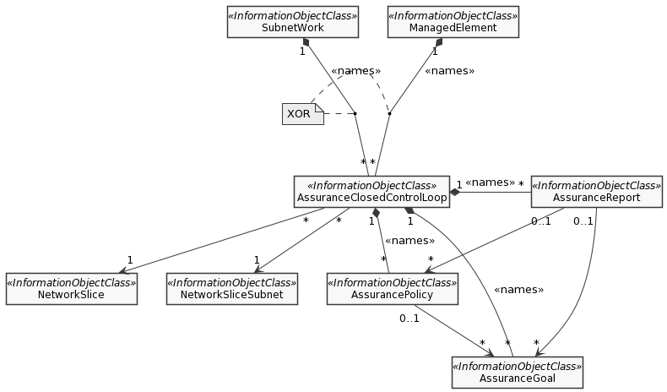
Figure 2: Assurance management NRM fragment
Proposal 2: Modeling the mapping relations between AssuranceReport and AssuranceGoal, beteen AssuranceReport and AssurancePolicy as 0..1 to * currently until the relations become clearer and adding an Editor’s NOTE to clarify that it will be revisited.

4 Detailed proposal
In this contribution, the following observation and proposals are made:
Observation 1: There may be some relations between the assurance report and the assurance goal, e.g. effects of the actions on assurance goal fulfilment;
Observation 2: There may be some relations between the assurance report and the assurance policy, e.g. actions and the applied policy which trigger the actions;
Observation 3: The assurance report may also be independent of assurance goal or assurance policy.
Proposal 1: It is proposed to introduce AssuranceReport IOC for ACCL, some of its attributes are reportId <<string>>, reportStatus<<ENUM>>, timestamp<<string>>, reportType<<ENUM>> and reportContent<<IOC>>. Additional attributes and allowed values could be FFS currently.
Proposal 2: Modeling the mapping relations between AssuranceReport and AssuranceGoal, beteen AssuranceReport and AssurancePolicy as 0..1 to * currently until the relations become clearer and adding an Editor’s NOTE to clarify that it will be revisited.
It is proposed to introduce AssuranceReport in TS 28.536 [2]. Detail proposals are included in the following draftCRs:
S5-212122 Rel-17 draftCR TS 28.536 Add assurance report for closed control loop

