3GPP TSG-SA5 Meeting #135e S5-211348

e-meeting, 25 January – 3 February 2021

Source: Nokia, Nokia Shanghai Bell

Title: TD forge process proposal for yaml code in 135e meeting

Document for: Discussion and Endorsement
Agenda Item: 6.3

1 Decision/action requested
Please discuss and endorse

2 References
[1] 3GPP TS 28.541: "Management and orchestration; 5G Network Resource Model (NRM); Stage 2 and Stage 3".

3 Rationale
More than 100 compilation errors of OpenAPI code found in latest Rel16 and Rel17 TSs, many of them were editorial issues, e.g. implement/merge CRs incorrectly or missed some changes as too much lines scattered in a large yaml file, format error such as different indent, copy paste error, inconsistent between yaml files from different TSs, etc. Most of the errors cannot be addressed with existing forge process.
As we agreed in process before, only compilation error free code, then related stage 2 and 3 CRs, can be agreed in group. With the code in current TS and existing process, it’s very difficult to CR author to validate the code correctly, then the NRM CRs cannot be agreed without proof of succesfully code validation.
Note: You could check if there’s compilation error in forge validation report. If the code was compiled successfully, you will either not receive “[3GPP Forge] Validation failed: sa5-data-models-any-commit” email from 3GPP Forge, or from the link in the email, you will see the file you changed is valid. E.g. if you changed sliceNrm.yaml, and there’s no compilation error introduced by your change, after you commit the change in Forge, you will either see the commit is successful, or you may receive an email from 3GPP Forge with the validation report link, from the report you should see “---- Validating ./sliceNrm.yaml: /specs/sliceNrm.yaml is valid”.
Observation 1: As dependency between codes in multiple TSs and “editorial” error introduced during implementation of TS, we could always get compilation error for code in published TSs, then in published forge release branch. For Rel16 TSs after SA#90 as an example, the Rel16-SA90-agreed branch is just reflected the published TSs agreed in SA#90, compilation errors are still existed on the branch. We have to create another branch, e.g. Rel16-SA90-agreed-fix-compilation-error branch to fix compilation errors for Rel16, and create CRs based on this branch to fix TSs, but can be only approved in next SA meeting. In addition, referring the code in forge to update TSs line by line by comparing Rel16-SA90-agreed and Rel16-SA90-agreed-fix-compilation-error branches is doable, but it’s really complicated and also time consumable and error prone.
Observation 2: As CR author create their CR branch from release branch, e.g. Rel16 branch, the baseline itself is not error free, this cause challenges for the CR authors to validate their change. They have to rebased their change on error free branch, e.g. Rel16-SA90-agreed-fix-compilation-error with git tool and operations proposed by Michele, this can be a little challenges to many CR authors.
Note from Forge expert: rebasing is strongly recommended in order to prevent merge conflicts. Unfortunately Gitlab support for rebase is partial, therefore some rebase operations should be done locally and uploaded to the Forge via usage of Git or a Git Client. For information on rebasing, please refer to https://git-scm.com/book/en/v2/Git-Branching-Rebasing .
What CR authors should do, is to rebase their own branch onto Rel16-SA90-agreed-fix-compilation-error (or similar for Rel17). To do this operation, independently from the tooling, please do:
- Make sure your local clone of the repository is up to date (git-fetch operation)
- Make a local copy of the -agreed-fix-compilation-error branch
- Checkout your working branch containing your CR
- Execute the rebase onto the -fix-compilation-error branch, (from the command line use -i option, or use a Graphical Tool)

Note: For Rel17, we have more open issues which suggest being discussed in another paper.
Please see the current status of Rel 16 OpenAPI code in forge in below picture.
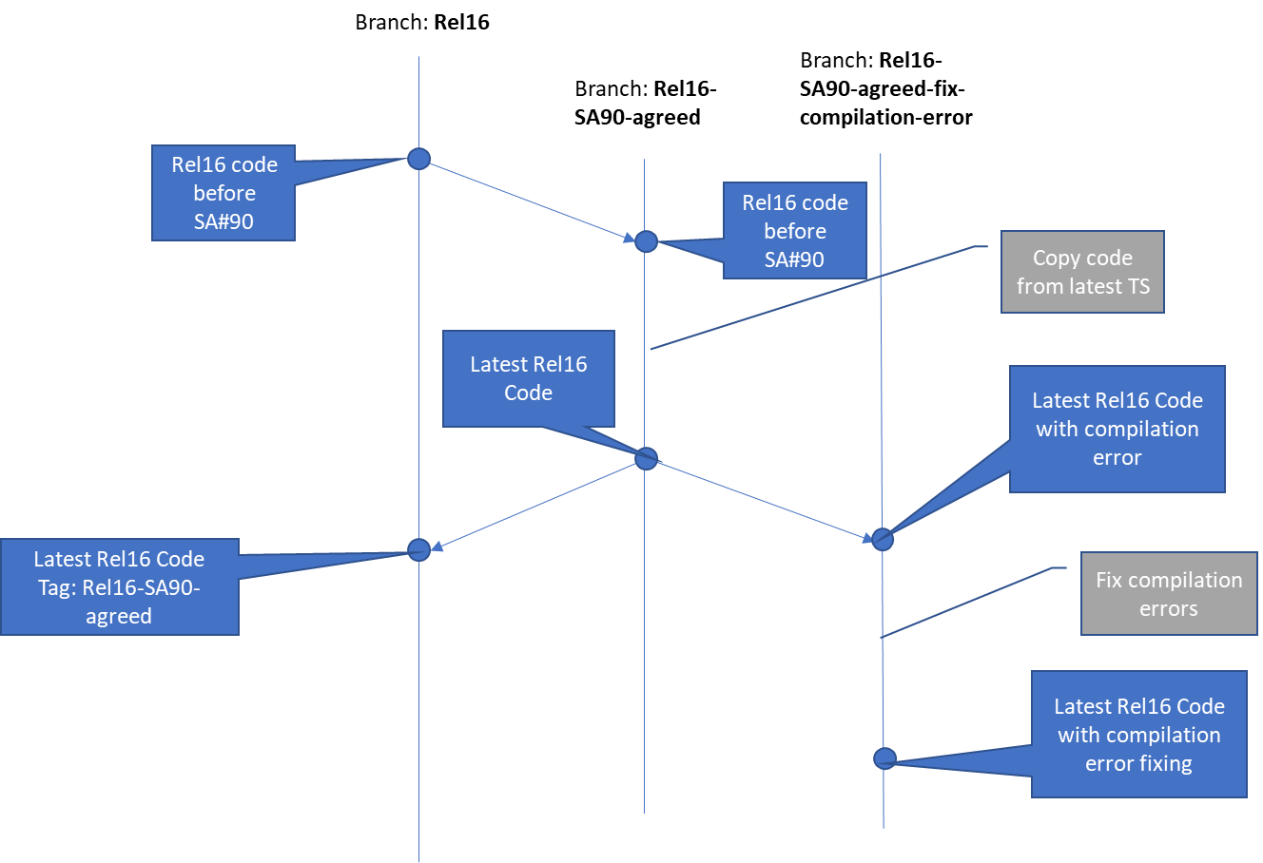

Three options are proposed in clause 4 to implement and validate OpenAPI code in both TS and Forge in this meeting.

4 Detailed proposal

4.1 Option 1: create CR branch based on latest codes of TSs
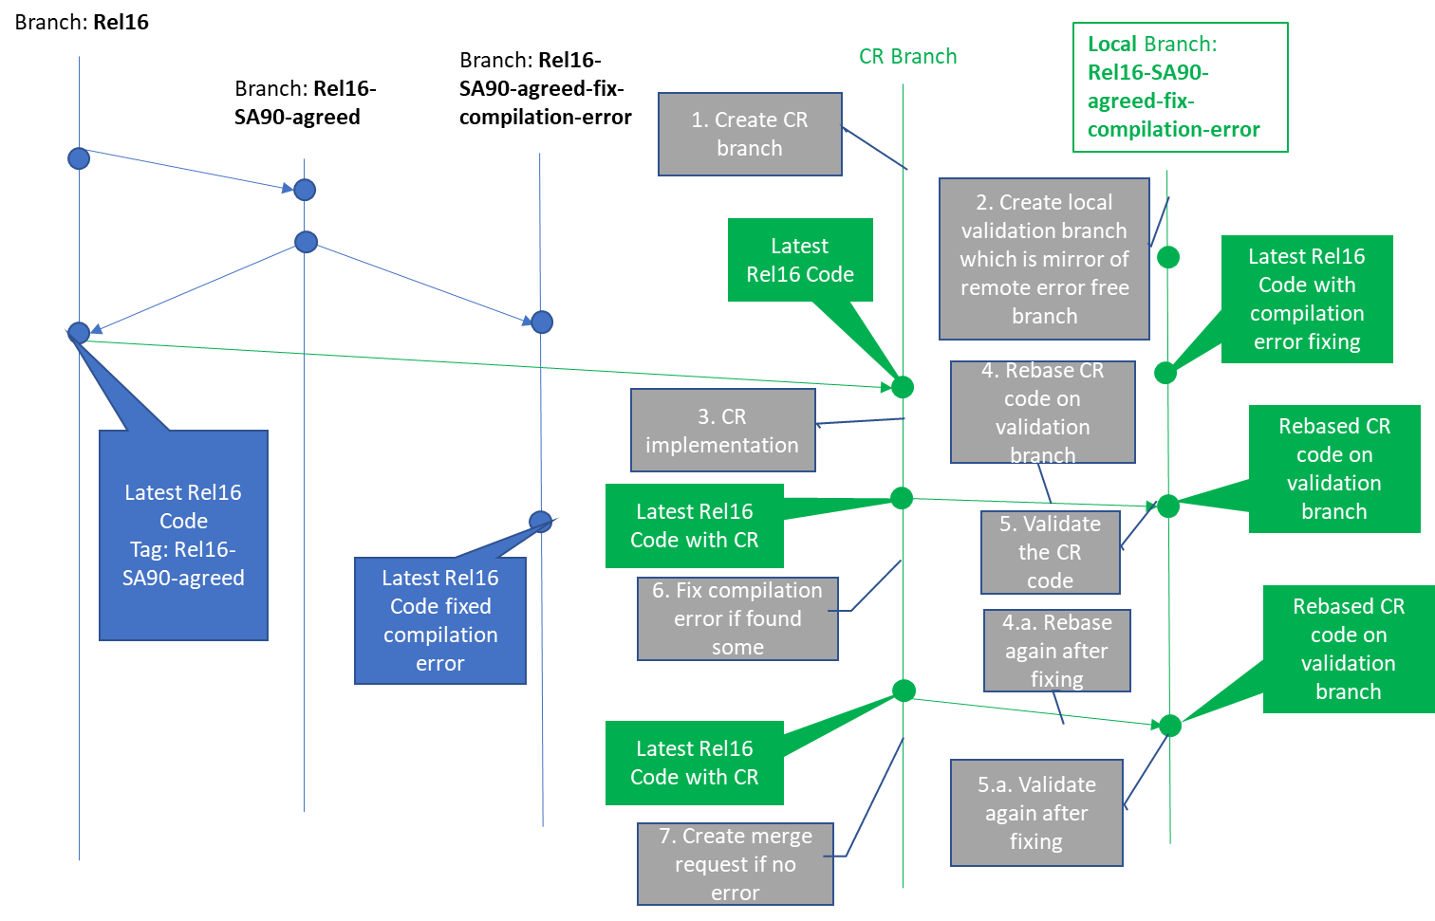
Precondition:
- update TS for the CR, copy updated TS code to Forge file in step 3
Post condition:
- update TS accordingly if compilation error found and fixed in forge.
- CRs will be merged by MCC one by one after being approval in SA meeting.
Note: CRs to fix compilation errors of latest TSs will be proceeded as normal CR
Pros:
- Strictly follow SA/CT process
Cons:
- referring the code in forge to update TSs line by line, or change the code in TS directly line by line is complicated, time consumable and error prone for the author.
- implement hundreds line change of code is complicated, time consumable and error prone for MCC
- change of code in different TSs which the current TS depends on can’t be detected
- the procedure to validate the code is challenge to CR authors

4.2 Option 2: create CR branch based on latest codes with compilation error fixing
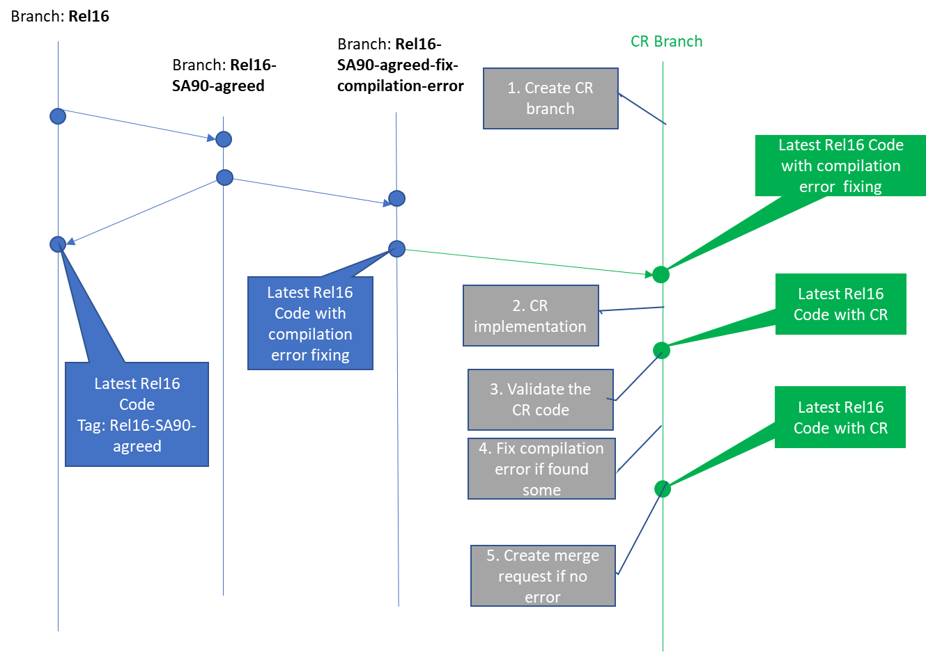
Precondition:
- Code moderator Create CRs (call baseline CRs) to replace code in latest TS with error free forge file (code on Rel16-SA90-agreed-fix-compilation-error), and create baseline of the TS for this meeting
- CR (call normal CR) author update TS for the CR based on the new TS baseline created by Code moderator in last step
- CR author copy updated TS code to Forge file in step 2
Post condition:
- update TS accordingly if compilation error found and fixed in forge.
- when implement CRs after SA meeting, MCC merges the baseline CRs first, then merge other normal CRs one by one
Note: baseline CRs will be handled differently than other normal CRs. Relevant comments should be put for both baseline and normal CRs on CR cover page. E.g. For baseline CR, put comments such as “this CR is baseline CR, and need to be merged first” . For other CRs, put comments such as “the CR is dependent on baseline CR xxxx, and merged based on that CR ”
Pros:
- Simplify the validation procedure for normal CR author
- Still comply with SA/CT process in most extent
- Simplify code moderator and MCC’s work to build baseline and merge code
Cons:
- the CR author still need to change the code line by line in TS
- change of code in different TSs which the current TS depends on can’t be detected

4.3 Option 3: create CR branch based on latest codes with compilation error fixing and copy merged code to TS

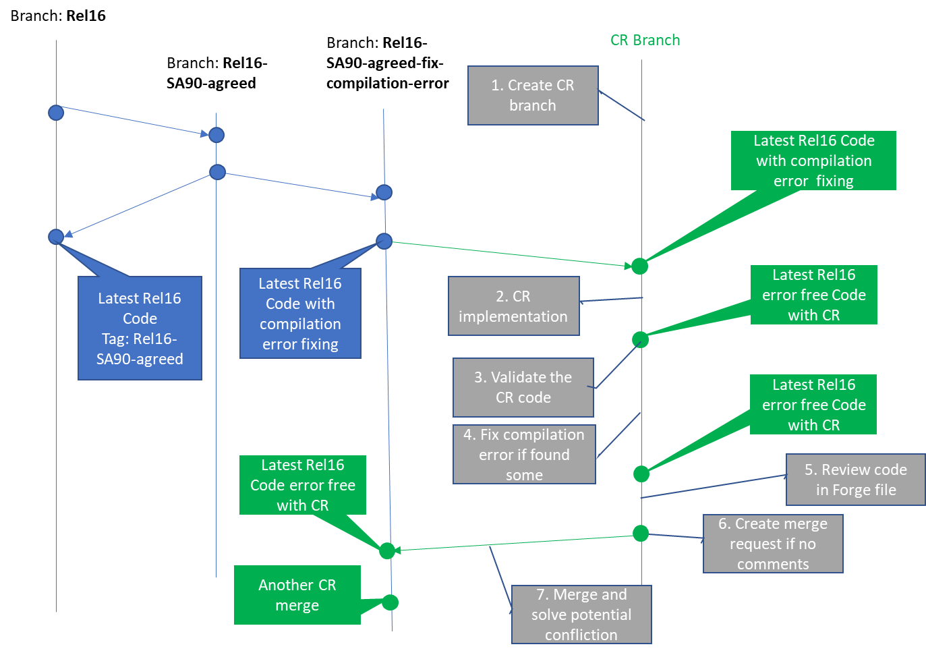
Precondition:
- All CR authors don’t need to touch TS but just work on Forge
Post condition:
- Code moderator assists to merge each CR branch to compilation error branch after the CR agreed (no review issue, no validation error).
- After all CR agreed, code moderator create CR to copy the code to TS in one time
- MCC implement only this CR for OpenAPI code
Pros:
- Simplify the OpenAPI code implementation and validation procedure for all stackholders
- dependency between different TSs could be solved
Cons:
- not really follow SA/CT process
- if some agreed CRs could not be finally approved in SA meeting, need to split related change out, that can be a complicated work
Note:
In step 2, CR author implements stage 3 code of the CR directly on forge file
For step 5, CR author could put the link of forge code and validation report (see commit result) in either cover page of tDoc or in the email thread for review.

Please endorse option 3 as it looks more balanced.

