3GPP TSG-SA5 Meeting #135e S5-211314

e-meeting, 25 January – 3 February 2021

Source: Nokia, Nokia Shanghai Bell

Title: TD tenant information to support multi-tenancy for network slice management

Document for: Discussion and Endorsement
Agenda Item: 6.4.7

1 Decision/action requested
Please discuss and endorse

2 References
[1] 3GPP TS 28.201: "Charging management; Network slice performance and analytics charging in the 5G System (5GS); Stage 2 ".
[2] 3GPP TS 28.202: "Charging management; Network slice management charging in the 5G System (5GS); Stage 2 ".
[3] 3GPP TS 28.541: "Management and orchestration; 5G Network Resource Model (NRM); Stage 2 and Stage 3".

3 Rationale
As studied in TR 28.804, management resource isolation and management service exposure to different tenants is critical to multi-tenancy network slice environement.
As shown in below picture, 3GPP management service consumer on behalf of an administrator of a tenant may call MnS of 3GPP managmenet system to provision or mornitor a network slice allocated to the tenant.
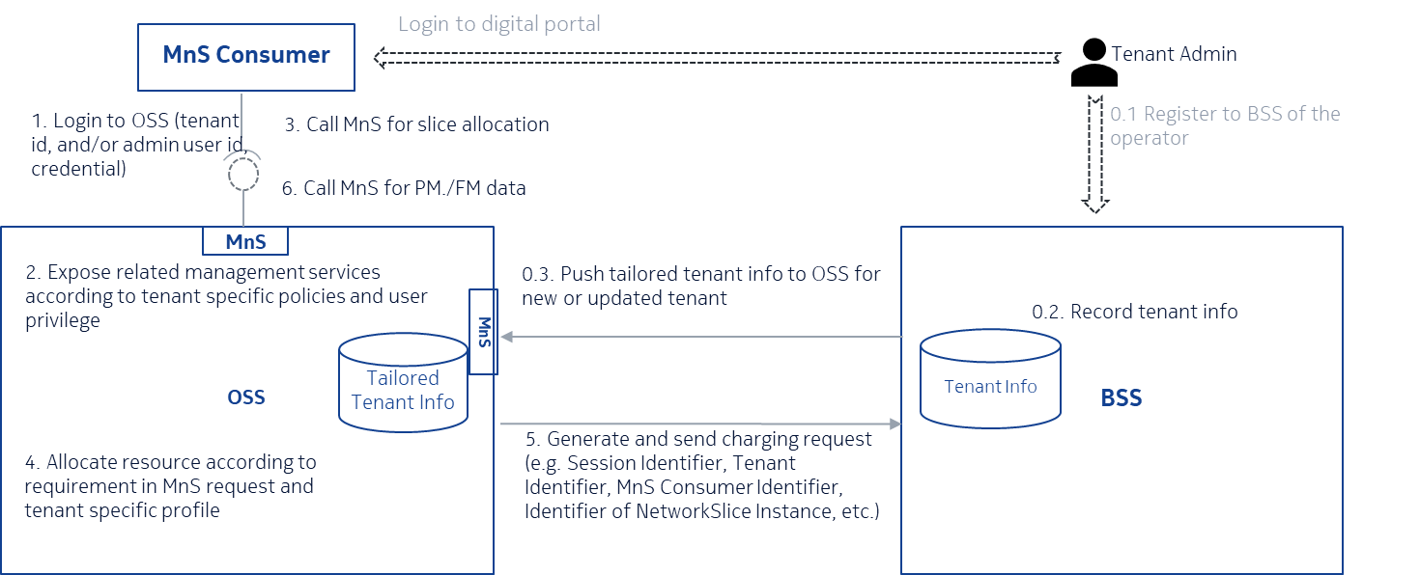

Therefore tenant info may be used in OSS in following cases:
1. A MnS consumer would be authenticated and authorized by MnS producer of an operator according to tenant information, e.g. authorization/access control policies could be influenced by profile of the tenant, e.g. some tenant can only monitor the networks/services while others can provision the service.

2. MnS producer, or exposure governence managemetn function, exposes conrespoinging management capability to the MnS consumer according to the access polices, e.g , expose part of provisioing (e.g. create/delete/update service), or monitoring (e.g. report performance measurements, alarm of service) MnS to the consumer based on the policies.
3. MnS producer allocates resource to MnS consumer based on servie requirements and other SLAs signed with the tenant, as well as specific tenant profile. e.g. according to tenant profile, the resource allocated to the tenant can only be shared with other tenant(s) from same industry.
4. MnS Producer (act as charging trigger function (CTF)) sends Charging Data Request [Event] to CHF associated to the network slice provisioning (e.g. Creation) transaction, tenant Identifer is included in the CDR
Therefore, first, the tenant information should be in BSS system of operator after a tenant signed contract with operator. Part of the tenant information need to be transferred to OSS system to allow the OSS system to proceed service request from the service consumer on behalf of the tenant.
Tenant information is need to OSS to authenticate the MnS consumer on behalf of the tenant and allow OSS to grant permissions of management services to the MnS consumer based on agreement between operator and tenant, in addition to allocate resource for the service request accorindg to agreed polices.
On the other hand, as tenant information is sensitive to both operator and consumer, it should be separately and securely managed by producer and authorized consumer. Association between a tenant and services/resources allocated to the tenant should be securely created to support management resource isolation and management service exposure without leak tenant’s information to unauthorized users or systems.

4 Detailed proposal

Introduced a Tenant IOC in NRM fragment as below
NRM Fragment to support multi-tenancy

The Tenant IOC includes attributes inherited from Top IOC and the following attributes:
Attribute name | Support Qualifier | isReadable | isWritable | isInvariant | isNotifyable
tenantId | M | T | F | T | F
administrativeState | M | T | T | F | T
tenantProfile | O | T | T | F | T
Attribute related to role
networkSliceRef | O | T | F | F | T

Attribute properties:
Attribute Name | Documentation and Allowed Values | Properties
administrativeState | It indicates the administrative state of the tenant object in the network slice provider environment. An authorized operator could lock/unlock the tenant, and the tenant could lock the tenant object.  allowedValue: LOCKED, UNLOCKED | type: ENUM  multiplicity: 1  isOrdered: N/A  isUnique: N/A  defaultValue: None  allowedValues: N/A  isNullable: False
tenantId | It is identifier that the network slice provider assigns to a tenant. It should be unique in the network slice provider environment. | type: string  multiplicity: 1  isOrdered: N/A  isUnique: N/A  defaultValue: None  allowedValues: N/A  isNullable: False
tenantProfile | The parameter defines necessary properties and policies of a tenant to support access control, resource allocation and management for the tenant. It can be read and updated by the tenant and autormized operator on behalf of the tenant. e.g. The properties of a tenant could be industry the tenant belong to, the policies of a tenant could be the tenant can only monitor the services allocated to it without any provioining on the service. | type: string  multiplicity: 1  isOrdered: N/A  isUnique: N/A  defaultValue: None  allowedValues: N/A  isNullable: False
networkSliceRef | This parameter specifies the network slice(s) offered to the tenant by network slice provider. | type: DN  multiplicity: *  isOrdered: N/A  isUnique: N/A  defaultValue: None  allowedValues: N/A  isNullable: False

