3GPP TSG SA WG5 Meeting 135-e S5-211285

electronic meeting, online, 25th January – 3rd February 2021

Source: Ericsson

Title: Update definitions around MDA and ML training

Document for: Approval
Agenda Item: 6.5.1

1 Decision/action requested
This contribution is for approval.

2 References
[1] 3GPP TS 28.809 Management and orchestration; Study on enhancement of Management Data Analytics (MDA)

3 Rationale
The ML/AI is relatively new concept in telecom industry and a number of definitions around MDA and ML training in TR 28.809 [1], should be clarified further
Ch.5.3 describes two separate processes supported by MDAS producer: Data Analysis and Model Training. Each process has a separate input and definition of Data Classification function makes no sense (classify already separate inputs). It is proposed to remove “Data Classification” altogether from ch.5.3 of the Report
Model ID is an important information for the Model Training process e.g. to allow its life-cycle management hence it is added to solution describing the process itself and its output in ch.6.99.1 of the Report

4 Detailed proposal
It is proposed to update the following chapters in TR 28.809 [1].
1st Modified Section

5.3 MDA process
The MDA may rely on ML technologies, which may need the consumer to be involved to optimize the accuracy of the MDA results.
The MDA process in terms of the interaction with the consumer, when utilizing ML technologies, is described in the figure below.
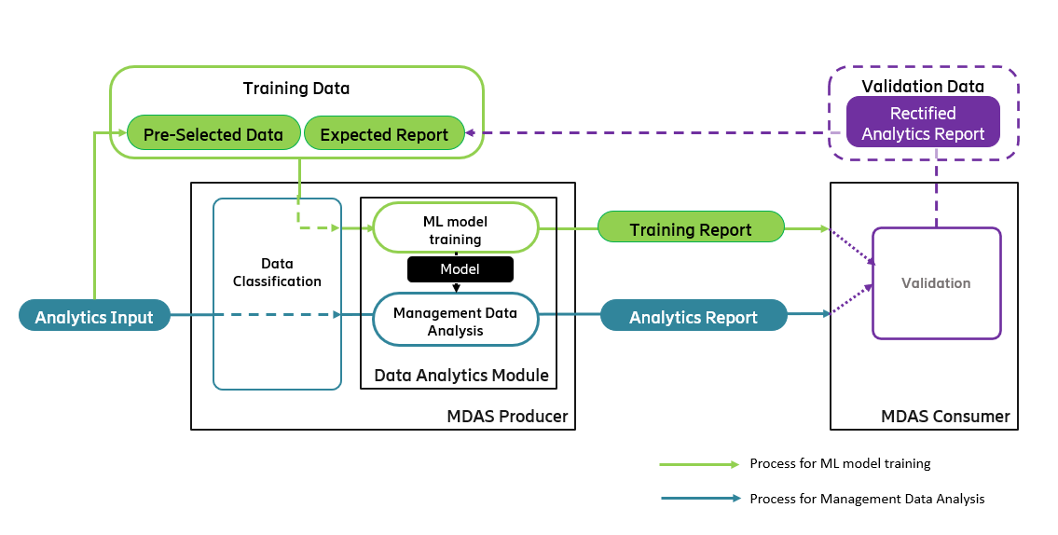

Figure 5.3-1: MDA process
There are two kinds of processes for MDA, the process for ML model training and the process for management data analysis. In the process for ML model training, the MDA producer, trains the ML model and provides the ML training report. The process for ML model training may also get the consumer involved, i.e., allowing the consumer to provide input for ML model training. The ML model training may be performed on an un-trained ML model or a trained ML model. In the process for management data analysis, the MDA producer analyses the data by the trained ML model, and provides the analytics report to the consumer.
Data classification: The data input to the MDA producer could be used for ML model training or for the actual management data analysis. The MDA producer classifies the input data and passes the classified data along to corresponding step for further processing.
ML model training: The MDAS producer trains the ML model, i.e., to train the algorithm of the ML model to be able to provide the expected training output by analysis of the training input. The data for ML model training may be the training data (including the training input and the expected output) and/or the validation data provided by the consumer. After the ML model training, the MDAS producer provides an ML model training report.
Management data analysis: The trained ML model analyses the classified data and generates the management data analytics report(s). Analytics reports were presented in clause 5.1.
Validation: The consumer may validate the output data provided by the MDAS producer. The output data to be validated may be the analytics report and/or the ML model training report as described above. The consumer may provide the validation data as feedback to the MDAS producer, and the MDAS producer will use the validation data for further ML model training with the historical data that are used to generate the validated output data.

2nd Modified Section

6.99.1 ML model training for MDA

6.99.1.1 Use case
The MDA process may rely on ML technologies. To optimize the accuracy of MDA result, the ML model of the MDA process may need to be trained.
For training the ML model of the MDA process, the consumer provides the training data including training input and the desired output to the MDAS producer. The MDAS producer uses the training input and the desired output to train the ML model, i.e., to train the algorithm of the ML model to approximate the desired output as accurately as possible by analysis of the training input. The MDAS producer provides an ML model training report output to the consumer.
With a trained ML model for MDA, the MDAS producer can analyse the analytics input and generate the analytics report as output data of the analysis to the consumer.
The consumer may validate the output data provided by the MDAS producer. The output data to be validated may be the analytics report and/or the ML model training report as described above. The consumer may provide the validation data as feedback to the MDAS producer, and the MDAS producer will use the validation data for further ML model training for MDA with the historical data that are used to generate the validated output data.

6.99.1.2 Potential requirements
REQ-MDA_MGMT-CON-1 The MDAS producer should have a capability allowing the consumer to provide the data for training (or re-training) the ML model for MDA.
REQ-MDA_MGMT-CON-2 The MDAS producer should have a capability to provide ML model training report to the consumer.
REQ-MDA_MGMT-CON-3 The MDAS producer should have a capability to receive the validation data from the consumer and re-train the pre-existing ML model for MDA based on the received validation data.

6.99.1.3 Possible solutions

6.99.1.3.1 Solution description
The MDAS producer trains the ML model with the training data or the validation data received from consumer. The ML model training should have no or minimal impact to the normal data analytics.
For the ML model training with the training data, the training data (see subclause 6.99.1.3.2) should include the training Id, the training input and expected training output:
- The training Id is used to identify the ML model training request, and to associate with the training report.
- Model ID identifies the Model the training is executed for
The training input is a set of training input data with the indicated data type (e.g., performance measurements, MDT report, NRM, etc.).
- The expected training output specifies the analysis result that the ML model should aim to achieve based on the training input.
For the ML model training with the validation data, the validation data (see subclause 6.99.1.3.2) should include the validation report Id, analytics report Id that was validated, and the validated information including the data that are rectified. The MDAS producer looks up the historical data that are associated with the validated analytics report and trains the ML model with the historical data and the validation data.
The MDAS producer provides a training report (as shown in subclause 6.99.1.3.3) to the consumer, with indication of whether the training (identified by the training Id or validation Id) is successful and possibly the failure cause if the training is not fully successful.

6.99.1.3.2 Data required for ML model training for MDA
The following table describes the data required for ML model training for MDA:
Data category | Required data
Training data | The training data include a training identifier, the training input and the expected training output.  Training Id: Identifier of the training.  Model Id (optional): Identifier of a pre-existing model, when re-training.  The training input contains the same types of information that should be included in a normal analytics input.  The expected training output contains the same types of information that should be included in a normal analytics report.
Validation data | The training data include a validation report Id, analytics report Id that was validated, and the data that are rectified. Example of the rectified data is the originally reported root cause is not accurate by validation and should be updated to another.

6.99.1.3.3 ML model training report
Following table provides the potential contents of the ML model training report.
ML model training report | Attribute Name | Description
ML model training report | Training Id | The training Id that the training report is associated to.
ML model training report | Model Id | The identifier for the trained model (needed for re-training).
ML model training report | Training result | Indication of whether the training is successful, partially successful or failed.
ML model training report | Failure cause | The cause of the failure if the training is not fully successful.

6.99.1.4 Evaluation
The solution described in clause 6.99.1.3 requires the input s described in in clause 6.99.1.3.2, wherein
- the training data are fully aligned with the analytics input and output of the concrete analytics use cases.
- and validation data can be provided by the consumer.
Therefore, this solution is a feasible candidate for ML model training for the use cases that are concluded with a feasible solution.

End of Modified Sections

