3GPP TSG SA WG5 Meeting 135-e S5-211230

electronic meeting, online, 25 January - 3 February 2021

Source: China Mobile, Huawei, China Telecom, China Unicom

Title: pCR 28.100 Add use case and requirements for fault management

Document for: Approval
Agenda Item: 6.4.9

1 Decision/action requested
The group is asked to discuss and approval.

2 References
[1] 3GPP draft TS 28.100: “Levels of autonomous network v0.2.0”.
[2] 3GPP TR 28.810: “Study on concept, requirements and solutions for levels of autonomous network v17.0.0”

3 Rationale
The fault recovery use case example for network autonomy level is described in clause 5.1 in TR 28.810[2]. This contribution proposes to add use case and requirements for different autonomous network levels of fault management.

4 Detailed proposal
It proposes to make the following changes to TS 28.100[1].
1st Change

6.3.X Autonomous network level for fault management
Editor's Note: whether the following use case need to be generalized for common maintenance scenarios is FFS.

6.3.X.1 Introduction
Fault management use case refers to the entire workflow of network fault management, autonomy of fault management can help the network operator to reduce OPEX by reducing manual involvement in such tasks and to enhance user experience and reduce network and service failure time by reducing the time for network fault supervision and recovery. However, full autonomy of fault management is a long term goal, it will be beneficial for operator to achieve this goal step by step and have clear view on which typical issues can be addressed by utilizing network autonomy mechanism in corresponding steps. The requirements for each autonomous level for fault management autonamy are different.

6.3.X.2 Workflow
Following are the entire workflow for fault management:
Intent handling:
- Task A: Fault management policies generation. The group of tasks of generating the fault management related rules and/or policies (e.g., alarm filtering rules, fault recognition and root cause analysis policies, fault recovery policies) based on fault management intent (e.g. reduce fault recovery response time to a certain value, reduce network and service failure times to a certain value whitin a specific duration).
- Task B: Fault management intent fulfilment evaluation. The group of tasks of evaluating fault management intent fulfilment information (e.g. corresponding fault recovery response time is satisfied or not).
Awareness:
- Task C: Fault related information collection. The group of tasks which collect the alarm information and other fault related information (e.g. performance information and configuration information etc.).
- Task D: Alarm filtering. The group of tasks which filter the alarms collected in Task C based on the filtering rules specified. A single network fault may generate a large number of correlative alarms over space and time, therefore it is considered advantageous to have methods filtering the redundant alarms. Reporting only effective alarms without redundant alarms would improve the efficiency of alarm management.
Analysis:
- Task E: Fault recognition. The group of tasks which recognize the fault and its category (including fault domain, fault type) based on the alarm information and other fault related information.
- Task F: Fault prediction. The group of tasks which predict the potential fault and its category based on the performance information and other fault related information.
- Task G: Fault root cause analysis (RCA). The group of tasks which analyse the detailed root cause of the network and service failure.
- Task H: Fault recovery mechanism analysis. The group of tasks which analyse the possible fault recovery mechanisms based on the fault root cause, thereby generate the feasible options (e.g. recommended recoverysolutions).
Decision:
- Task I: Fault management action generation. The group of tasks which evaluate the feasible options and determine the fault recovery solutions and other corresponding actions (e.g. clear of alarms, storage and retrieval of alarms).
Execution:
- Task J: Fault management action execution. The group of tasks which execute the fault recovery actions and other corresponding actions.
Note: If the faulty resource has no redundancy (e.g. backup equipment/board/battery/transport link) and all the fall back recovery actions are not available nor effective, then the subsequent fault recovery actions (e.g. replace physical equipment/board/battery, repair the physical connector/fiber/cable, repair the power supply, etc.) are considered as beyond the capabilities of the telecom system. And those actions execution is excluded from the consideration of autonomous network level classification.

6.3.X.3 Classification of autonomous network level
Level 0:
- All the tasks in the fault management workflow (Task A, Task B, Task C, Task D, Task E, Task F, Task G, Task H, Task I, Task J) are accomplished by human.
Level 1:
- Telecom system executes the tasks of fault related information collection (Task C) automatically based on predefined rules, and the tasks of fault management action execution (Task J) based on specified action execution rules. Telecom system can also execute the tasks of alarm filtering (Task D) based on specified alarm filtering rules.
- All the other tasks in the fault management workflow (Task A, Task B, Task E, Task F, Task G, Task H, Task I) are accomplished by human.
Level 2:
- Compared to Level 1, telecom system can additionally executes the tasks of fault recognition (Task E) based on specified rules. The tasks of fault management action execution (Task J), fault related information collection (Task C) and alarm filtering (Task D) are fully accomplished by telecom system based on specified rules.
- All the other tasks (Task A, Task B, Task F, Task G, Task H, Task I) are accomplished by human.
Level 3:
- Compared to Level 2, telecom system can additionally execute the tasks of fault root cause analysis based on specified analysis policies (Task G). For certain network faults, telecom system can also additionally exexute the tasks of fault recovery mechanism analysis (Task H) and action generation (Task I) based on specified fault management policies.
- All the other tasks (Task A, Task B, Task F) are accomplished by human.
Level 4:
- Compared to Level 3, the telecom system can additionally execute the task of fault prediction (Task F). For certain scenario, telecom system additionally execute the tasks of fault management policies generation (Task A) and fault management intent fulfilment information evaluation (Task B) based on specified intent handling policies. The tasks of fault recovery mechanism analysis (Task H) and action generation (Task I) are accomplished automatically by telecom system without human intervention.
- Intent handling policies can be pre-defined and specified by human.
Level 5:
- The entire fault management workflows is accomplished by telecom system without human intervention and human predefined rules or policies.
- Human can optionally supervise the fault management action generated by telecom system.
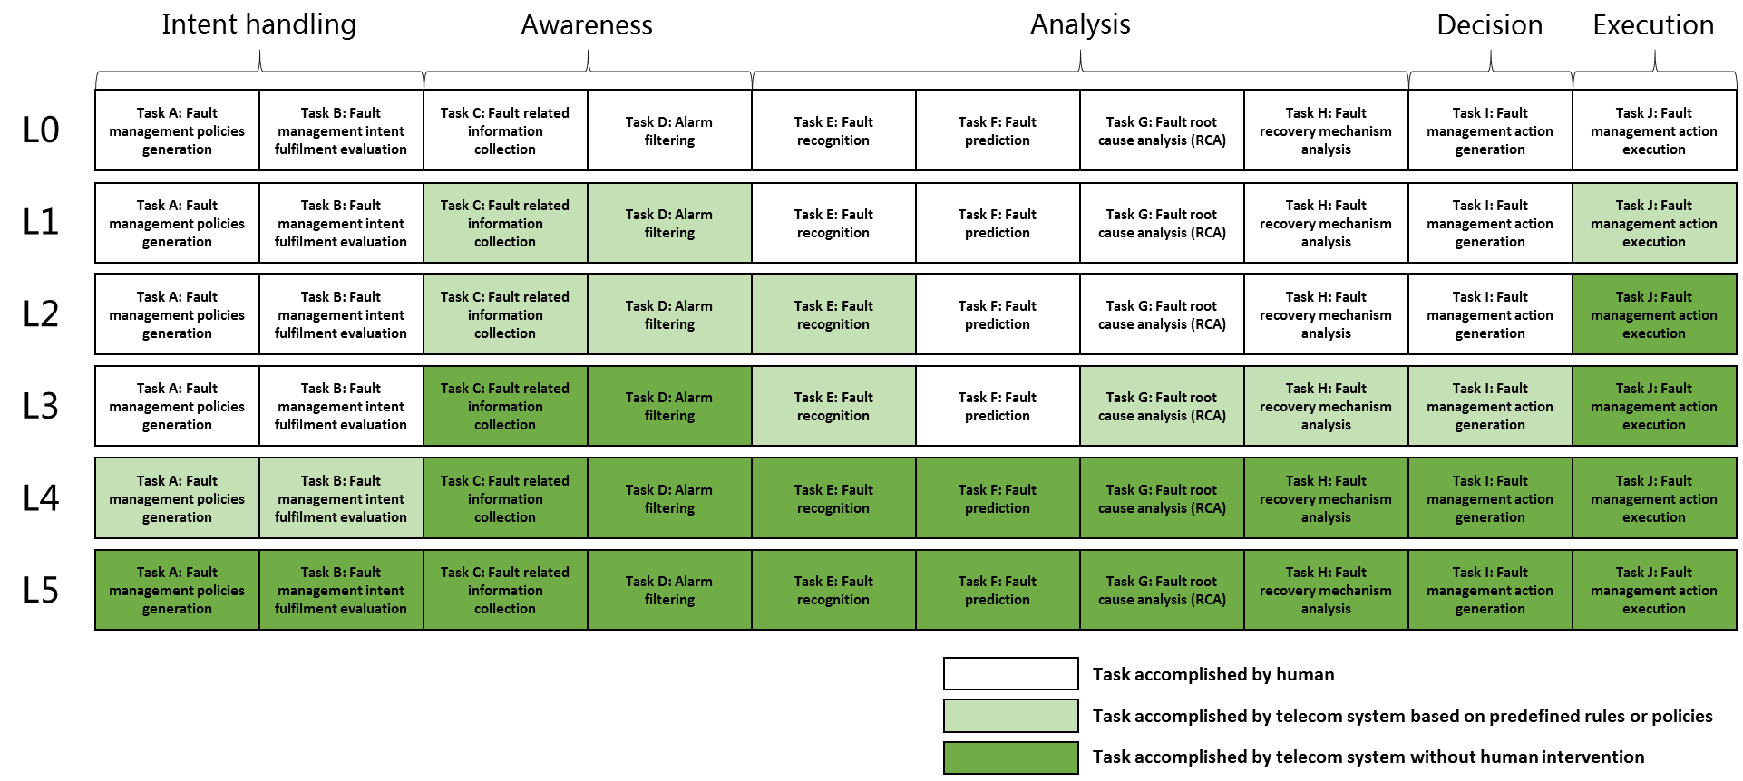
Figure 6.3.X.3-1: Classification of autonomous network level for fault management

6.3.X.4 Requirements
Following are the functional requirements and interface requirements for 3GPP management system to support each autonomous network level (except for level 0) for fault management.

6.3.X.4.1 Requirements to support autonomous network level 1
REQ-ANL-Level_1-FM-FUN-1 The 3GPP management system shall have autonomy capability to execute the network recovery actions (including reset the hardware/software, switch to the backup hardware, rollback to the backup software/firmware) based on the specified fault recovery rules.
REQ-ANL-Level_1-FM-FUN-2 The 3GPP management system shall have autonomy capability to collect fault related data (including alarms, events, signalling data, performance data, configuration data and environment data) based on specified collection rules.
REQ-ANL-Level_1-FM-FUN-3 The 3GPP management system shall have autonomy capability to filter the alarms based on the specified filtering rules.
REQ-ANL-Level_1-FM-MnS-1 The 3GPP management system shall have the capability allowing its authorized consumer to specify the fault recovery rules.
REQ-ANL-Level_1-FM-MnS-2 The 3GPP management system shall have the capability allowing its authorized consumer to specify the fault related data collection rules.
REQ-ANL-Level_1-FM-MnS-3 The 3GPP management system shall have the capability allowing its authorized consumer to specify the alarm filtering rules
REQ-ANL-Level_1-FM-MnS-4 The 3GPP management system shall have the capability allowing its authorized consumer to obtain fault related data (including alarms, events, signalling data, performance data, configuration data and environment data).
REQ-ANL-Level_1-FM-MnS-5 The 3GPP management system shall have the capability allowing its authorized consumer to obtain the filtered alarm data.

6.3.X.4.2 Additional requirements to support autonomous network level 2
REQ-ANL-Level_2-FM-FUN-1 The 3GPP management system shall have the autonomy capability to recognize the fault category (including fault domain and type) based on specified fault recognition rules.
REQ-ANL-Level_2-FM-MnS-1. The 3GPP management system shall have the capability allowing its authorized consumer to specify the fault recognition rules.
REQ-ANL-Level_2-FM-MnS-2 The 3GPP management system shall have the capability allowing its authorized consumer to obtain the fault recognition information (inlcuing fault domain and type information).

6.3.X.4.3 Additional requirements to support autonomous network level 3
REQ-ANL-Level_3-FM-FUN-1 The 3GPP management system shall have autonomy capability to analyse the root cause of the network fault based on specified fault root cause analysis policies.
REQ-ANL-Level_3-FM-FUN-2 The 3GPP management system shall have autonomy capability to analyse and generate the recommended fault recovery mechanism and determine the fault recover actions to be executed based on specified fault recovery mechanism analysis and decision policies.
REQ-ANL-Level_3-FM-MnS-1 The 3GPP management system shall have the capability allowing its authorized consumer to specify the fault root cause analysis policies.
REQ-ANL-Level_3-FM-MnS-2 The 3GPP management system shall have the capability allowing its authorized consumer to specify the fault recovery mechanism analysis policies.
REQ-ANL-Level_3-FM-MnS-3 The 3GPP management system shall have the capability allowing its authorized consumer to specify the fault recovery mechanism decision policies.
REQ-ANL-Level_3-FM-MnS-4 The 3GPP management system shall have the capability allowing its authorized consumer to obtain the root cause of the network fault.
REQ-ANL-Level_3-FM-MnS-5 The 3GPP management system shall have the capability allowing its authorized consumer to obtain the recommended fault recovery mechanism.
REQ-ANL-Level_3-FM-MnS-6 The 3GPP management system shall have the capability allowing its authorized consumer to obtain the fault recovery actions to be executed.

6.3.X.4.4 Additional requirements to support autonomous network level 4
REQ-ANL-Level_4-FM-FUN-1 The 3GPP management system shall have autonomy capability to generate or update fault management policies according to fault management intent based on specified intent translation policies.
REQ-ANL-Level_4-FM-FUN-2 the 3GPP management system shall have autonomy capability to evaluate fault management intent fulfilment based on specified intent evaluation policies.
REQ-ANL-Level_4-FM-FUN-3 The 3GPP management system shall have autonomy capability to predict the potential fault.
REQ-ANL-Level_4-FM-MnS-1 The 3GPP management system shall have the capability allowing its authorized consumer to specify the fault management intent.
REQ-ANL-Level_4-FM-MnS-2 The 3GPP management system shall have the capability allowing its authorized consumer to specify the fault management intent translation policies.
REQ-ANL-Level_4-FM-MnS-3 The 3GPP management system shall have the capability allowing its authorized consumer to specify the fault management evaluation policies.
REQ-ANL-Level_4-FM-MnS-4 The 3GPP management system shall have the capability allowing its authorized consumer to obtain the fault management fulfilment information.
REQ-ANL-Level_4-FM-MnS-5 The 3GPP management system shall have the capability allowing its authorized consumer to obtain the potential fault prediction information.

6.3.X.4.5 Additional requirements to support autonomous network level 5
REQ-ANL-Level_5-FM-FUN-1 The 3GPP management system shall have autonomy capability to generate the fault management intent translation and evaluation policies.

End of changes

