3GPP TSG SA WG5 Meeting 135-e S5-211220

electronic meeting, online, 25 January - 3 February 2021

Source: Huawei, China Mobile, China Telecom, China Unicom

Title: Update use case for coverage optimization

Document for: Approval
Agenda Item: 6.4.9

1 Decision/action requested
The group is asked to discuss and approval.

2 References
[1] 3GPP draft TS 28.100: “Levels of autonomous network v0.2.0”.
[2] 3GPP TR 28.810: “Study on concept, requirements and solutions for levels of autonomous network v17.0.0”

3 Rationale
Based on Coverage optimization use case example for classification of network autonomy and potential requirements for classification of network autonomy for coverage optimization described in clause 6.2.3 in TS 28.810[2], this contribution proposes to add the detailed workflow, classification of autonomous network level and corresponding requirements for coverage optimization in clause 6.4.1 Autonomous network level for radio network coverage optimization.

4 Detailed proposal
It proposes to make the following changes to TS 28.100[1].
1st Change

6.4.1 Autonomous network level for radio network coverage optimization
Editor's Note: whether the following use case need to be generalized for common optimization scenarios is FFS.

6.4.1.1 Introduction
Radio networks are geographically distributed, and mobile user activity varies significantly in different places and at different times of day. To achieve the optimal coverage, a set of initial coverage configuration parameters (e.g. coverageShape, digitalTilt and digitalAzimuth) may not always meet the requirements. Therefore, the coverage configuration parameters need to be adjusted in a differentiated manner with the change of the radio network environment. It’s complex for the adjustment due to multiple factors needs to be considered, e.g. interference control, huge data and frequent traffic changes. So introducing the autonomous network level for radio network coverage optimization will benefit for operator to achieve the full autonomy goal step by step and have clear view on which typical issues can be addressed by utilizing autonomy mechanism in corresponding steps. The requirements for each autonomous level for radio network coverage optimization are different.

6.4.1.2 Workflow
Following are the entire workflow for the radio network coverage optimization:
Intent handling:
- Task A: Coverage optimization policies generation and determination. The tasks of generating and determining the coverage optimization related policies (e.g., weak coverage issue identification policies, weak coverage analysis policies and coverage parameters adjustment policies) based on received coverage optimization intent (e.g. coverage targets(e.g. weak coverage ratio) for the specified areas).
- Task B: Coverage optimization intent evaluation. The tasks of evaluating coverage optimization intent fulfilment information (e.g. corresponding coverage targets are satisfied or not).
Awareness:
- Task C: Coverage related information collection. The tasks of collecting coverage related data, including coverage performance data (i.e. performance measurement, MDT data), coverage configuration data (e.g. coverageShape, digitalTilt and digitalAzimuth) and environment data (e.g. electronic map)).

Analysis:
- Task D: Coverage issues identification. The tasks of analysing the coverage performance (e.g. geographical grid based coverage performance) and identifying the coverage issues (e.g. weak coverage, coverage hole, overshoot coverage) and corresponding location.
- Task E: Coverage deterioration prediction. The tasks of analysing current coverage performance and historical coverage performance, predicting the coverage performance trend in the future and identifying potential coverage performance deterioration in advance.
- Task F: Coverage issue analysis. The tasks of analysing the root cause (e.g. affected Cells) of the identified or predicted coverage issues.
- Task G: Coverage adjustment solutions generation. The tasks of generating the recommended coverage adjustment solution which can address the identified or predicted coverage issues.
Decision:
- Task H: Coverage adjustment solutions evaluation and determination. The tasks of evaluating the recommended coverage adjustment solutions, and deciding the coverage adjustment solutions to be executed.
Execution:
- Task I: Coverage adjustment solutions execution. The tasks of adjusting and configuring the coverage related parameters (e.g. selection of coverageShape, digitalTilt and digitalAzimuth).

6.4.1.3 Classification of autonomous network level
Editor’s note: following classification of autonomous network level needs to be revised based on the discussion of the framework approach for evaluating autonomous network level in clause 5.
Level 0:
- All the tasks in the radio network coverage optimization workflow (Task A, Task B, Task C, Task D, Task E, Task F, Task G, Task H, Task I) are accomplished by human.
Level 1:
- Telecom system executes the tasks of coverage adjustment solutions execution based on the specified coverage related parameters (Task I). Telecom system also can execute the tasks of coverage related information collection based on the specified collection rule (Task C). At this level, telecom system can assist human to improve the execution and awareness efficiency for radio network coverage optimization.
- All the other tasks in the radio network coverage optimization workflow (Task A, Task B, Task D, Task E, Task F, Task G, Task H) are accomplished by human.
Level 2:
- Compared to Level 1, telecom system additionally executes the tasks of coverage issues identification, coverage issue analysis based on the specified coverage issue identification and analysis rule (Task D, Task F). At this level, telecom system can assist human to achieve the closed loop for radio network coverage optimization based on human defined rules.
- All the other tasks in the radio network coverage optimization workflow (Task A, Task B, Task E, Task G, Task H) are accomplished by human.
Level 3:
- Compared to Level 2, telecom system additionally executes the tasks of coverage adjustment solutions generation (Task G) and coverage adjustment solutions evaluation and determination (Task H) based on the specified coverage adjustment policies and evaluation policies. At this level, the telecom system can achieve the closed loop automation for coverage optimization based on the human defined optimization policies.
- All the other tasks in the radio network coverage optimization workflow (Task A, Task B, Task E) are accomplished by human.
Level 4:
- Compared to Level 3, the telecom system additionally executes the tasks of coverage deterioration prediction (Task E), coverage optimization policies determination (Task A), and coverage optimization intent evaluation (Task B) based on received coverage optimization intent and intent translation/evaluation policies. At this level, telecom system can achieve the intent driven closed loop automation for radio network coverage optimization based on human defined intent translation and evaluation policies
- The intent translation and evaluation policies maybe pre-defined and specified by human to assist the telecom system.
Level 5:
- Telecom system can autonomously execute the entire workflow of radio network coverage optimization for all scenarios, which means the telecom system can achieve the full autonomy for radio network coverage optimization for full scenarios.

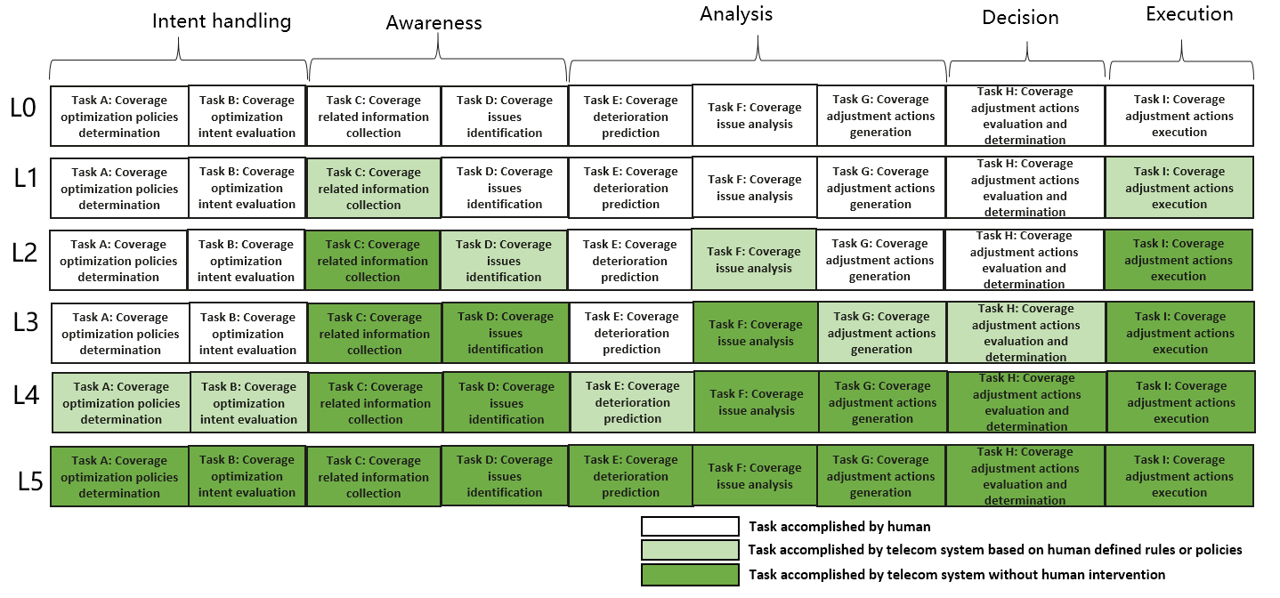
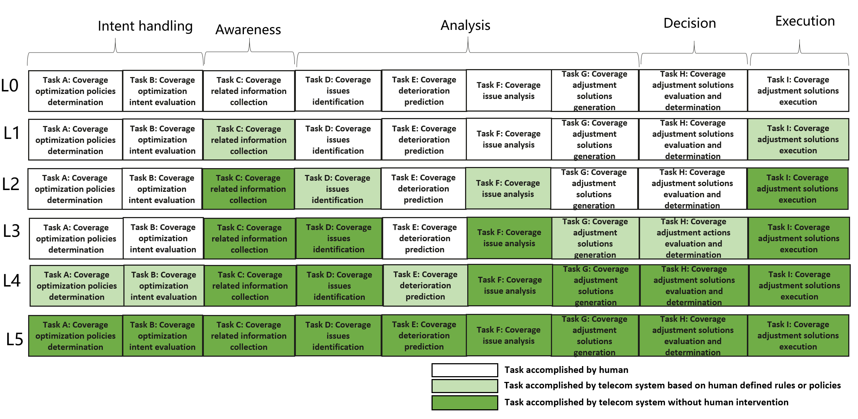
Figure 6.4.1.3-1 Classification of autonomous network level for coverage optimization

6.4.1.4 Requirements
Following are the functional requirements and interface requirements for 3GPP management system to support each autonomous network level (except for level 0) for radio network coverage optimization.
Editor’s note: All requirements that do not have any stage 2 and 3 solution shall be deleted before this TS is made public.

6.4.1.4.1 Requirements to support autonomous network level 1
REQ-ANL-CovOpt-Level_1- FUN-1 The 3GPP management system shall have autonomy capability to adjust coverage related parameters based on the specified coverage configuration parameters.
REQ-ANL-CovOpt-Level_1-FUN-2 The 3GPP management system shall have autonomy capability to collect coverage related data (including coverage performance data, coverage configuration data and environment data) based on specified collection rules.
REQ-ANL-CovOpt-Level_1-MnS-1 The 3GPP management system shall have the capability allowing its authorized consumer to specify the coverage configuration parameters.
REQ-ANL-CovOpt-Level_1-MnS-2 The 3GPP management system shall have the capability allowing its authorized consumer to specify the coverage related data collection rules.
REQ-ANL-CovOpt-Level_1-MnS-3 The 3GPP management system shall have the capability allowing its authorized consumer to obtain the coverage related data (including coverage performance data, coverage configuration data and environment data).

6.4.1.4.2 Additional requirements to support autonomous network level 2
REQ-ANL-CovOpt-Level_2-FUN-1 The 3GPP management system shall have autonomy capability to identify the coverage issue based on the specified coverage issue identification rule.
REQ-ANL-CovOpt-Level_2-FUN-2 The 3GPP management system shall have autonomy capability to diagnose the coverage issue based on the specified coverage issue diagnose rule.
REQ-ANL-CovOpt-Level_2-MnS-1 The 3GPP management system shall have the capability allowing its authorized consumer to specify the coverage issue identification rule.
REQ-ANL-CovOpt-Level_2-MnS-2 The 3GPP management system shall have the capability allowing its authorized consumer to obtain the coverage issue.
REQ-ANL-CovOpt-Level_2-MnS-3 The 3GPP management system shall have the capability allowing its authorized consumer to specify the coverage issue analysis rule.
REQ-ANL-CovOpt-Level_2-MnS-4 The 3GPP management system shall have the capability allowing its authorized consumer to obtain the coverage issue analysis result.

6.4.1.4.3 Additional requirements to support autonomous network level 3
REQ-ANL-CovOpt-Level_3-FUN-1 The 3GPP management system shall have the autonomy capability to analyse and generate the recommended coverage adjustment solutions based on specified coverage adjustment policies.
REQ-ANL-CovOpt-Level_3-FUN-2 The 3GPP management system shall have autonomy capability to evaluate the recommended coverage adjustment solutions and determine the coverage adjustment solutions to be executed based on specified coverage adjustment decision policies.
REQ-ANL-CovOpt-Level_3-MnS-1 The 3GPP management system shall have the capability allowing its authorized consumer to specify the coverage adjustment policies.
REQ-ANL-CovOpt-Level_3-MnS-2 The 3GPP management system shall have the capability allowing its authorized consumer to obtain the recommended coverage adjustment actions.
REQ-ANL-CovOpt-Level_3-MnS-3 The 3GPP management system shall have the capability allowing its authorized consumer to specify the coverage adjustment decision policies.

6.4.1.4.4 Additional requirements to support autonomous network level 4
REQ-ANL-CovOpt-Level_4-FUN-1 The 3GPP management system shall have autonomy capability to determine or update coverage optimization policies according to coverage optimization intent based on specified intent translation policies.
REQ-ANL-CovOpt-Level_4-FUN-2 the 3GPP management system shall have autonomy capability to evaluate coverage optimization intent fulfilment result based on specified intent evaluation policies.
REQ-ANL-CovOpt-Level_4-FUN-3 The 3GPP management system shall have autonomy capability to predict coverage performance deterioration.
REQ-ANL-CovOpt-Level_4-MnS-1 The 3GPP management system shall have the capability allowing its authorized consumer to specify the coverage optimization intent.
REQ-ANL-CovOpt-Level_4-MnS-2 The 3GPP management system shall have the capability allowing its authorized consumer to specify the coverage optimization intent translation policies.
REQ-ANL-CovOpt-Level_4-MnS-3 The 3GPP management system shall have the capability allowing its authorized consumer to specify the coverage optimization evaluation policies.
REQ-ANL-CovOpt-Level_4-MnS-4 The 3GPP management system shall have the capability allowing its authorized consumer to obtain the coverage optimization fulfilment information.
REQ-ANL-CovOpt-Level_4-MnS-5 The 3GPP management system shall have the capability to obtain the coverage performance deterioration prediction information.

6.4.1.4.5 Additional requirements to support autonomous network level 5
REQ-ANL-CovOpt-Level_5-FUN-1 The 3GPP management system shall have autonomy capability to generate the coverage optimization intent translation and evaluation policies.

End of changes

