3GPP TSG SA WG5 Meeting 135-e TDoc S5-211212

electronic meeting, online, 25 January - 3 February 2021

Source: Huawei, China Telecom,China Unicom,China Mobile

Title: Discussion on activities for enhancement of the service based management architecture

Document for: Discussion and Endorsement
Agenda Item: 6.2

1 Decision/action requested
It proposes to discuss an endorse

2 References
[1] 3GPP TS 32.101
[2] 3GPP TS 28.533

Rationale
Following are some observations related to management architectures.
Obervation#1: Some study regarding architecture description enhancement in TS 28.533 is needed with considering how the interfaces in TS 32.101 to support SBMA.
- TS 32.101[1] clause 5 described the Management reference model and interfaces as follows. The Operations System internal and exernal interfaces are identified in this Management reference model:
- Operations Systems internal interfaces of the same Organization (including interface Type 2, 4, 7)
- Operations Systems external interfaces of the same Organization
  - Interface from Operations System to Enterprise System (including interface Type 3)
  - Interfaces from Operations Systems to NEs (Type 1 & 2)
- Operations Systems external interfaces of different Organizations(including Interface Type5,6)
Figure 1: Management reference model

- The following concept is described in TS 28.533 clause 4.5.
Management Function can be deployed as a separate entity or embedded in Network Function to provide MnS(s). Following figure 4.5.2 shows an example (on the left) which MnF deployed as a separate entity to provide MnS(s) and another example (on the right) which MnF is embedded in Network Function to provide MnS(s):
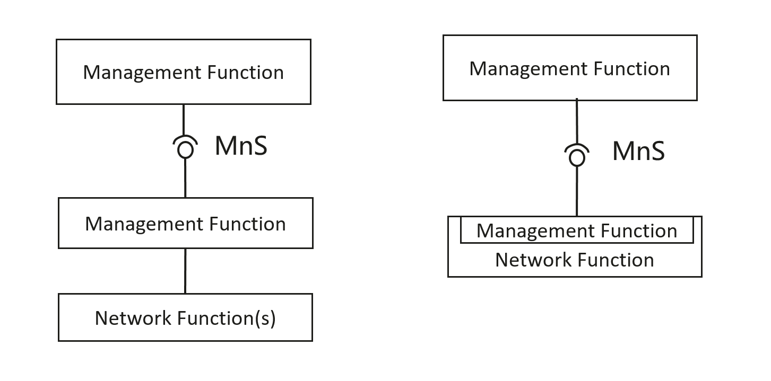
Figure 4.5.2 Examples of MnS deployment scenario
- Some content in TS 32.101 may still applicable and need to be included in TS 28.533.
Analysis#1:
- How reference-point based architecture (32.101) can be realized with management services defined in SBMA specified in TS 28.533 needs to be investigated. For example, whether the management services applied to “Interfaces from Operations Systems to NEs (Type 1 & 2) ” could be also applicable for Interface from Operations System to Enterprise System (including interface Type 3).
- Some content in TS 32.101 may still valid or can be revised to applicable for 5G SBMA, e.g. the content Interface levels described in clause5.
- Whether IRP approach applies to non-standalone scenario needs to be studied.

Obervation#2: Some elaboaration description of 28.533 is needed.
- The concept of Management capability exposure governance is described in clause 4.4 and Utilization of management services by Exposure Governance Management Function (EGMF) are described in Annex A.3.
Analysis#2: Some elaboration on the consumer of the services provided by EGMF may be studied, for example, whether the EGMF exposure MnS needs to differentiate the consumer entity in the Operations System, or consumer entity outside the Operations System, or specific consumer entity outside the Operations System.
2. TS 28.533 Clause 5 described the Architecture reference model for SBMA, which including
- General concepts (This is concept of SBMA)
- Management interactions with NFV MANO (This is reference mode for interaction with NFV MANO)
- Management service deployment based on ZSM framework (one potential)
- Management interactions with NWDAF (This is refence mode for interaction one specific NE)
Analysis#3: The reference model for SBMA needs to be elaborated to improve the readibility.

Obervation#3: Architecture work in other groups needs to be taken into account.
ETSI ZSM published the ZSM002 Zero-touch network and service management reference architecture. TMF published the framework of Autonomous Networks consists of “3-layer, 4-closed-loop” and organizes multiple SDO collaboration activity.
Analysis#5: The utilization of SBMA concept in ETSI ZSM reference architecture and TMF framework of Autonomous Networks are needed with considering the inclusion of architecture support of autonomous capabilities.

Based on above analysis, it is necessary to create the activities for enhancement of the service based management architecture in Rel-17.

4 Detailed proposal
1. We propose to start the study on potential enhancement of the service based management architecture in Rel-17 considering the following aspects:
- Investigate the information in TS 32.101 which could be applicable for 5G management architecture.

- Study on how reference-point based architecture (32.101) can be realized with management services defined in SBMA specified in TS 28.533.
- Investigation on whether there are more information in other IRP specifications that should be moved or converted to SMBA information in 28.533.
- Study and clarify the management architecture and management service support for 5G NA and NSA scenarios.
- Study how management capability exposure governance in SBMA could differentiate the exposure capability according to different type of consumers (e.g. operator’s management system, NWDAF etc.), investigate the potential enhancement on architectural models in TS 28.533.
- Take into account of architecture discussion in other management groups.

