3GPP TSG SA WG5 Meeting 135-e S5-211071
electronic meeting, online, 25 January - 3 February 2021

Source: Huawei Technologies Co.,Ltd., Samsung, Intel

Title: pCR 28.814 solution for ECS deployment

Document for: Approval
Agenda Item: 6.5.3

1 Decision/action requested
The group is asked to discuss and approve the proposals.

2 References
[1] TR 28.814 “Study on enhancements of edge computing management”
[2] 3GPP TS 23.558: "Architecture for enabling Edge Applications;"

3 Rationale
Adds an potention solution for ECS deployment.

4 Detailed proposal

1st modified section

7.x ECS lifecycle management

7.x.1 General
Figure 7.x.1-1 shows that the PLMN operator or ECSP as the consumer requests the ECS lifecycle management via the provisioning MnS.
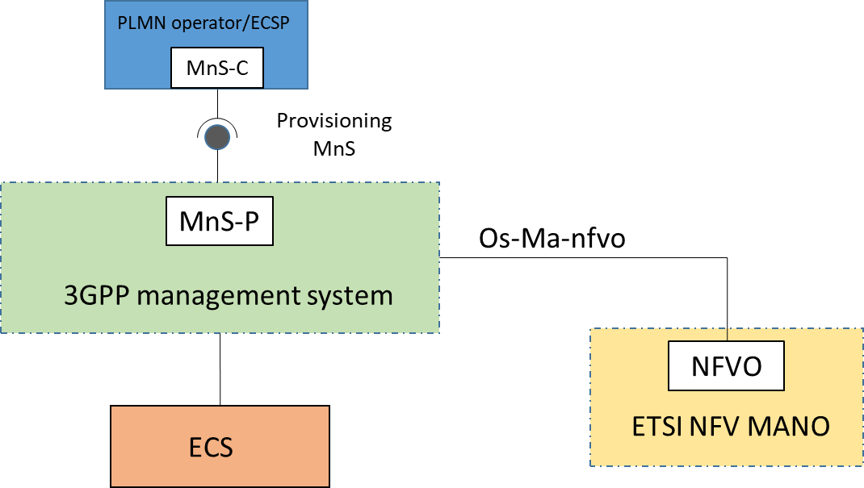

Figure 7.x.1-1: ECS lifecycle management via provisioning MnS
This solution is to support the ECS instantiation and termination use case in 6.2.5 and 6.2.6. To support ECS deployment via provisioning MnS, the ECSFunction IOCs should be defined with the following attributes:
- ECSFunction IOC ID: the identifier of ECS VNF instance.
- End Point: The endpoint address (e.g. URI, IP address) of the ECS.
NOTE: End Point could also be defined as a separate IOC with relationship with ECSFunction IOC.
- Serving EES: Information about EES(s) known to ECS including EES end point
NOTE: Serving EES could also be defined as a separate IOC with relationship with ECSFunction IOC.
- EDN connection information: Information regarding EDN connection including DNN/APN, EES, S-NSSAI etc.
NOTE: This information can be provided after ECS instantiation.
- ECS VNF information: The information needed to instantiate the ECS VNF.
- Software image information (see clause 7.1.6.5 in in ETSI NFV IFA-011 [6])
- Software image location including location, minimum RAM and disk requirements for the software image. (see clause 7.1.6.5 in in ETSI NFV IFA-011 [6])
- Virtual compute resources including virtual CPU, virtual memory and virtual disk

7.x.2 ECS instantiation
The NF instance creation procedure as described in 7.10 of [5] is reused to instantiate the ECS VNF instance with the requirements captured in the ECSFunction IOC. The request is to create the MOI for ECSFunction IOC.

- 7.x.3 ECS termination
The NF instance deletion procedure as described in 7.12 of [5] is reused to terminate a ECS VNF instance by providing the identifier of ECSFunction indicating the ECS VNF instance to be terminated.

End of modified section

