3GPP TSG SA WG5 Meeting 135-e S5-211071
electronic meeting, online, 25 January - 3 February 2021

Source: Huawei Technologies Co.,Ltd., Samsung

Title: pCR 28.814 solution for ECS deployment

Document for: Approval
Agenda Item: 6.5.3

1 Decision/action requested
The group is asked to discuss and approve the proposals.

2 References
[1] TR 28.814 “Study on enhancements of edge computing management”
[2] 3GPP TS 23.558: "Architecture for enabling Edge Applications;"

3 Rationale
Adds an potention solution for ECS deployment.

4 Detailed proposal

1st modified section

7.x ECS lifecycle management by PLMN operator

7.x.1 General
Figure 7.x.1-1 shows that the PLMN operator as the consumer requests the ECS lifecycle management via the provisioning MnS.
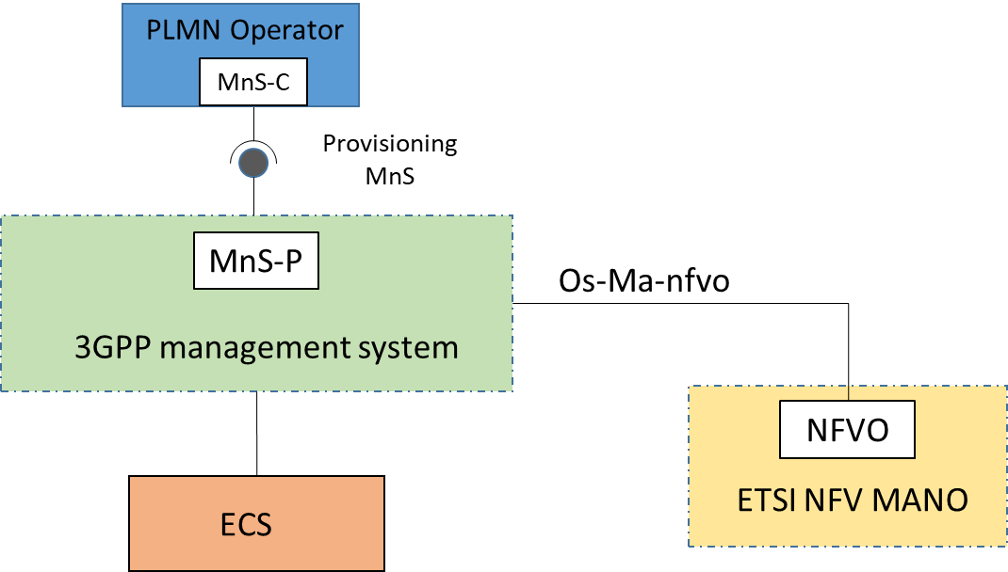
Figure 7.x.1-1: ECS lifecycle management via provisioning MnS
This solution is to support the ECS instantiation and termination use case in 6.2.5 and 6.2.6. To support ECS deployment via provisioning MnS, the ECSFunction IOCs should be defined with the following properties:
- ECSFunction IOC ID: the identifier of ECS VNF instance.
- End Point: The endpoint address (e.g. URI, IP address) of the ECS.
NOTE: End Point could also be defined as a separate IOC with relationship with ECSFunction IOC.
- Serving EES: Information about EES(s) known to ECS including EES end point
NOTE: Serving EES could also be defined as a separate IOC with relationship with ECSFunction IOC.
- EDN connection information: Information regarding EDN connection including DNN/APN, EES, S-NSSAI etc.
Note: This information can be provided after ECS instantiation.

7.x.2 ECS instantiation
The ECS instantiation procedure shall follow the NF instance creation procedure as described in 7.10 of [5] with the following exception:
- The MOI for ECSFunction IOC will be created.
- The creation request may provide set of EDN connection information which this ECS can provide as part of service provisioning procedures as defined in [2].

7.x.3 ECS termination
The ECS termination procedure shall follow the NF instance deletion procedure as described in 7.12 of [5] with the exception of ECSFunction MOI getting deleted.

End of modified section

