3GPP TSG SA WG5 Meeting 135-e TDoc S5-211058

electronic meeting, online, 25 January - 3 February 2021
CR-Form-v12.0
CHANGE REQUEST
 | 28.533 | CR | 0077 | rev | - | Current version: | 16.6.0
For HELP on using this form: comprehensive instructions can be found at
http://www.3gpp.org/Change-Requests.

Proposed change affects: | UICC apps |  | ME |  | Radio Access Network |  | Core Network | X

Title: | Fix errors in Exposure Governance descriptions
Source to WG: | Huawei
Source to TSG: | SA5
Work item code: | TEI15 |  |  |  |  |  | Date: |  |  | 2021-01-15
Category: | A |  |  |  |  |  | Release: |  |  | Rel-16
 | Use one of the following categories:  F (correction)  A (mirror corresponding to a change in an earlier release)  B (addition of feature),  C (functional modification of feature)  D (editorial modification)  Detailed explanations of the above categories can  be found in 3GPP TR 21.900. |  |  |  |  |  |  |  | Use one of the following releases:  Rel-8 (Release 8)  Rel-9 (Release 9)  Rel-10 (Release 10)  Rel-11 (Release 11)  Rel-12 (Release 12)  Rel-13 (Release 13)  Rel-14 (Release 14)  Rel-15 (Release 15)  Rel-16 (Release 16)
Reason for change: |  | Multiple errors exist in the description of management capability exposure governance. This causes the description to be incorrect and inconsistent with the associated figure.
Summary of change: |  | Fix incorrect description.
Consequences if not approved: |  | Incorrect description of management capability exposure governance will cause confusion and possibly incorrect implementations.
Clauses affected: |  | 4.4
 |  | Y | N
Other specs |  |  | X | Other core specifications |  |  |  | TS/TR ... CR ...
affected: |  |  | X | Test specifications |  |  |  | TS/TR ... CR ...
(show related CRs) |  |  | X | O&M Specifications |  |  |  | TS/TR ... CR ...
Other comments:
This CR's revision history:

1st Change

4.4 Management capability exposure governance
As precondition for Management Service exposure governance offer, producer of management capability exposure governance should have access to:
An association between information about specified management service components and instances of management services.
NOTE: The detail creation of an association is left for implementation and out of scope of 3GPP standardization.
Management capability exposure governance provides exposure governance on basic elements of management function service based interface:
1) Management service component type A
2) Management service component type B
3) Management service component type C
As described in Figure 4.4.1 left hand part, when there is a Management Service A exposure without exposure governance, Management Service A Consumer (e.g. 3rd party) can access all management capability offered by Management Service A Producer.
As described in Figure 4.4.1 right hand part, when Management Service A is exposed with applied exposure governance it becomes Management Service A'. Management Service A' Consumer can access Management Service A' after following steps:
- Management Service A, exposed by Management Service A Producer, is consumed by Management Service A Consumer;
- Management Service B, exposed by Management Service B Producer, is consumed by Management Service B Consumer (e.g. operator) who is authorized to access offered management capabilities exposure governance(s);
- Management Service B Consumer (e.g. operator) request a specified exposure governance on Management Service A;
- Management Service A' Producer produces Management Service A' based on applied exposure governance on consumed Management Service A.
NOTE: The Management Service A Consumer, the Management Service A' Producer and Management Service B Producer can be represented as a single Management Function e.g. a single MnF).
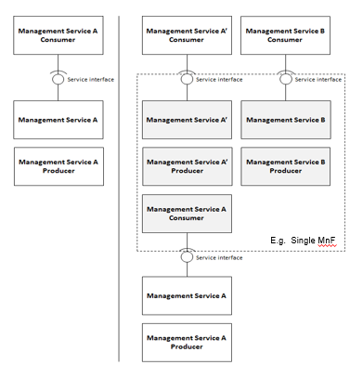
Figure 4.4.1: Management capability exposure governance applied on exposed Management Service A

End of changes

