3GPP TR 28.812 V17.1.0 (2020-12)
Technical Report

3rd Generation Partnership Project;
Technical Specification Group Services and System Aspects;
Telecommunication management; Study on scenarios for Intent driven management services for mobile networks (Release 17)
 | 
The present document has been developed within the 3rd Generation Partnership Project (3GPP TM) and may be further elaborated for the purposes of 3GPP.
The present document has not been subject to any approval process by the 3GPP Organizational Partners and shall not be implemented.
This Specification is provided for future development work within 3GPP only. The Organizational Partners accept no liability for any use of this Specification.
Specifications and Reports for implementation of the 3GPP TM system should be obtained via the 3GPP Organizational Partners' Publications Offices.

3GPP
Postal address

3GPP support office address
650 Route des Lucioles - Sophia Antipolis
Valbonne - FRANCE
Tel.: +33 4 92 94 42 00 Fax: +33 4 93 65 47 16
Internet
http://www.3gpp.org

Copyright Notification
No part may be reproduced except as authorized by written permission.
The copyright and the foregoing restriction extend to reproduction in all media.

© 2020, 3GPP Organizational Partners (ARIB, ATIS, CCSA, ETSI, TSDSI, TTA, TTC).
All rights reserved.

UMTS™ is a Trade Mark of ETSI registered for the benefit of its members
3GPP™ is a Trade Mark of ETSI registered for the benefit of its Members and of the 3GPP Organizational Partners
LTE™ is a Trade Mark of ETSI registered for the benefit of its Members and of the 3GPP Organizational Partners
GSM® and the GSM logo are registered and owned by the GSM Association

Contents

Foreword 6
1 Scope 8
2 References 8
3 Definitions of terms, symbols and abbreviations 9
3.1 Terms 9
3.2 Symbols 9
3.3 Abbreviations 9
4 Concepts and Background 9
4.1 Intent driven management service 9
4.1.1 Introduction 9
4.1.2 Intent driven Management Service (Intent driven MnS) concept 10
4.1.2.1 Overview 10
4.1.2.2 Roles for utilization of intent 11
4.1.2.3 Management Functions 11
4.1.2.4 Intent related to roles description 11
4.1.2.4.0 Use of intents 11
4.1.2.4.1 Intent from Communication Service Customer (Intent-CSC) 12
4.1.2.4.2 Intent from Communication Service Provider (Intent-CSP) 12
4.1.2.4.3 Intent from Network Operator (Intent-NOP) 12
4.1.2.5 Intent driven Management Service (MnS) interactions with 3GPP management functions 12
4.1.3 Intent expression 13
4.1.4 Intent translation 13
4.2 Dimensions of intent driven framework 14
4.2.1 Introduction 14
4.2.2 Definitions 15
4.2.2.1 Users 15
4.2.2.2 Networks 16
4.2.2.3 Operated System 16
4.2.2.4 Infrastructure for automation 16
4.3 Automation mechanisms and intent driven management 16
4.4 Intent Driven Management vs Policy Driven Management 17
4.5 Relation between intent driven MnS and SON 17
4.6 Lifecycle management of intent 18
5 Scenarios for Intent driven management services for mobile network 19
5.1 Scenarios related to Intent-CSC 19
5.1.1 Service deployment 19
5.1.1.1 Introduction 19
5.1.1.2 Pre-condition 19
5.1.1.3 Description 19
5.1.1.4 Post-condition 19
5.1.2 Intent driven service creation 19
5.1.2.1 Pre-condition 19
5.1.2.2 Description 20
5.1.2.3 Post-condition 20
5.1.3 Intent driven Communication Service deployment at the edge 20
5.2 Scenarios related to Intent-CSP 20
5.2.1 Network provisioning 20
5.2.1.1 Pre-conditions 20
5.2.1.2 Description 20
5.2.1.3 Post-conditions 21
5.2.2 NSI resource utilization optimization 21
5.2.2.1 Pre-condition 21
5.2.2.2 Description 21
5.2.2.3 Post-condition 22
5.2.3 Intent driven NSI resource capacity planning scenario 22
5.2.3.1 Pre-condition 22
5.2.3.2 Description 22
5.2.3.3 Post-condition 23
5.2.4 Intent driven NSI performance assurance scenario 23
5.2.4.1 Pre-condition 23
5.2.4.2 Description 23
5.2.4.3 Post-condition 24
5.3 Scenarios related to Intent-NOP 24
5.3.1 Cell Re-home 24
5.3.1.1 Pre-condition 24
5.3.1.2 Description 24
5.3.1.3 Post-condition 25
5.3.2 Area load balance 25
5.3.2.1 Pre-condition 25
5.3.2.2 Description 25
5.3.2.3 Post-condition 26
5.3.3 Instant Cell Updating 26
5.3.3.1 Pre-condition 26
5.3.3.2 Description 26
5.3.3.3 Post-condition 27
5.3.4 Instant Cell Deletion 27
5.3.4.1 Pre-condition 27
5.3.4.2 Description 27
5.3.4.3 Post-condition 28
5.3.5 Intent driven network optimization scenario 28
5.3.5.1 Pre-condition 28
5.3.5.2 Description 28
5.3.5.3 Post-condition 29
5.3.6 Capacity Management 29
5.3.6.1 Introduction 29
5.3.6.2 Pre-condition 29
5.3.6.3 Description 29
5.3.6.4 Post-condition 30
5.3.7 Intent driven NF deployment 30
5.3.7.1 Pre-condition 30
5.3.7.2 Description 30
5.3.7.3 Post-condition 31
5.3.8 Intent driven NF capacity changing 31
5.3.9 Intent driven management for area based deployment scenario 32
5.3.10 Intent driven coverage optimization scenario 33
5.3.10.1 Pre-condition 33
5.3.10.2 Description 33
5.3.10.3 Post-condition 33
6 Introduction and standard consideration for intent driven management service 34
6.1 Introduction 34
6.2 Operation and/or notification used for intent 34
6.3 Intent Expression 35
6.3.1 Description 35
6.3.2 Intent Driven Object 35
6.3.3 Intent Driven Action 35
6.4 Analysis on intent driven scenarios 35
6.4.1 Area Load Balance 35
6.4.4 Network provisioning 39
6.4.5 Area-based radio network 39
6.4.5.1 Introduction 39
6.4.5.2 Area-based radio network deployment intent 40
6.4.6 CSI Deployment at edge (CSIatEdge) 40
7 Key issues of Intent driven MnSstudy 41
7.1 Key issue-1: Study on the level of automation in mobile network management 41
7.2 Key issue-2: Study the scenarios which are related to Intent driven MnS 41
8 Potential requirements for intent driven MnS 41
9 Recommendation and Conclusion 42
Annex A: Categories for Intent driven management services scenarios 44
Annex B: Change history 45

Foreword
This Technical Report has been produced by the 3rd Generation Partnership Project (3GPP).
The contents of the present document are subject to continuing work within the TSG and may change following formal TSG approval. Should the TSG modify the contents of the present document, it will be re-released by the TSG with an identifying change of release date and an increase in version number as follows:
Version x.y.z
where:
x the first digit:
1 presented to TSG for information;
2 presented to TSG for approval;
3 or greater indicates TSG approved document under change control.
y the second digit is incremented for all changes of substance, i.e. technical enhancements, corrections, updates, etc.
z the third digit is incremented when editorial only changes have been incorporated in the document.
In the present document, modal verbs have the following meanings:
shall indicates a mandatory requirement to do something
shall not indicates an interdiction (prohibition) to do something
The constructions "shall" and "shall not" are confined to the context of normative provisions, and do not appear in Technical Reports.
The constructions "must" and "must not" are not used as substitutes for "shall" and "shall not". Their use is avoided insofar as possible, and they are not used in a normative context except in a direct citation from an external, referenced, non-3GPP document, or so as to maintain continuity of style when extending or modifying the provisions of such a referenced document.
should indicates a recommendation to do something
should not indicates a recommendation not to do something
may indicates permission to do something
need not indicates permission not to do something
The construction "may not" is ambiguous and is not used in normative elements. The unambiguous constructions "might not" or "shall not" are used instead, depending upon the meaning intended.
can indicates that something is possible
cannot indicates that something is impossible
The constructions "can" and "cannot" are not substitutes for "may" and "need not".
will indicates that something is certain or expected to happen as a result of action taken by an agency the behaviour of which is outside the scope of the present document
will not indicates that something is certain or expected not to happen as a result of action taken by an agency the behaviour of which is outside the scope of the present document
might indicates a likelihood that something will happen as a result of action taken by some agency the behaviour of which is outside the scope of the present document
might not indicates a likelihood that something will not happen as a result of action taken by some agency the behaviour of which is outside the scope of the present document
In addition:
is (or any other verb in the indicative mood) indicates a statement of fact
is not (or any other negative verb in the indicative mood) indicates a statement of fact
The constructions "is" and "is not" do not indicate requirements.

1 Scope
The present document describes, intent driven management concept, intent driven management scenarios, and recommendation for the way forward on standardization expression of the intent in normative phase. The relation with other automation mechanisms is also addressed in this study.
The present document considers below dimensions when studying Intent driven management. For each dimension the scope is narrowed down to a certain aspect:
1) Users; The study covers the Technical (NOP, NEP) and Techno-Business (CSP)
2) Networks; The study covers the 5G and 4G
3) Operated System; The study covers the Co-ordinated and Complex systems
4) Infrastructure Automation; The study covers more Autonomous and less Automatic
5) Language; The scope covers more declarative and less Imperative

2 References
The following documents contain provisions which, through reference in this text, constitute provisions of the present document.
- References are either specific (identified by date of publication, edition number, version number, etc.) or non-specific.
- For a specific reference, subsequent revisions do not apply.
- For a non-specific reference, the latest version applies. In the case of a reference to a 3GPP document (including a GSM document), a non-specific reference implicitly refers to the latest version of that document in the same Release as the present document.
[1] 3GPP TR 21.905: "Vocabulary for 3GPP Specifications".
[2] 3GPP TS 28.531: "Management and orchestration; Provisioning".
[3] 3GPP TS 28.530: "Management and orchestration; Concepts, use cases and requirements".
[4] 3GPP TS 28.552: "Management and orchestration; 5G performance measurements".
[5] 3GPP TS 28.554: "Management and orchestration; 5G end to end Key Performance Indicators (KPI)".
[6] 3GPP TS 28.533: " Management and orchestration; Architecture framework".
[7] IETF RFC 3198: Terminology for Policy-Based Management
[8] 3GPP TS 28.545: "Management and orchestration; Fault Supervision (FS)".
[9] 3GPP TS 28.532: "Management and orchestration; Generic management services".
[10] 3GPP TS 28.550: "Management and orchestration; Performance assurance".
[11] 3GPP TS 28.541: "Management and orchestration of 5G networks; Network Resource Model (NRM); Stage 2 and stage 3".
[12] 3GPP TR 28.805: "Study on management aspects of communication services".
[13] 3GPP TS 28.628: "Telecommunication management; Self-Organizing Networks (SON) Policy Network Resource Model (NRM) Integration Reference Point (IRP); Information Service (IS)".

3 Definitions of terms, symbols and abbreviations

3.1 Terms
For the purposes of the present document, the terms given in 3GPP TR 21.905 [1] and the following apply. A term defined in the present document takes precedence over the definition of the same term, if any, in 3GPP TR 21.905 [1].
Policy management: A function that governs the choices in behaviour of a system.
NOTE: It specifies the action(s) to be taken when specified condition(s) occur. See IETF RFC 3198 [7] for details about definition and terminologies for policy driven management.
Intent: A desire to reach a certain state/position for a specific entity for instance for a service assurance or network deployment task.
NOTE: An intent does not define the necessary steps to get to the wanted state.
Intent driven MnS: A management service that allows its consumer to express an Intent.

3.2 Symbols
Void.

3.3 Abbreviations
For the purposes of the present document, the abbreviations given in 3GPP TR 21.905 [1] and the following apply. An abbreviation defined in the present document takes precedence over the definition of the same abbreviation, if any, in 3GPP TR 21.905 [1].
CSC Communication Service Customer
CSP Communication Service Provider
Intent-CSC Intent from Communication Service Customer
Intent-CSP Intent from Communication Service Provider
Intent-NOP Intent from Network Operator
MOI Managed Object Instance
MnS Management Service
NEP Network Equipment Provider
NOP Network Operator
NSI Network Slice Instance
VISP Virtualization Infrastructure Service Provider

4 Concepts and Background

4.1 Intent driven management service

4.1.1 Introduction
Introduction of service-based architecture for 5G, in combination with functional model of business roles, exceeds the level of complexity for managing deployment and assurance use case scenarios both in a single and multivendor network. New/simpler ways of managing are needed.
Intent driven management service (Intent driven MnS) reduces the complexity of management without getting into the intricate detail of the underlying network infrastructure. It will also contribute to efficient network management, especially in a multiple vendor scenario.

4.1.2 Intent driven Management Service (Intent driven MnS) concept

4.1.2.1 Overview
An Intent driven MnS allows its consumer to express desired intent for managing the network and services. The Intent driven MnS producer paraphrases the intent to executable actions for service assurance and deployment.
The executable actions can be one or more of the following:
- Perform network management tasks
- Identifying, formulating and activating network management policies
The following figure 4.1.2.1-1 shows the model elements of the MnS and usage of the Intent driven MnS between consumer and producer
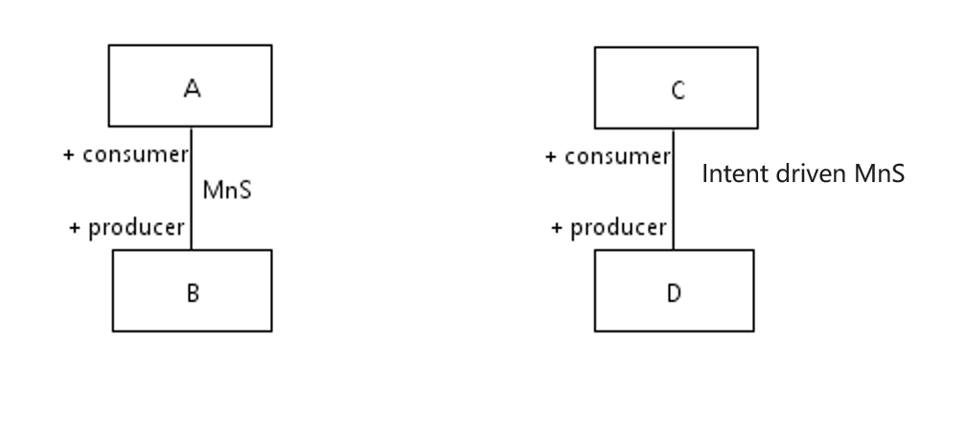
Figure 4.1.2.1-1: Model elements of MnS and Intent driven MnS
The combination of management service components (see subclause 4.3 in TS 28.533 [6]) for Intent driven MnS is described as follows:
- MnS component type A, the operations and/or notifications agnostic of specified intent type, for example, a generic operation to transfer intent from Consumer to Producer.
- MnS component type B, the model of intent, which is used to modelling the intent expression information described in clause 4.1.3. As examples described in clause 4.1.3, the intent driven model may include 'Action' and 'Object'.
- MnS component type C, performance information and fault information related to the intent
The MnS of various kinds are specified for deployment over many standardized reference interfaces. So, the Intent driven MnS could in principle, be specified for deployment over the same set of standardized reference interfaces, as a replacement of or as an addition to the deployed MnS, where the consumer focuses on the 'what' and the producer is concerned about the 'how'.
The following figure 4.1.2.1-2 shows an example using Intent driven MnS to provision a service.
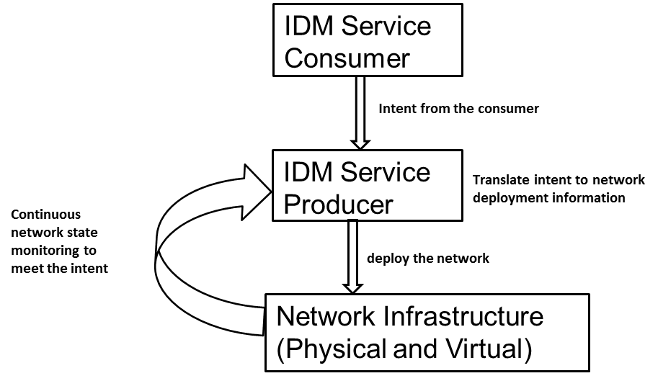
Figure 4.1.2.1-2: An example of using Intent driven management service for network provisioning

4.1.2.2 Roles for utilization of intent
In an intent driven management service the roles for utilization of intent are defined as:
- Communication Service Customer (CSC): The communication service customer expresses intents for communication services. This role is not necessarily aware of the network and service operations. The CSCs will monitor the expressed intents. For details about this role see 3GPP 28.530 [3].
- Communication Service Provider (CSP): Expresses the intents for deployment (build, design) and assurance (operation) for communication services. The CSPs will monitor the expressed intents.
- Network Operator (NOP): Expresses the intents for deployment (build, design) and assurance (operation) for network and infrastructure resources. NOPs will monitor the expressed intents.

4.1.2.3 Management Functions
A Management Function captures the essence of what is managed, by implementing the network resource model governed by that management function and providing management data, operations and notifications.
A Management Function can produce or consume both classic and intent driven MnSs, letting any management layer to be intent driven.

4.1.2.4 Intent related to roles description

4.1.2.4.0 Use of intents
Different kinds of intents are applicable for different kinds of standardized reference interfaces.
- Intent from Communication Service Customer (Intent-CSC)
- Intent from Communication Service Provider (Intent-CSP)
- Intent from Network Operator (Intent-NOP)
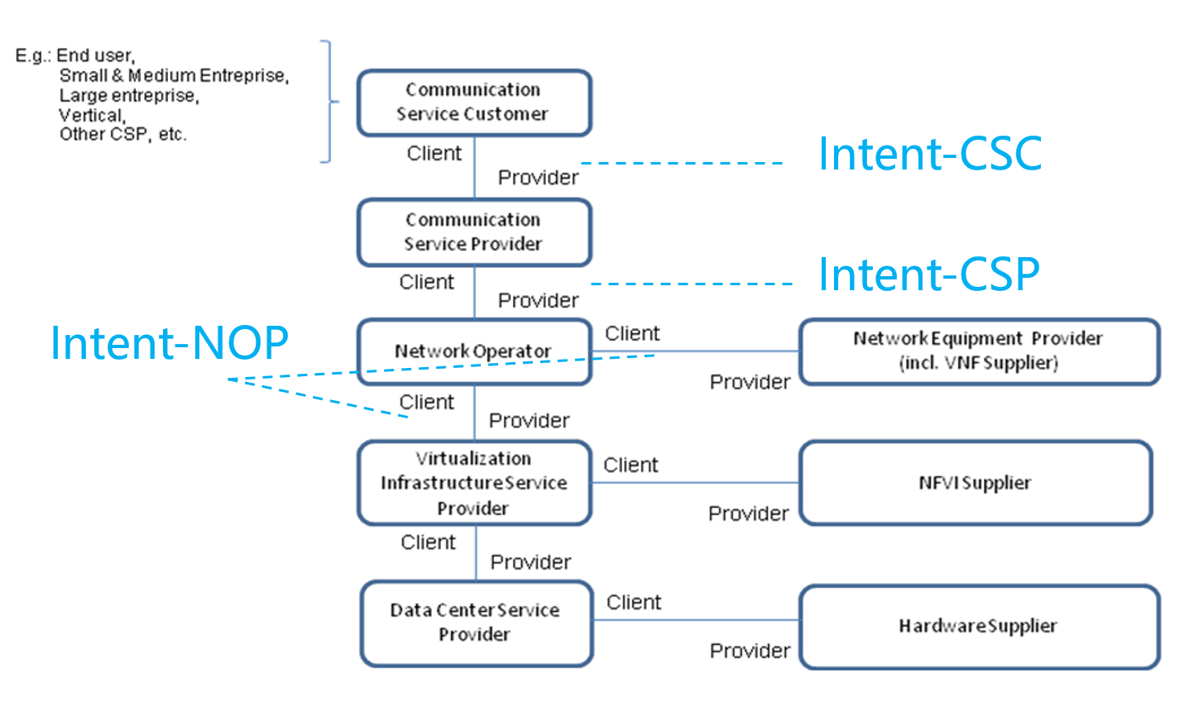
Figure 4.1.2.4.0-1: Concept for utilization of intent

4.1.2.4.1 Intent from Communication Service Customer (Intent-CSC)
Intent from Communication Service Customer enables Communication Service Consumer (CSC) to provide what CSC would like to do for the communication service management without knowing how to do the detailed management. The CSC may not need to be aware of the details of the network and service operation when using the communication services. The CSC only provides communication service management related intent(s) to CSP. The received intents are translated to network management related intents or detailed network management requirements.
After the intent received or implemented, CSP provides the feedback information to the CSC consumer. The feedback information include information indicating whether the intent is successfully executed or not, and possibly the reasons for not successful executions (e.g., conflicting with existing intents).

4.1.2.4.2 Intent from Communication Service Provider (Intent-CSP)
Intent from communication service provider enables Communication Service provider (CSP) to express an intent about what CSP would like to achieve in the network management without knowing how to do the detailed management. The CSP may not need to have professional knowledge of network operations. The CSP only provides network management related intent(s) to the NOP, and the NOP translate the received intent(s) to network equipment management related intents or detailed network equipment management requirements.
After the intent received and implemented, NOP provides the feedback information to the CSP.

4.1.2.4.3 Intent from Network Operator (Intent-NOP)
Intent from network operator enables Network Operator (NOP) to provide what NOP would like to do for the network resource management without knowing how to do the detailed management. The NOP may not have professional knowledge of network equipment operation or virtualized infrastructure operation. There are two type of Intent-NOP:
- Intent-NOP for NEP, the NOP only expresses network equipment management related intent to the NEP, and the NEP translates the received intent to network equipment management requirements.
- Intent-NOP for VISP, the NOP only expresses virtualized infrastructure resource management related intent to the VISP, and the VISP translates the received intent to virtualized infrastructure resource requirements.
After the intent implemented and received, NEP or VISP provides the feedback information to the NOP. The feedback information see clause 4.1.2.2.

4.1.2.5 Intent driven Management Service (MnS) interactions with 3GPP management functions
The following figure shows the interaction of intent driven management service (MnS) with management functions.
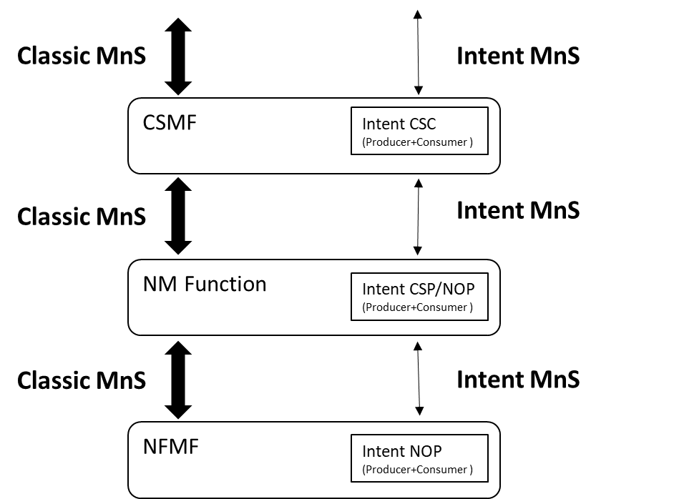
Figure 4.1.2.5.1: The intent driven management service (MnS) vs classic MnS
The Classic MnSs are specified as follows; Fault Supervision TS 28.545 [8], TS 28.532 [9], Provisioning TS 28.531 [2], TS 28.532 [9] and Performance Assurance TS 28.550 [10], TS 28.532 [2], Network Resource Model (NRM) TS 28.541 [11], Performance measurements and assurance data TS 28.552 [4] and 5G End-end Key Performance Indicators (KPI's) TS 28.554 [5].
Note 1: The MnS provided by the CSMF is described in TR 28.805 [12].
Note 2: The interactions between Classic MnS and Intent driven MnS is not addressed in the present document.

4.1.3 Intent expression
An intent is a desire to reach a certain state/position for a specific entity for instance for a service assurance or network deployment task. When an intent is expressed by a consumer, it needs to be interpreted by the producer without any ambiguity. This can be achieved by using a machine-readable input, for instance a declarative language.
The intent expression information may include particular objective and possibly some related details. For example, the intent expression from CSC may contain elements such as 'Car A wants to acquire V2X communication service' which include 'acquire' and 'V2X communication service' in its intent expressions. The intent expression from CSP may contain elements such as 'Provide V2X communications for highway-417 to support 500 vehicles simultaneously' which include 'provide' and 'V2X communications'. The intent expressed from NOP to NEP may contain elements such as 'optimize the network to satisfy certain performance requirements' which include 'optimize' and 'target performance requirements' in its intent expressions. It is the Intent driven MnSProducers' responsibility to translate the intent expression information into services, network operations, and related resource requirements, to fulfil the intent.

4.1.4 Intent translation
The Intent MnS service producer is the provider of Intent driven MnS and is responsible for deriving activities for networks and services or other intent(s).
The MnS consumer may consume Intent Driven MnS(s) provided by the Intent driven MnS producer(s) or may have the consumer role for non-intent MnS producers.
The conflict(s) including conflict between the intent and other intent(s) and/or Non-intent requirements needs to be detected and resolved during the intent translation. Figure 4.1.4-1 illustrate the potential way to execute intents:
- Intent-CSC MnS producer provides intent driven MnS for communication services. Intent-CSC MnS producers receive the expressed intent and translate it to Intent-CSP or network requirements, then may consume Intent-CSP MnS(s) or Non-Intent MnS(s) for network to fulfil the intent-CSC.
- Intent-CSP MnS producer provides intent driven MnS for network services. Intent-CSP MnS producers receive the intent and translate it to new Intents for NOP or network element requirements, then may consume Intent-NOP MnS(s) or Non-Intent MnS(s) for NE to fulfil the intent-CSP.
- Intent-NOP MnS producer provides intent driven MnS for network equipment. Intent-NOP MnS Producers receive the expressed intent, and translate it to detailed network element requirements, then takes some internal actions to fulfil the intent-NEP.
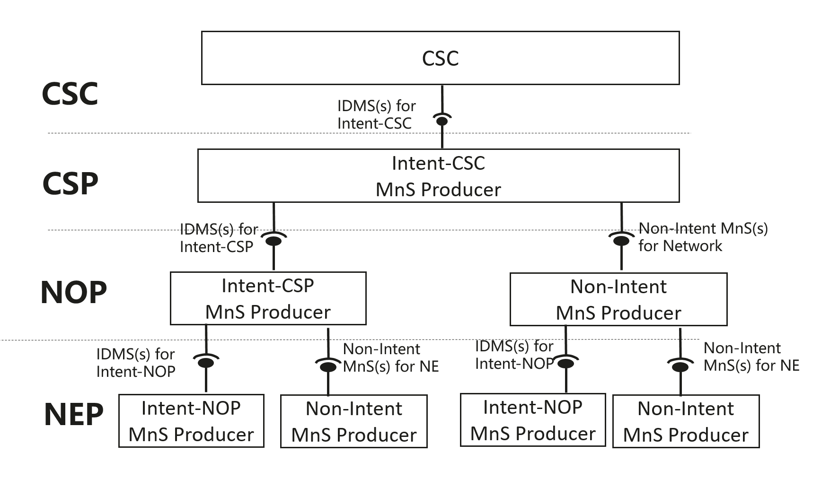
Figure 4.1.4-1: Potential way to satisfy intent-CSC

4.2 Dimensions of intent driven framework

4.2.1 Introduction
The dimensions shown in the figure 4.2.1-1 illustrates various aspects of intent driven management and shows the boundaries to the ambition aspects of intent driven management solution.
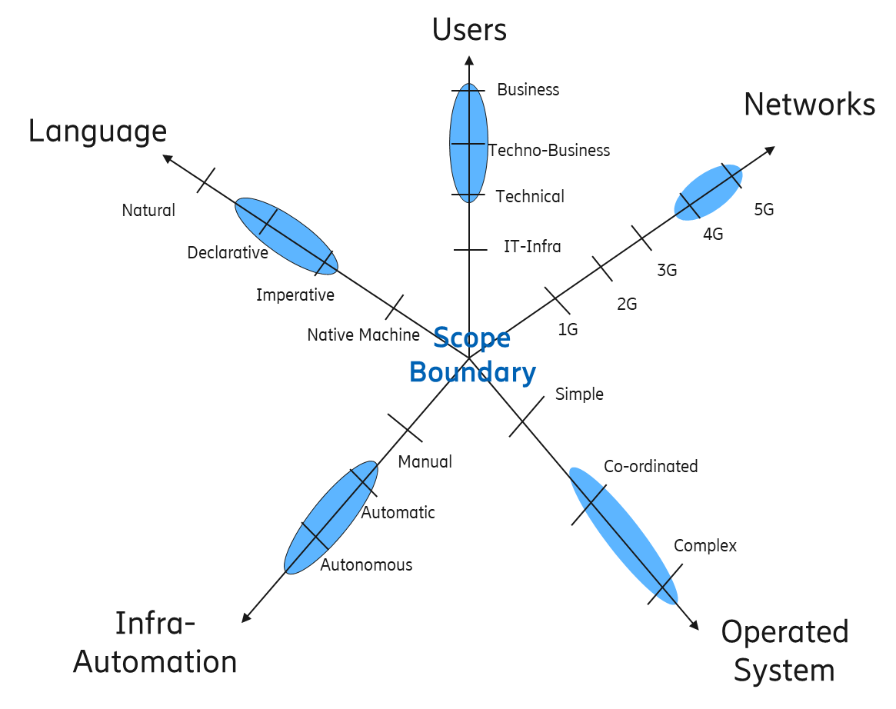
Figure 4.2.1-1: Dimension of intent
Note: The relation between the Operated system and Management system (Intent driven MnS producer as a part of it) needs to be clarified and is not addressed in the present document.

4.2.2 Definitions

4.2.2.1 Users
In an intent driven management system, the type "user" is one of the dimensions that plays a role in the definition of the intent driven management system capabilities. The user of the system will bring expertise from its role and responsibilities and will have certain expectations on what the system might do. The user dimension and its levels proposed for the study are those from the 28.530, Figure 4.8.1 [2]:
IT Infra user type: these are the Data Centre Service Provider and the Virtualization Infrastructure Service Providers.
Technical user type: these are the Network Operators which may or may not combine this role with that of Communication Service Provider, In the case of a combined role the organization will have a technical department taking care of network operations and a more customer centric role taking care of the communication services.
Techno-business user type: these are the Communication Service Providers with a more customer and business centric role providing communication services to different type of customers.
Business user type: these are the organizations that traditionally do not have a telecom or IT background and focus on the business aspects, work closely together with CSP and NOP to enable ubiquitous communication for their industry or business.

4.2.2.2 Networks
Supported technology; LTE, 5G, ….
Mobile networks have evolved over different generations and the intent expression used and interpretation of the intent may vary between generations therefore the generation of the mobile network technology is a dimension.

4.2.2.3 Operated System
The operated system are the systems that are the receivers and processors of the intent. The technological evolution has enabled operated system to become more complex through the introduction of artificial intelligence and machine learning. While previous generations of operated system are classified as simple (and maybe not as open as today's operated system), the introduction of "virtualization" has made operated system more flexible as various system functions can be co-ordinated in an agile sort of way. Maybe the co-ordinated system is generally the current state of the technology, while complex system with AI and ML are there but not on a ubiquitous scale. These complex systems will require governance by intents and policies.

4.2.2.4 Infrastructure for automation
This dimension is about the ability of an intent driven system to learn from its environmental context and apply those learnings to resolution of intent expressions. The more context the system can learn the less information needs to be expressed in the intent.
Wikipedia:
Automatic is Capable of operating without external control or intervention. (more automatic or less automatic)
Autonomous is Self-governing. Intelligent, sentient, self-aware, thinking, feeling, governing independently.
4.2.2.5 Language
A language is used to express an instruction/activity/operation. There are different types of languages:
- Native Machine language: An instruction is expressed in native machine language (Basically, used to refer to the native computer code i.e. binary code).
- Imperative: An instruction is expressed in simple statements. It focuses more on describing the "How" but less on "What".
- Declarative: An instruction is expressed without describing control flow. It focuses more on describing the "What" but less on "How".
- Natural: An instruction is expressed in human language.

4.3 Automation mechanisms and intent driven management
The Intent driven MnS producer may utilize management closed-loop automation mechanisms (e.g. continuously monitor the intent fulfilment status, analyse the service and network information and meet the intent automatically etc.). The closed-loop automation mechanisms to achieve the intent are the implementation of the producer and are not standardized. The closed-loop automation of Intent driven MnS Producer is shown in the figure 4.3-1.
For example, to satisfy the Intent-NOP for NEP, after Intent-NOP MnS Producer translates the received intent to network equipment management requirements, the Intent-NOP MnS Producer may continuously monitoring the intent fulfilment status, making analysis and adjust the network automatically to meet the intent requirements. Some SON automatic mechanisms could be reused by the producer if needed.
Figure 4.3-1: Closed-loop automation of Intent driven MnS producer

4.4 Intent Driven Management vs Policy Driven Management
A policy is a function that governs the choices in behavior of a system. It specifies the action(s) to be taken when specified condition(s) occur. See IETF RFC 3198 [7] for details about definition and terminologies for policy driven management.
An intent defines to what position (in what state) the consumer wants as specific entity to be. The necessary steps to get to this position is not defined by the intent but by policy.
The relation between the policy driven management (rule based) and intent driven management is shown in the figure below.
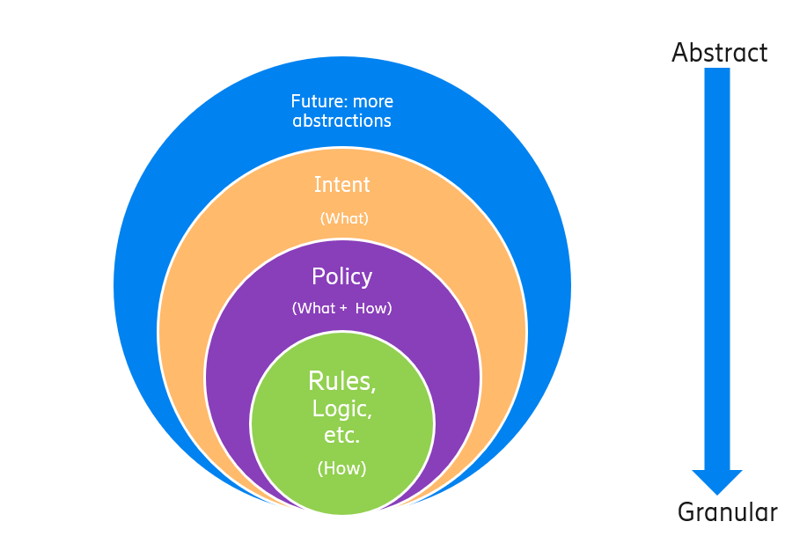
Figure 4.4-1: Intent driven management vs Policy driven management
This figure describes the "What-How" view. As it now stands, the systems are mainly focused on "How" and "less What". The networks like 5G brings more operational complexities, which is driving systems to shift the focus from "How" to "What". The first step towards that shift, has been "Policy driven management", with more focus on "How" and less on "What" covering domain specific issues/aspects. As technologies are evolving and the level of complexity exceeds, the need for an abstraction level (Intent) becomes more apparent. An intent driven system will be able to learn the behavior of networks and services and allows an operator to provide the desired state, without detailed knowledge of how to get to the desired state.

4.5 Relation between intent driven MnS and SON
SON target information can be derived from Intent, which means MnS producer can translate the intent to SON target information (e.g. the UE throughput intent can be translated to SON target information to for one or multiple SON, e.g. CCO, HO, etc) or MnS producer can use the information in the intent for SON target directly (e.g. information in the area load balance intent can be used for SON target of LBO Function).

4.6 Lifecycle management of intent
An intent is subject to lifecycle management. An intent request is mapped to an expression that can be interpreted by a computer and processed with some input parameters from the request and parameters from the system. The intent is an instantiation of the intent expression and the associated parameters. This is captured by the system and lifecycle managed. The lifecycle management operations of intent may include:
1) Create intent, MnS Consumer deliver a new intent to MnS Producer.
2) Activate intent, MnS Consumer request the MnS Producer to activate an intent when the intent is inactive.
3) Monitor the network service and performance before and after the implementation of the intent to evaluate the effect of the intent on the performance [KPIs].
4) Supervise the fault status before and after the implementation of the intent to evaluate the effect of the intent on the fault status.
5) De-activate intent, MnS consumer request the MnS Producer to de-activate an intent. For example, for optimization related intent, the MnS Consumer may request to de-activate the intent for a period of time.
6) Delete intent, MnS Consumer request the MnS Producer to remove an intent.
7) Query intent, MnS Consumer request MnS Producer to return information, including content of the intent, state of the intent (e.g. active, inactive), fulfilment information of the intent.
8) Rollback intent, MnS Consumer requests to revert the active intents of the MnS Producer to a certain previous state, for example in case problems are detected during the monitor and supervise operations.
NOTE: The need for all actions above and details would be further discussed in the normative phase.
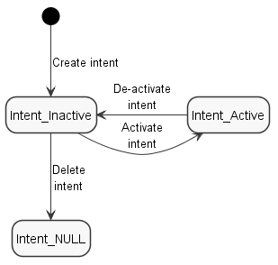
Figure 4.6-1: The transition of the intent state with lifecycle management operations

5 Scenarios for Intent driven management services for mobile network

5.1 Scenarios related to Intent-CSC

5.1.1 Service deployment

5.1.1.1 Introduction
In this business scenario a service provider organization expresses the intent to provide a new service to its customers. The business intent can result in a number of intent expressions that cover various aspects of the business intent.

5.1.1.2 Pre-condition
See description.

5.1.1.3 Description
In an organization, the research and market groups perform analysis and provides input to the Service Strategy & Planning group. The Service Strategy & Planning group identifies service capabilities and geographical locations where the services should be running. Based on these results the business group expresses their intent to introduce "a new service for priority customers". This may lead to it, that parts of the organization have to take actions concerning the expressed intent.
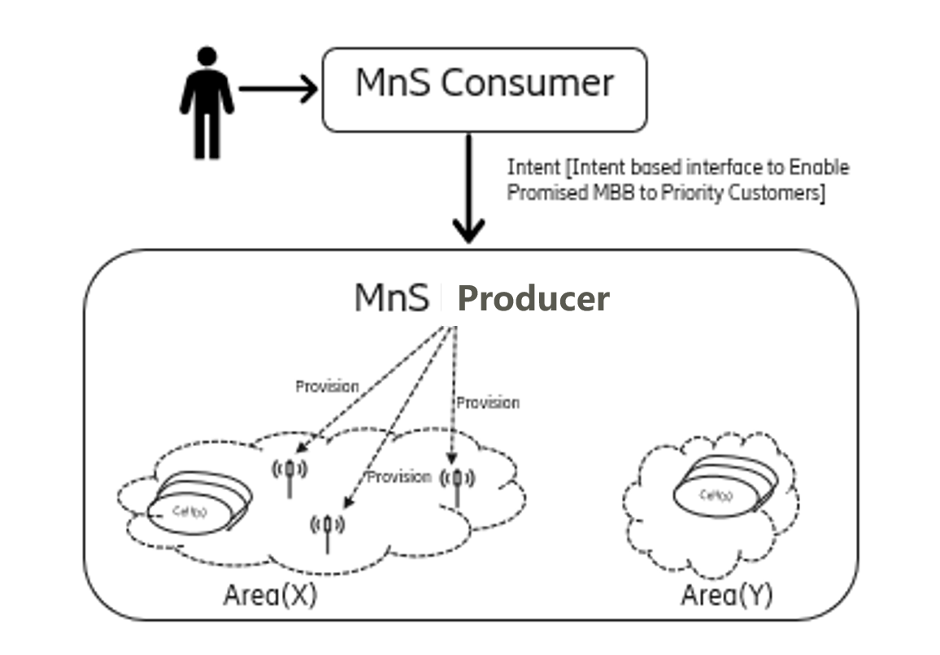
Figure 5.1.1.3-1: Enable MBB Service to Priority Customers

5.1.1.4 Post-condition
Successful activation of the service.

5.1.2 Intent driven service creation

5.1.2.1 Pre-condition
A communication service customer expresses its intent to order a 3GPP service to support a group of end users.

5.1.2.2 Description
In order to enable a group of end users to connect to a 3GPP network, a communication service customer (CSC) as a MnS Consumer expresses its intent to order a 3GPP service to CSP. The MnS producer in the CSP translates the CSC's intent to relevant 3GPP service creation requirements (e.g. routing configuration needed to connect the group of users to the corresponding data network, QoS requirements (e.g., latency, jitter, error rate, etc.) and relevant authentication and authorization rules specifying that only the users specified by the CSP can access the network).

5.1.2.3 Post-condition
The requested 3GPP service for a specified group of end users is provisioned.

5.1.3 Intent driven Communication Service deployment at the edge
5.1.3.1 Introduction
In this scenario a CSC expresses the intent to deploy a URLLC service at the edge of the network. The intent is expressed in terms of service requirements. The service is deployed without the CSC knowing the details of service components, their configuration and provisioning.
5.1.3.2 Pre-condition
CSC express the intent to deploy a URLLC service at the edge of the network.
5.1.3.3 Description
CSC, as the MnS consumer, express the intent to deploy a URLLC service at the edge of the network. The service requirements are expressed in terms of service description (e.g. availability), required SLA (e.g. latency) and the information to identify the edge (e.g. geographical area) where the service needs to be deployed. The MnS producer in the CSP translates the CSC's intent to relevant procedures to be done, including:
- Identifying the network edge to be used according to the information provided for the same in the Intent expression.
- Identifying the CS profile available as per the service description and the SLA provided.
- Identification of the resources (NSI/NSSI) to be assigned to the service. The NSI/NSSI selected contains the suitable edge application required to provide the service (e.g. a video streaming server for an ultra-low latency video streaming service).
- Evaluation of the virtual resources available to the NSI and need to assign more resources, if required.
5.1.3.4 Post-condition
Successful activation of the requested service at the network edge.

5.2 Scenarios related to Intent-CSP

5.2.1 Network provisioning

5.2.1.1 Pre-conditions
The network consumer (e.g. vertical customer etc.) wants the network producer to allocate a network to satisfy the network consumer's intent (e.g. provided with specific network characteristics).
The network provider analyses the intent and triggers the network allocation.

5.2.1.2 Description
The network consumer as MnS consumer expresses his intent for a network by providing high level requirements (e.g. the service type to be supported with corresponding geographical areas and time durations, maximum number of UEs, DL/UL throughput per UE) to MnS consumer). The network consumer does not care about what network elements are used and how to connect those network elements.
The MnS consumer translates the intent from the MnS consumer to network deployment related requirements (e.g. using network slice or not, network topologies, etc.) and configurations (e.g. radio access network configurations such as cell list, TA list, DL/UL throughput per cell and UE measurements or core network configurations such as capacity, memory). According to these network related requirements, the MnS consumer provides the network to satisfy the intent of the MnS consumer, using the network provisioning procedures described in clause 7 in TS 28.531 [2].
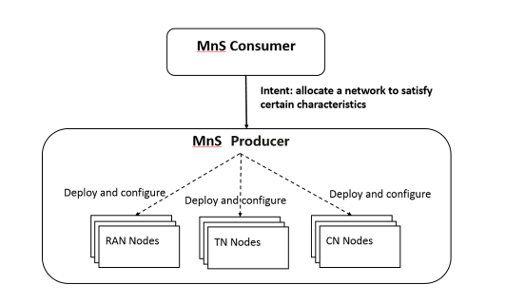
Figure 5.2.1.2-1: Network provisioning

5.2.1.3 Post-conditions
The requested network as expressed in the intent from the network consumer is provisioned.

5.2.2 NSI resource utilization optimization

5.2.2.1 Pre-condition
Operator wants to optimize the NSI resource utilization efficiency. Since the network resource has a wide scope, the operator needs to determine further details, e.g. the aspect of resource utilization efficiency. For instance, the operator can indicate desired network utilization KPIs such as mean number of PDU sessions of network and NSI, and virtualised resource utilization of NSI. The operator can also determine the optimization to be end-to-end or focused on a selected geographical area.

5.2.2.2 Description
In order to enhance its services, Operator as MnS Consumer expresses intent to optimize NSI resource utilization to improve network usage efficiency. The intent expression for NSI resource utilization can include information on target resource utilization related KPIs, service quality requirements which can(not) be compromised, service areas for which the NSI resource utilization should be optimized, and other relevant information.
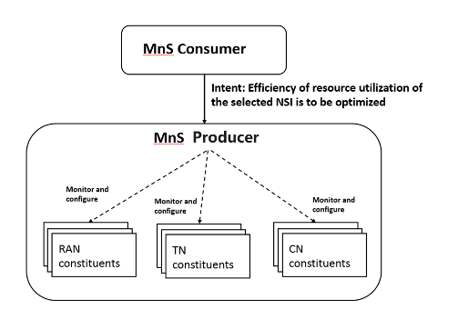
Figure 5.2.2.2-1: NSI Performance optimization scenario
Based on the intent expression, the MnS Producer decides on necessary configurations and monitoring for NSI components. Handling the complexity of the optimization process is the responsibility of the MnS Producer, which simplifies the process from the perspective of the MnS Consumer. MnS Producer can utilize SON and MDA services to monitor and predict the performance of each component, and take some actions to fulfil the intent received from the operator.

5.2.2.3 Post-condition
Operator's intent that the network resource utilization optimization is fulfilled by the MnS Producer.

5.2.3 Intent driven NSI resource capacity planning scenario

5.2.3.1 Pre-condition
The NSI consumer (e.g. vertical slice customer etc.) wants the NSI Producer to plan the NSI resource in an optimal status to satisfy the NSI consumer's intent (e.g. NSI resource capacity utilization over 90 %, frequency (daily, weekly, monthly, etc.), scope (IDs of target NSIs)).
The NSI Producer analyses the intent and triggers the requested NSI capacity planning operation.

5.2.3.2 Description
The NSI consumer as provisioning MnS consumer expresses his intent for a NSI resource capacity planning (e.g. desired utilization ratio of the target NSI, indication of pre-emption of existing provisioned resources, frequency (daily, weekly, monthly, etc.), scope (target NSIs), etc.) to provisioning MnS Producer. The NSI consumer does not care about what capacity planning optimization algorithm is used.
The MnS Producer translates the intent from the MnS consumer to the implementable NSI resource capacity planning related requirements and performs NSI resource capacity planning operation to satisfy the intent of the MnS consumer. All implementable NSI resource capacity planning related requirements and associated procedure are described in TS 28.531 [2].
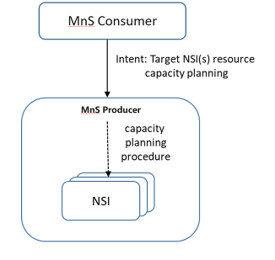
Figure 5.2.3.2-1: An example of intent driven NSI resource capacity planning scenario

5.2.3.3 Post-condition
The requested NSI resource capacity planning requirements as expressed in the intent from the NSI consumer is fulfilled and the result of the NSI resource capacity planning procedure is notified.

5.2.4 Intent driven NSI performance assurance scenario

5.2.4.1 Pre-condition
The NSI consumer (e.g. vertical slice customer etc.) wants the NSI Producer to assure the performance of the provided NSI based on its intent (e.g. type of services that need performance assurance, granularity of performance assurance report notifications, etc.).
The NSI Producer translates the intent and triggers the requested NSI performance assurance operations including resource provisioning based on the performance requirements, performance monitoring, and performance notification.

5.2.4.2 Description
The NSI consumer as performance assurance MnS consumer expresses his intent for a NSI performance assurance (e.g. high-level abstraction of the SLA for performance assurance, granularity of performance assurance report notifications, etc.) to performance assurance MnS Producer. The NSI consumer does not care about what the details of mechanisms to assure the performance.
The MnS Producer translates the intent from the MnS consumer to the implementable NSI performance assurance related requirements and provisions target resources, deploy performance monitoring management services, and perform periodic optimization operations to ensure the target KPIs through the associated performance assurance related management services. It also generates performance assurance reports and notifies to the MnS consumers.
All implementable NSI performance assurance related requirements and associated procedures are defined in TS 28.531 [2], 28.550 [3], 28.552 [4], 28.554 [5].
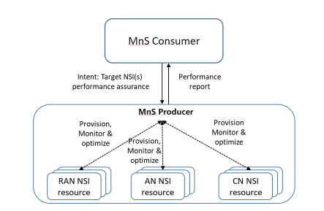
Figure 5.2.4.2-1: An example of intent driven NSI performance assurance scenario

5.2.4.3 Post-condition
The requested NSI performance assurance requirements as expressed in the intent from the NSI consumer is fulfilled.

5.3 Scenarios related to Intent-NOP

5.3.1 Cell Re-home

5.3.1.1 Pre-condition
The operator wants to re-home a selected Cell from source RAN Node to destination RAN Node.
The selected Cell has already been deployed.

5.3.1.2 Description
Due to network planning or load balance between different RAN Nodes, the operator wants to re-home a selected Cell from source RAN Node to destination RAN Node. So operator as MnS Consumer expresses his intent that the selected Cell needs to be rehomed from the source RAN Node to the destination RAN Node to the MnS Producer.
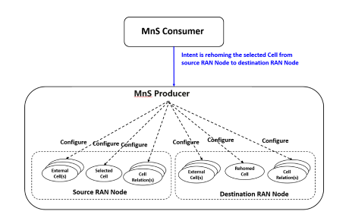
Figure 5.3.1.2-1: An example of cell Re-home scenario
MnS Producer associates the selected re-home Cell to the destination RAN Node.
MnS Producer may adjust corresponding cell relations of the selected Cell and its neighbour cells within the management scope. MnS Producer may also adjust corresponding external neighbour Cell.
MnS Producer may notify other MnS Producer (s) to adjust the selected cell related cell relation(s) according to the selected Cell rehomed.

5.3.1.3 Post-condition
Operator's intent that the selected Cell is re-homed to the destination RAN Node is fulfilled by the MnS Producer which means the selected Cell is associated to the destination RAN Node and related cell relation(s) and external neighbour cell(s) are adjusted.

5.3.2 Area load balance

5.3.2.1 Pre-condition
Operator wants the selected area to be balanced and ensure sufficient traffic capacity for new UE(s) to access.

5.3.2.2 Description
In order to avoid traffic congestion for certain Cells and failure access of new UE(s) in the specified area, Operator as MnS Consumer expresses his intent that load in the specified area needs to be balanced and ensure sufficient traffic capacity for new UE(s) access to MnS Producer.
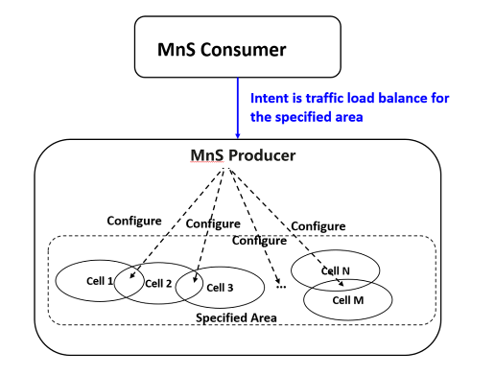
Figure 5.3.2.2-1: An example of area load balance scenario
Based on the intent received, the MnS Producer decides load balance between which neighbour Cells in the specified area is needed.
MnS Producer monitors and predicts the traffic load for the each Cell(s) in the specified areas, and take some actions to fulfil the intent received from the operator.
The following example is illustrated:
MnS Consumer expresses his intent that the area 1 needs to be load balanced. MnS Producer identifies the selected area is covered by Cell 1 and Cell 2, and decides the load balance between neighbour Cell 1 and Cell 2 is needed.
When MnS Producer predicts the traffic may increase with a large number of UEs in the area, MnS Producer could in advance provide the corresponding RAN with information that considering the new UEs to access to Cell 1 which has low traffic compared with Cell 2.

5.3.2.3 Post-condition
Operator's intent that traffic load balance for the specified area is fulfilled by the MnS Producer.

5.3.3 Instant Cell Updating

5.3.3.1 Pre-condition
The operator wants to update Cell with new Cell information (e.g. Frequency information, PCI) and adjust all associated Cell configuration (e.g. Cell Relation(s) and External Cell(s)).

5.3.3.2 Description
The operator as MnS expresses his intent that the selected Cell need to be updated with new Cell information (e.g. frequency information, PCI), and all associated Cell configuration (e.g. CellRelation(s) and ExternalCell(s)) needs to be updated.
MnS Producer updates the selected Cell with new cell information.
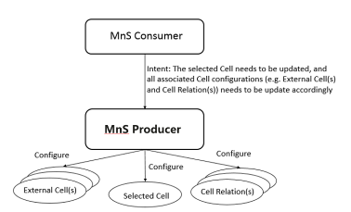
Figure 5.3.3.2-1: Instant Cell updating scenario
MnS Producer updates corresponding External Cell(s) and Cell Relation(s) which are associated with the selected Cell with the new Cell information.
MnS Producer may notify other MnS Producer (s) to adjust corresponding External Cell(s) and Cell Relation(s) which are associated with the selected Cell with the new Cell information.

5.3.3.3 Post-condition
Operator's intent that the selected Cell and all associated Cell configuration (i.e. CellRelation(s), External Cell(s)) need to be updated with new Cell information is fulfilled by the MnS Producer.

5.3.4 Instant Cell Deletion

5.3.4.1 Pre-condition
The operator wants to delete an existing Cell, and delete all associated Cell Relation(s) and External Cell(s).

5.3.4.2 Description
Due to network planning (e.g. reduce the capacity can be provided by certain RAN node), the operator wants to delete a selected Cell. So operator as MnS Consumer expresses his intent that the selected Cell needs to be deleted and all associated Cell Relation(s) and External Cell(s) need to be deleted to MnS Producer.
MnS Producer delete the selected Cell.
MnS Producer derive all associated Cell Relation(s) and External Cell(s), and delete them.
MnS Producer may notify other MnS Producer(s) to delete ExternalCell(s) and CellRelation(s) which is associated with the selected Cell.
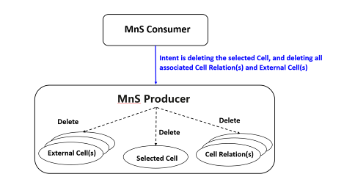
Figure 5.3.4.2-1: An example of instant Cell Deletion

5.3.4.3 Post-condition
Operator's intent that the selected Cell, and all associated Cell Relation(s) and External Cell(s) needs to be deleted is fulfilled by the MnS Consumer.

5.3.5 Intent driven network optimization scenario

5.3.5.1 Pre-condition
The operator wants to optimize the network to satisfy certain user experience related performance requirements (e.g. the percentage of users with low experienced data rate (e.g. < 5 Mbps) should be less than certain value (e.g. 1 %), the average experienced data rate should be greater than 7 Mbps).

5.3.5.2 Description
Due to some user complaint information received, the operator as MnS Consumer expresses his intent that the network in the specified area needs to be optimized to satisfy certain user experience related performance requirements (e.g. the percentage of users with low experienced data rate (e.g. < 5 Mbps) should be less than certain value (e.g. 1 %), the average experienced data rate should be greater than 7 Mbps).
Based on the intent received, the MnS Producer detects the potential network issues which lead to this poor user experience related performance requirements (e.g. low experienced data rate (e.g. < 5 Mbps)), for example, the handover is happened frequently between some neighbour Cells, some weak coverage area with large number of users, etc.
The MnS Producer decides the network optimization method (e.g. CCO, HO, machine learning, etc) to be used and derives the corresponding requirements (e.g. policy for HO) for the selected network optimization method. For example, MnS Producer decide to trigger coverage and capacity optimization to enhance the coverage for the weak areas and trigger the handover optimization to reduce the frequency of handover between certain neighbour Cells. Another example, MnS producer may configure admission control policies for the RAN Node(s) in the specified area to ensure the user experience related performance requirements.
MnS Producer adjust and monitor the network iteratively until the specified user experience related performance requirements are satisfied.
MnS Producer may notify the MnS Consumer the fulfilment information of the network optimization intent (e.g. fulfil or not, percentage of users with low experienced data rate in the specified area).
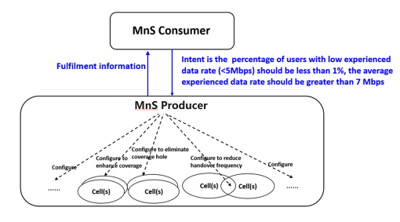
Figure 5.3.5.2-1: An example of utilizing user experience related performance requirements for network optimization scenario

5.3.5.3 Post-condition
Operator's intent that the network in the specified area needs to be optimized to satisfy certain user experience related performance requirements are fulfilled.

5.3.6 Capacity Management

5.3.6.1 Introduction
In this scenario there is a need to rearrange resources in the network to address a capacity trend. This may result in the rearrangement of physical resources which can result in the movement of physical resources from one location to another location. The rearrangement of capacities can be viewed from a network operator perspective as an external task while the rearrangement of physical resources can be seen as a network operator internal task.

5.3.6.2 Pre-condition
In a given geographical area, the sales and marketing group performs an analysis of Service(A) in the area X where is identified that the data traffic is declining and in area Y where the data traffic is increasing.

5.3.6.3 Description
The operator wants to rearrange the resource capacity concerning the Service (A) between area (X) and area (Y). The capacity rearrangement may involve the reduction of physical resources in one location and an increase of physical resources in another location. The network operator as a consumer expresses the requirement in an intent expression for a rearrangement of the resources in both locations.
NOTE: A physical resource can have different embodiments, it can be for example a piece of equipment, it can be one or more NFs that are instantiated on a single piece of HW or in a datacentre or a combination of both.
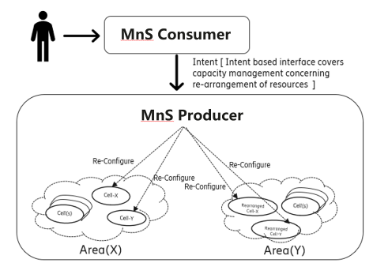
Figure 5.3.6.3-1: Resource capacity rearrangement

5.3.6.4 Post-condition
The resource capacity rearrangement is successfully done by the producer and the desired outcome is provided to the consumer.

5.3.7 Intent driven NF deployment

5.3.7.1 Pre-condition
The operator wants a new NF (e.g. UPF) to support certain number of UE(s) (e.g. 5 million) with specified performance requirements (e.g. average latency should be less than 2 ms).

5.3.7.2 Description
Due to network planning, the operator wants a new NF in the specified area to support certain number of UE(s) (e.g. 5 million) with specified performance requirements (e.g. average latency should be less than 2 ms). So the operator as MnS Consumer expresses his intent that he wants a new NF to support certain number of UE(s) with specified performance requirements to the MnS Producer.
MnS Producer translates the received intent to the detailed deployment requirements (e.g. configuration parameters for corresponding MOI (e.g. MF, EP_RP) and virtualized infrastructure resource requirements (e.g. VNFD and flavour Id) if the NF contain virtualized part).
MnS Producer deploys the NF based on the derived network configuration requirements and virtualized infrastructure resource requirements.
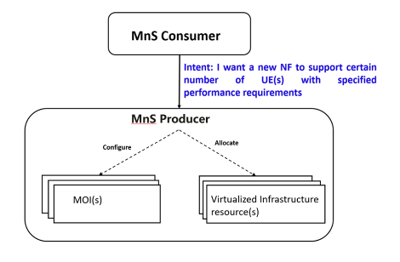
Figure 5.3.7.2-1: Intent driven NF deployment scenario

5.3.7.3 Post-condition
A new NF is deployed which can support certain number of UE(s) with specified performance requirements.

5.3.8 Intent driven NF capacity changing
5.3.8.1 Pre-condition
The operator wants to change the capacity of an existing NF instance, for example, expand capacity of an existing NF instance to support additional certain number of UE(s) (e.g. 1 million) or shrink capacity of an existing NF instance to support less number of UE(s).
5.3.8.2 Description
Due to network planning, the operator wants to change capacity of an existing NF instance, for example, expand capacity of an existing NF instance to support additional certain number of UE(s) (e.g. 1 million). So the operator as MnS Consumer expresses his intent that expand capacity of an existing NF instance to support additional certain number of UE(s) (e.g. 1 million) to the MnS Producer.
MnS Producer translates the received intent to the detailed modification requirements (e.g. configuration parameters for corresponding MOI(s)), virtualized infrastructure resource modification requirements (e.g. flavorId) if the NF contain virtualized part, physical infrastructure resource modification requirements).
MnS Producer modifies corresponding NF instance based on the derived detailed modification requirements.
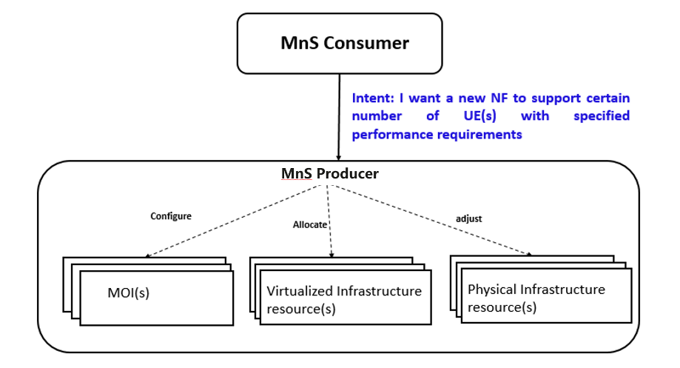
Figure 5.3.8.2-1: Example of intent driven NF capacity changing scenario
5.3.8.3 Post-condition
The capacity of existing NF instance is changed to fulfil the intent.

5.3.9 Intent driven management for area based deployment scenario
Area based deployment scenario is a potential deployment scenario for which the intent driven management can be applied. In this deployment scenario, the operator's network can be divided into several areas and managed based on area granularity. The network equipment in one area are from one producer. MnS Producer who is responsible for management of network in the specified area is responsible for the closed loop automation in this area. One MnS Producer can manage network in one or multiple area(s).
In an Intent driven management service, the consumer, expresses the intent for the specified area to the MnS Producer which is responsible for this network management in this area. MnS Producer translates the intent for the specified area to the detailed management tasks for managed network equipment's in this specified area, and continuously monitor the managed network equipment to ensure the intent.
The intent for area-based deployment scenario can either be:
- "Provisioning of the network in a specified area with some area network characteristics (e.g. provisioning radio access network in the specified area with specified frequency, user experience throughput, user number, isolation requirements)", or "Enabling certain service in the specified area for certain user group (e.g. enable V2X service for enterprise A in the area X)".
- "Optimization of the network in a specified area with some area optimization target (e.g. Load Balance in the area X, Admission control in the area X with admission control requirements)".
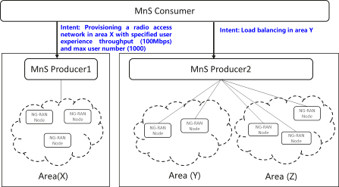
Figure 5.3.9-1: Example of intent driven management for area based deployment scenario

5.3.10 Intent driven coverage optimization scenario

5.3.10.1 Pre-condition
Operator wants to optimize the radio network in the specified area to satisfy the coverage target requirements (e.g. weak coverage ratio less than 5 %, coverage hole ratio less than 1 %, overshoot coverage ratio less than 2 %).

5.3.10.2 Description
Due to some network coverage issues identified or user complaint information received, MnS Consumer expresses its intent that the coverage in the specified area needs to be optimized to satisfy certain coverage requirements (e.g. weak coverage ratio less than 5 %, coverage hole ratio less than 1 %, overshoot coverage less than 2 %) to corresponding MnS Producer.
Based on the intent received, MnS Producer collects and analyses corresponding coverage related measurements of the cells in the specified areas and identifies the potential cells with network issues.
MnS Producer decides the corresponding management tasks to address the identified network issues, for example, decides the network optimization methods (e.g. CCO, AAS) for certain cells and derives the optimization requirements for the selected network optimization methods, adjust coverage of certain RAN NFs.
MnS Producer monitors the network and calculates the coverage KPI for the specified area (e.g. weak coverage ratio, coverage hole ratio, overshoot coverage ratio), and decides whether coverage target in the intent is satisfied, if not satisfied, MnS Producer triggers management tasks iteratively until the intent is satisfied.
MnS Producer may notify the MnS Consumer the coverage KPI for the specified area (e.g. weak coverage ratio, coverage hole ratio) to enable MnS Consumer monitor the intent.

5.3.10.3 Post-condition
Operator's intent that the network in the specified area needs to be optimized to satisfy certain coverage requirements are fulfilled.

6 Introduction and standard consideration for intent driven management service

6.1 Introduction
Intent driven MnS allows its consumer the ability to provide desired intent for managing the network and service. Intent driven MnS (see subclause 4.3 in TS 28.533 [6]), includes following MnS components:
- MnS component type A, operations and/or notifications used for communication between Intent driven MnS consumer and Intent driven MnS producer (e.g. provide intent from consumer to producer).
- MnS component type B, Intent expression, which is used to describe the intent information.

6.2 Operation and/or notification used for intent
Operations and/or notification is used for communication between Intent driven MnS consumer and producer. Following figures illustrate the potential synchronous mode and asynchronous mode for communication between Intent driven MnS consumer and producer.
Figure 6.2-1: Asynchronous mode for communication between Intent driven MnS consumer and producer
Figure 6.2-2: Synchronous mode for communication between Intent driven MnS consumer and producer
The intent fulfilment information may contain the information of intent fulfilled, intent unfulfilled, progress of intent fulfilment or conflicted with other intent, etc. For asynchronous mode, the notification may be sent for multiple times, either periodically or event-driven (e.g. fulfilment state changes).
One potential solution for the lifecycle management operations of intent specified in clause 4.5 is reusing operations of generic provisioning MnS [9]. An intent is described as a management object. In order to implement activate/de-activate intent, an attribute (e.g. intentState) may be introduced for Intent IOC to specify the intent state. The intentState can be enumerative including "Inactive" and "Active".
Following are the mapping of the LCM operations of intent to operations of generic provisioning MnS.
Table 6.2-1: Mapping of LCM operations of intent to operations of generic provisioning MnS
LCM operations of intent | Operations of generic provisioning MnS | Remarks
Create intent | createMOI
Activate intent | modifyMOIAttributes | The intentState attribute is set as "Active".
De-activate intent | modifyMOIAttributes | The intentState attribute is set as "Inactive".
Delete intent | deleteMOI
Query intent | getMOIAttributes

6.3 Intent Expression

6.3.1 Description
Intent Expression represents the intent including network models and operation action, which enable consumer describe their requirements for network and service management.
Each Intent is described by IntentDrivenAction(IDA) and IntentDrivenObject(IDO) as follows:

6.3.2 Intent Driven Object
Intent Driven Object provides the management object information according to intent requirements. An IntentDrivenObject is described by IntentDrivenObjectName and a limited set of attributes which are necessary to identify the object.
Intent Driven Object could be:
- Existing managed object with simplified attributes. For example, NetworkSlice can be reused as Intent Driven Object with part of attributes described in ServiceProfile (e.g. SST, maxNumberofUE, latency, geographical information) and Cell can be reused as Intent Driven Object with limited attributes (e.g. cellId, pci and frequency information). For another example, Subnetwork can be reused as Intent Driven Object with some common configuration information of underlying managed objects (e.g. frequency information, PCIList) for a high-level management.
- New abstract managed object. To enable area-based service or network deployment and optimization, a new managed object (e.g. 'RAN Cluster') may be introduced to represent the management aspect of the network element in a specific area. RAN Cluster represents a group of RAN Nodes and/or cells for specific management purposes.
The legal values of Intent Driven Object may be different for different types of intents. For Intent-CSCs, an example of Intent Driven Object is Communication Service. For Intent-CSPs, an example of Intent Driven Object is NetworkSlice. For Intent-NOPs, Intent Driven Object can be SubNetwork, RAN Cluster, Cell or MF.

6.3.3 Intent Driven Action
Intent Driven Action provides, abstract and simplified network and operation information according to intent requirements. An IntentDrivenAction is described by IntentDrivenActionName and a limited set of related properties.
Intent Driven Action could be:
- Deployment related action. For example, the Intent Driven Action could be Rehome in the cell rehoming scenario, and could be Provision in the network provisioning scenarios.
- Optimization related action, For example, the Intent Driven Action could be LoadBalance in the area loadbalance scenario, and could be User throughput optimization in the scenario of area-based user throughput optimization.

6.4 Analysis on intent driven scenarios

6.4.1 Area Load Balance
1. Intent driven MnS Consumer deliver the following area load balance intent to Intent driven MnS Producer.
Intent expression information is illustrated in the following table:
Table 6.4.1-1: Content for area load balance intent
Intent | IntentDrivenAction | IntentDrivenObject
AreaLoad balance Intent | LoadBalance | AreaInfo

The load information specifying which load information needs to be balanced may be specified in the intent, load information can be PRB usage, user number or other load information.
2. When received the area load balance, Intent driven MnS Produce may execute the following management tasks:
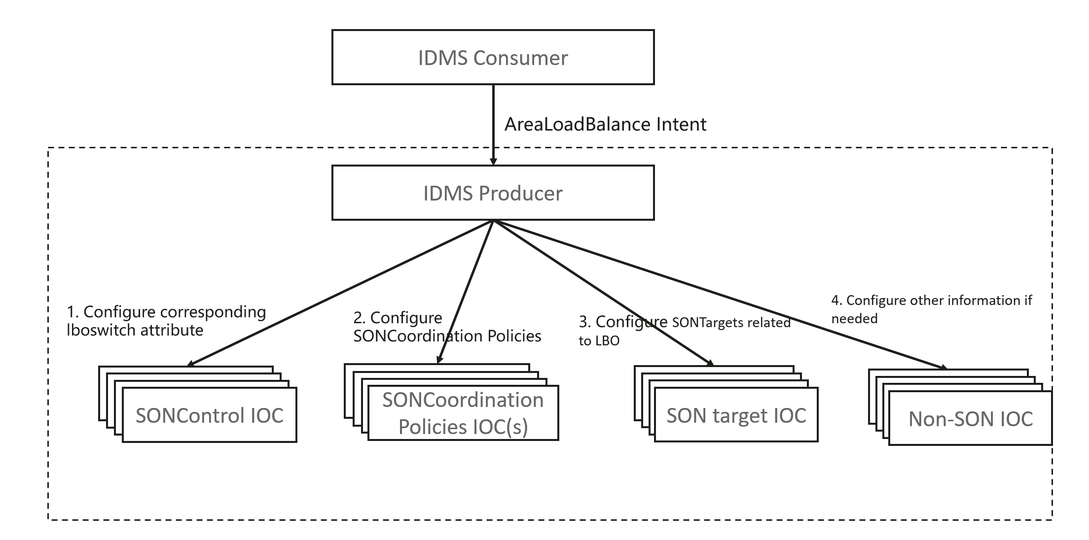
Figure 6.4.1-1: Example of Intent driven MnS Producer utilizing LBO to satisfy AreaLoadBalance Intent
2.1 Intent driven MnS Producer analyses information for all Cells in the specified area and identify overlapping coverage, hierarchical coverage and neighbouring overage Load Balance scenarios for Cells as described in clause 5.4.1 in TS 28.627.
2.2 Intent driven MnS Producer analyses load balancing allowed/prohibited from each cell to other cells as described in clause 6.4.2 in TS 28.627, and configures all corresponding SON Control Function IOC instance (which is name contained by ManagedFunction) with lboSwitch attribute to enable switching on all necessary LBO Functions. Intent driven MnS Producer may create new SON Control Function IOC instance.
2.3 For each identified LBO Function instance needed, Intent driven MnS Producer analyses and decides corresponding SON target IOC related to LBO Function for each related cell (e.g. EutranGenericCell, NRCellCU), SON target IOC for LTE is defined in clause 5.3.1 in 3GPP TS 28.628[13]. Intent driven MnSmay create corresponding LBO Function IOC instances or reconfigure existing LBO Function IOC instance.
2.4 Intent driven MnSProducer analyses and configures the SON coordination policies IOC for different LBO Function instances, and also SON coordination policies for LBO Function instance with other SON Function instances. SONCoordinationPolicies IOC is defined in 3GPP TS 28.628[13].
2.5 Intent driven MnSProducer may do other analysis and management tasks to fulfil the intent.
3. Intent driven MnSProducer continuously collect performance measurements defined in clause 4.2.5 in 3GPP TS 28.628 [13] to evaluate the effect for each LBO Function instances, then evaluate the effect for area load balance intent based on the evaluation for each LBO Function instance. If the area load balance cannot be satisfied, Intent driven MnSProducer may execute step 2 recursively to ensure the area load balance fulfilled.
4. Intent driven MnSProducer may notify Intent driven MnSConsumer about the fulfil information of area load balance during intent execution.

6.4.2 Cell Rehoming
Cell Rehoming scenario (i.e. re-home a selected Cell from source RAN Node to destination RAN Node) is described in clause 5.3.1. So following procedure illustrates the solution for cell rehoming.
1. Intent driven MnS Consumer delivers the following cell rehoming intent to Intent driven MnS Producer. Cell Rehoming intent information is illustrated in the following table:
Table 6.4.2-1 Content for Cell Rehoming intent
Intent | IntentDrivenAction | IntentDrivenObject
CellRehoming Intent | Rehome | DN of rehomed Cell MOI,  DN of source RAN Node MOI,  DN of destination RAN Node MOI

2. When receive the cell rehoming intent, Intent driven MnS Producer may execute several management tasks to satisfy the intent. Following is an example:
2.1 Intent Driven MnS Producer analyses the received cell rehoming intent and configuration information of the corresponding MOIs (e.g. Cell MOI and corresponding child MOIs, ExternalCellMOI(s), CellRelationMOI(s)). 2.2 Intent Driven MnS Producer creates a new MOI tree of rehomed cell (i.e. rehomed Cell MOI and its child MOI(s)) contained by destination RAN Node MOI, and configure these MOI(s) with same attributes captured in the original MOI tree.
2.3 Intent Driven MnS Producer modify existing CellRelation IOC (which associated to rehomed Cell MOI) contained in tree of source and destination RAN Node MOIs to the new created rehomed Cell MOI.
2.4 Intent Driven MnS Producer modify existing CellRelation IOC (which associated to rehomed Cell MOI) contained in tree of other RAN Node MOI(s) to the new created rehomed Cell MOI.
2.5 Intent Driven MnS Producer delete existing MOI tree of rehomed cell contained by the source RAN Node MOI.
2.6 Intent Driven MnS Producer may do other analysis (e.g. PCI collision analysis) and management tasks to fulfil the cell rehomed intent.
3. Intent Driven MnS Producer may notify Intent Driven MnS Consumer about the fulfil information of cell rehoming intent during intent execution.
Figure 6.4.2-1 shows a simple example of cell rehoming scenario (which MOI tree only contains two ENBFunction MOIs, three EUtranGenericCell(s) and EUtranRelationMOI(s)), in real deployment scenario, the MOI tree is more complex, which may contain hundreds of RAN Node MOIs, thousands of Cell MOIs and CellRelation MOIs.
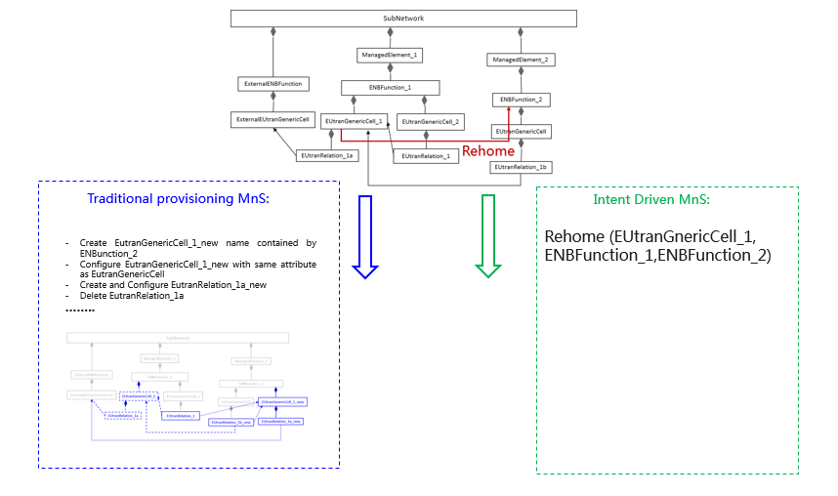
Figure 6.4.2-1: Simple example of cell rehoming scenario

6.4.3 UE throughput optimization
1. Intent driven MnS Consumer sends the following UE throughput optimization intent to Intent driven MnS Producer.
Table 6.4.3-1: Content of UE throughput optimization intent
Intent | IntentDrivenAction | IntentDrivenObject
UE throughput optimization | UE throughput Optimization | AreaInfo  Max percentage of UE with low throughput  Min average UE throughput

The threshold for low throughput needs to be specified (e.g. 5 Mbps).
2. When received the UE throughput optimization intent, Intent driven MnS Producer may execute the following management tasks to satisfy the intent. Following is an example:
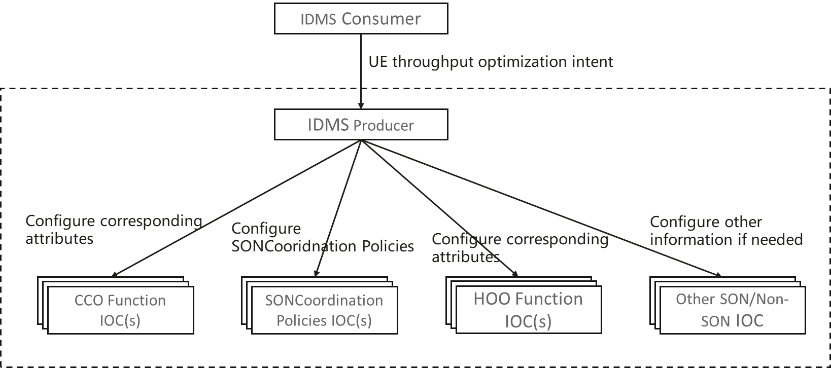

Figure 6.4.3-1: Example of Intent driven MnS Producer satisfying UE throughput optimization intent
2.1 Intent driven MnS Producer analyses the network performance and detects the potential network issues which lead to this poor network performance in the specified area (e.g., the handover is happened frequently between some neighbour Cells, some weak coverage area with large number of UEs).
2.2 Intent driven MnS Producer identifies the potential SON Function instances (e.g. HOO Function, CCO Function, LBO Function) for corresponding managed objects (e.g. Cell) to optimize the network, and configure all corresponding SON Control Function IOC instance (described in clause 5.3.2 in TS 28.628) to enable switching on required SON Functions (e.g. HOO Function, CCO Function).
2.3 For each identified SON Function instance, Intent driven MnS Producer analyses and decides corresponding SON target IOC. SON target IOC for LTE is defined in clause 5.3.1 in TS 28.628. Intent driven MnS may create corresponding SON Function IOC instances or reconfigure existing SON Function IOC instance.
2.4 Intent driven MnS Producer analyses and configures the SON coordination policies IOC for the identified SON Function IOC instances. SONCoordinationPolicies IOC for LTE is defined in TS 28.628.
2.5 Intent driven MnS Producer may do other analysis and management methods (e.g., machine learning) to fulfil the intent.
3. Intent driven MnS Producer continuously collects throughput of all the UEs in the area indicated by the intent, and calculates the percentage of UEs with the low throughput and average UE throughput in the area so as to evaluate whether the intent is fulfilled. If the intent cannot be satisfied, Intent driven MnS Producer may execute step 2 recursively to ensure the intent fulfilled.
4. Intent driven MnS Producer may notify Intent driven MnS Consumer about the fulfilment information of UE throughput optimization during intent execution.

6.4.4 Network provisioning
1. Intent driven MnS Consumer sends the following network provisioning intent to Intent driven MnS Producer.
Table 6.4.4-1: Content of network provisioning intent
Intent | IntentDrivenAction | IntentDrivenObject
Network provisioning | Network provisioning | AreaInfo  Maximum number of UEs  DL/UL throughput per UE  Service/Slice Type  latency

2. When received the network provisioning intent, Intent driven MnS Producer may execute the several management tasks to satisfy the intent. Following is an example:
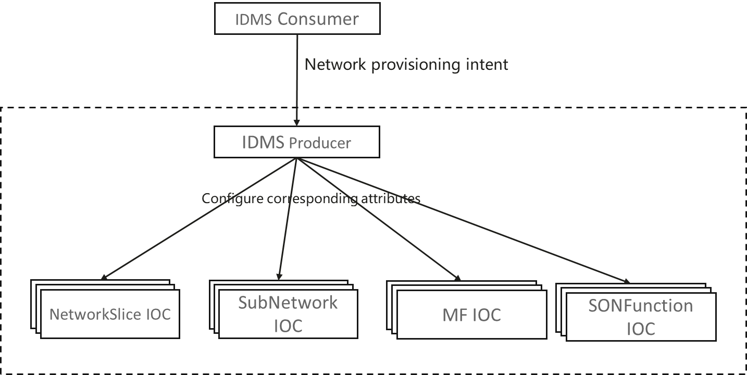
Figure 6.4.4-1: Example of Intent driven MnS Producer satisfying network provisioning intent
2.1 Intent driven MnS Producer analyses the network requirements (e.g. Maximum number of UEs, DL/UL throughput per UE) indicated in the network provisioning intent and decides to use network with or without slicing to satisfy the intent.
2.2 If using a network with slicing, Intent driven MnS Producer derives the network slice related requirements as described in TS 28.531 based on the network requirement indicated in the network provisioning intent, and create Network Slice IOC instance including ServiceProfile DataType to create a network slice instance or reconfigure existing Network Slice IOC instance including ServiceProfile DataType to reuse an existing network slice instance. The detailed procedure for Network Slice Creation including Network Slice SubNetwork Creation is described in TS 28.531.
2.3 If using a network without slicing, Intent driven MnS Producer derives the requirements for SubNetwork and MF as described in TS 28.622 and TS 28.541 based on the network requirement indicated in the network provisioning intent, and create SubNetwork IOC instance (including corresponding child IOC) to create a new subnetwork instance or reconfigure SubNetwork IOC instance (including corresponding child IOC) to use existing subnetwork instance.
2.4 Intent driven MnS Producer may configure other IOCs to fulfil the intent.
3. Intent driven MnS Producer may notify Intent driven MnS Consumer about the fulfilment information of network provisioning intent after the intent execution.

6.4.5 Area-based radio network

6.4.5.1 Introduction
Area-based radio network deployment scenario described in clause 5.3.9. Following Figure 6.4.5.1-1 illustrates utilization of Intent driven MnS(s) for the area based radio network deployment scenario.
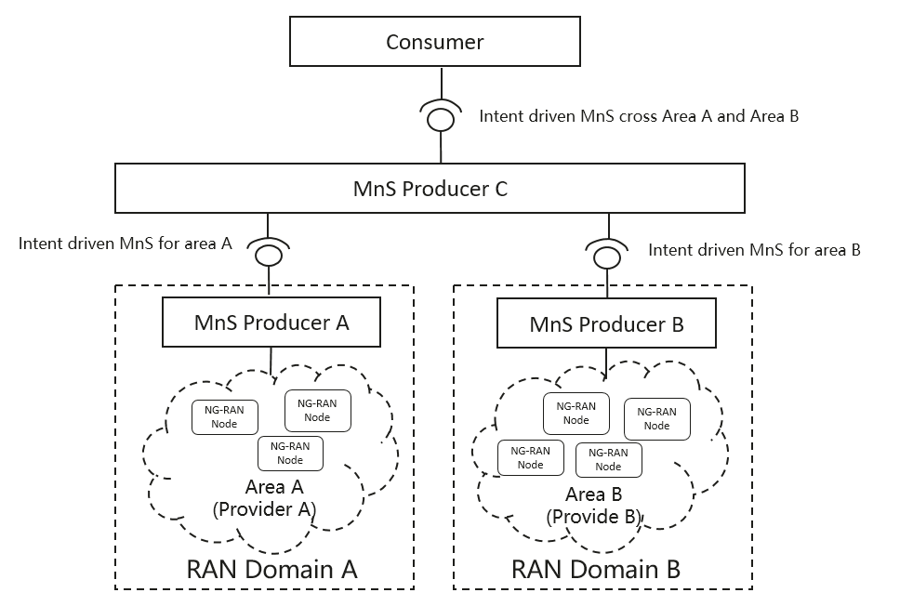
Figure 6.4.5.1-1 Utilization of Intent driven MnS(s) for the area based radio network deployment scenario

6.4.5.2 Area-based radio network deployment intent

Following procedure illustrates a potential solution for the area-based radio network deployment scenario.
1. Intent-driven MnS Consumer delivers a radio network deployment intent (i.e. deploy RAN Cluster) to Intent-driven MnS Producer. Information in the intent expression includes specified radio coverage area (e.g. a list of sector areas needed to be covered), supported frequencies isolation requirements (e.g. whether the user plane in the RAN Cluster is shared with other RAN Clusters), transport information, CellLocalId list and RAN Node Id list that available for the RAN Nodes or Cells in the RAN Cluster, supported service type, max number of UEs and DL/UL throughput of the UE in RAN Cluster, without detailed radio configuration parameters.
Table 6.4.5.2-1 Content of ared-based redio network deployment intent
Intent | IntentDrivenAction | IntentDrivenObject
RAN Deployment | Provisioning | radio coverage area information  frequency information  isolation requirements  transport information  ranges of CellLocalId and RAN Node Id  service type  Maximum number of UEs  DL/UL throughput per UE

2. When receiving the intent, the MnS Producer may execute several management tasks to fulfil the RAN deployment intent, for example by utilizing network slice subnet procedure described in TS 28.531[1] or executing the following procedure:
2.1 Intent-driven MnS Producer identifies the RAN Nodes within the RAN Cluster according to the specified radio coverage area information, and creates necessary RAN ManagedFunction MOI(s) and configures with corresponding RAN Node Id (e.g. gNBId).
2.2 Intent-driven MnS Producer creates a group of Cell MOI(s) with radio configurations (including CelllocalId and frequency information) and ensures that these cells are able to carry the maximum number of UEs and provide DL/UL throughput per UE.
2.3 Intent-driven MnS Producer creates EP_RP MOI(s) for logical links between the RAN Cluster and other network entities according to the transport information.
2.4 Intent-driven MnS may implement necessary policies to satisfy isolation requirements.
3. Intent-driven MnS Producer notifies Intent-driven MnS Consumer about the fulfilment information of RAN Cluster deployment intent after the configuration is finished.

6.4.6 CSI Deployment at edge (CSIatEdge)
1. Intent driven MnS Consumer sends the following CSIatEdge intent to Intent driven MnS Producer.
Figure 6.4.6-1: Content of CSIatEdge intent
Intent | IntentDrivenAction | IntentDrivenObject
CSIatEdge Intent | CSI Deployment | Service type  Service requirement  Service availability  Edge identification information

1.1 Service type: TS 23.501 defined three types of slice/service type; eMBB, URLLC, MIoT. The Service type parameter can have values related to three defined service type or any additional service type, as required.
1.2 Service requirements: This parameter provides various service requirements e.g. No. of concurrent subscribers, No. of concurrent sessions, requested server side application
1.3 Service availability: This parameter defines availability of the service. For e.g., it can define a time bound availability for the service. This is useful to enable the targeted availability of the service at a particular point of time or day of the week or a combination of both.
1.4 Edge identification information: A service provider may have edge network deployed at many locations. It is crucial to identify the targeted edge network where the communication service need to be deployed. It may contain edge ID, geoLocation, area info etc.
2 Post receiving the CSIatEdge Intent, Intent driven MnS Producer will create and instantiate the CSI as described in [12] with the following additional procedure
2.1 The edge network will be identified based on the information provided in the request.
2.2 In addition to the required 5GS network functions (for example, UPF) the NSI used contains the applications (requested as part of service requirements) providing server functionality for the required service (for example, a video streaming server functionality for an ultra-low latency video streaming service).

7 Key issues of Intent driven MnSstudy

7.1 Key issue-1: Study on the level of automation in mobile network management
There are many different ways to reduce the complexity of network and service management with automation mechanisms. It is necessary to identify the potential automation levels in mobile network management and clarify which management scenario is related to which level. The relation between SON, Intent driven MnS or other automation mechanisms needs to be addressed under this study.

7.2 Key issue-2: Study the scenarios which are related to Intent driven MnS
Intent driven MnS can be leveraged to alleviate the complexity of network management for mobile networks. Intent driven MnSabstracts the network implementation details and allows the consumer to manage its network and service using high level instructions. In an intent driven network management scenario, a consumer expresses the desired outcome of the management of network, i.e., 'what' the management of network should do. The Intent driven MnSproducer translates the intent from the Intent driven MnSconsumer and figures out 'how' the intent is realized. It is necessary to identify the scenarios which are valid for IDM.

8 Potential requirements for intent driven MnS
REQ-Intent -CON-01 The intent driven MnS shall have capability enabling MnS consumer to convey intent for coverage optimization to MnS Producer.
REQ-Intent-CON-02 The intent driven MnS shall have capability enabling MnS consumer to convey intent for cell rehome to MnS producer.
REQ-Intent-CON-03 The intent driven MnS shall have capability enabling MnS consumer to convey intent for UE throughput optimization to MnS producer.
REQ-Intent-CON-04 The intent driven MnS shall have capability enabling MnS consumer to convey intent for network provisioning to MnS producer.
REQ-Intent-CON-05 The intent driven MnS shall have capability enabling MnS consumer to convey intent for network performance assurance to MnS producer.
REQ-Intent-CON-06 The intent driven MnS shall have capability enabling MnS consumer to convey intent for service deployment to MnS producer.
REQ-Intent-CON-07 The intent driven MnS shall have capability enabling MnS consumer to convey intent for area based network deployment.
REQ-Intent-CON-08 The intent driven MnS shall have capability enabling MnS consumer to convey intent for area based network assurance.
REQ-Intent-CON-09 The intent driven MnS shall have capability enabling MnS consumer to request MnS producer to create and delete an intent.
REQ-Intent-CON-10 The intent driven MnS shall have capability enabling MnS consumer to request MnS producer to activate/de-activate an intent.
REQ-Intent-CON-11 The intent driven MnS shall have capability enabling MnS consumer to request MnS producer to query an intent (including obtaining information about fulfilment of an intent).
REQ-Intent-CON-12 The intent driven MnS shall have capability enabling MnS consumer to obtain performance and fault information related to intent.
REQ-Intent -CON-13 The intent driven MnS shall have capability enabling MnS consumer to convey intent for CSI deployment at the edge to MnS Producer.

9 Recommendation and Conclusion
The study has identified:
- Definition of intent, Policy management and intent driven MnS.
- Concepts related to intent driven management, including intent driven MnS, intent expression, intent translation, dimensions of intent driven framework, automation mechanisms and intent driven management, intent driven management vs policy driven management, relation of intent driven MnS and SON, and lifecycle management of intent.
- Several scenarios related to Intent-CSC, Intent-CSP and Intent-NOP which can reduce the management complexity. For example, a series of area based network management scenarios are introduced to simplify the management interface by managing the mobile network in area granularity.
- Potential requirements for intent driven MnS.
- Standard consideration for Intent Driven MnS which include intent driven related operation and/or notification and Intent Expression. The potential solution for intent driven related operations is reusing CRUD operation defined in generic provisioning MnS. Intent Expression include Intent Driven Object and Intent Driven Action. Intent Driven Object could be existing managed object with simplified attributes or new abstract managed object (e.g. introduce RAN Cluster to represent the management aspect of the network element in a specific area). Intent Driven Action could be deployment related action or optimization related action.
- Analysis on solution (including Intent Driven Object and Intent Driven Action for the some of the identified scenarios have been addressed as examples.
It is recommended to consider normative work for the Intent driven management services for mobile networks with considering the following aspects:
- Intent driven management related definition and concepts.
- Roles which are related to the intent driven management.
- Typical scenarios and management requirements for intent driven management which can reduce the management integration complexity.
- The mechanisms for reuse the generic management service CRUD operation to realize Intent driven MnS.
- Specify the modelling solution including Intent Driven Action and Intent Driven Object for the identified scenarios.

Annex A:
Categories for Intent driven management services scenarios
Scenarios for Intent driven MnS can be categorized based on the network operations and services provided by the mobile network operator. The scenarios are applicable to different teams/group within the mobile network operator's organization and involve providing/updating/new resource/network information or ensuring the network/services are performing optimally. Different approaches might be taken to fulfil a particular scenario depending on the type of scenario.
Identified scenarios in the present document are either a deployment or an assurance scenario. Other categories might exist but not yet identified or included in the present document.
Examples on Deployment scenarios in clause 5: "Service deployment", "Cell re-home", "Instant Cell Updating" and "Instant Cell Deletion", "Capacity Management", "Intent driven NF deployment", and "Intent driven NF capacity changing".
Examples on Assurance scenarios in clause 5: "NSI resource utilization optimization", "Intent driven NSI performance assurance", "Area Load Balance", and "Intent driven network optimization".

Annex B:
Change history
Change history
Date | Meeting | TDoc | CR | Rev | Cat | Subject/Comment | New version
2020-09 | SA#89e |  |  |  |  | Upgrade to change control version including EditHelp comments | 17.0.0
2020-12 | SA#90e | SP-201065 | 0003 | - | D | Address the issues requested by EditHelp | 17.1.0

