3GPP TSG SA WG5 Meeting 134-e S5-206251

electronic meeting, online, 16th - 25th November 2020

Source: Nokia, Nokia Shanghai Bell, Telefónica S.A.

Title: deploy two network slices of same customer

Document for: Approval
Agenda Item: 6.5.2

1 Decision/action requested
The group is asked to discuss and approve the proposal..

2 References
[1] 3GPP TR 28.811: "Management and orchestration; Network Slice Management Enhancement"
[2] 3GPP TS 28.541: "Management and orchestration; 5G Network Resource Model (NRM);
Stage 2 and stage 3"

3 Rationale
Weak network slice isolation may compromise the entire 5G security, e.g. sensitive data of one network slice could be exposed to applications running in other network slices through side channel attacks. This risk is even higher since resource is distributed over multiple domains of the 5G architecture. Therefore, slice isolation is important for reliable and warranted service assurance, and crucial for commercial deployment of 5G network based on network slicing technology.
To support network slice isolation requirement, GSM Association (GSMA) defined attribute in General Slice Template (GST) to isolate resource of network slices in different levels (refer to GSMA NG.116 - Generic Network Slice Template, [x]). e.g. there’s physical or logical isolation, the physical isolation includes processor, memory and network isolation, and logical isolation includes virtual resource, network function or service/tenant isolation, etc.
In addition, to optimize operation and improve resource efficiency, network slices with same isolation requirement and security level (e.g. network slices belong to same customer, or with have same service/slice type ) could be grouped together, and isolated from network slices in other groups.
This pCR is to add one use case for network slice isolation

4 Detailed proposal

Start of 1st Change

x.y use case – Isolated deployment of multiple network slices of same customer

x.y.1 Introduction
In this use case, one network slice customer (e.g. a public safety department, or NSC_PS-1) requests two network slices from a network slice provider to support mIoT services of two regions, e.g. in two cities, and other service requirements (besides coverage area) of the two slices can be different also. The isolation requirements of the two mIoT network slices are same, both require to physically isolate user plane of the network slice from network slices of other network slice customers (no restriction on control plane). In addition, to save total cost, the network slice customer NSC_PS-1 agrees that the two mIoT network slices can share resources with each other without physical isolation. As shown in below, user plane of both NS_mIoT-1 and NS_mIoT-2 are separated from NS_x1 and NS_x2, e.g. NS_mIoT-1 and NS_mIoT-2 are deployed on different physical nodes (e.g. physical gNBs, physical UPFs or servers to accommodate virtualized UPF instances) than nodes of NS_x1 and NS_x2. However, NS_mIoT-1 and NS_mIoT-2 could share same physical resources, e.g. physical UPF or server/host OS in where the virtualized UPF instances are deployed.

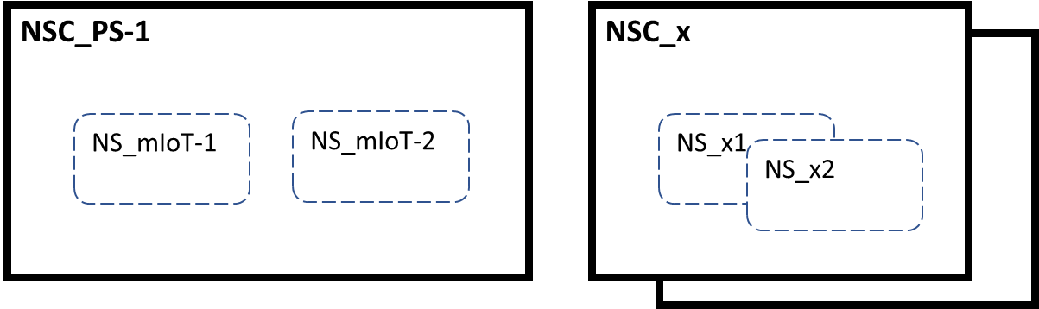
Figure x.y.1-1 example of isolated deployment of two network slices of same customer
In other words, NS_mIoT-1 and NS_mIoT-2 of NSC_PS-1 are deployed in one security domain (refer to 33.210), which is isolated from other security domains. The NS_mIoT-1 and NS_mIoT-2 share isolation requirements, as well as resources.
To optimize operational procedures, an MNO/NOP (as internal customer) may create network slices for their own eMBB service subscribers in different cities. e.g. NS_eMBB-1 and NS_eMBB-2, and other service requirements (besides coverage area) of the two slices can be different also. To better utilize resource, these two eMBB services can share same resources. As shown in below, resource of both NS_eMBB-1 and NS_eMBB-2 are separated from NS_x1 and NS_x2, but NS_eMBB-1 and NS_eMBB-2 could share same resource.

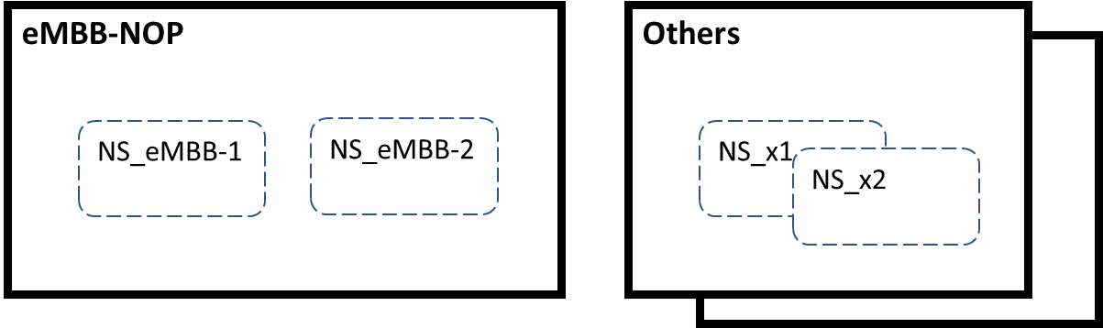
Figure x.y.1-2 example of isolated deployment of two network slices of operator

x.y.2 Potential requirement
- The 3GPP management system could have the capability to allocate network slice based on granular isolation requirements on the network slice
Note: For example, instead of binary sharing/non-sharing indicator, granular isolation requirements could be multi- levels requirement, such as isolation attribute specified in GSMA PRD NG.116
- The 3GPP management system could have the capability to group network slices with same isolation requirements and security level

- The 3GPP management system could have the capability to support authorized network slice related management service consumer to query and select group to the network slice to be deployed
Note: For example, the authorized network slice related management service consumer could be another high privileged management system or administrator of the NOP.

x.y.3 Issue and gaps
The resourceSharingLevel attribute is defined in ServiceProfile dataType - see Network Slice IOC defined in 5G Network Resource Model (NRM). This attribute only specifies whether the resources to be allocated to the network slice can be shared with other network slice(s). The existing 3GPP management system capabilities cannot support the use cases and potential requirements described above, which implied not only granular isolation requirements for network slice (e.g. isolation attribute specified in GSMA PRD NG.116), but also flexible inclusion/exclusion rules between network slices (e.g. group network slices with same isolation requirement and security level together, and isolate the network slices in the group from network slices in other groups).

End of Change

Start of 2nd Change

7 Possible solutions for Network Slicing Management Enhancements

7.x Possible solutions for network slice isolation
It is proposed to enhance the 5G NRM to support network slice isolation
- Define isolation group in NRM to represent a group of network slice sharing same isolation requirements and resources. The group can be based on tenant, SST, region, security level, etc.
- Define isolation profile in NRM to represent a set of isolation requirements.
- Associate a network slice to an isolation group
- Associate an isolation group to an isolation profile
Figure 7.x-1 NRM fragment proposal for network slice isolation

End of Change

