3GPP TSG SA WG5 Meeting 134-e S5-206217

electronic meeting, online, 16th - 25th November 2020

Source: Huawei,Ericsson, China Mobile, China Unicom

Title: Add relation of intent driven management and policy driven management

Document for: Approval
Agenda Item: 6.4.2

1 Decision/action requested
The group is asked to discuss and approval.

2 References
[1] 3GPP draft TS 28.312: “Management and orchestration; Intent driven management services for mobile networks v0.1.0”.
[2] 3GPP TR 28.812: “Study on scenarios for Intent driven management services for mobile networks v17.0.0”.

3 Rationale
The relation of intent driven management and policy driven management is studied and described in clause 4.4 in TR 28.812[2], which using the “What-How” view to clearly describe the difference of intent and policy. So this contribution proposes to add corresponding content in clause 4 in TS 28.312[1].

4 Detailed proposal
It proposes to make the following changes to TS 28.312[1].

1st Change

4.N Relation between the policy driven management and intent driven management
An intent specifies the expectations including requirements, goals, and constraints for a specific service or network management workslow, while a policy specifies the action(s) to be taken when given condition occurs. For certain scenarios, policies can be used in conjunction with intents to achive the autonomous purposes.
Figure 4.N-1 describes the relation between the policy and intent in the “what-how” view. As it now stands, the telecom systems are mainly focused on "how" and "less what". The current 5G networks brings more operational complexities, and the telecom system need to be able to adapt their operation to the business objectives of the operator as well as expectations of customer, which is driving customer to shift the focus from "how" to "what". The first step towards that shift, has been "Policy driven management", with more focus on "how" and less on "what" covering domain specific issues/aspects (an example for policy is when the average throughput is lower than certain threshold, take specified actions). As technologies are evolving and the level of complexity exceeds, the need for an abstraction level description (i.e. Intent) becomes more apparent (an example for intent is the target average throughput for certain area should be assured). An intent driven system will be able to learn the behaviour of networks and services and allows a customer to provide the desired state, without detailed knowledge of how to get to the desired state.

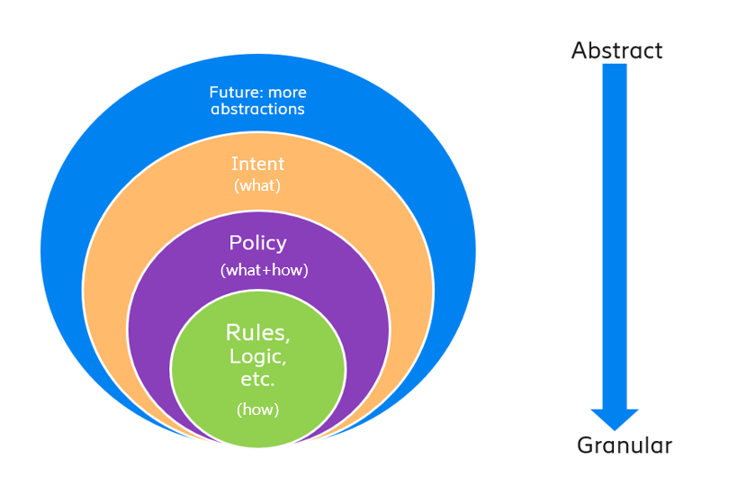
Figure 4.N-1: Relation between the policy and intent

End of changes

