3GPP TSG SA WG5 Meeting 134-e S5-206216

electronic meeting, online, 16th - 25th November 2020

Source: Huawei, China Mobie, Ericsson, China Unicom

Title: Update Clause 4.1.1 Introduction

Document for: Approval
Agenda Item: 6.4.2

1 Decision/action requested
The group is asked to discuss and approval.

2 References
[1] 3GPP draft TS 28.312: “Management and orchestration; Intent driven management services for mobile networks v0.1.0”.

3 Rationale
This contribution proposes to add general intent concepts in clause 4.1.1 Introduction.

4 Detailed proposal
It proposes to make the following changes to TS 28.312[1].

1st Change

4.1.1 Introduction
An intent specifies the expectations including requirements, goals, and constraints for a specific service or network management workflow. The intent expression information may include particular objective and possibly some related details. Following are some general concepts for intent:
- Intent is understandable by humans, and also needs to be interpreted by the machine without any ambiguity.
- Intent is declarative, which focus more on describing the “What” but less on “How”, which not only relieves the burden of the consumer knowing implementation details but also leaves room to allow the producer to explore alternative options and find optimal solution. Intent describes the properties that allows a satisfactory outcome.
- The expectations expressed by an intent is agnostic to the underlying system implementation, technology and infrastructure. Area can be used as managed object in the expectations expressed by an intent to achieve system implementation, technology and infrastructure agnostic.
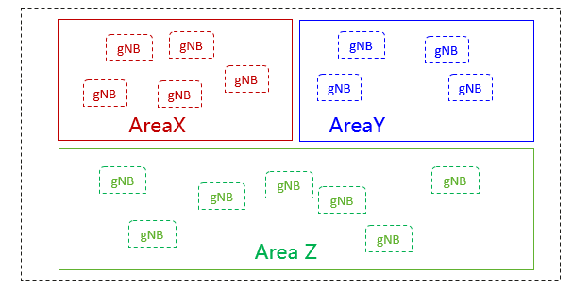
- Intent needs to be quantifiable from network data so that the fulfilment result can be measured and evaluated.

Intent can be categorized based on different user types or different management scenario types.

End of changes

