3GPP TSG-SA5 Meeting #134e S5-206204

e-meeting 16th - 25th November 2020

Source: Huawei

Title: Discussion on management of coordination between control loops

Document for: Approval, Information, Discussion
Agenda Item: 6.4.4

1 Decision/action requested
The group is asked to discuss and agree on the proposal.

2 References
[1] 3GPP TS 28.536: “Management services for communication service assurance; Stage 2 and stage 3”.
[2] ETSI GS ZSM 009-1: “Zero-touch network and Service Management (ZSM); Closed-loop automation; Enablers”.

3 Rationale
There are multiple control loops on an E2E network. And the managed entities in these control loops are associated.
- Two or more managed entities share resources. For example, two NSIs share the same NSSI.
- Two or more managed entities at the same level, such as two NSIs, are associated with the same communication services.
- There may be reference relationship between MOIs of managed entities at different levels, e.g., NSIs reference NSSIs.
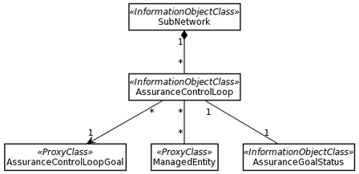
Based on the above relationshipsbetween the managed entities, the interactions between control loops are needed.
- Interactions between E2E control loop and domain control loop
- Interactions between domain control loops.
- Interactions between E2E control loops
- Interactions within domain control loops or within E2E control loops

Information interacted between control loops may include:
- The AssuranceControlLoopGoal in the E2E control loop is divided into the AssuranceControlLoopGoal of each domain control loop.
- The AssuranceGoalStatus of domain control loops may be aggregated for the AssuranceGoalStatus of the E2E control loop, e.g. for the purpose of E2E analysis or demarcation of SLS assurance issues.
- For control loops with communication service association or resource sharing, the AssuranceGoalStatus information of each control loop may need to be shared with all associated control loops.
- For control loop services the managed entities may share resources, priority may be defined for the control loopsto avoid potential conflictions.
For an open control loop, each step (Monitor, Analyze, Decide, and Execute) in the control loop may expose management capability or information to allow management or control from the authorized consmumers, e.g. the MnS producers for other control loops. For example:
- The the MnS producer for E2E control loop may request the execution of certain actions by the MnS producers for domain control loops.
- The MnS producers for domain control loops may send analytical reports to the MnS producer for E2E control loop for monitoring.
- The MnS producers for domain control loops may send analytical reports to the MnS producer for another domain control loops for monitoring.

- Etc;

4 Detailed proposal
It is proposed to add the coordinations between control loops in TS 28.536. Detail proposals are included in CR “S5-206205 Rel-17 CR TS 28.535 Coordination between control loops”

