3GPP TSG SA WG5 Meeting 134-e S5-206178

electronic meeting, online, 16th - 25th November 2020

Source: China Mobile, Huawei, China Unicom, China Telecom

Title: pCR 28.100 Add dimensions for evaluating autonomous network levels

Document for: Approval
Agenda Item: 6.4.1

1 Decision/action requested
The group is asked to discuss and approval.

2 References
[1] 3GPP draft TS 28.100: “Levels of autonomous network v0.1.0”.
[2] 3GPP TR 28.810: “Study on concept, requirements and solutions for levels of autonomous network v17.0.0”

3 Rationale
This contribution propose to add dimensions for evaluating autonomous network levels in concept clause in TS 28.100[1] according to the dimensions for classification of network autonomy documented in clause 4.4 in TR 28.810[2].

4 Detailed proposal
It proposes to make the following changes to TS 28.100[1].
1st Change

4 Concepts and background
Editor's note: this clause will contain the concept of autonomous network levels, dimensions for evaluating autonomous network levels, framework approach for classification of autonomous network level definition.

4.Z Dimensions for evaluating autonomous network levels.

4.Z.1 Introduction
This clause describes the dimensions i.e. scenarios, management scope and workflow, which can be used for evaluating autonomous network level.

4.Z.2 Scenarios
The autonomous network can be implemented for different scenarios, the complexity of autonomous network depends on the detailed scenarios where it is applied. Also it will be more challenging for the telecommunication system to achieve the autonomous network for full scenarios than for certain scenarios. The autonomy capabilities of the scenarios will impact the autonomous network level for the whole autonomous network.
Following are scenario types categorized by network and service management process for autonomous network:
- Network and service planning
- Network and service deployment
- Network and service maintenance
- Network and service optimization
Editor's note: network and service planning is FFS.

4.Z.3 Management scope
The autonomy can be implemented in different scopes, the complexity of autonomous network depends on its applicable scope. For example, it will be more challenging for the telecommunication system to achieve the autonomous network on cross domain network layer than domain network layer, because more autonomy mechanism needs to be introduced for the coordination between different domains. The autonomy capabilities of the management scope will impact the autonomous network level for the whole autonomous network.
Following are applicable scopes for autonomous network:
- Autonomy in NE/NF layer, which means the autonomy mechanisms are executed in the NE/NF.
- Autonomy in domain network layer, which means the autonomy mechanisms are executed in the MnF(s) in domain.
- Autonomy in cross domain network layer, which means the autonomy mechanisms are executed in the MnF(s) in cross domain.
- Autonomy in communication service layer, how to execute the autonomy mechanisms are executed in MnF(s) for communication service.
Editor's note: autonomy in communication service layer is FFS.
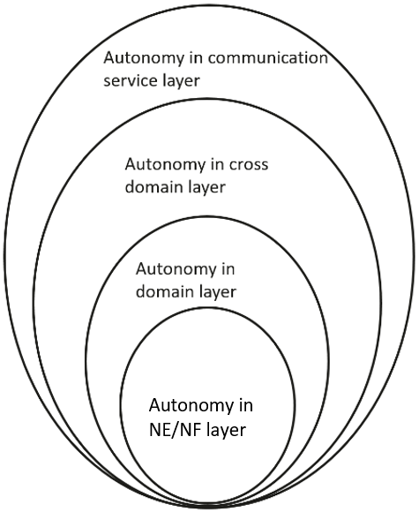
Figure 4.Z.3-1: Autonomy for different management scope

4.Z.4 Workflow
Workflow is used to describe the necessary steps to achieve certain management and control purposes. A workflow is composed of one or more management and control tasks. Each workflow task may be accomplished by human, or accomplished by telecommunication system with human assistance, or accomplished by telecommunication system without human intervention. The autonomy capabilities of the tasks in the workflow may impact the autonomous network level.
Following are the categorization of the tasks in a workflow:
- Intent handling: The group of tasks which translate network or service intent from operator or customer into detailed operations and/or policies which may affect one or more of the following groups of tasks (i.e. awareness, analysis, decision, execution), also evaluate and feedback intent fulfilment information (e.g. the intent is satisfied or not) based on the detailed network and service information.
- Awareness: The group of tasks which monitor network and service information (including network and service performance, network and service anomaly, network and service event, etc.).
- Analysis: The group of tasks which analyse the obtained network and service information (e.g. network and service status, network and service issues and so on) or based on the historical network and service information to further predict the future change trend of the above network and service status, and make recommendation for decision.
- Decision: The group of tasks which evaluate and decide the necessary operation for execution, e.g. network configuration or adjustment.
- Execution: The group of tasks which execute the operations.
Editor's note: the relationship between the above categorization of the tasks and the other standardized features including intent driven management and COSLA is FFS.

End of changes

