3GPP TSG SA WG5 Meeting 134-e S5-206170

electronic meeting, online, 16th - 25th November 2020

Source: Huawei, China Mobile

Title: Add use case and requirements for coverage optimization

Document for: Approval
Agenda Item: 6.4.1

1 Decision/action requested
The group is asked to discuss and approval.

2 References
[1] 3GPP draft TS 28.100: “Levels of autonomous network v0.1.0”.
[2] 3GPP TR 28.810: “Study on concept, requirements and solutions for levels of autonomous network v17.0.0”

3 Rationale
The Coverage optimization use case example for classification of network autonomy is described in clause 5.2.1 in TS 28.810[2], and the potential requirements for classification of network autonomy for coverage optimization is described in clause 6.2.3 in TS 28.810[2]. This contribution proposes to add use case and requirements for

4 Detailed proposal
It proposes to make the following changes to TS 28.100[1].
1st Change

5.X.1 Autonomous radio network coverage optimization

Editor’s Note: whether the following use case and requirements needs to be generailized for common optimization scenarios is FFS.

5.X.1.1 Introduction
Radio networks are geographically distributed, and mobile user activity varies significantly in different places and at different times of day. To achieve the optimal coverage, a set of initial coverage configuration parameters (e.g. coverageShape, digitalTilt and digitalAzimuth) may not always meet the requirements. Therefore, the coverage configuration parameters need to be adjusted in a differentiated manner with the change of the radio network environment. It’s almost not possible for manual adjustment due to multiple factors needs to be considered, e.g. interference control, huge data and frequent traffic changes, and also manual adjustment takes time. So it is benefits to introduce the autonomy technologies to achieve the optimal coverage configuration parameters automatically to deliver the best coverage for the complex wireless environments.
Full autonomy of coverage optimization for radio network is a long term goal, it will be beneficial for operator to achieve this goal step by step and have clear view on which typical issues can be addressed by utilizing autonomy mechanism in corresponding steps.

5.X.1.2 Workflow
Following are the entire workflow for the radio network coverage optimization:
Intent handling:
- Task A: Coverage optimization policies generation and determination. The tasks of generating and determining the coverage optimization related policies (e.g., weak coverage issue identification policies, weak coverage analysis policies and coverage parameters adjustment policies) based on coverage optimization intent (e.g. coverage targets(e.g. weak coverage ratio) for the specified areas).
- Task B: Coverage optimization intent evaluation. The tasks of evaluating coverage optimization intent fulfilment information (e.g. corresponding coverage targets are satisfied or not).
Awareness:
- Task C: Coverage related information collection. The tasks of collecting coverage related data, including coverage performance data (i.e. performance measurement, MDT data), coverage configuration data (e.g. coverageShape, digitalTilt and digitalAzimuth) and environment data (e.g. electronic map)).
- Task D: Coverage issues identification. The tasks of analysing the coverage performance (e.g. geographical grid based coverage performance) and identifying the coverage issues (e.g. weak coverage, coverage hole, overshoot coverage) and corresponding location.
Analysis:
- Task E: Coverage deterioration prediction. The tasks of analysing current coverage performance and histical coverage performance, predicting the coverage performance trend in the future and identifying potential coverage performance deterioration in advance.
- Task F: Coverage issue analysis. The tasks of analysing the root cause (e.g. affected Cells) of the identified or predicted coverage issues.
- Task G: Coverage adjustment actions generation. The tasks of generating the recommended coverage adjustment actions which can address the identified or predicted coverage issues.
Decision:
- Task H: Coverage adjustment actions evaluation and determination. The tasks of evaluating the recommended coverage adjustment actions, and deciding the coverage adjustment actions to be executed.
Execution:
- Task I: Coverage adjustment actions execution. The tasks of adjusting and configuring the coverage related parameters (e.g. selection of coverageShape, digitalTilt and digitalAzimuth).

5.X.1.3 Classification of autonomous network level
Level 0:
- All the tasks in the radio network coverage optimization workflow (Task A, Task B, Task C, Task D, Task E, Task F, Task G, Task H, Task I) are accomplished by human.
Level 1:
- Telecom system executes the tasks of coverage adjustment action execution based on coverage related parameters specified by human (Task I). Telecom system also can execute the tasks of coverage related information collection based on collection rule specified by human (Task C). At this level, telecom system can assist human to improve the execution and awareness efficiency for radio network coverage optimization.
- All the other tasks in the radio network coverage optimization workflow (Task A, Task B, Task D, Task E, Task F, Task G, Task H) are accomplished by human.
Level 2:
- Compared to Level 1, telecom system additionally executes the tasks of coverage issues identification, coverage issue analysis based on the coverage issue identification and analysis rule specified by human (Task D, Task F). At this level, telecom system can assist human to achieve the closed loop for radio network coverage optimization based on human defined rules.
- All the other tasks in the radio network coverage optimization workflow (Task A, Task B, Task E, Task G, Task H) are accomplished by human.
Level 3:
- Compared to Level 2, telecom system additionally executes the tasks of coverage adjustment actions generation (Task G) and coverage adjustment actions evaluation and determination (Task H) based on coverage adjustment policies and evaluation policies specified by human. At this level, the telecom system can achieve the closed loop automation for coverage optimization based on the human defined optimization policies.
- All the other tasks in the radio network coverage optimization workflow (Task A, Task B, Task E) are accomplished by human.
Level 4:
- Compared to Level 3, the telecom system additionally executes the tasks of coverage deterioration prediction (Task E), coverage optimization policies determination (Task A), and coverage optimization intent evaluation (Task B) based on received coverage optimization intent and intent translation/evaluation policies specified by human. At this level, telecom system can achieve the intent driven closed loop automation for radio network coverage optimization based on human defined intent translation and evaluation policies
- The intent translation and evaluation policies maybe pre-defined and specified by human to assist the telecom system.
Level 5:
- Telecom system can autonomously execute the entire workflow of radio network coverage optimization for all scenarios, which means the telecom system can achieve the full autonomy for radio network coverage optimization for full scenarios.
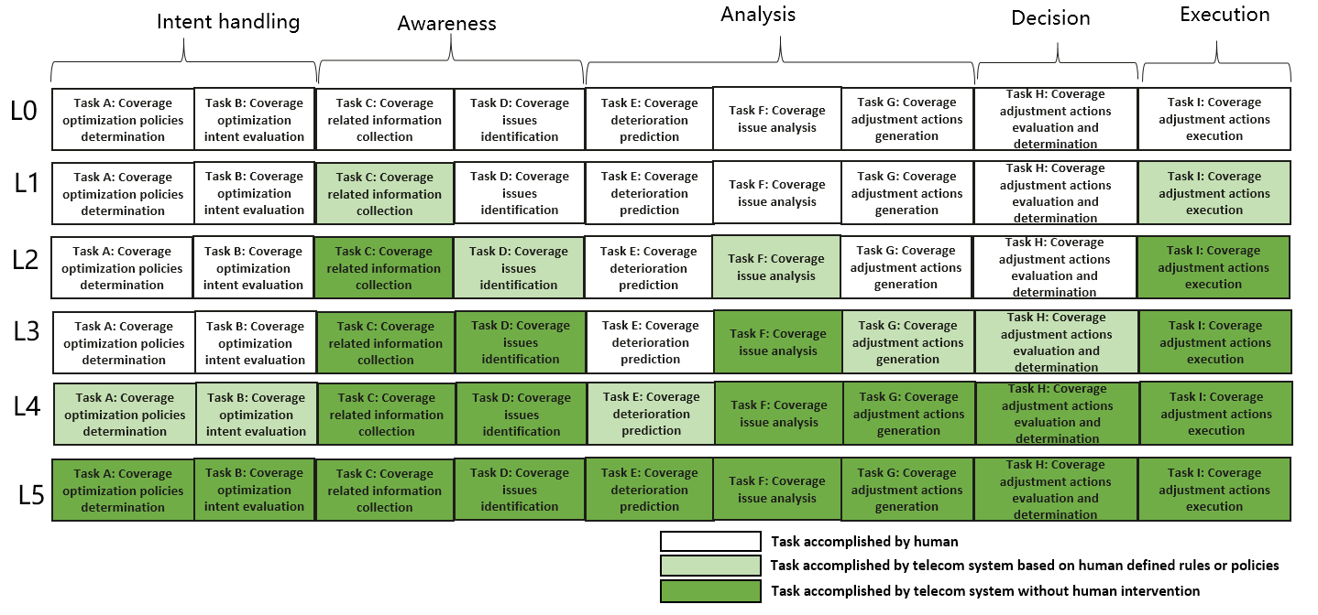
Figure 5.X.1.3-1: Classification of autonomous network level for radio network coverage optimization

5.X.1.4 Requirements
Following are the requirements for each autonomous network level (except for level 0) for radio network coverage optimization.
Requirements to support autonomous network level 1 for radio network coverage optimization:
REQ-ANL-Level_1-CON 1 The RAN MnF shall have autonomy capability to support adjusting coverage related parameters based on the specified coverage configuration parameters.
REQ-ANL-Level_1-CON 2 The RAN MnF shall have autonomy capability to support collecting coverage related data (including coverage performance data, coverage configuration data and environment) based on specified collection rules.
Additional requirements to support autonomous network level 2 (compared to level 1) for coverage optimization:
REQ-ANL-Level_2-CON 1 The RAN MnF shall have autonomy capability to support identifying the coverage issue based on the specified coverage issue identification rule.
REQ-ANL-Level_2-CON 2 The RAN MnF shall have autonomy capability to support analysing the coverage issue based on the specified coverage issue analysis rule.
Additional requirements to support autonomous network level 3 (compared to level 2) for coverage optimization:
REQ-ANL-Level_3-CON 1 The RAN MnF shall have autonomy capability to support generating the recommended coverage adjustment actions based on specified coverage adjustment policies.
REQ-ANL-Level_3-CON 2 The RAN MnF shall have autonomy capability to support evaluating the recommended coverage adjustment actions and determining the coverage adjustment actions to be executed.
Additional requirements to support autonomous network level 4 (compared to level 3) for coverage optimization:
REQ-ANL-Level_4-CON 1 the RAN MnF shall have autonomy capability to support determining or updating coverage optimization policies according to coverage optimization intent based on specified intent translation policies.
REQ-ANL-Level_4-CON 2 the RAN MnF shall have autonomy capability to support evaluating coverage optimization intent fulfilment result based on specified intent evaluation policies.
REQ-ANL-Level_4-CON 3 The RAN MnF shall have autonomy capability to support predicting coverage performance deterioration.
Additional requirements to support autonomous network level 5 (compared to level 4) for coverage optimization:
REQ-ANL-Level_5-CON 1 The RAN MnF shall have autonomy capability to support generating the intent translation and evaluation policies.
REQ-ANL-Level_5-CON 2 The RAN MnF shall have autonomy capability to support entire coverage optimization workflow automation for all scenarios.
Note: RAN MnF means the MnS Producer who provide MnS(s) for RAN management

End of changes

