3GPP TSG-SA5 Meeting #133e S5-205355d1

e-meeting 12th - 21st October 2020

Title: O-RAN - 3GPP Cooperation on Management Services
Response to: LS S5-205023/S-2020003 from O-RAN WG1
Release: 3GPP Rel-16, 3GPP Rel-17
Work Item: n/a

Source: 3GPP SA5
To: O-RAN WG1
Cc:

Contact Person:

Name: Anatoly Andrianov
Tel. Number:

E-mail Address: anatoly<dot>andrianov<at>nokia<dot>com

Send any reply LS to: 3GPP Liaisons Coordinator, mailto:3GPPLiaison@etsi.org

Attachments: none

1. Overall Description:
3GPP SA5 appreciates the information O-RAN WG1 shared about their progress with definitions of O1 interface. We would like to thank O-RAN for the interest to 3GPP SA5 specifications and for commitment to follow them as much as possible.

Regarding your question on YANG definitions for network slicing, we would like to inform you that the relevant configurable attributes, data types and IOCs are present in 3GPP TS 28.541 NR NRM (dedicated data types "S-NSSAI" in clause 4.3.37, "PLMNInfo" in clause 4.3.41 and "RRMPolicyMember" in clause 4.3.42; attribute definitions for "NRCellCU.pLMNInfoList", "rRMPolicyMemberList" and "sNSSAIList" in clause 4.4.1) with corresponding YANG solution set definitions in Annex.E (e.g. see: "module _3gpp-nr-nrm-gnbcuupfunction.yang", " module _3gpp-nr-nrm-nrcellcu@2020-02-14.yang", " module _3gpp-nr-nrm-nrcelldu@2020-02-14.yang", "module _3gpp-nr-nrm-rrmpolicy.yang" and "module _3gpp-nr-nrm-common@2020-02-14.yang").

The role of network slice NRM specified in clause 6 of 3GPP TS 28.541 is illustrated in the figure L.2.1 (also included below). The SLS captured in the form of ServiceProfile is translated into SliceProfile and further into configuration parameters. For O-RAN NG-RAN domain these configuration parameters would be communicated over the O1 interface.

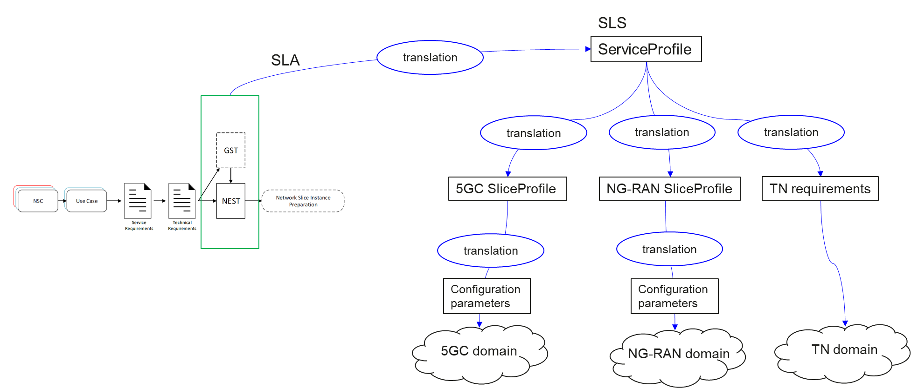
3GPP SA5 is actively working on further specification of topics related to SLA/SLS assurance and will be happy to inform O-RAN about any updates of NR NRM (e.g. new or updated NG-RAN configuration parameters) that may be triggered by this activity.

The latest version of 3GPP Rel-16 TS 28.541 (v.16.6.0 at the moment) is available at https://www.3gpp.org/ftp//Specs/archive/28_series/28.541/28541-g60.zip
The 3GPP Rel-16 YANG and OpenAPI NRM definitions are available on 3GPP FORGE at https://forge.3gpp.org/rep/sa5/MnS/tree/Rel-16.

2. Actions:
To O-RAN WG1 group.
ACTION: 3GPP SA5 kindly asks O-RAN WG1 to take the information provided in this LS and in 3GPP TS 28.541 into account. Please, do not hesitate to contact 3GPP SA5 with any additional questions or O-RAN specific requirements.

3. Date of Next TSG-SA WG5 Meetings:
SA5#134e 16 - 25 November 2020 Online
SA5#135e 25 - 29 January 2021 Online

