3GPP TSG-SA5 Meeting #133e S5-205248

e-meeting, 12 – 21 October 2020

Source: Nokia, Nokia Shanghai Bell

Title: TD clarify concept of service level specification

Document for: Discussion and Endorsement
Agenda Item: 6.4.2

1 Decision/action requested
Please discuss and endorse

2 References
[1] 3GPP TS 28.530: "Management and orchestration; Concepts, use cases and requirements".
[2] 3GPP TS 28.531: "Management and orchestration; Provisioning".
[3] 3GPP TS 28.541: "Management and orchestration; 5G Network Resource Model (NRM); Stage 2 and Stage 3".

[5] 3GPP TS 28.202: "Charging management; Network slice management charging in the 5G System (5GS); Stage 2"

3 Rationale
Concept of network slice and service level specification (SLS) were defined in TS 28.530. In addition relationship between network slice and SLS, network slice and communication service were described in 28.530 and 28.531, as well as in GSMA NG.116. e.g.:
- In clause 3.1 of 28.530, definition
network slice: a logical network that provides specific network capabilities and network characteristics, supporting various service properties for network slice customers.
Service Level Specification (SLS) : a set of service level requirements associated with a Service Level Agreement (SLA) to be satisfied by a network slice.

- In clause 4.1.8 of 28.530, Network slice delivery concepts
Network slices are provided in different compositions to the customer which may include access to different management capabilities and network slice provisioning procedures for the customer.
For example, a network slice may be delivered
a) to meet customer's communication service requirements without any exposure of internal network slice structures (applicable to both individual subscribers and NSaaS); or
b) to meet the network slice requirements, with some exposure of the internal network slice structures (e.g. NFs, topology, etc.) and with some network monitoring capability as enabled by the provider; or
c) to meet the network slice requirements with some exposure of the internal network slice structures (e.g. NFs) with some management capabilities as enabled by the provider.

- In clause 4.8 of 28.530, roles related to 5G networks and network slicing management
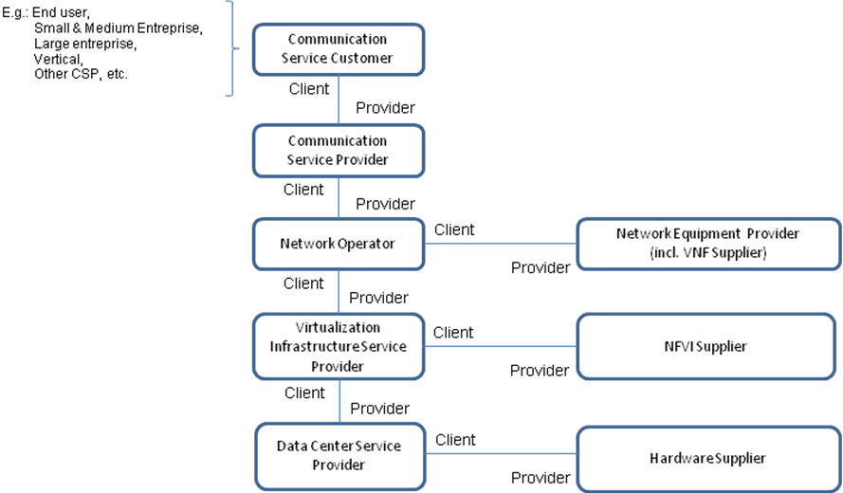

- In Annex A of 28.531: A network slice journey example
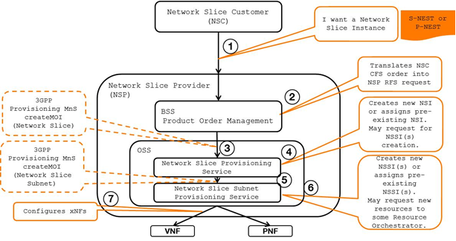
- In 4.5 of 28.531, General information for service profile
Depending on industry requirements and operator’s design requirements, different service profiles may be used to represent SLS associated with instances of Network Slice IOC.
The following are examples for service profiles:
- A service profile is used to capture a set of requirements for the new network slice instance such as (eMBB, MIoT, URLLC).
- A service profile is used to capture a set of specific industry requirements for creation of network slice instance such as V2X, smart grid, Remote Healthcare.
- In addition, in TS 28.202, it specified Network Slice Management charging based on network slice (or NetworkSlice MOI) associated with service profile (SLS).

Some observations were got based on information listed above:
Observation 1: network slice could be service/business object to be offered from network slice provider (NSP) to network slice customer (NSC).
Observation 2: A communication service and network slice are not the same thing, also communication service is not business representation of network slice. The purpose of defining a network slice is not limited to offering a specific communication service, but may include operational efficiencies (e.g. optimize operator’s O&M procedures), providing PNI-NPNs, and any number of other reasons. Even when a specific network slice supports a specific communication service, they can be offered as a service product (in such case, the end user may be aware that a ‘network slice’ is utilized).
Observation 3: service profile, which represents SLS, is used to capture a set of requirements for a service.
However, network slice is tightly coupled with communication service, or even mixed the two concepts in some specifications of SA5, and service profile is not clearly defined and correctly used in some places.

4 Detailed proposal
4.1 Endorse observations 1-3
4.2 Move service profile concept definition from 28.531 to 28.530)
4.3. Fix 28.530, 28.531, 28.541 to reflect correct relationship between communication service, network slice, service level specification and service profile, please see the concrete CRs

