3GPP TSG-SA5 Meeting #133e S5-205226rev1

e-meeting, 12 - 21 October 2020

Source: Orange

Title: Network Function energy consumption estimation – detailed potential solution

Document for: Approval
Agenda Item: 6.5.2

1 Decision/action requested
The group is asked to discuss and agree on the proposal.

2 References
[1] TR 28.813 0.2.0: Study on new aspects of Energy Efficiency (EE) for 5G

3 Rationale
This contribution proposes a detailed solution for estimating the 5GC NF energy consumption (Key Issue #5).

4 Detailed proposal
This document proposes the following changes in TR 28.813 [1].

1st Change

4.5 Key Issue #5: 5GC NF Energy Consumption estimation

4.5.1 Description
In Release 16, the Energy Consumption (EC), as defined in TS 28.552 [4] clause 5.1.1.19, is defined for Physical Network Functions (PNF) only, and associated to corresponding ManagedElement IOC instances.
In case of 5GC Network Functions (NF) composed of Virtualized Network Functions (VNF) running on a Network Function Virtualization Infrastructure (NFVI), it is expected to be able to measure the energy consumption of each VNF separately, aggregate it at the Network Function level and associate it to corresponding ManagedFunction IOC instances.
However, in a NFVI, the finest grain at which Energy Consumption can be measured is the NFVI Node, making it impossible to measure the energy consumed by each and every VNF separately given that a) a VNF can run on more than one NFVI node and b) a NFVI node can support more than one VNF.
As a workaround, it is proposed to estimate the Energy Consumption of each and every VNF instance composing Network Functions, aggregate it at the Network Function level and associate it to the ManagedFunction IOC instance representing the management view of the Network Function.

4.5.2 Potential solutions

4.5.2.1 Potential solution #1: 5GC NF EC estimation based on relative vCPU usage

4.5.2.1.1 Introduction
In TS 28.622 [8] clause 4.3.4.2, the ManagedFunction IOC attribute ‘vnfParametersList’ lists the VNF instance(s) forming the ManagedFunction. This ManagedFunction IOC relation to VNF class is also represented in [9] as follows:
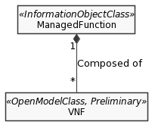
Figure 4.5.2.1.1-1: Managed Function-VNF relationship

ETSI GR NFV-IFA 015 [9] states that:
- a VNF is composed of 1-to-many VNF Component(s) (VNFC) – see diagram below.
- a VNFC runs over a single VirtualisationContainer – see diagram below.
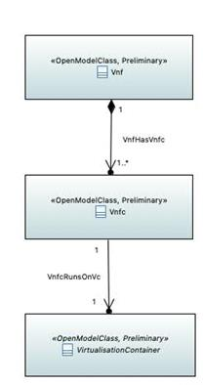
Figure 4.5.2.1.1-2: VNF-VNFC-Virtualisation Container relationship

, where a Virtualisation Container is defined in ETSI GR NFV 003 [10] as follows:
“
partition of a compute node that provides an isolated virtualised computation environment.
NOTE: Examples of virtualisation container includes virtual machine and OS container.
”.
Hence, a Virtualisation Container runs on a single NFVI Compute Node. A NFVI Compute Node may support 1-to-many Virtualisation Container(s).
To summarize:
- A network function (e.g. SMF in 5GC), represented from the management point of view by a ManagedFunction IOC instance, when realized by software running on NFVI, is composed of 1-to-many VNF instances, where each VNF instance pertains to one and only one Network Function (see NOTE 1);
- Each VNF instance may be composed of 1-to-many VNFC instances, where each VNFC instance pertains to one and only one VNF instance;
- Each VNFC instance runs on one and only one Virtualisation Container, which is a partition of a NFVI Compute Node;
- Each VNFC instance utilizes virtual CPUs of one single NFVI Compute Node;
- Each NFVI Compute Node hosts zero-to-many VNFC instances.
NOTE 1: How a 5GC NF is composed of VNFs is implementation specific. In particular, whether a VNF instance is shared or not between more than one NF is implementation specific. Hence, the case where a VNF instance is shared between multiple NFs is out of scope of the present potential solution.
Given that it is impossible to measure the energy consumed by each and every VNFC instance separately, aggregate it at the VNF instance level and then at the network function (e.g. SMF) level, it is proposed here to estimate VNFC instance energy consumption relatively to the NFVI Compute Node (on which it runs) energy consumption, in the same proportion as the VNFC instance virtual CPU usage relatively to the NFVI Compute Node (on which it runs) CPU usage during the same measurement period.
Here below is an illustration of the proposed solution on a virtualized SMF instance:
1. Consider SMF-1 is a 5GC Network Function instance;
2. Consider SMF-1 is composed of 2 VNF instances:
- VNF-11 (e.g. a load balancer), and
- VNF-12 (e.g. where the SMF logic is running);
3. Consider VNF-11 is composed of 2 VNFC instances (output from network planning):
- VNFC-111 (running on NVFI Node X), and
- VNFC-112 (running on NFVI Node Y);
4. Consider VNF-12 is composed of 2 VNFC instances (e.g. output from network dimensioning):
- VNFC-121 (running on NFVI Node X), and
- VNFC-122 (running on NFVI Node Y);
5. Consider NFVI Node X hosts 3 vCPU instances:
- X-1,
- X-2, and
- X-3;
6. Consider NFVI Node Y hosts 4 vCPU instances:
- Y-1,
- Y-2,
- Y-3, and
- Y-4;
7. Suppose that, during a given time period:
7.1 VNFC-111 has used 30% of the vCPU X-1of NFVI Node X (calculated by VNFM based on input data from the VIM in charge of NFVI Node X),
7.2. VNFC-112 has used 35% of the vCPU Y-1 of NFVI Node Y (calculated by VNFM based on input data from the VIM in charge of NFVI Node Y),
7.3. VNFC-121 has used 20% of the vCPU X-2 of NFVI Node X (calculated by VNFM based on input data from the VIM in charge of NFVI Node X),
7.4. VNFC-122 has used 60% of the vCPU Y-2 of NFVI Node Y (calculated by VNFM based on input data from the VIM in charge of NFVI Node Y),
7.5. vCPU instance X-3 has been used by a VNFC instance from another NF (vCPU usage = 50%),
7.6 vCPU instances Y-3 and Y-4 have been used by a VNFC instance from yet another NF (vCPU usage = 25% and 45% respectively);
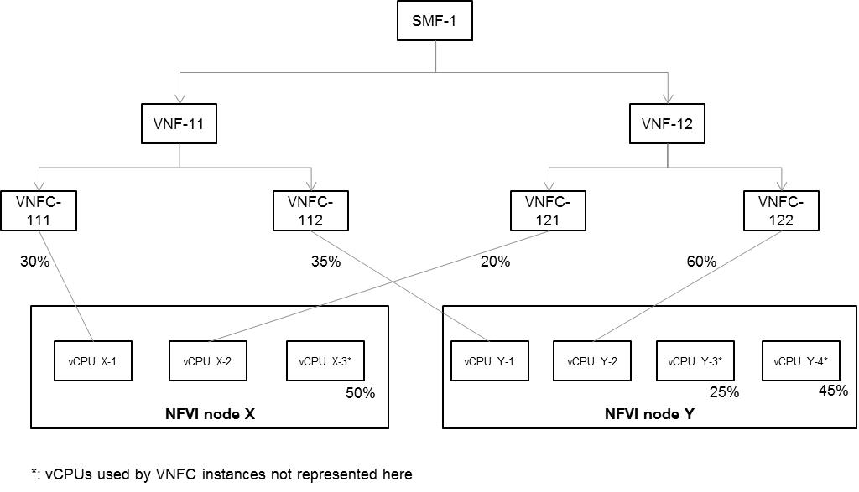
8. Based on the measurement obtained at step 7.1, it can be estimated that VNFC-111 has consumed 30% (= 30 / (30 + 20 + 50)) of the energy consumed by NFVI Node X during the same time period;
9. Based on the measurement obtained at step 7.2, it can be estimated that VNFC-112 has consumed 21% (= 35 / (35 + 60 + 25 + 45)) of the energy consumed by NFVI Node Y during the same time period;
10. Based on the measurement obtained at step 7.3, it can be estimated that VNFC-121 has consumed 20% (= 20 / (30 + 20 + 50)) of the energy consumed by NFVI Node X during the same time period;
11. Based on the measurement obtained at step 7.4, it can be estimated that VNFC-122 has consumed 55% (= 60 / (35 + 60 + 25 + 45)) of the energy consumed by NFVI Node Y during the same time period;
10. The energy consumed by NFVI Nodes X and Y during the same time period is measured separately. Let’s name these measurements as EC-X and EC-Y respectively;
11. Finally, the energy consumed by SMF-1 can be estimated by the sum of:
a. 50% (= 30 + 20) of EC-X,
b. 76% (= 21 + 55) of EC-Y.

12. End.
NOTE 2: In the above procedure, it is assumed that the multiple vCPUs located within the same NVFI Node are identical.

4.5.2.1.2 Description

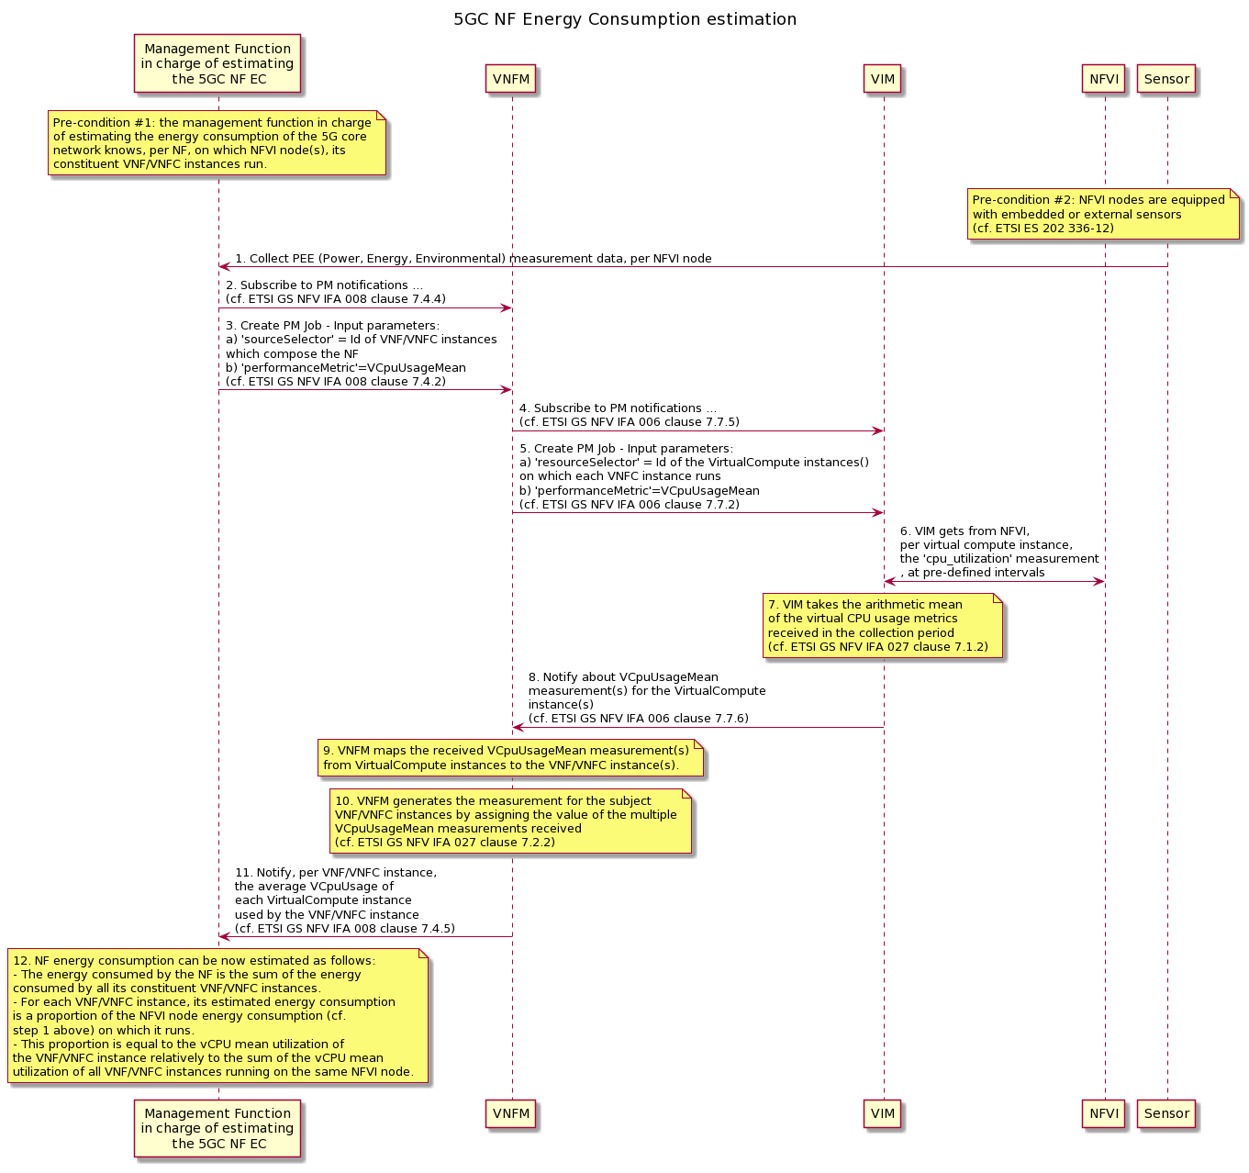

Pre-condition #1: the management function in charge of estimating the energy consumption of the 5G core network knows, per NF, on which NFVI node(s), its constituent VNF/VNFC instances run.

Pre-condition #2: NFVI nodes are equipped with embedded or external sensors (cf. ETSI ES 202 336-12).

1. The management function in charge of estimating the energy consumption of the 5G core network collects Power, Energy and Environmental (PEE) measurements from NFVI nodes (cf. ETSI ES 202 336-12), during a given period of time. The procedure described here is independent from whether the NFVI nodes are equipped with embedded sensors or external sensors (cf. ETSI ES 202 336-12);
2. The management function in charge of estimating the energy consumption of the 5G core network subscribes to PM notifications towards the VNFM, so as to receive notifications about the vCPU usage of each VNF/VNFC instance of the 5GC NF (cf. ETSI GS NFV IFA 008 clause 7.4.4) for a given period of time;
3. The management function in charge of estimating the energy consumption of the 5G core network requests the VNFM to create a PM job to collect the vCPU usage of each VNF/VNFC instance of the 5GC NF (cf. ETSI GS NFV IFA 008 clause 7.4.2);
4. The VNFM subscribes to PM notifications towards the VIM, so as to receive notifications about the vCPU usage of the virtual compute instances on which each VNF/VNFC instance runs (cf. ETSI GS NFV IFA 006 clause 7.7.5);
5. The VNFM requests the VIM to create a PM job to collect the vCPU usage of the virtual compute instances on which each VNF/VNFC instance runs and whose id’s are provided as input parameters of the CreatePMJob request (cf. ETSI GS NFV IFA 006 clause 7.7.2);
6. The VIM gets, from the NFVI, per virtual compute instance, the vCPU usage measurement data, at pre-defined intervals. Whether the VIM gets this data in pull mode or in push mode is out of scope of the present document;
7. The VIM takes the arithmetic mean of the vCPU usage values received in the collection period (cf. ETSI GS NFV IFA 027 clause 7.1.2);
8. The VIM notifies the VNFM about VCpuUsageMean measurement(s) for the virtual compute instance(s) (cf. ETSI GS NFV IFA 006 clause 7.7.6);
9. The VNFM maps the received VCpuUsageMean measurement(s) from virtual compute instances to the VNF/VNFC instance(s);
10. The VNFM generates the measurement for the subject VNF/VNFC instances by assigning the value of the multiple VCpuUsageMean measurements received (cf. ETSI GS NFV IFA 027 clause 7.2.2);
11. The VNFM notifies the Management Function in charge of estimating the 5GC NF EC, about the average VCpuUsageMean of each virtual compute instance used by the VNF/VNFC instance(s) which constitute the NF (cf. ETSI GS NFV IFA 008 clause 7.4.5);
12. NF energy consumption can be now estimated as follows:
The energy consumed by the NF is the sum of the energy consumed by all its constituent VNF/VNFC instances.
For each VNF/VNFC instance, its estimated energy consumption is a proportion of the NFVI node energy consumption (cf. step 1 above) on which it runs.
This proportion is equal to the vCPU mean utilization of the VNF/VNFC instance relatively to the sum of the vCPU mean utilization of all VNF/VNFC instances running on the same NFVI node.

End of change

