**3GPP TSG-SA5 Meeting #133e *S5-205057***

**e-meeting 12th - 21st October 2020**

|  |  |  |  |  |  |  |  |  |
| --- | --- | --- | --- | --- | --- | --- | --- | --- |
| *CR-Form-v12.0* | | | | | | | | |
| **CHANGE REQUEST** | | | | | | | | |
|  | | | | | | | | |
|  | **32.422** | **CR** | **0347** | **rev** | **-** | **Current version:** | **16.3.0** |  |
|  | | | | | | | | |
| *For* [***HE******LP***](http://www.3gpp.org/3G_Specs/CRs.htm#_blank)*on using this form: comprehensive instructions can be found at* [*http://www.3gpp.org/Change-Requests*](http://www.3gpp.org/Change-Requests)*.* | | | | | | | | |
|  | | | | | | | | |

|  |  |  |  |  |  |  |  |  |
| --- | --- | --- | --- | --- | --- | --- | --- | --- |
| ***Proposed change affects:*** | UICC apps |  | ME |  | Radio Access Network | **X** | Core Network | **X** |

|  |  |  |  |  |  |  |  |  |  |  |
| --- | --- | --- | --- | --- | --- | --- | --- | --- | --- | --- |
|  | | | | | | | | | | |
| ***Title:*** | Clarification of tracing roaming UE for 5GC | | | | | | | | | |
|  |  | | | | | | | | | |
| ***Source to WG:*** | Huawei | | | | | | | | | |
| ***Source to TSG:*** | S5 | | | | | | | | | |
|  |  | | | | | | | | | |
| ***Work item code:*** | 5GMDT | | | | |  | ***Date:*** | | | 2020-09-30 |
|  |  | | | |  | |  | | |  |
| ***Category:*** | **F** |  | | | | | ***Release:*** | | | Rel-16 |
|  | *Use one of the following categories:* ***F*** *(correction)* ***A*** *(mirror corresponding to a change in an earlier release)* ***B*** *(addition of feature),* ***C*** *(functional modification of feature)* ***D*** *(editorial modification)*  Detailed explanations of the above categories can be found in 3GPP [TR 21.900](http://www.3gpp.org/ftp/Specs/html-info/21900.htm). | | | | | | | | *Use one of the following releases: Rel-8 (Release 8) Rel-9 (Release 9) Rel-10 (Release 10) Rel-11 (Release 11) Rel-12 (Release 12)* *Rel-13 (Release 13) Rel-14 (Release 14) Rel-15 (Release 15) Rel-16 (Release 16)* | |
|  |  | | | | | | | | | |
| ***Reason for change:*** | | The scenario of activation of Trace session for roaming subscriber is described for UMTS and EPS in clause 4.1.2.1.1, but the roaming scenario is missing for 5GC (clause 4.1.2.1.1).  While for trace session/recording session deactivation, roaming scenario has been covered for both EPS and 5GC as described in clause 4.2.5. | | | | | | | | |
|  | |  | | | | | | | | |
| ***Summary of change:*** | | Adds the text to clarify the scenario when sending Trace session activation for roaming subscriber in 5GC. | | | | | | | | |
|  | |  | | | | | | | | |
| ***Consequences if not approved:*** | | It is not clear about the scenario when sending Trace session activation for roaming subscriber in 5GC, differernt interpretation may lead to differernt implementations. | | | | | | | | |
|  | |  | | | | | | | | |
| ***Clauses affected:*** | | 4.1.2.1.2 | | | | | | | | |
|  | |  | | | | | | | | |
|  | | **Y** | **N** |  | | | |  | | |
| ***Other specs*** | |  | **X** | Other core specifications | | | | TS/TR ... CR ... | | |
| ***affected:*** | |  | **X** | Test specifications | | | | TS/TR ... CR ... | | |
| ***(show related CRs)*** | |  | **X** | O&M Specifications | | | | TS/TR ... CR ... | | |
|  | |  | | | | | | | | |
| ***Other comments:*** | |  | | | | | | | | |
|  | |  | | | | | | | | |
| ***This CR's revision history:*** | |  | | | | | | | | |

|  |
| --- |
| **1st of Changes** |

##### 4.1.2.1.2 General signalling activation mechanisms for 5GS

In 5GS the signaling trace activation utilizes the Services Based Management Architecture (SBMA) defined in TS 28.533 [48]. A 5GC NE is configured with Trace Control and Configuration parameters via interaction between Provisioning MnS (see definitions in TS 28.532 [47]) consumer and Provisioning MnS producer. Figure 4.1.2.1.2-1 below illustrates the 5GS signaling activation where the role of a Provisioning MnS producer is played by the 5GC NE and the role of a Provisioning MnS consumer is played by the Management System.

In case of home subscriber trace (i.e. in the HPLMN), the Trace Session activation shall go to the 5GC NE which played as the Provisioning MnS producer, such as UDM, AMF and SMF. . Instances where the home subscriber is roaming in a VPLMN, the Provisioning MnS producer may initiate a trace in that VPLMN. The VPLMN may reject such requests.

In case of foreign subscriber trace (i.e. the HPLMN operator wishes to trace foreign subscribers roaming in his PLMN), the Trace Session activation shall go to the 5GC NE located in the PLMN operator (i.e. the 5GC NE belongs to VPLMN as described in clause 4.2.4 of TS 23.501 [40], such as AMF/SMF).

Depending on the Trace Control and Configuration parameters received, the configured 5GC NE shall propagate the activation to selected NE's in the entire network – RAN and Core Network.

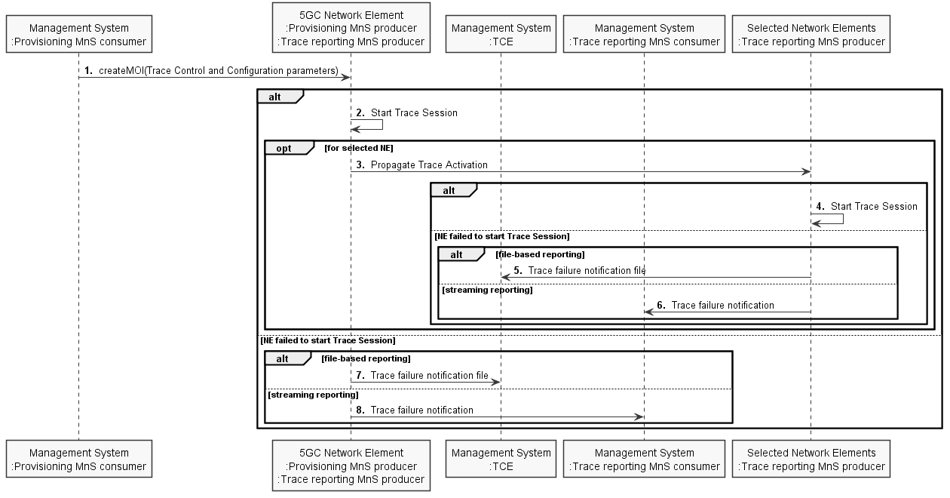

Figure 4.1.2.1.2-1: Overview of signaling activation for 5GS

If the NE failed to activate the Trace Session in a file-based reporting case, a Trace failure notification file shall be sent to the TCE following the Trace failure notification file XML schema defined in Annex A. If the NE failed to activate the Trace Session in a streaming reporting case, a Trace failure notification shall be sent to the Trace Reporting MnS consumer. In addition, a new Alarm may be reported via the Fault Supervision MnS (see definitions in TS 28.532 [47]).

|  |
| --- |
| **End of Change** |