3GPP TSG-SA5 Meeting #131e S5-203429

e-meeting 25th May-3rd June 2020 Revision of S5- 203246

Source: China Mobile, Ericsson, Deutsche Telekom

Title: pCR 28.535 Update Clause 4.2 Management control loops

Document for: Approval
Agenda Item: 6.4.7

1 Decision/action requested
The group is asked to discuss and approval.

2 References
[1] 3GPP TS 28.535: “Management Services for Communication Service Assurance Requirements (Release 16) v1.2.0”.

3 Rationale
This contribution proposes to Update Clause 4.2 Management control loops.

4 Detailed proposal
It proposes to make the following changes to TS 28.535[1].
1st Change

4.2 Management control loops

4.2.1 Overview
For communication service assurance one can identify two interactions of management control loops:
- between the CSC and the CSP: In this case, the CSC provides the requirements for an assured communication service to the CSP, the CSP provides the corresponding communication service, the CSP also provides feedback to the CSC. The CSP adjusts the CSI or the CSC adjusts the SLS continuously to achieve the assured requirements.
- between the CSP and the NSP: the CSI provided by CSP requires the network capabilities. For example, the CSP requires a certain network latency. The NSP management system adjusts the network or CSP adjusts the latency requirement continuously to satisfy the latency requirement.

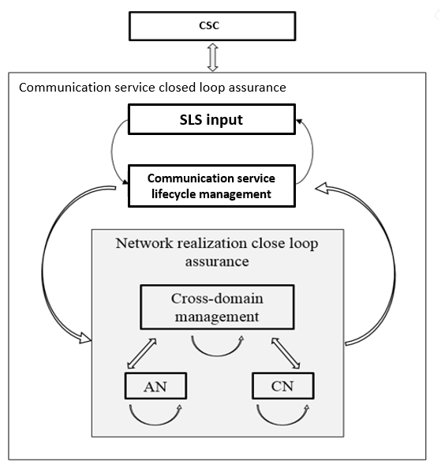
Figure 4.2.1.1: Communication service closed loop assurance
Generally, the management control loop for a CSI consists of the steps Monitoring, Analysis, Decision and Execution.The adjustment of CSI is completed by the continuous iteration of the steps in a management closed control loop. As described in section 4.1, the management closed control loop for CSI is deployed in the preparation phase and takes effect during the preparation phase and operation phase.
Figure 4.2.1.1 shows the overall process of the CSI management control loop:
Figure 4.2.1.2: Management Control Loop
End of changes

