3GPP TSG-SA5 Meeting #131-e S5-203304

Online, , 25th May 2020 - 3rd Jun 2020
CR-Form-v12.0
CHANGE REQUEST
 | 28.531 | CR | 0052 | rev | - | Current version: | 16.5.0
For HELP on using this form: comprehensive instructions can be found at
http://www.3gpp.org/Change-Requests.

Proposed change affects: | UICC apps |  | ME |  | Radio Access Network | x | Core Network | x

Title: | Rel-16 CR 28.531 Correction of provisioning services and procedures
Source to WG: | Nokia, Nokia Shanghai Bell, Orange
Source to TSG: | SA5
Work item code: | NETSLICE-PRO_NS, TEI16 |  |  |  |  |  | Date: |  |  | 2020-05-15
Category: | F |  |  |  |  |  | Release: |  |  | Rel-16
 | Use one of the following categories:  F (correction)  A (mirror corresponding to a change in an earlier release)  B (addition of feature),  C (functional modification of feature)  D (editorial modification)  Detailed explanations of the above categories can  be found in 3GPP TR 21.900. |  |  |  |  |  |  |  | Use one of the following releases:  Rel-8 (Release 8)  Rel-9 (Release 9)  Rel-10 (Release 10)  Rel-11 (Release 11)  Rel-12 (Release 12)  Rel-13 (Release 13)  Rel-14 (Release 14)  Rel-15 (Release 15)  Rel-16 (Release 16)
Reason for change: |  | Improper use of non-management domain and other SDO terminology resulted in inconsistent documentation of 3GPP management procedures and generation of unnecessary content. Significant part of the TS is non-implementable.
Summary of change: |  | Remove unnecessary and redundant content. Re-align the use of management terminology to ensure consistency with other SA5 specifications.
Consequences if not approved: |  | Incosistent, misleading specification that is impossible to implement. As a result, lack of support for standardized management and orchestration of Network Slicing in 3GPP Rel-16.
Clauses affected: |  | 6.1, 6.2, 6.4, 6.5 (void), 7.2, 7.3, 7.4, 7.5, 7.6, 7.7, 7.8, 7.9, 7.10, 7.11, 7.12, 7.13, 7.14, 7.15, 7.16, 8 (void)
 |  | Y | N
Other specs |  |  | x | Other core specifications |  |  |  | TS/TR ... CR ...
affected: |  |  | x | Test specifications |  |  |  | TS/TR ... CR ...
(show related CRs) |  |  | x | O&M Specifications |  |  |  | TS/TR ... CR ...
Other comments:
This CR's revision history:

1st Modified Section

6.1 Management services for network slice provisioning
The management services for network slice provisioning are listed in table 6.1-1.
Table 6.1-1: Management services for network slice provisioning
MnS Name | MnS Component Type A  (operations and notifications) | MnS Component Type B  (information model) | Note
Provisioning for network slice | Operations defined in clause 5 of TS 28.532 [8]:  - createMOI operation  - deleteMOI operation  - getMOIAttributes operation  - modifyMOIAttributes operation  Operations defined in clause 6.5:  - allocateNsi operation  - deallocateNsi operation | Network slice information model defined in clause 6.3 of TS 28.541 [6] | This management service enables its consumer to request allocating, deallocating, or modifying a NetworkSlice MOI.  The typical scenario is "Network Slices as NOP internals" model where this MnS is consumed by operators.
Provisioning data report for network slice | Operations defined in clause 5 of TS 28.532 [8]:  - subscribe operation  - unSubscribe operation  Notifications defined in clause 5 of TS 28.532 [8]:  - notifyMOICreation notification  - notifyMOIDeletion notification  - notifyMOIAttributeValueChanges notification | Network slice information model defined in clause 6.3 of TS 28.541 [6] | This management service enables its consumer to obtain notifications about NetworkSlice MOI data.  The typical scenario is "Network Slices as NOP internals" model where this MnS is consumed by operators
Provisioning exposure for network slice | Operations defined in clause 5 of TS 28.532 [8]:  - createMOI operation  - deleteMOI operation  - getMOIAttributes operation  - modifyMOIAttributes operation  Operations defined in clause 6.5:  - allocateNsi operation  - deallocateNsi operation | Network slice information model defined in clause 6.3 of TS 28.541 [6] | This management service enables its consumer to request allocating, deallocating or modifying an NetworkSlice MOI.  The typical scenario is NSaaS model where this MnS is consumed by vertical industry.
Provisioning data report exposure for network slice | Operations defined in clause 5 of TS 28.532 [8]:  - subscribe operation  - unSubscribe operation  Notifications defined in clause 5 of TS 28.532 [8]:  - notifyMOICreation notification  - notifyMOIDeletion notification  - notifyMOIAttributeValueChanges notification | Network slice information model defined in clause 6.3 of TS 28.541 [6] | This management service enables its consumer to obtain notifications about NetworkSlice MOI data.  The typical scenario is NSaaS model where this MnS is consumed by vertical industry.

2nd Modified Section

6.2 Management services for network slice subnet provisioning
The management services for network slice subnet provisioning are listed in table 6.2-1.
Table 6.2-1: Management services for network slice subnet provisioning
MnS Name | MnS Component of type A (Operations and notifications) | MnS Component of type B (information model)
Provisioning for network slice subnet | Operations defined in clause 5 of TS 28.532 [8]:  - createMOI operation  - modifyMOIAttributes operation  - getMOIAttributes operation  - deleteMOI operation  Operations defined in clause 6.5:  - allocateNssi operation  - deallocateNssi operation | NetworkSliceSubnet IOC information model defined in clause 6.3 of TS 28.541 [6]
Provisioning data report for network slice subnet | Operations defined in clause 5 of TS 28.532 [8]:  - subscribe operation  - unSubscribe operation  Notifications defined in clause 5 of TS 28.532 [8]:  - notifyMOICreation notification  - notifyMOIDeletion notification  - notifyMOIAttributeValueChanges notification | NetworkSliceSubnet IOC information model defined in clause 6.3 of TS 28.541 [6]

3rd Modified Section

6.4 Management services for network and sub-network provisioning
The management services for network and sub-networks provisioning are listed in table 6.4-1.
Table 6.4-1: Management services for network and sub-network provisioning
MnS name | MnS Component of type A (Operations and notifications) | MnS Component of type B (information model)
Provisioning for network and sub-networks | Operations defined in clause 5 of TS 28.532 [8]:  - createMOI operation  - modifyMOIAttributes operation  - getMOIAttributes operation  - deleteMOI operation  Operation defined in clause 6.5:  - AllocateNetwork operation | NetworkSliceSubnet IOC, as defined in TS 28.541 [6]
Provisioning data report for sub-networks | Operations defined in clause 5 of TS 28.532 [8]:  - subscribe operation  - unSubscribe operation  Notifications defined in clause 5 of TS 28.532 [8]:  - notifyMOICreation notification  - notifyMOIDeletion notification  - notifyMOIAttributeValueChanges notification | NetworkSliceSubnet IOC(s) as defined in TS 28.541 [6]

4th Modified Section

6.5. Operations of provisioning

6.5.1 AllocateNsi operation

6.5.1.1 Description
This operation is invoked by allocateNsi operation service consumer to request the provider to allocate a network slice instance to satisfy network slice related requirements. The provider may create a new NSI or using existing NSI to satisfy the request.

6.5.1.2 Input parameters
Parameter Name | Support Qualifier | Information Type / Legal Values | Comment
attributeListIn | M | LIST OF SEQUENCE< attribute name, attribute value> | This parameter specifies the network slice related requirements defined in ServiceProfile in Clause 6.3.3 in TS 28.541 [6].

6.5.1.3 Output parameters
Parameter name | Support Qualifier | Matching Information / Legal Values | Comment
attributeListOut | M | LIST OF SEQUENCE< attribute name, attribute value> | This list of name/value pairs contains the attributes of the NSI which has been allocated and the actual value assigned to each.
status | M | ENUM (OperationSucceeded, OperationFailed) | An operation may fail because of a specified or unspecified reason.
nSId | M | An attribute uniquely identifies the network slice instance. | It specifies the unifique identifier of the NSI which has been allocated.

6.5.2 AllocateNssi operation

6.5.2.1 Description
This operation is invoked by allocateNssi operation service consumer to request the provider to allocate a network slice subnet instance to satisfy the network slice subnet related requirements. The provider may create a new NSSI or using existing NSSI to satisfy the request.

6.5.2.2 Input parameters
Parameter Name | Support Qualifier | Information Type / Legal Values | Comment
attributeListIn | M | LIST OF SEQUENCE< attribute name, attribute value> | This parameter specifies the network slice subnet related requirements defined in SliceProfile in Clause 6.3.4 in TS 28.541 [6].

6.5.2.3 Output parameters
Parameter name | Support Qualifier | Matching Information / Legal Values | Comment
attributeListOut | M | LIST OF SEQUENCE< attribute name, attribute value> | This list of name/value pairs contains the attributes of the NSSI which has been allocated and the actual value assigned to each.
status | M | ENUM (OperationSucceeded, OperationFailed) | An operation may fail because of a specified or unspecified reason.
nSSId | M | An attribute uniquely identifies the network slice subnet instance. | It specifies the unifique identifier of the NSSI which has been allocated.

6.5.3 DeallocateNsi operation

6.5.3.1 Description
This operation is invoked by deallocateNsi operation service consumer to request the provider to deallocate a network slice instance since the NSI is no longer needed for the consumer. The provider may terminate the requested NSI or modify the requested NSI without termination to satisfy the request.

6.5.3.2 Input parameters
Parameter Name | Support Qualifier | Information Type / Legal Values | Comment
nSId | M | An attribute uniquely identifies the network slice instance. | It specifies the unifique identifier of the NSI which need to be deallocated.

6.5.3.3 Output parameters
Parameter name | Support Qualifier | Matching Information / Legal Values | Comment
status | M | ENUM (OperationSucceeded, OperationFailed) | An operation may fail because of a specified or unspecified reason.

6.5.4 DeallocateNssi operation

6.5.4.1 Description
This operation is invoked by deallocateNssi operation service consumer to request the provider to deallocate a network slice subnet instance since the NSSI is no longer needed for the consumer. The provider may terminate the requested NSSI or modify the requested NSSI without termination to satisfy the request.

6.5.4.2 Input parameters
Parameter Name | Support Qualifier | Information Type / Legal Values | Comment
nSSId | M | An attribute uniquely identifies the network slice subnet instance. | It specifies the unifique identifier of the NSSI which need to be deallocated.

6.5.4.3 Output parameters
Parameter name | Support Qualifier | Matching Information / Legal Values | Comment
status | M | ENUM (OperationSucceeded, OperationFailed) | An operation may fail because of a specified or unspecified reason.

6.5.5 AllocateNetwork operation

6.5.5.1 Description
This operation is invoked by allocateNetwork operation service consumer to request the provider to satisfy the network related requirements.

6.5.5.2 Input parameters
Parameter Name | Support Qualifier | Information Type / Legal Values | Comment
attributeListIn | M | LIST OF SEQUENCE< attribute name, attribute value> | This parameter specifies the network related requirements defined in ServiceProfile in Clause 6.3.3 in TS 28.541 [6].

6.5.5.3 Output parameters
Parameter name | Support Qualifier | Matching Information / Legal Values | Comment
serviceProfileId | M | String | A unique identifier of the network related requirements which have been supported by the allocated network.
status | M | ENUM (OperationSucceeded, OperationFailed) | An operation may fail because of a specified or unspecified reason.

5th Modified Section

7.2 Procedure of network slice allocation
The Figure 7.2-1 illustrates the procedure of network slice allocation with options for creating a new NetworkSlice MOI or using an existing NetworkSlice MOI to satisfy the required network slice related requirements.
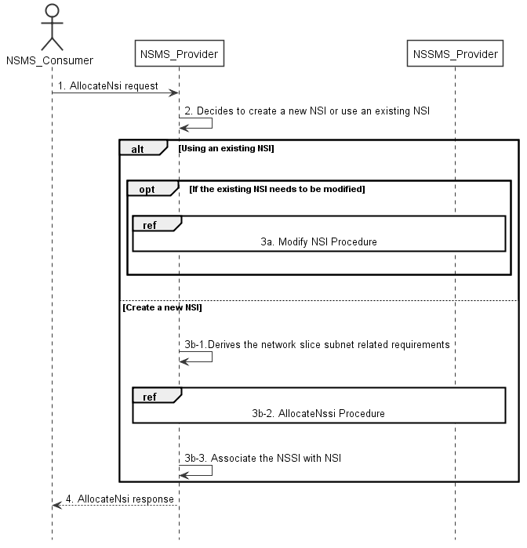
Figure 7.2-1: Network slice allocation request procedure
1) Network Slice Management Service Provider (NSMS_Provider) receives a request for from Network Slice Management Service Consumer (NSMS_Consumer) with network slice related requirements (see ServiceProfile defined in clause 6.3.3 in TS 28.541[6]).
2) Based on the network slice related requirements, the NSMS_Provider decides whether to use an existing NetworkSlice MOI or create a new NetworkSlice MOI. If the network slice related requirements allow the requested MOI to be shared and if an existing suitable MOI can be reused, the NSMS_Provider may decide to use the existing MOI.
3a) If using an existing NetworkSlice MOI and the existing NetworkSlice MOI needs to be modified to satisfy the network slice related requirements, the NSMS_Provider invokes the procedure to modify the existing NetworkSlice MOI as described in clause 7.6.
3b-1) If creating a new MOI, the NSMS_Provider derives the network slice subnet related requirements from the received network slice related requirements. Before NSMS_Provider derives the network slice subnet related requirements, NSMS_Provider may invoke corresponding network slice subnet capability information querying procedure as descried in clause 7.8.
3b-2) The NSMS_Provider invokes the Network slice subnet allocation procedure as described in clause 7.3.
3b-3) The NSMS_Provider creates the MOI for NetworkSlice and configures the MOI with the DN of MOI for the NetworkSliceSubnet, other configuration information may be configured for the created MOI.
Note: The detailed configuration information is described in network slice NRM (see NetworkSlice IOC defined in clause 6.3.1 in TS 28.541 [6]).
4) The NSMS_Provider sends network slice allocation result to the NSMS_Consumer. If an existing NetworkSlice MOI is modified or a new NetworkSlice MOI is created successfully to satisfy the network slice related requirements, the result includes the relevant network slice instance information (see NetworkSlice IOC defined in clause 6.3.1 in TS 28.541 [6]):
- DN of the NetworkSlice MOI.
Otherwise the result may include the reason of failure, for example, the required latency or user number cannot be satisfied, or the physical resource is not enough.

6th Modified Section

7.3 Procedure of network slice subnet allocation
The Figure 7.3-1 illustrates the procedure of creating a new NetworkSliceSubnet MOI or using an existing NetworkSliceSubnet MOI to satisfy the required network slice subnet related requirements.
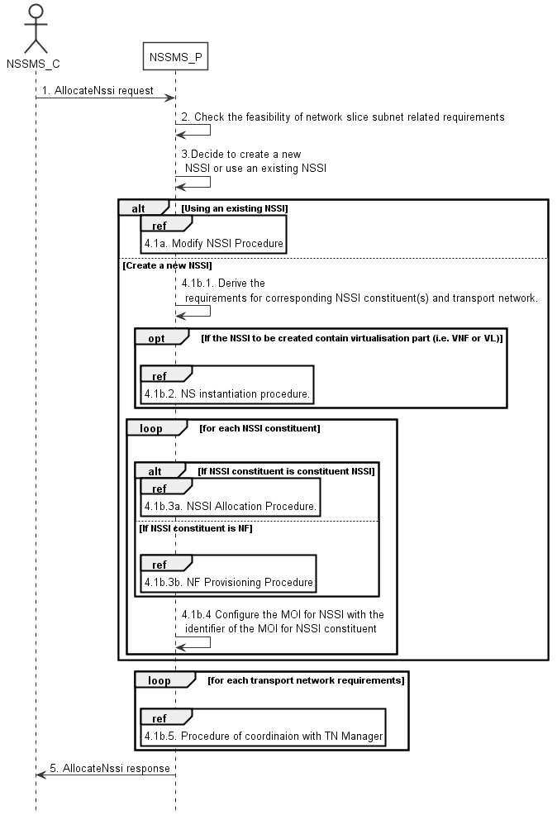
Figure 7.3-1: Network slice subnet allocation request procedure
1) Network Slice Subnet Management Service Provider (NSSMS_P) receives a request to create a NetworkSliceSubnet MOI from Network Slice Subnet Management Service Consumer (NSSMS_C) with network slice subnet related requirements (see SliceProfile defined in claue 6.3.4 in TS 28.541[6]).
2) NSSMS_P check the feasibility of network slice subnet related requirements. If the network slice subnet related requirements can be satisfied, the following step 3) are needed, else go to step 5).
3) Based on the network slice subnet related requirements, NSSMS_P decides whether to use an existing NetworkSliceSubnet MOI or create a new NetworkSliceSubnet MOI. If the network slice subnet related requirements allow the requested NetworkSliceSubnet MOI to be shared and if an existing suitable NetworkSliceSubnet MOI can be reused, the NSSMS_P decides to use the existing NetworkSliceSubnet MOI.
4.1a) If using an existing NetworkSliceSubnet MOI and the existing NetworkSliceSubnet MOI needs to be modified to satisfy the network slice subnet related requirements, the NSSMS_P invokes the procedure to modify the existing NetworkSliceSubnet MOI as described in clause 7.7.
4.1b.1) If creating a new NetworkSliceSubnet MOI, the NSSMS_P creates the MOI. NSSMS_P derives the corresponding network slice subnet constituent (i.e. ManagedFuncion MOI, constituent NetworkSliceSubnet MOI) related requirements and transport network related requirements (e.g. 3GPP endpoint information, latency requirements, bandwidth requirements, isolation requirements) from the received network slice subnet related requirements. Before NSSMS_Provider derives the constituent network slice subnet related requirements, NSMS_Provider may invoke corresponding network slice subnet capability information querying procedure as described in clause 7.8.2.
4.1b.2) If the NetworkSliceSubnet MOI to be created contains virtualisation part (i.e. VNF or VL), NSSMS_P derives the NetworkSlice MOI instantiation information (the NetworkSlice MOI instantiation information is described in clause 7.3.2.2 and clause 7.3.3.2 [3]) based on network slice subnet related requirements. NSSMS_P determines VNF instance(s) that need to be deployed according to the necessary network function(s) and then derives the profile of virtual link(s) according to the connection requirements between the network functions. NSSMS_P chooses a proper NSD deployment flavour and creates data concerning the SAPs of the NS instance. NSSMS_P invokes the NS instantiation procedures to create a NS instance. NSSMS_P configures the NSS MOI with the NS instance identifier.
Note: NS instantiation procedure is described in TS 28.526 [7].
4.1b.3) For each required NetworkSliceSubnet MOI constituent, the following step 4.1b.3a) and 4.1b.3b) are needed:
4.1b.3a) If the required NetworkSliceSubnet MOI constituent is constituent NetworkSliceSubnet MOI, NSSMS_P invokes network slice subnet allocation procedure.
4.1b.3b) If the required NetworkSliceSubnet MOI constituent is NF instance, NSSMS_P invokes ManagedFunction MOI creation procedure as described in clause 7.10 or ManagedFunction MOI modification procedure as described in clause 7.11.
4.1b.4) NSSMS_P configures the MOI for NetworkSliceSubnet with the DN of the MOI for NetworkSliceSubnet constituent (i.e. ManagedFunction MOI, constituent NetworkSliceSubnet MOI).
4.1b.5) For each required transport network related requirements, NSSMS_P invokes corresponding procedure of coordination with relevant TN Manager to handle the TN part as described in clause 7.9.
5) The NSSMS_P sends the NetworkSliceSubnet MOI allocation result to the NSSMS_C. If the NetworkSliceSubnet MOI is created successfully, the result includes the relevant constituent network slice subnet instance information (see NetworkSliceSubnet IOC defined in clause 6.3.2 in TS 28.541 [6]):
- DN of the NetworkSliceSubnet MOI.
- NetworkSlice MOI Info (e.g. DN)
Otherwise the result may include the reason of failure, for example, the required latency or user Number cannot be satisfied, or the physical resource is not enough.

7th Modified Section

7.4 Procedure of network slice deallocation
Figure 7.4-1 depicts the procedure of deallocating a network slice by the network slice management service provider to satisfy the deallocation request received from an authorized consumer.
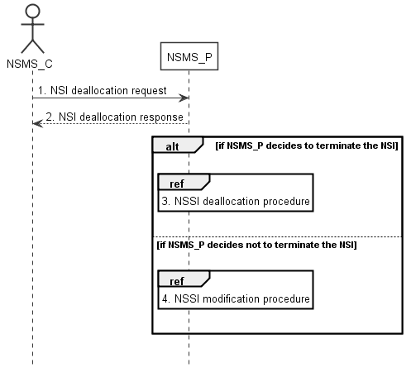
Figure 7.4-1: Network slice deallocation procedure
1) The network slice management service provider (NSMS_P) receives a network slice deallocation request from network slice management service consumer (NSMS_C) indicating that the NetworkSlice MOI is no longer needed for the consumer.
2) The NSMS_P sends the network slice deallocation response to NSMS_C.
3) The NSMS_P may decide to terminate the NetworkSlice MOI, then it invokes the network slice subnet deallocation procedure as described in clause 7.5.
4) The NSMS_P may decide not to terminate the NetworkSlice MOI but to modify the NetworkSlice MOI, then it invokes the network slice modification procedure as described in clause 7.6.

8th Modified Section

7.5 Procedure of network slice subnet deallocation
Figure 7.5-1 depicts the procedure of deallocating a network slice subnet by the network slice subnet management service provider to satisfy the NetworkSliceSubnet MOI deallocation request received from an authorized consumer.
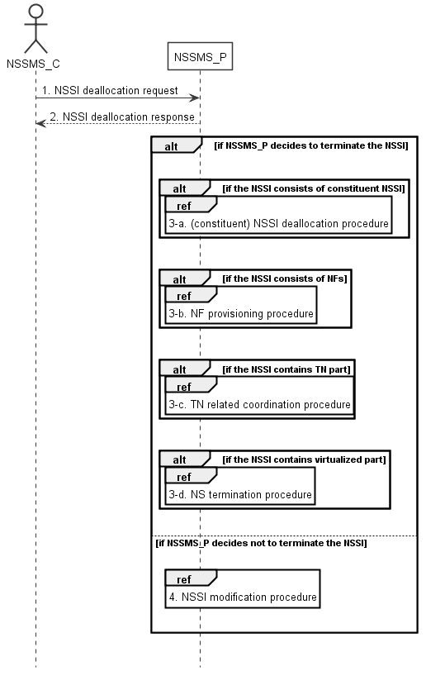
Figure 7.5-1: Network slice subnet deallocation procedure
1) The network slice subnet management service provider (NSSMS_P) receives NetworkSliceSubnet MOI deallocation request from network slice subnet management service consumer (NSSMS_C).
2) NSSMS_P sends response of NSSI deallocation service to NSSMS_C.
3-a) NSSMS_P may decide to terminate the NetworkSliceSubnet MOI, it invokes (constituent) network slice subnet deallocation procedure as described in clause 7.5 if the NetworkSliceSubnet MOI consists of constituent NetworkSliceSubnet MOI.
3-b) NSSMS_P invokes ManagedFunction MOI deletion procedure as described in clause 7.12 or ManagedFunction MOI modification procedure as described in clause 7.11 if the NetworkSliceSubnet MOI consists of ManagedFunction MOIs.
3-c) NSSMS_P invokes TN related coordination procedure with responsible manager as described in clause 7.9 if the NSSI consists of TN part.
3-d) NSSMS_P invokes NS termination procedure if the NetworkSliceSubnet MOI contains virtualized part.
Note: NS termination procedure is described in TS 28.526 [7].
4) NSSMS_P may decide not to terminate the NetworkSliceSubnet MOI, it invokes network slice subnet modification procedure as described in clause 7.7.

9th Modified Section

7.6 Procedure of network slice modification
The Figure 7.6-1 illustrates the procedure of modifying an existing NetworkSlice MOI.
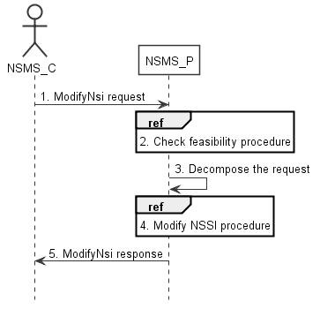
Figure 7.6-1: Network slice modification request procedure
1) Network Slice Management Service Provider (NSMS_P) receives a request (see modifyMOIAttributes operation defined in TS 28.532 [8]) from Network Slice Management Service Consumer (NSMS_C) with the DN of NetworkSlice MOI and the new network slice related requirements (see ServiceProfile defined in clause 6.3.3 in TS 28.541[6]).
2) Based on the new network slice related requirements, NSMS_P invokes the feasibility check procedure. If the modification requirements can be satisfied, go to step 3), else go to step 5).
3) NSMS_P decomposes the NetworkSlice MOI modification request into NetworkSliceSubnet MOI modification request(s), i.e., generating the new network slice subnet related requirements for each NetworkSliceSubnet MOI if needed.
4) NSMS_P, as the role of Network Slice Subnet Management Service Consumer (NSSMS_C), invokes the network slice subnet modification procedure.
5) NSMS_P sends NetworkSliceSubnet MOI modification result (see modifyMOIAttributes operation defined in TS 28.532 [8]) to NSMS_C.

10th Modified Section

7.7 Procedure of network slice subnet modification
The Figure 7.7-1 illustrates the procedure of modifying an existing NetworkSliceSubnet MOI.

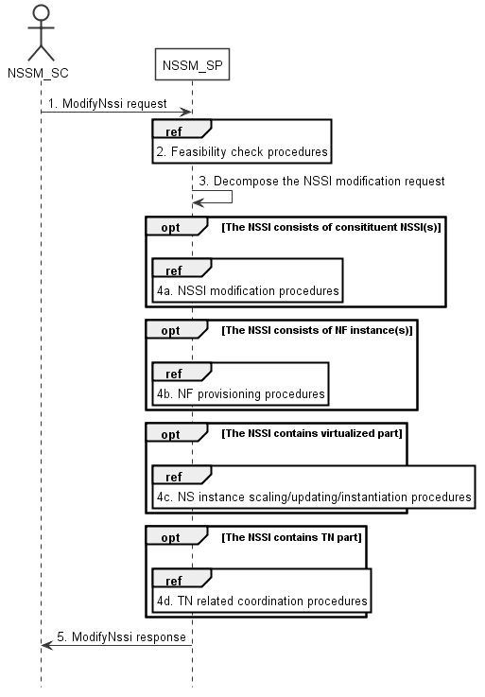
Figure 7.7-1: Network slice subnet modification request procedure
1) Network Slice Subnet Management Service Provider (NSSM_SP) receives a request (see modifyMOIAttributes operation defined in TS 28.532 [8]) from Network Slice Subnet Management Service Consumer (NSSM_SC) with the DN of NetworkSliceSubnet MOI and the new network slice subnet related requirements (see SliceProfile defined in clause 6.3.3 in TS 28.541[6]).
2) Based on the new network slice subnet related requirements, NSSM_SP invokes the feasibility check procedure. If the modification requirements can be satisfied, go to step 3), else go to step 5).
3) NSSM_SP decomposes the NetworkSliceSubnet MOI modification request into modification requests for each NetworkSliceSubnet MOI constituent.
4a) If the requested NetworkSliceSubnet MOI constituent is constituent NetworkSliceSubnet MOI, NSSM_SP invokes network slice subnet modification procedure as described in clause 7.7.
4b) If the requested NetworkSliceSubnet MOI constituent is ManagedFunction MOI, NSSM_SP invokes ManagedFunction MOI creation procedure as described in clause 7.10 or ManagedFunction MOI modification procedure as described in clause 7.11.
4c) If the NetworkSliceSubnet MOI contains the virtualized part, NSSM_SP invokes the NS instance scaling and/or NS instance updating and/or NS instance instantiation procedure as described in TS 28.526 [7].
4d) If the NetworkSliceSubnet MOI contains the TN part, NSSM_SP invokes the TN related coordination procedure as described in clause 7.9.
5) NSSM_SP sends NetworkSliceSubnet MOI modification results (see modifyMOIAttributes operation defined in TS 28.532 [8]) to NSSM_SC.

11th Modified Section

7.8 Procedure of obtaining network slice subnet capability

7.8.1 Introduction
The clause illustrates possible procedures of obtaining network slice subnet capability information (e.g. supported maximum latency, supported capacity (e.g. maximum user number)) of network slice subnet instance(s) which can be provided by network slice subnet management service provider.

7.8.2 Querying network slice subnet sapability Information
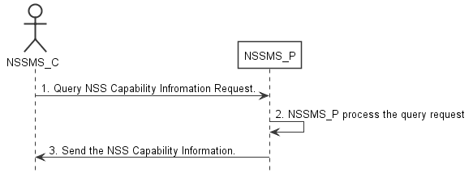
Figure 7.8-2: Procedure of querying network slice subnet capability information
1) Network Slice Subnet Management Service Consumer (NSSMS_C) wants to query the NetworkSliceSubnet MOI capability information of the NetworkSliceSubnet MOI(s) which can be provided by corresponding Network Slice Subnet Management Service Consumer (NSSMS_P), NSSMS_C sends NetworkSliceSubnet MOI capability querying request (see getMOIAttributes operation defined in TS 28.532 [8]) to NSSMS_P to obtain the NetworkSliceSubnet MOI capability information of the NetworkSliceSubnet MOI(s) which can be provided by corresponding NSSMS_P.
2) NSSMS_P processes the NetworkSliceSubnet MOI capability information querying request.
3) NSSMS_P sends the NetworkSliceSubnet MOI capability information (e.g. supported maximum latency, supported capacity (e.g. user number)) of NSSI(s) that can be provided by itself (see getMOIAttributes operation defined in TS 28.532 [8]) to NSSMS_C.

7.8.3 Notify network slice subnet capability Information
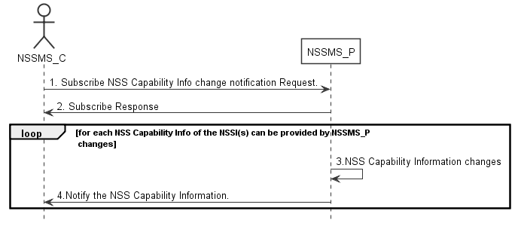
Figure 7.8-3: Procedure of notifying network slice subnet capability information
1) NSSMS_C wants to subscribe the change notification of NetworkSliceSubnet MOI capability information of the NSSI(s) can be provided by NSSMS_Provider, NSSMS_C sends NetworkSliceSubnet MOI Capability change subscription request to NSSMS_P to subscribe the NetworkSliceSubnet MOI capability information change notification.
2) NSSMS_P sends the subscribe response to NSSMS_C.
3) NetworkSliceSubnet MOI capability information of the NetworkSliceSubnet MOI(s) can be provided by NSSMS_P changes.
4) NSSMS_P notify NSSMS_C with the NetworkSliceSubnet MOI capability information (e.g. supported maximum latency, supported capacity (e.g. user number)) of NetworkSliceSubnet MOI(s) which can be provided by itself.

12th Modified Section

7.9 Procedure of TN coordination supporting network slicing

7.9.1 Introduction
This clause describes procedures of coordination with TN Manager to handle TN part supporting network slicing.
NOTE: The present document: addresses interactions with NFVO as TN manager,. interactions with other types of TN Manager (e.g. Optical, IP bearer transport network, etc.) have not been addressed.

7.9.2 Interaction with NFVO as TN Manager
This clause considers the procedure of interaction between the 3GPP management system and the NFVO, which behaves as TN Manager, to satisfy the TN related requirements for the virtual links used in NetworkSliceSubnet MOI. The procedure is applicable to creation and modification of the NetworkSliceSubnet MOI.
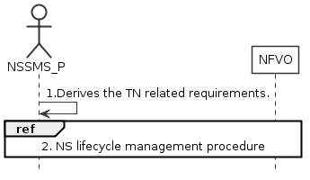
Figure 7.9.2-1: Interaction with NFVO as TN manager to support network slicing
1) Network Slice Subnet Management Service Provider (NSSMS_P) derives the TN related requirements (e.g. 3GPP endpoint information, latency requirements, bandwidth requirements, isolation requirements) for the TN part to be used in the NetworkSliceSubnet MOI.
2) To satisfy the TN related requirements NSSMS_P invokes the corresponding NS instance lifecycle management procedures as described in TS 28.526 [7].
3) After the NFVO executes the requested operation, it sends the corresponding notification to the NSSMS_P as described in TS 28.526 [7].

13th Modified Section

7.10 Procedure of ManagedFunction MOI creation
The Figure 7.10-1 illustrates the procedure of creating a new ManagedFunction MOI to satisfy the required network function related requirements.
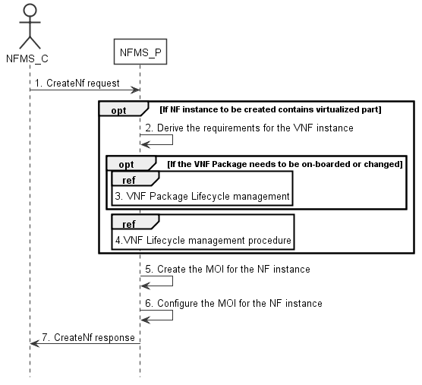
Figure 7.10-1: ManagedFunction MOI creation procedure
1) Network Function Management Service Provider (NFMS_P) receives a request (see createMOI operation defined in TS 28.532 [8]) from Network Function Management Service Consumer (NFMS_C) with network function related requirements.
Note: The network function related requirements see information model definition for NR NRM in clause 4 and information model definition for 5GC NRM in clause 5 in TS 28.541[6] .
2) If NF instance to be created contains virtualized part, NFMS_P derives the requirements for VNF instance based on the network function related requirements.
3) If corresponding VNF Package needs to be on-boarded or changed, the NFMS_P invoke corresponding VNF Package management procedure as described in clause 4.3 in TS 28.526 [7].
4) The NFMS_P invokes VNF lifecycle management with requirements for VNF instance as descried in clause 4.2.2.2 in TS 28.526 [7].
5) The NFMS_P creates the MOI for the ManagedFunction to be created. If the ManagedFunction MOI contains virtualized part, the NFMS_P may send the request of creating the MOI to the NFMS_P in the ManagedFunction.
6) The NFMS_P configures the new created MOI with corresponding configuration information (see information model definition for NR NRM in clause 4 and information model definition for 5GC NRM in clause 5 in TS 28.541[6]).
7) The NFMS_P sends the response (see createMOI operation defined in TS 28.532 [8]) to NFMS_C with DN of MOI and with identifier of NFMS_P which actually maintains the MOI for ManagedFunction.

14th Modified Section

7.11 Procedure of ManagedFunction MOI modification
The Figure 7.11-1 illustrates the procedure of modify ManagedFunction MOI.
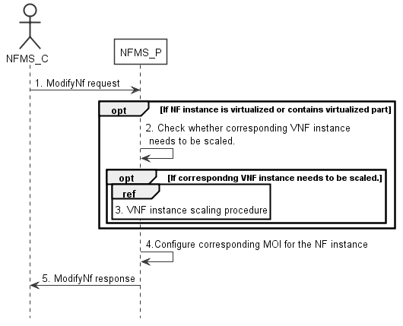
Figure 7.11-1: ManagedFunction MOI modify procedure
1) Network Function Management Service Provider (NFMS_P) receives a request (see modifyMOIAttributes operation defined in TS 28.532 [8])from Network Function Management Service Consumer (NFMS_C) with DN of MOI for ManagedFunction and network function related requirements.
Note: The network funcation related requirements see information model definition for NR NRM in clause 4 and information model definition for 5GC NRM in clause 5 in TS 28.541[6].
2) If ManagedFunction MOI contains virtualized part, NFMS_P checks whether corresponding VNF instance needs to be scaled to satisfy the network function related requirements.
3) If corresponding VNF instance needs to be scaled, NFMS_P invokes corresponding VNF instance scaling procedure as described in clause 4.2.3 in TS 28.526 [7].
4) NFMS_P reconfigures corresponding ManagedFunction MOI.
5) The NFMS_P sends the response (see modifyMOIAttributes operation defined in TS 28.532 [8]) to NFMS_C.

15th Modified Section

7.12 Procedure of ManagedFunction MOI deletion
The Figure 7.12-1 illustrates the procedure of deleting ManagedFunction MOI.
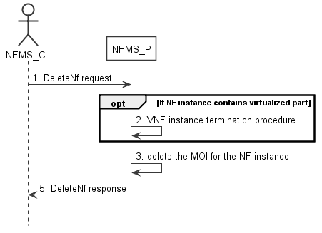
Figure 7.12-1: ManagedFunction MOI deletion procedure
1) Network Function Management Service Provider (NFMS_P) receives request (see deletetMOI operation defined in TS 28.532 [8]) from Network Function Management Service Consumer (NFMS_C) with DN of ManagedFunction MOI.
2) If the ManagedFunction MOI contains virtualized part, NFMS_P invokes VNF instance termination procedure as described in clause 4.2.4 in TS 28.526 [7].
3) NFMS_P deletes the ManagedFunction MOI.
4) NFMS_P sends the response (see deleteMOI operation defined in TS 28.532 [8]) to NFMS_C.

16th Modified Section

7.13 Procedure of reservation and checking feasibility of Network Slice
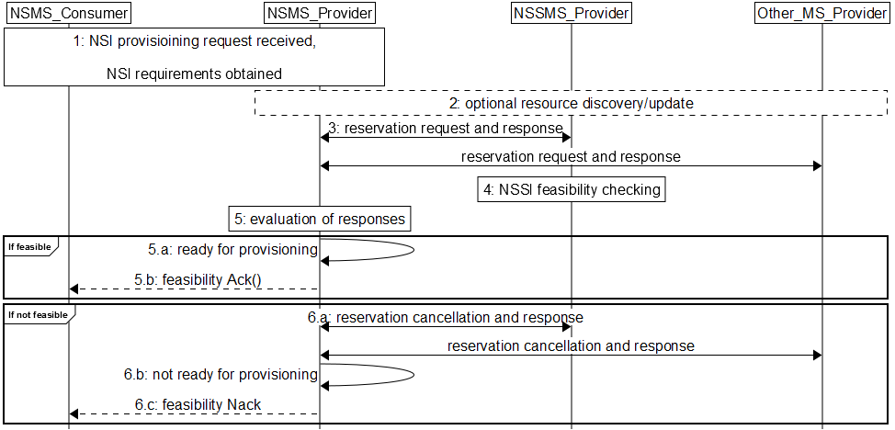
Figure 7.13-1 Network slice feasibility check procedure
1) Network Slice Management Service Provider (NSMS_Provider) receives a provisioning NetworkSlice MOI request (e.g., a modify network slice request (see modifyMOIAttributes operation defined in TS 28.532 [8])) from Network Slice Management Service Consumer (NSMS_Consumer) with network slice related requirements (e.g. Area information, User Number, traffic demand, QoS Quality, whether the requested network slice instance could be shared).
2) [Optional] NSMS_Provider may request information and updates from NSSMS_Provider and Other_MS_Provider regarding the resources.
3) NSMS_Provider sends reservation requests to Network Slice Subnet Management Service Provider (NSSMS_Provider) and (if needed) Other Management Service Providers (Other_MS_Provider), e.g., MANO, TN manager. NSMS_Provider receives responses with information regarding allocated resources, e.g., their availability, identification information of reserved resources and so on.
4) A reservation request to NSSMS_Provider can trigger NetworkSliceSubnet MOI feasibility checking.
5) NSMS_Provider evaluates the responses to determine if the network slice requirements can be satisfied.
6) If feasible,
6.a) NSMS_Provider is ready for provisioning.
6.b) [Optional] Acknowledgement regarding reservation check results can be sent to NSMS_Customer.
7) If not feasible,
7.a) NSMS_Provider cancels reservations, optionally may receive acknowledgement.
7.b) NSMS_Provider is not ready for provisioning.
7.c) NSMS_Provider may send negative acknowledgement regarding results of reservation check to NSMS_Customer.

17th Modified Section

7.14 Procedure of reservation and checking feasibility of network slice subnet
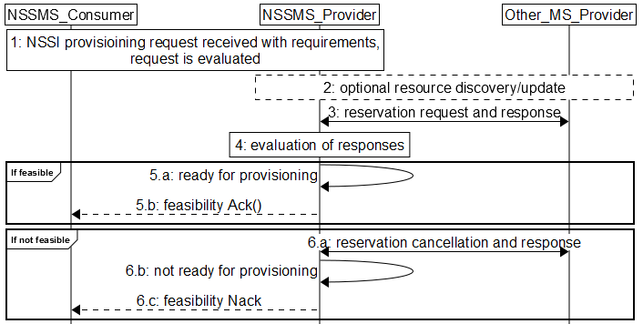
Figure 7.14-2 Network slice subnet feasibility check procedure
1) Network Slice Subnet Management Service Provider (NSSMS_Provider) receives a provisioning NetworkSliceSubnet MOI request (e.g., a modify network slice subnet request (see modifyMOIAttributes operation defined in TS 28.532 [8])) from Network Slice Subnet Management Service Consumer (NSSMS_Consumer) with network slice subnet related requirements (e.g. Area information, User Number, traffic demand, QoS Quality, whether the requested network slice instance could be shared). The request is evaluated and initial resources to be allocated are identified.
2) [Optional] NSSMS_Provider may request information and updates from NSSMS_Provider and Other_MS_Provider regarding the resources.
3) NSSMS_Provider sends reservation requests to Other Management Service Providers (Other_MS_Provider), e.g., MANO, TN manager. NSSMS_Provider receives responses with information regarding reserved resources, e.g., their availability, identification information of reserved resources and so on.
4) NSSMS_Provider evaluates the responses to determine if the network slice subnet requirements can be satisfied.
5) If feasible:
5.a) NSSMS_Provider is ready for provisioning.
5.b) [Optional] Acknowledgement regarding reservation check results can be sent to NSSMS_Customer.
6) If not feasible,
6.a) NSSMS_Provider cancels reservations, optionally may receive acknowledgement.
6.b) NSSMS_Provider is not ready for provisioning.
6.c) NSSMS_Provider may send negative acknowledgement regarding results of reservation check to NSSMS_Customer.

18th Modified Section

7.15 Procedure of network slice capacity planning
The Figure 7.15-1 illustrates the procedure of capacity planning of network slices (including both NetworkSlice MOIs and NetworkSliceSubnet MOIs).
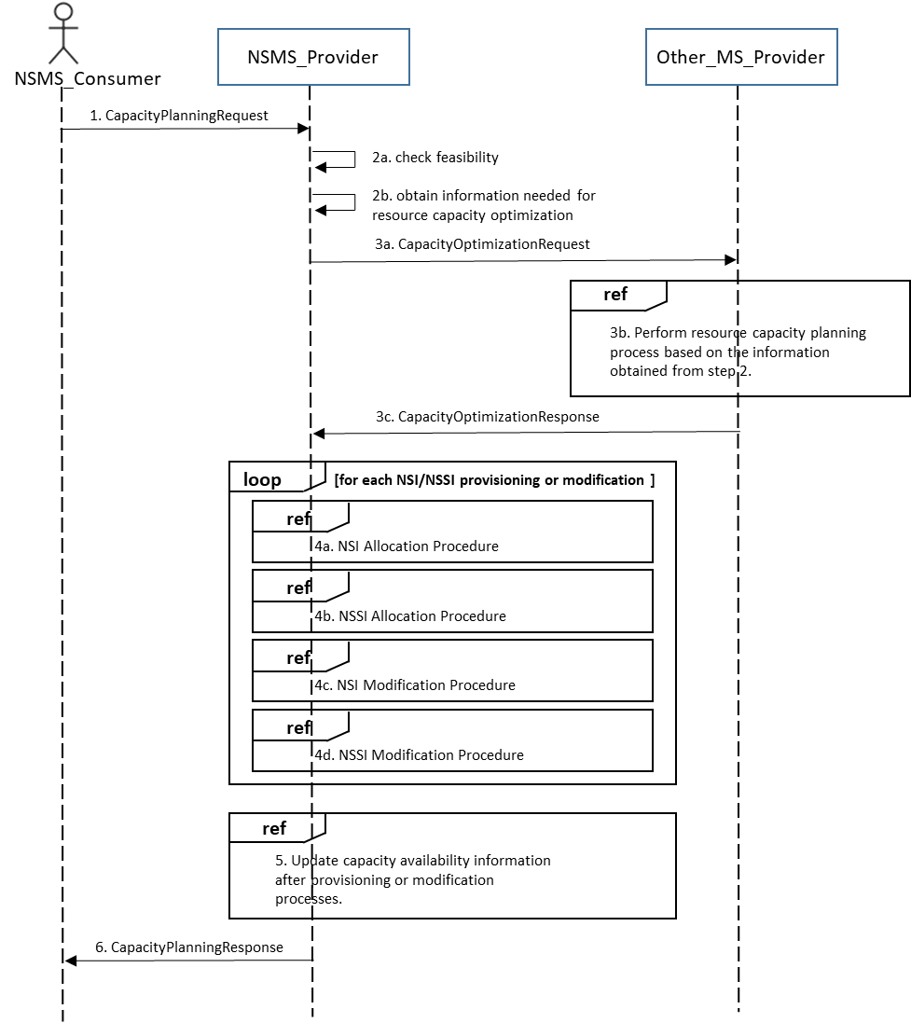
Figure 7.15-1: Network slice resource capacity planning procedure
1) Network Slice Management Service Provider (NSMS_P) receives capacity planning request from Network Slice Management Service Consumer (NSMS_C).
2a) NSMS_P checks feasibility.
2b) NSMS_P obtains slice provisioning requirements, existing active or non-active NetworkSlice MOI and/or NetworkSliceSubnet MOI resource information, and performance measurement data.
3a) NSMS_P requests network resource capacity optimization calculation to the Other_MS_Provider.
3b) Other_MS_Provider performs network resource capacity planning process based on the information obtained from step 2.
Other_MS_Provider can be a capability of NSMS_Provider or external management entities.

3c) Other_MS_Provider replies the result of network resource capacity optimization calculation in the form of the network resource capacity optimization objective. The result includes a set of NetworkSlice MOI and/or NetworkSliceSubnet MOI provisioning and modification requirements.
4) NSMS_P proceeds with network slice (NetworkSlice MOI and/or NetworkSliceSubnet MOI) provisioning or modification processes (loop of 4a – 4d) until it meets the network resource capacity optimization objective.
5) NSMS_P updates network capacity availability information after provisioning or modification processes.
6) NSMS_P returns the network resource capacity planning results to NSMS_C.

19th Modified Section

7.16 Procedure of allocating network with or without slicing for communication services
The Figure 7.16-1 illustrates the procedure of allocating network with or without slicing for communication services.
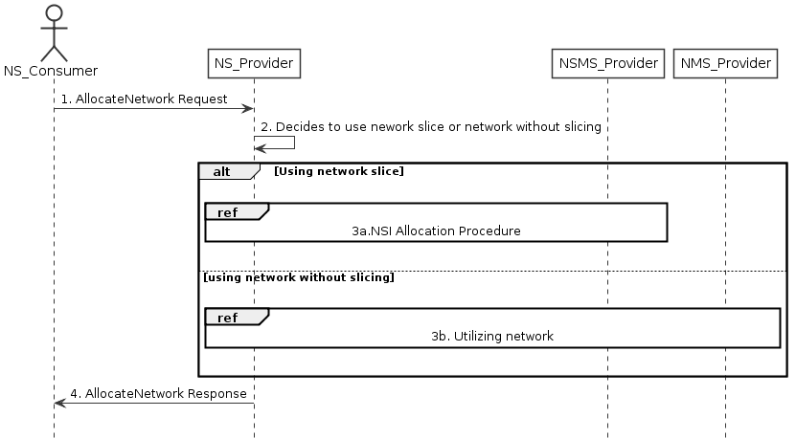
Figure 7.16-1 Allocating network with or without slicing for communication services
1) Network Service Provider (NS_Provider) receives request from Network Service Consumer (NS_Consumer). The received request includes network related service requirements (e.g. isolation, latency, coverage).
2) NS_Provider decides to use the network with or without slicing depending on these network related service requirements based on some internal admission control.
3) Based on the decision by NS_Provider:
3a) If NS_Provider decides to use a network with slicing, network slice allocation procedures in clause 7.2 follows. These procedures may result a new NetworkSlice MOI to be created, or use an existing NetworkSlice MOI with modification.
3b) If NS_Provider decides to use network without slicing, the network without slicing is utilized to satisfy the network related service requirements, there may be modification of the existing NetworkSliceSubnet MOI or creation of a new NetworkSliceSubnet MOI.
4) NS_Provider sends the response to NS_Consumer.

20th Modified Section

8 Void

.1-1: Mapping of IS operations to SS equivalents

Table 8.1.2-1: Mapping of IS operation input parameters to SS equivalents (HTTP POST)
Table 8.1.2-2: Mapping of IS operation output parameters to SS equivalents (HTTP POST)

Table 8.1.3-1: Mapping of IS operation input parameters to SS equivalents (HTTP POST)
Table 8.1.3-2: Mapping of IS operation output parameters to SS equivalents (HTTP POST)

Table 8.1.4-1: Mapping of IS operation output parameters to SS equivalents (HTTP DELETE)

Table 8.1.5-1: Mapping of IS operation output parameters to SS equivalents (HTTP DELETE)

Table 8.1.6-1: Mapping of IS operation input parameters to SS equivalents (HTTP POST)

.1.6-2: Mapping of IS operation output parameters to SS equivalents (HTTP POST)

End of Modifications

