3GPP TSG-SA5 Meeting #131e S5-203196rev3

e-meeting, 25th May-3rd June 2020

Source: Orange, China Mobile, Huawei

Title: Key Issue: EE KPI in case of NG-RAN sharing scenario

Document for: Approval
Agenda Item: 6.6.6

1 Decision/action requested
The group is asked to discuss and agree on the proposal.

2 References
[1] TS 28.813 0.0.0: Study on new aspects of Energy Efficiency (EE) for 5G
[2] ETSI ES 203228: Environmental Engineering (EE); Assessment of mobile network energy efficiency
[3] 3GPP TS 28.554: Management and orchestration; 5G end to end Key Performance Indicators (KPI)
[4] 3GPP TS 28.552: Management and orchestration; 5G performance measurements

3 Rationale
ETSI ES 203 228 [2] defines the Mobile Network data Energy Efficiency (EE_{MN,DV}) as the ratio between the performance indicator (DV_{MN}) and the energy consumption (EC_{MN}) when assessed during the same time frame.
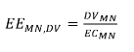
, where EE_{MN, DV} is expressed in bit/J.

3GPP / SA5 has been working on the definition of this KPI for 5G radio access networks (cf. 3GPP TS 28.554 [3]), as well as the definition of 5G performance measurements for both DV_{MN} and EC_{MN} (cf. 3GPP TS 28.552 [4]).
As currently defined, this EE KPI does not take into account the NG-RAN sharing scenario.

4 Detailed proposal
This document proposes the following changes in TS 28.813 [1].
1st Change

2 References
The following documents contain provisions which, through reference in this text, constitute provisions of the present document.
- References are either specific (identified by date of publication, edition number, version number, etc.) or non-specific.
- For a specific reference, subsequent revisions do not apply.
- For a non-specific reference, the latest version applies. In the case of a reference to a 3GPP document (including a GSM document), a non-specific reference implicitly refers to the latest version of that document in the same Release as the present document.
[1] 3GPP TR 21.905: "Vocabulary for 3GPP Specifications".

[x] 3GPP TS 23.501: "5G; System Architecture for the 5G System".
[y] 3GPP TS 32.130: "Telecommunication management; Network sharing; Concepts and requirements".
[z] 3GPP TS 28.552: "Management and orchestration; 5G performance measurements".
[t] 3GPP TS 28.554: "Management and orchestration; 5G end to end Key Performance Indicators (KPI)".

Next Change

3.3 Abbreviations
For the purposes of the present document, the abbreviations given in 3GPP TR 21.905 [1] and the following apply. An abbreviation defined in the present document takes precedence over the definition of the same abbreviation, if any, in 3GPP TR 21.905 [1].
MOP Master Operator
POP Participating Operator

Next Change

X Key Issues and potential solutions

X.Y Key Issue #<X>: EE KPI in case of NG-RAN sharing

X.Y.1 Description

X.Y.1.1 Existing NG-RAN EE KPI and related measurements
In TS 28.554 [t] – clause 6.7.1, the NG-RAN data Energy Efficiency KPI is defined as follows:
EE_{MN,DV}
- for non-split gNBs;
- for split-gNBs.

For non-split gNBs, the data volume measurements used in this KPI are defined in TS 28.552 [z] – clause 5.1.2.1, as follows:
- UL PDCP SDU Data Volume: provides the Data Volume (amount of PDCP SDU bits) in the uplink delivered from PDCP layer to higher layers. The measurement is calculated per PLMN ID and per QoS level (mapped 5QI) and per S-NSSAI;
- DL PDCP SDU Data Volume: provides the Data Volume (amount of PDCP SDU bits) in the downlink delivered to PDCP layer. The measurement is calculated per PLMN ID and per QoS level (mapped 5QI) and per S-NSSAI.
NOTE: for the rest of the discussion, it is important to note that these measurements can be obtained per PLMN ID.

X.Y.1.2 5G RAN sharing
TS 23.501 [x] – figure 5.1.18-1 gives a network sharing architecture allowing multiple Participating Operators (POP) (see TS 32.130 [y]) to share resources of a single shared radio access network made available by a Master Operator (MOP) [y] according to a RAN sharing contract.
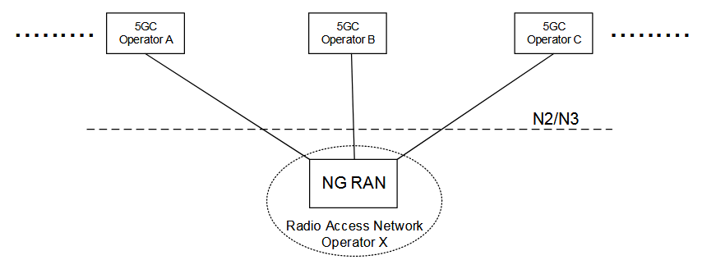

X.Y.1.3 Problem statement
In case of RAN sharing:
- The energy consumed, which measurement (cf. PEE.Energy [z]) is collected by the Master Operator and calculated per gNB only, with no split between Master and Participating Operators;
- The data volume measurements are collected by the Master Operator and calculated:
- at gNB level, i.e. not per PLMN ID. In this case, these measurements don’t separate the traffic between the Master Operator and each Participating Operator. As a consequence, the existing EE KPI is obtained by dividing all Operators included Data Volume, by gNB Energy Consumption
- for the Master Operator, the resulting EE KPI value does not reflect that the gNB is shared,
- for Participating Operators, they are unable to measure the EE KPI value for this shared gNB, though they have some traffic across this shared gNB
- per PLMN ID. In this case, these measurements can be obtained separately for the Master Operator and for each Participating Operator
- For the Master Operator and all Participating Operators, the resulting EE KPI value is the per Operator Data Volume divided by the all Operators included Energy Consumption of the shared gNB.

As explained above, in case of a shared gNB, the value of the existing EE_{MN,DV} may be biased depending on how it is calculated.

X.Y.2 Potential solutions

X.Y.2.1 Potential solution #1: EE KPI in case of NG-RAN sharing

X.Y.2.1.1 Introduction
In this potential solution, a per Operator EE KPI is defined as follows:
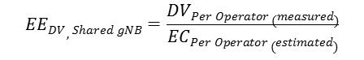
, where:
- EE_{DV, Shared gNB} is the per Operator EE KPI in case of a shared gNB,
- DV_{Per Operator (measured)} is the per Operator Data Volume, measured
- EC_{Per Operator (estimated)} is the per Operator Energy Consumption, estimated. An estimation can be made by calculating the proportion of each Operator Data Volume over all Operators included Data Volume, and then apply this proportion to calculate the per Operator EE KPI.

X.Y.2.1.2 Description

In this potential solution #1, given that each Operator Energy Consumption (EC) is estimated proportionally to its measured Data Volume (DV), the resulting EE KPI value is the same for all Operators, i.e. for the Master Operator (MOP) and the Participating Operators (POP).
In a RAN sharing deployment, depending on the agreement between the MOP and the POPs:
- either the MOP provides each POP with its own measured DV and estimated EC values, and each POP calculates the resulting EE KPI value,
- or the MOP calculates the EE KPI per POP and provide each POP with its own value.
The above statements are proposed to be added to clause A.16 (Use case for 5G Energy Efficiency (EE) KPI) of TS 28.554 [t].

End of change

