3GPP TSG-SA5 Meeting #131e S5-203140

e-meeting 25th May-3rd June 2020

Source: Huawei

Title: Discussion network slicing Capability model

Document for: Approval, Information, Discussion
Agenda Item: 6.2

1 Decision/action requested
The group is asked to discuss and agree on the proposal.

2 References
[1] 3GPP TS 28.531 V16.5.0 Management and orchestration; Provisioning;
[2] 3GPP TS 28.541 V16.4.1 Management and orchestration; 5G Network Resource Model (NRM);
Stage 2 and stage 3.
[3] 3GPP TS 28.809 V0.3.0 Management and orchestration; Study on enhancement of Management Data Analytics (MDA)

3 Rationale
Network slice and network slice subnet capability model provide flexible means for selecting or constructing the suitable capability to match the requirements in the ServiceProfile and SliceProfile.
For provisioning of network slice and network slice subnet, NSMS_Provider and NSSMS_Provider may obtain network slice subnet capability information when allocating network slice and network slice subnet. In the network slice and network slice subnet operating phase, capability model is beneficial for calculating resource configurations for SLA assurance. The network slice/network slice subnet capability may need to be updated according to network status, performance measurements and requirements modifications.
In the procedure of network slice instance allocation in clause 7.2 and the procedure of network slice subnet instance in clause 7.3 respectively, network slice subnet capability information may be obtained by invoking the procedure of Querying network Slice Subnet Capability Information in clause 7.8.2 and the procedure of Notify network Slice Subnet Capability Information in clause 7.8.3. The network slice subnet capability information is useful for creating new network slice/network slice subnet or using existing network slice/network slice subnet, the capability information of the constituent network slice subnets should be obtained.
Capability model informaiton is described in TS 28.531[1]. The quotations below give example relevant text extracted from the above technical specification.

Text quoted from TS 28.531 [1]:

4.3 General information for network slice instance
The general information used to describe a network slice instance may include:
-Capability model information, which describes the capability including supported communication service characteristic information (e.g. service type, UE mobility level, density of users, traffic density), QoS attributes (e.g. bandwidth, latency, throughput and so on) and capacity (e.g. maximum number of UEs), can be exposed to CSC via CSMF.
4.4 General information for network slice subnet instance
The general information used to describe a network slice subnet instance may include:
-Capability model information, which describes the capability including supported communication service characteristic information (e.g. service type, UE mobility level, density of users, traffic density), QoS attributes (e.g. bandwidth, latency, throughput and so on) and capacity (e.g. maximum number of UEs).
Capability model is used to describe the network slice or network slice subnet capability that can be provided by network slice provider (e.g. NSMF) or network slice subnet provider (e.g. NSSMF) . While the service/slice profiles are used to describe the requirements from the network slice consumer or network slice subnet consumer.
Before a network slice comsumer create the network slice instance or network slice subnet instance, the consumer need to get the capability info from network slice providers. e.g Provide A can provide network slice with Lantency<5ms,etc; and Provide B can prove network slice with 5ms<Lantency <10ms.etc; Then the network slice consumer will select the network slice provider A since he needs a latency<5ms network slice instance. And then the network slice consumer will send network slice allocation request to the network slice provider A.
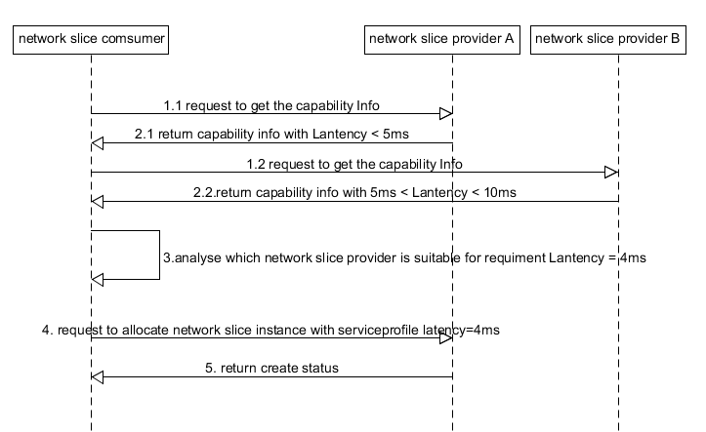

7.2 Procedure of Network Slice Instance Allocation
The Figure 7.2-1 illustrates the procedure of creating a new NSI or using an existing NSI to satisfy the required network slice related requirements.
3b-1) If creating a new NSI, the NSMS_Provider derives the network slice subnet related requirements from the received network slice related requirements. Before NSMS_Provider derives the network slice subnet related requirements, NSMS_Provider may invoke corresponding network slice subnet capability information querying procedure as descried in clause 7.8.
7.3 Procedure of Network Slice Subnet Instance Allocation
The Figure 7.3-1 illustrates the procedure of creating a new network slice subnet instance or using an existing network slice subnet instance to satisfy the required network slice subnet related requirements.
4.1b.1) If creating a new NSSI, the NSSMS_P creates the MOI for the NSSI to be created. NSSMS_P derives the corresponding network slice subnet constituent (i.e. NF, constituent NSS) related requirements and transport network related requirements (e.g. 3GPP endpoint information, latency requirements, bandwidth requirements, isolation requirements) from the received network slice subnet related requirements. Before NSSMS_Provider derives the constituent network slice subnet related requirements, NSMS_Provider may invoke corresponding network slice subnet capability information querying procedure as described in clause 7.8.2.
7.8.2 Querying Network Slice Subnet Capability Information
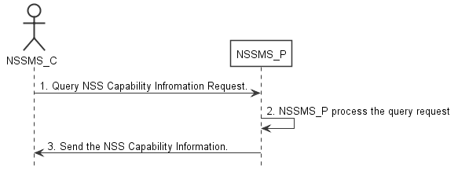
Figure 7.8-2: Procedure of querying network slice subnet capability information
7.8.3 Notify Network Slice Subnet Capability Information
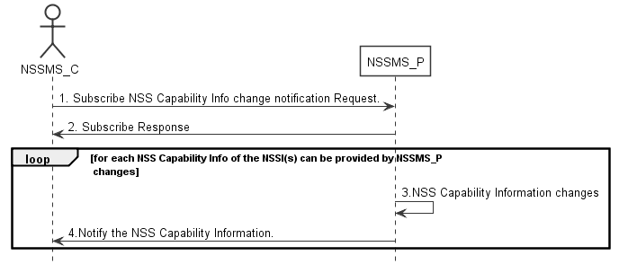
Figure 7.8-3: Procedure of notifying network slice subnet capability information

When network slice consumer request the network slice provider create a network slice subnet, the network slice consumer first may needs to obtain which network slice capability can be provided by the network slice provider, For example: network slice provider can only provide eMBB slice, based on such capability information, network slice consumer can only request the network slice provider provide the eMBB Slice, will not request the network slice provider provide URLLC slice; Another example, the network slice provider can provide the eMBB Slice with 1ms latency, 5ms latency and 10 ms latency, such information is capture in network slice capability information, then network slice consumer can query such network slice capability information, based on its own service requirements, the network slice consumer may request the network slice provider to provide or create an network slice instance with network slice related requirements (eMBB, 1ms latency), such network slice related requirements from network slice consumer is captured in ServiceProdile.

Figure 1 depicts the relationships between ServiceProfile, SliceProfile and network slice/network slice subnet capability model.
In the procedure of network slice provisioning, the network slice related requirements are included in the ServiceProfile and SliceProfile, delivered to the corresponding MNS providers from top to bottom. Network slice and network slice subnet capability information is obtained for feasibility check in the allocation of network slice and network slice subnet. Network slice subnet and network slice capability information are provided from bottom up to match the network slice related requirements.

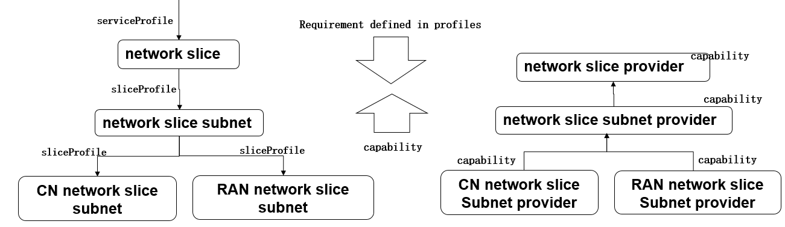
Figure 1: relationships between ServiceProfile, SliceProfile and network slice/network slice subnet capability model
ServiceProfile and SliceProfile are defined in TS 28.541, while network slice and network slice subnet capability model information are missing, current specification lacks the support of network slice/network slice subnet allocation functionality from the integrity perspective.
- Before a network slice is generated:
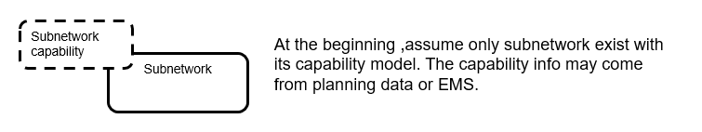
- The capability of lower layer network is queried before the creation request is delivered.
- There is no capability information for the network slice or slice subnet before it is created.
- The capability information is obtained based on the capability of the lower-layer network. For example, the subnetwork capability information is queried by the consumer before it sends the network slice subnet creation request. The capability information may be obtained from the planning data, EMS, and may also relate to the FM/PM analysis.
- After a network slice is generated, if there is capacity demand or capacity change, capability information may need to be reported by the producer. --The capability model may include the following aspects:
- Residual capabilities of the subnetwork
- In the scenario where a network slice subnetwork would be shared by multiple network slices, the capability of the network slice subnet should be able to support requirements of multiple network slices. How to calculate its capability is FFS.
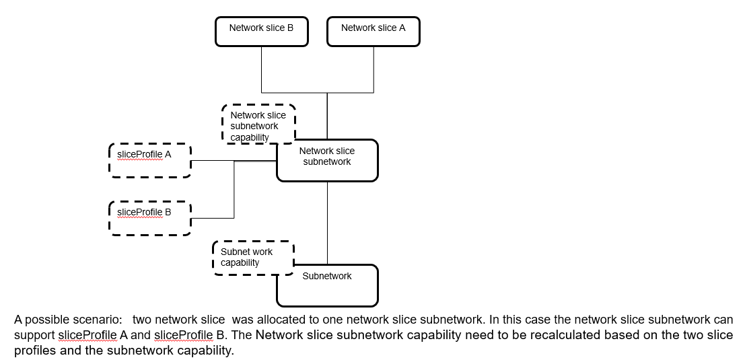
- Capability of the created slice instance: When the parameters and configurations of the network slice instance are automatically adjusted in the running state, it should be checked whether the capability can still meet the requirements in the serviceprofile or sliceprofile.
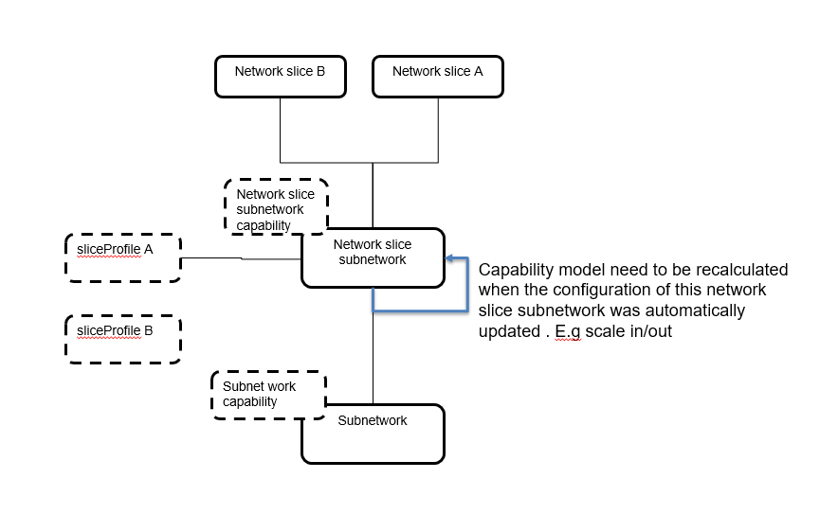
- There are potentially two solution candidates to match the capability model and the requirements:
- The producer reports the capability, and the consumer determines whether the capability can meet its requirements.
- The consumer directly sends requriements to the producer, the producer performs feasibility check and determines whether its cability can meet the requirements.
Capability model is also very helpful for the producer to perform the feasibility check.

4 Detailed proposal
It is proposed to start a new WI on network slice and network slice subnet capability model, the decomposition of ServiceProfile into SliceProfile is also included in this WI.

