3GPP TS 32.156 V15.3.0 (2019-06)
Technical Specification
3rd Generation Partnership Project;
Technical Specification Group Services and System Aspects;
Telecommunication management;
Fixed Mobile Convergence (FMC)
Model repertoire
(Release 15)



The present document has been developed within the 3rd Generation Partnership Project (3GPP TM) and may be further elaborated for the purposes of 3GPP..
The present document has not been subject to any approval process by the 3GPP Organizational Partners and shall not be implemented.
This Specification is provided for future development work within 3GPP only. The Organizational Partners accept no liability for any use of this Specification.
Specifications and Reports for implementation of the 3GPP TM system should be obtained via the 3GPP Organizational Partners' Publications Offices.

Keywords
Fixed Mobile Convergence, FMC, Model Repertoire, Converged Management
3GPP
Postal address

3GPP support office address
650 Route des Lucioles - Sophia Antipolis
Valbonne - FRANCE
Tel.: +33 4 92 94 42 00 Fax: +33 4 93 65 47 16
Internet
http://www.3gpp.org
Copyright Notification
No part may be reproduced except as authorized by written permission.
The copyright and the foregoing restriction extend to reproduction in all media.

© 2019, 3GPP Organizational Partners (ARIB, ATIS, CCSA, ETSI, TSDSI, TTA, TTC).
All rights reserved.

UMTS™ is a Trade Mark of ETSI registered for the benefit of its members
3GPP™ is a Trade Mark of ETSI registered for the benefit of its Members and of the 3GPP Organizational Partners
LTE™ is a Trade Mark of ETSI registered for the benefit of its Members and of the 3GPP Organizational Partners
GSM® and the GSM logo are registered and owned by the GSM Association
Contents
Foreword 6
1 Scope 7
2 References 7
3 Definitions and abbreviations 7
3.1 Definitions 7
3.2 Abbreviations 8
4 Requirements 9
5 Model Elements and Notations 9
5.1 General 9
5.2 Basic model elements 9
5.2.1 Attribute 10
5.2.1.1 Description 10
5.2.1.2 Example 10
5.2.1.3 Name style 11
5.2.2 Association relationship 11
5.2.2.1 Description 11
5.2.2.2 Example 11
5.2.2.3 Name style 12
5.2.3 Aggregation association relationship 12
5.2.3.1 Description 12
5.2.3.2 Example 12
5.2.3.3 Name style 12
5.2.4 Composite aggregation association relationship 12
5.2.4.1 Description 12
5.2.4.2 Example 13
5.2.4.3 Name style 13
5.2.5 Generalization relationship 13
5.2.5.1 Description 13
5.2.5.2 Example 13
5.2.5.3 Name style 13
5.2.6 Dependency relationship 13
5.2.6.1 Description 13
5.2.6.2 Example 14
5.2.6.3 Name style 14
5.2.7 Comment 14
5.2.7.1 Description 14
5.2.7.2 Example 14
5.2.7.3 Name style 14
5.2.8 Multiplicity, a.k.a. cardinality in relationships 14
5.2.8.1 Description 14
5.2.8.2 Example 15
5.2.8.3 Name style 15
5.2.9 Role 15
5.2.9.1 Description 15
5.2.9.2 Example 16
5.2.9.3 Name style 16
5.2.10 Xor constraint 16
5.2.10.1 Description 16
5.2.10.2 Example 17
5.2.10.3 Name style 17
5.3 Stereotype 17
5.3.0 Description 17
5.3.1 <<ProxyClass>> 17
5.3.1.1 Description 17
5.3.1.2 Example 18
5.3.1.3 Name style 18
5.3.2 <<InformationObjectClass>> 18
5.3.2.1 Description 18
5.3.2.2 Example 18
5.3.2.3 Name style 19
5.3.3 <<names>> 19
5.3.3.1 Description 19
5.3.3.2 Example 19
5.3.3.3 Name style 19
5.3.4 <<dataType>> 19
5.3.4.1 Description 19
5.3.4.2 Example 20
5.3.4.3 Name style 20
5.3.5 <<enumeration>> 21
5.3.5.1 Description 21
5.3.5.2 Example 21
5.3.5.3 Name style 21
5.3.6 <<choice>> 21
5.3.6.1 Description 21
5.3.6.2 Example 21
5.3.6.3 Name style 22
5.4 Others 23
5.4.1 Association class 23
5.4.1.1 Description 23
5.4.1.2 Example 23
5.4.1.3 Name style 23
5.4.2 Abstract class 24
5.4.2.1 Description 24
5.4.2.2 Example 24
5.4.2.3 Name style 24
5.4.3 Predefined data types 24
5.4.3.1 Description 24
5.4.3.2 Example 25
5.4.3.3 Name style 25
6 Qualifiers 26
7 UML Diagram Requirements 27
Annex A (informative): Examples of using <<ProxyClass>> 28
A.1 First Example 28
A.2 Second Example 29
Annex B (normative): Attribute properties 30
Annex C (normative): Design patterns 31
C.1 Intervening Class and Association Class 31
C.1.1 Concept and Definition 31
C.1.2 Usage in the non-transport domain 34
C.1.3 Usage in the transport domain 34
C.2 Use of “ExternalXyz” class 35
Annex D (informative): Void 36
Annex E (normative): <<SupportIOC>> stereotype definition 37
E.1 Description 37
E.2 Example 37
E.3 Name style 37
Annex F (normative): Application of <<InformationObjectClass>> and <SupportIOC>> 38
Annex G(informative): Change history 40

Foreword
This Technical Specification has been produced by the 3rd Generation Partnership Project (3GPP).
The contents of the present document are subject to continuing work within the TSG and may change following formal TSG approval. Should the TSG modify the contents of the present document, it will be re-released by the TSG with an identifying change of release date and an increase in version number as follows:
Version x.y.z
where:
x the first digit:
1 presented to TSG for information;
2 presented to TSG for approval;
3 or greater indicates TSG approved document under change control.
y the second digit is incremented for all changes of substance, i.e. technical enhancements, corrections, updates, etc.
z the third digit is incremented when editorial only changes have been incorporated in the document.

1 Scope
UML provides a rich set of concepts, notations and model elements to model distributive systems. This paper documents the necessary and sufficient set of UML notations and model elements, including the ones built by the UML extension mechanism <<stereotype>> to model network management systems and their managed nodes. This set of notations and model elements is called the FMC Model Repertoire; see also 3GPP TS 32.107 [5] and 3GPP TS 28.620 [6].

2 References
[1] OMG "Unified Modelling Language (OMG UML), Infrastructure", Version 2. 4.
[2] OMG "Unified Modelling Language (OMG UML), Superstructure", Version 2. 4.
[3] 3GPP TS 32.300: "Telecommunication management; Configuration Management (CM); Name convention for Managed Objects".
[4] Void
[5] 3GPP TS 32.107: " Telecommunication management; Fixed Mobile Convergence (FMC) Federated Network Information Model (FNIM)".
[6] 3GPP TS 28.620: " Telecommunication management; Fixed Mobile Convergence (FMC) Federated Network Information Model (FNIM) Umbrella Information Model (UIM)".
[7] ITU-T X.680,"OSI networking and system aspects – Abstract Syntax Notation One (ASN.1)".
[8] Void
[9] 3GPP TS 32.602 "Telecommunication management; Configuration Management (CM); Basic CM Integration Reference Point (IRP): Information Service (IS)".
[10] 3GPP TS 32.612: "Telecommunication management; Configuration Management (CM); Bulk CM Integration Reference Point (IRP): Information Service (IS)".
[11] 3GPP TS 32.111-2: " Telecommunication management; Fault Management; Part 2: Alarm Integration Reference Point (IRP): Information Service (IS)".
[12] 3GPP TS 32.302: "Telecommunication management; Configuration Management (CM); Notification Integration Reference Point (IRP): Information Service (IS)".
[13] 3GPP TS 32.404: "Telecommunication management; Performance Management (PM); Performance measurements - Definitions and template".
[14] 3GPP TS 28.545 "Management and orchestration; Fault Supervision (FS)".
[15] 3GPP TS 28.541 "Management and orchestration; 5G Network Resource Model (NRM); Stage 2 and stage 3".
[16] 3GPP TS 28.532 "Management and orchestration; Generic management services".
[17] 3GPP TS 28.531 "Management and orchestration; Provisioning".
[18] 3GPP TR 21.905: "Vocabulary for 3GPP Specifications".

3 Definitions and abbreviations

3.1 Definitions
For the purposes of the present document, the terms and definitions given in 3GPP TR 21.905 [18] and the following apply. A term defined in the present document takes precedence over the definition of the same term, if any, in 3GPP TR 21.905 [18].
Naming attribute: It is a class attribute that holds the class instance identifier. See attribute id of Top_ [6]. See examples of naming attribute in 3GPP TS 32.300 [3].
Lower Camel Case: The practice of writing compound words in which the words are joined without spaces and that the initial letter of all except the first word is capitalized.
EXAMPLES: ’managedNodeIdentity’ and ‘minorDetails’ are the LCC for "managed node identity" and “minor details” respectively.
Upper Camel Case: The practice of writing compound words in which the words are joined without spaces and that the initial letters of all words are capitalised.
EXAMPLES: ‘ManagedNodeIdentity’ and ‘MinorDetails’ are the UCC for "managed node identity" and "minor details" respectively.
Well Known Abbreviation: An abbreviation that can be used as the modelled element name or as a component of a modelled element name.
NOTE 1: The abbreviation, when used in such manner, is in the same document where the modelled element is defined.

3.2 Abbreviations
For the purposes of the present document, the abbreviations given in 3GPP TR 21.905 [18], 3GPP TS 28.620 [6] and the following apply. An abbreviation defined in the present document takes precedence over the definition of the same abbreviation, if any, in 3GPP TR 21.905 [18], and 3GPP TS 28.620 [6].
CM Conditional Mandatory
CO Conditional Optional
IRP Integration Reference Point
LCC Lower Camel Case
M Mandatory
MnS Management Service
NA Not Applicable
O Optional
UCC Upper Camel Case
WKA Well Known Abbreviation

4 Requirements
The UML notations and model elements captured in this repertoire shall be used to model behaviours of the systems/entities such as the Umbrella Information Model (UIM) of the FNIM in 3GPP TS 28.620 [6].

5 Model elements and notations

5.1 General
Note that the graphical notation in this document is only used to represent particular model elements. Although the graphical notation is a correct representation of the model element, it may not be a valid representation of a UML class diagram.
The examples used in this document are for illustration purposes only and may or may not exist in specifications.
UML properties not described in this document shall not be used in specifications based on this repertoire.

5.2 Basic model elements
UML has defined a number of basic model elements. This subclause lists the subset selected for use in specifications based on this repertoire. The semantics of these selected basic model elements are defined in [1].
For each basic model element listed, there are three parts. The first part contains its description. The second part contains its graphical notation examples and the third part contains the rule, if any, recommended for labelling or naming it.
The graphical notation has the following characteristics:
→ Subclause 7.2.7 of [2] specifies "A class is often shown with three compartments. The middle compartment holds a list of attributes while the bottom compartment holds a list of operations" and "Additional compartments may be supplied to show other details". This repertoire only allows the use of the name (top) compartment and attribute (middle) compartment. The operation (bottom) compartment may be present but is always empty.
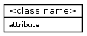
→ Classes may or may not have attributes. The graphical notation of a class may show an empty attribute (middle) compartment even if the class has attributes, as shown in figure below.
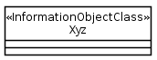
→ The visibility symbol shall not appear along with the class attribute, as shown below.
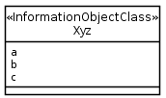
→ The use of the decoration, i.e. the symbol in the name (top) compartment, is optional.

5.2.1 Attribute

5.2.1.1 Description
It is a typed element representing a property of a class. See 10.2.5 Property of [1].
An element that is typed implies that the element can only refer to a constrained set of values.
See 10.1.4 Type of [1] for more information on type.
See 5.3.4 and 5.4.3 for predefined data types and user-defined data types that can apply type information to an element.
The following table captures the properties of this modelled element.
Table 5.2.1.1-1: Attribute properties
Property name | Description | Legal values
documentation | Contains a textual description of the attribute.  Should refer (to enable traceability) to the specific requirement. | Any
isOrdered | For a multi-valued multiplicity; this specifies if the values of this attribute instance are sequentially ordered. See subclause 7.3.44 and its Table 7.1 of [2]. | True, False (default)
isUnique | For a multi-valued multiplicity, this specifies if the values of this attribute instance are unique (i.e., no duplicate attribute values). See subclause 7.3.44 and its Table 7.1 of [2]. | True (default), False
isReadable | Specifies that this attribute can be read by the manager. | True (default), False
isWritable | Specifies that this attribute can be written by the manager under the conditions specified in Annex B. | True, False (default)
type | Refers to a predefined (see subclause 5.4.3) or user defined data type (see section 5.3.4). See also subclause 7.3.44 of [2], inherited from StructuralFeature. | NA
isInvariant | Attribute value is set at object creation time and cannot be changed under the conditions specified in Annex B. | True, False (default)
allowedValues | Identifies the values the attribute can have. | Dependent on type
isNotifyable | Identifies if a notification shall be sent in case of a value change (see Note 1, Note 2). | True (default), False
defaultValue | Identifies a value at specification time that is used at object creation time under conditions defined in Annex B. | No value (default) or a value that is dependent on allowedValues
multiplicity | Defines the number of values the attribute can simultaneously have. See subclause 7.3.44 of [2]; inherited from StructuralFeature. | See 5.2.8 Default is 1
isNullable | Identifies if an attribute can carry no information. The implied meaning of carrying “no information” is context sensitive and is not defined in this Model Repertoire. | True, False (default)
supportQualifier | Identifies the required support of the attribute. See also subclause 6. | M, O (default), CM, CO, C
Note 1: Whether a client/manager can receive the notification depends on a) if the client/manager has subscribed or registered for reception of such notification and b) if a notification mechanism is supported.
Note 2: If the attribute is a role-attribute and its property passedById is ‘False’, then changes in the navigable association target end instance alone shall not trigger a notification.

5.2.1.2 Example
This example shows three attributes, i.e., a, b and c, listed in the attribute (the second) compartment of the class Xyz.
Figure 5.2.1.2-1: Attribute notation

5.2.1.3 Name style
An attribute name shall use the LCC style.
Well Known Abbreviation (WKA) is treated as a word if used in a name. However, WKA shall be used as is (its letter case cannot be changed) except when it is the first word of a name; and if so, its first letter must be in lower case.

5.2.2 Association relationship

5.2.2.1 Description
It shows a relationship between two classes and describes the reasons for the relationship and the rules that might govern that relationship.
It has ends. Its end, the association end(s), specifies the role that the object at one end of a relationship performs. Each end of a relationship has properties that specify the role (see 5.2.9), multiplicity (see 5.2.8), visibility and navigability (see the arrow symbol used in Figure 5.2.2.2-2: Unidirectional association relationship notation) and may have constraints. Note that visibility shall not be used in models based on this Repertoire (see bullet 3 of 5.1).
See 7.3.3 Association of [2].
Three examples below show a binary association between two model elements. The association can include the possibility of relating a model element to itself.
The first example (Figure 5.2.2.2-1) shows a bi-directional navigable association in that each model element has a pointer to the other. The second example (Figure 5.2.2.2-2) shows a unidirectional association (shown with an open arrow at the target model element end) in that only the source model element has a pointer to the target model element and not vice-versa. The third example (Figure 5.2.2.2-3) shows a bi-directional non-navigable association in that each model element does not have a pointer to the other; i.e., such associations are just for illustration purposes.

5.2.2.2 Example
An association shall have an indication of cardinality (see 5.2.8).
It shall, except the case of non-navigable association, have an indication of the role name (see 5.2.9). The model element involved in an association is said to be “playing a role” in that association. The role has a name such as +aClass in the first example below. Note that the "+" character in front of the role name, indicating the visibility, is ignored.
Figure 5.2.2.2-1: Bidirectional association relationship notation
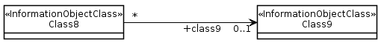
Figure 5.2.2.2-2: Unidirectional association relationship notation
Figure 5.2.2.2-3: Non-navigable association relationship notation
Note that some tools do not use arrows in the UML graphical representation for bidirectional associations. Therefore, absence of arrows is not, but absence of role names is, an indication of a non-navigable association.

5.2.2.3 Name style
An Association can have a name. Use of Association name is optional. Its name style is LCC style.
A role name shall use the LCC style.
NOTE: The role name needs not resemble the class name.

5.2.3 Aggregation association relationship

5.2.3.1 Description
It shows a class as a part of or subordinate to another class.
An aggregation is a special type of association in which objects are assembled or configured together to create a more complex object. Aggregation protects the integrity of an assembly of objects by defining a single point of control called aggregate, in the object that represents the assembly.
See 7.3.2 AggregationKind (from Kernel) of [2].

5.2.3.2 Example
A hollow diamond attached to the end of a relationship is used to indicate an aggregation. The diamond is attached to the class that is the aggregate. The aggregation association shall have an indication of cardinality at each end of the relationship (see 5.2.8).
Figure 5.2.3.2-1: Aggregation association relationship notation

5.2.3.3 Name style
An Association can have a name. Use of Association name is optional. Its name style is LCC.

5.2.4 Composite aggregation association relationship

5.2.4.1 Description
A composite aggregation association is a strong form of aggregation that requires a part instance be included in at most one composite at a time. If a composite is deleted, all of its parts are deleted as well.
A composite aggregation shall contain a description of its use.
See 7.3.3 Association (from Kernel) of [2].

5.2.4.2 Example
A filled diamond attached to the end of a relationship is used to indicate a composite aggregation. The diamond is attached to the class that is the composite. The composition association shall have an indication of cardinality at each end of the relationship (see 5.2.8).
Figure 5.2.4.2-1: Composite aggregation association relationship notation

5.2.4.3 Name style
An Association can have a name. Use of Association name is optional. Its name style is LCC.

5.2.5 Generalization relationship

5.2.5.1 Description
It indicates a relationship in which one class (the child) inherits from another class (the parent).
See 7.3.20 Generalization of [2].

5.2.5.2 Example
This example shows a generalization relationship between a more general model element (the SubNetwork) and a more specific model element (the NetworkSliceSubnet) that is fully consistent with the first element and that adds additional information.
Figure 5.2.5.2-1: Generalization relationship notation

5.2.5.3 Name style
It has no name so there is no name style.

5.2.6 Dependency relationship

5.2.6.1 Description
“A dependency is a relationship that signifies that a single or a set of model elements requires other model elements for their specification or implementation. This means that the complete semantics of the depending elements is either semantically or structurally dependent on the definition of the supplier element(s)...“, an extract from 7.3.12 Dependency of [2].

5.2.6.2 Example
This example shows that the BClass instances have a semantic relationship with the AClass instances. It indicates a situation in which a change to the target element (the AClass in the example) will require a change to the source element (the BClass in the example) in the dependency.
Figure 5.2.6.2-1: Dependency relationship notation

5.2.6.3 Name style
A Dependency can have a name. Use of Dependency name is optional. Its name style is LCC.

5.2.7 Comment

5.2.7.1 Description
A comment is a textual annotation that can be attached to a set of elements.
See 7.3.9 Comment (from Kernel) from [2].

5.2.7.2 Example
This example shows a comment, as a rectangle with a "bent corner" in the upper right corner. It contains text. It appears on a particular diagram and may be attached to zero or more modelling elements by dashed lines.
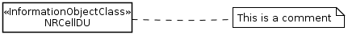
Figure 5.2.7.2-1: Comment notation

5.2.7.3 Name style
It has no name so there is no name style.

5.2.8 Multiplicity, a.k.a. cardinality in relationships

5.2.8.1 Description
“A multiplicity is a definition of an inclusive interval of non-negative integers beginning with a lower bound and ending with a (possibly infinite) upper bound. A multiplicity element embeds this information to specify the allowable cardinalities for an instantiation of this element…“, an extract from 7.3.32 MultiplicityElement of [2].
Table 5.2.8.1-1: Multiplicity-string definitions
Multiplicity | Explanation
1 | Attribute has one attribute value.
m | Attribute has m attribute values.
0..1 | Attribute has zero or one attribute value.
0..* | Attribute has zero or more attribute values.
* | Attribute has zero or more attribute values.
1..* | Attribute has at least one attribute value.
m..n | Attribute has at least m but no more than n attribute values.
The use of "0..n" is not recommended although it has the same meaning as " 0..* " and " *".
The use of a standalone symbol zero (0) is not allowed.

5.2.8.2 Example
This example shows a multiplicity attached to the end of an association path. The meaning of this multiplicity is one to many. One Class1 instance is associated with zero or more Class2 instances. Other valid examples can show the “many to many” relationship.
Figure 5.2.8.2-1: Cardinality notation
The cardinality zero is not used to indicate the IOC’s so-called “transient state” characteristic. For example, it is not used to indicate that the instance is not yet created but it is in the process of being created. The cardinality zero will not be used to indicate this characteristic since such characteristic is considered inherent in all IOCs. All IOCs defined are considered to have such inherent “transient state” characteristics.
The following table shows some valid examples of multiplicity.
Table 5.2.8.2-1: Multiplicity-string examples
Multiplicity | Explanation
1 | Attribute has exactly one attribute value.
5 | Attribute has exactly 5 attribute values.
0..1 | Attribute has zero or one attribute value.
0..* | Attribute has zero or more attribute values.
1..* | Attribute has at least one attribute value.
4..12 | Attribute has at least 4 but no more than 12 attribute values.

5.2.8.3 Name style
It has no name so there is no name style.

5.2.9 Role

5.2.9.1 Description
It indicates navigation, from one class to another class, involved in an association relationship. A role is named. The direction of navigation is to the class attached to the end of the association relationship with (or near) the role name.
The use of role name in the graphical representation is mandatory for bidirectional and unidirectional association relationship notations (see Figure 5.2.2.2-1: Bidirectional association relationship notation and Figure 5.2.2.2-2: Unidirectional association relationship notation). Role name shall not be used in non-navigable association relationship notation (see Figure 5.2.2.2-3: Non-navigable association relationship notation).
A role at the navigable end of a relationship becomes (or is mapped into) an attribute (called role-attribute) in the source class of the relationship. Therefore roles have the same behaviour (or properties) as attributes. See Table 5.2.1.1-1: Attribute properties.
The role-attribute shall have all properties defined for attributes in subclause 5.2.1 Attribute and in addition the following property
Table 5.2.9.1-1: passedById property
Property name | Description | Legal values
passedById | If True, the role-attribute (navigable association source end) contains a DN of the navigable association target end instance.  If False, the role-attribute contains (a copy of) the whole target end instance (e.g. X). If X has a role-attribute whose “passedById==False”, then the subject role-attribute contains (a copy of) X’s target end instance as well.  The above rule is applied repeatedly for all occurrences of “passedById==False”. This application can result in a collection of instances where no ordering can be implied and no instances are duplicated.  Use of “passedById==False” supports the efficient access of target end instances from a source end instance. The mechanism by which such access is achieved is operation model design specific (e.g. not related to resource model design). | True (default), False
:

5.2.9.2 Example
This example shows that a Person (say instance John) is associated with a Company (say whose DN is “Company=XYZ”). We navigate the association by using the opposite association-end such that John’s Person.company would hold the DN, i.e. "Company=XYZ".
Figure 5.2.9.2-1: Role notation

5.2.9.3 Name style
A role has a name. Use a noun for the name. The name style follows the attribute name style; see subclause 5.2.1.3.

5.2.10 Xor constraint

5.2.10.1 Description
“A Constraint represents additional semantic information attached to the constrained elements. A constraint is an assertion that indicates a restriction that must be satisfied by a correct design of the system. The constrained elements are those elements required to evaluate the constraint specification…“, an extract from 7.3.10 Constraint (from Kernel) of [2].
For a constraint that applies to two elements such as two associations, the constraint shall be shown as a dashed line between the elements labeled by the constraint string (in braces). The constraint string, in this case, is xor.

5.2.10.2 Example
The figure below shows a ServerObjectClass instance that has relation(s) to multiple instances of a class from the choice of ClientObjectCLass_Alternative1, ClientObjectClass_Alternative2 or ClientObjectCLass_Alternative3.
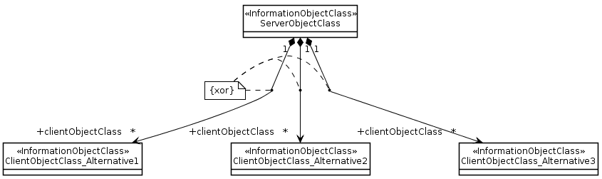
Figure 5.2.10.2-1: {xor} notation

5.2.10.3 Name style
It has no name so there is no name style.

5.3 Stereotype

5.3.0 Description
Subclause 5.1 listed the UML defined basic model elements. UML defined a stereotype concept allowing the specification of simple or complex user-defined model elements.
This subclause lists all allowable stereotypes for this repertoire.
The names of stereotypes shall be chosen such that they do not clash.
For each stereotype model element listed, there are three parts. The first part contains its description. The second part contains its graphical notation examples and the third part contains the rule, if any, recommended for labelling or naming it.

5.3.1 <<ProxyClass>>

5.3.1.1 Description
It is a form or template representing a number of <<InformationObjectClass>>. It encapsulates attributes, links, methods (or operations), and interactions that are present in the represented <<InformationObjectClass>>.
The semantics of a <<ProxyClass>> is that all behaviour of the <<ProxyClass>> is present in the represented <<InformationObjectClass>>. Since this class is simply a representation of other classes, this class cannot define its own behaviour other than those already defined by the represented <<InformationObjectClass>>.
A particular <<InformationObjectClass>> can be represented by zero, one or more <<ProxyClass>>. For example, the ManagedElement <<InformationObjectClass>> can have MonitoredEntity <<ProxyClass>> and ManagedEntity <<ProxyClass>>.
The attributes of the <<ProxyClass>> are accessible by the source entity that has an association with the <<ProxyClass>>.

5.3.1.2 Example
This shows a <<ProxyClass>> named MonitoredEntity. It represents (or its constraints is that it represents) all NRM <<InformationObjectClass>> (e.g. GgsnFunction <<InformationObjectClass>>) whose instances are being monitored for alarm conditions. It is mandatory to use a Note to capture the constraint.
Figure 5.3.1.2-1: <<ProxyClass>> notation
See Annex A for more examples that use <<ProxyClass>>.

5.3.1.3 Name style
For <<ProxyClass>> name, use the same style as <<InformationObjectClass>> (see 5.3.2).

5.3.2 <<InformationObjectClass>>

5.3.2.1 Description
The <<InformationObjectClass>> is identical to UML class except that it does not include/define methods or operations.
A UML class represents a capability or concept within the system being modelled. Classes have data structure and behaviour and relationships to other elements.
This class can inherit from zero, one or multiple classes (multiple inheritances).
See more on UML class in 10.2.1 of [1].

5.3.2.2 Example
This example shows an AbcFunction <<InformationObjectClass>>.
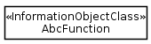
Figure 5.3.2.2-1: <<InformationObjectClass>> notation
The following table captures the properties of this modelled element.
Table 5.3.2.2-1: <<InformationObjectClass>> properties
Property name | Description | Legal values
documentation | Contains a textual description of this modelled element.  Should refer (to enable traceability) to a specific requirement. | Any
isAbstract | Indicates if the class can be instantiated or is just used for inheritance. | True, False (default)
isNotifyable | Identifies the list of the supported notifications. | List of names of notification
supportQualifier | Identifies the required support of the class. See also subclause 6. | M, O (default), CM, CO, C

5.3.2.3 Name style
The name shall use UCC style. The name shall end with an underscore if it is an abstract class in the UIM. The name must not end with an underscore if it is a concrete class.
WKA is treated as a word if used in a name. However, WKA shall be used as is (its letter case cannot be changed) except when it is the first word of the name; and if so, its first letter must be in upper case.
Embedded underscore is not allowed except the name is for an Association class (see 5.4.1.)

5.3.3 <<names>>

5.3.3.1 Description
The <<names>> is modelled by a composition association where both ends are non-navigable. The source class is the composition and the target class is the component. The target instance is uniquely identifiable, within the namespace of the source entity, among all other targeted instances of the same target class and among other targeted instances of other classes that have the same <<names>> composition with the source.
The source class and target class shall each has its own naming attribute.
The composition aggregation association relationship is used as the act of name containment providing a semantic of a whole-part relationship between the domain and the named elements that are contained, even if only by name. From the management perspective access to the part is through the whole. Multiplicity shall be indicated at both ends of the relationship.
A target instance cannot have multiple <<names>> with multiple source instances s, i.e. a target instance can not participate in or belong to multiple namespaces.

5.3.3.2 Example
This shows that all instances of Class4 are uniquely identifiable within a Class3 instance's namespace.
Figure 5.3.3.2-1: <<names>> notation

5.3.3.3 Name style
It has no name so there is no name style.

5.3.4 <<dataType>>

5.3.4.1 Description
It represents an attribute property type (see Table 5.2.1.1-1: Attribute properties).
This repertoire uses two kinds of data types: predefined data types and user-defined data types. The former is defined in subclause 5.4.3. The latter is defined by the specifications authors using this <<dataType>> model element.
The names of predefined data types and user-defined data types must be chosen such that they do not clash.
The user-defined data types support the modelling of structured data types (see <<dataType>> PLMNId in 5.3.4.2).
When a user-defined or predefined data type is used to apply type (see property named type in Table 5.2.1.1-1: Attribute properties) information to a class attribute, the data type name is shown along with the class attribute. See Example below.

5.3.4.2 Example
The following examples are two user-defined data types.
The left-most user-defined data type is named PLMNId . It has two attributes. One is the Mobile Country Code (MCC) of predefined data type String. The other is the Mobile Network Code (MNC) of predefined data type String as well.
The right-most user-defined data type is named Xyz. It has three attributes. The attribute1 uses predefined data type String. The attribute2 uses predefined data type Integer. The attribute3 uses user-defined data type PLMNId.

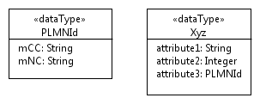
Figure 5.3.4.2-1: <<dataType>> notations
The following example shows a ZClass which has four attributes. Two attributes (i.e. attribute1, attribute4) use the user-defined data types (i.e. PLMNId, Xyz) and the other two attributes use the predefined data types.
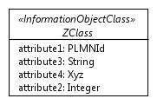
Figure 5.3.4.2-2: Usage example of <<dataType>>
The third column of the following shows some of the properties of an attribute attribute1 of ZClass. It shows the attribute1 attribute property type is PLMNId, a user-defined data type.
attribute1 | It is a PLMN identifiers. | type: PLMNId  multiplicity: 1  isOrdered: N/A  isUnique: N/A  defaultValue: None  isNullable: False

5.3.4.3 Name style
For <<dataType>> name, use the same style as <<InformationObjectClass>> (see 5.3.2).
For <<dataType>> attribute, use the same style as Attribute (see 5.2.1).

5.3.5 <<enumeration>>

5.3.5.1 Description
An enumeration is a data type. It contains sets of named literals that represent the values of the enumeration. An enumeration has a name.
See 10.3.2 Enumeration of [1].

5.3.5.2 Example
This example shows an enumeration model element whose name is Account and it has four enumeration literals. The upper compartment contains the keyword <<enumeration>> and the name of the enumeration. The lower compartment contains a list of enumeration literals.
Note that the symbol to the right of <<enumeration>> Account in the figure below is a feature specific to a particular modelling tool. It is recommended that modelling tool features should be used when appropriate.
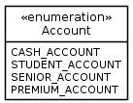
Figure 5.3.5.2-1: <<enumeration>> notation

5.3.5.3 Name style
For <<enumeration>> name, use the same style as <<InformationObjectClass>> (see 5.3.2).
For <<enumeration>> attribute (the enumeration literal), use the following rules:
• Enumeration literal is composed of one or more words of upper case characters. Words are separated by the underscore character.

5.3.6 <<choice>>

5.3.6.1 Description
The «choice» stereotype represents one of a set of classes (when used as an information model element) or one of a set of data types (when used as an operation model element).
This stereotype property, e.g., one out of a set of possible alternatives, is identical to the {xor} constraint (see 5.2.10).

5.3.6.2 Example
Sometimes the specific kind of class cannot be determined at model specification time. In order to support such scenario, the specification is done by listing all possible classes.
The following diagram lists 3 possible classes. It also shows a «choice, InformationObjectClass» named SubstituteObjectClass. This scenario indicates that only one of the three «InformationObjectClass» named Alternative1ObjectClass, Alternative2ObjectClass, Alternative3ObjectClass shall be realised.
The «choice» stereotype represents one of a set of classes when used as an information model element.
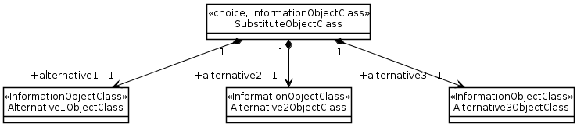
Figure 5.3.6.2-1: Information model element example using «choice» notation
Sometimes the specific kind of data type cannot be determined at model specification time. In order to support such scenario, the specification is done by listing all possible data types.
The following diagram lists 2 possible data types. It also shows a «choice» named ProbableCause. This scenario indicates that only one of the two «dataType» named IntegerProbableCause, StringProbableCause shall be realised.
The «choice» stereotype represents one of a set of data types when used as an operations model element.
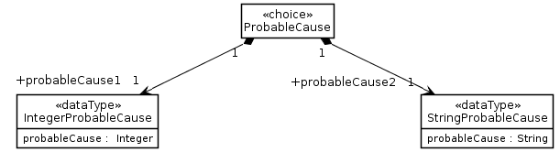
Figure 5.3.6.2-2: Operations model element example using «choice» notation
Sometimes models distinguish between sink/source/bidirectional termination points. A generic class which comprises these three specific classes can be modelled using the «choice» stereotype.
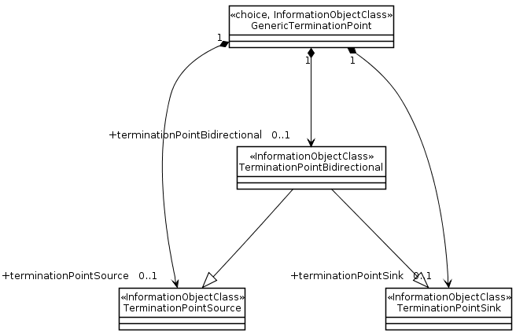
Figure 5.3.6.2-3: Sink/source/bidirectional termination points example using «choice» notation

5.3.6.3 Name style
For <<choice>> name, use the same style as <<InformationObjectClass>> (see 5.3.2).

5.4 Others

5.4.1 Association class

5.4.1.1 Description
An association class is an association that also has class properties (or a class that has association properties).
Even though it is drawn as an association and a class, it is really just a single model element.
See 7.3.4 AssociationClass of [2].
Association classes are appropriate for use when an «InformationObjectClass» needs to maintain associations to several other instances of «InformationObjectClass» and there are relationships between the members of the associations within the scope of the "containing" «InformationObjectClass». For example, a namespace maintains a set of bindings, a binding ties a name to an identifier. A NameBinding «InformationObjectClass» can be modelled as an Association Class that provides the binding semantics to the relationship between an identifier and some other «InformationObjectClass» such as Object in the figure. This is depicted in the following figure.

5.4.1.2 Example
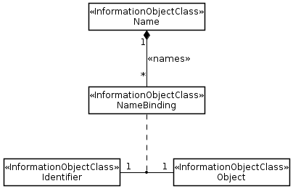
Figure 5.4.1.2-1: Association class notation

5.4.1.3 Name style
The name shall use the same style as in <<InformationObjectClass>> (see 5.3.2.3).

5.4.2 Abstract class

5.4.2.1 Description
It specifies a special kind of <<InformationObjectClass>> as the general model element involved in a generalization relationship (see 5.2.5). An abstract class cannot be instantiated.
This modelled element has the same properties as class. See 5.3.2.

5.4.2.2 Example
This shows that Class5_ is an abstract class. It is the base class for SpecializedClass5.
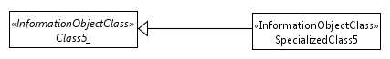
Figure 5.4.2.2-1: Abstract class notation

5.4.2.3 Name style
For abstract class name, use the same style as <<InformationObjectClass>> (see 5.3.2) . The name shall be in italics. In the UOM, its last character shall be an underscore

5.4.3 Predefined data types

5.4.3.1 Description
It represents the general notion of being a data type (i.e. a type whose instances are identified only by their values) whose definition is defined by this specification and not by the user (e.g. specification authors).
This repertoire uses two kinds of data types: predefined data types and user-defined data types. The latter is defined in 5.3.4 <<dataType>> and 5.3.5 <<enumeration>>.
The following table lists the UML data types selected for use as predefined data type.
Table 5.4.3.1-1: UML defined data types
Name | Description and reference
Boolean | See Boolean type of [7].
Integer | See Integer type of [7].
String | See PrintableString type of [7].

The following table lists data types that are defined by this repertoire.
Table 5.4.3.1-2: Non-UML defined data types
Name | Description and reference
AttributeValuePair |  | This data type defines an attribute name and the attribute’s value.
BitString |  | This data type is defined by Bit string of subclause 3 and subclause G.2.5 of [7].
DateTime | This data type is defined by GeneralizedTime of [7].
DN | This data type defines the DN (see Distinguished Name of ) of an object. It contains a sequence of one or more name components. The “initial sub-sequence” (note 1) of a DN is also a DN of an object.  Note 1: Suppose an object’s DN is composed of a sequence of 4 name components, i.e. 1st, 2nd, 3rd and 4th components. The “initial sub-sequence” of this DN is composed of the 1st, 2nd and 3rd components.
External | This data type is defined by another organization.
Real | This data type is defined by Real type of [7]

5.4.3.2 Example
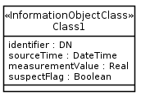
Figure 5.4.3.2-1: Predefined data types usage
Note: Use of this is optional. Uses of other means, to specify Predefined data types, are allowed.

5.4.3.3 Name style
It shall use the UCC style.

6 Qualifiers
This subclause defines the qualifiers applicable for model elements specified in this document, e.g. the IOC (see 5.3.2), the Attribute (see 5.2.1). The possible qualifications are M, O, CM, CO and C. Their meanings are specified in this subclause. This type of qualifier is called Support Qualifier (see supportQualifier of IOC in Table 5.3.2.2-1 and supportQualifier of attribute in Table 5.2.1.1-1).
This subclause also defines the qualifiers applicable to various properties of a model element, e.g. see the IOC properties excepting IOC supportQualifier in Table 5.3.2.2-1 and attributes properties excepting attribute supportQualifier in Table 5.2.1.1-1. The possible qualifications are M, O, CM, CO and " -" . Their meanings are specified in this subclause. This type of qualifier is simply called Qualifier.
Definition of M (Mandatory) qualification:
− The capability (e.g. the Attribute named abc of an IOC named Xyz; the write property of Attribute named abc of an IOC named Xyz; the IOC named Xyz) shall be supported.
Definition of O (Optional) qualification:
− The capability may or may not be supported.
Definition of CM (Conditional-Mandatory) qualification:
− The capability shall be supported under certain conditions, specifically:
- When the qualification is CM, the capability shall have a corresponding constraint defined in the specification. If the specified constraint is met then the capability shall be supported.
− Definition of CO (Conditional-Optional) qualification:
- The capability may be supported under certain conditions, specifically:
- When the qualification is CO, the capability shall have a corresponding constraint defined in the specification. If the specified constraint is met then the capability may be supported.
Definition of C (Conditional) qualification:
- Used for items that has multiple constraints. Each constraint is worded as a condition for one kind of qualification such as M, O or "-". All constraints must be related to the same qualification. Specifically:
- Each item having the support qualifier C shall have the corresponding multiple constraints defined in the IS specification. If the specified constraint is met and is related to mandatory, then the item shall be supported. If the specified constraint is met and is related to optional, then the item may be supported. If the specified constraint is met and is related to "no support", then the item shall not be supported.
NOTE: This qualification should only be used when absolutely necessary, as it is more complex to implement.
Definition of SS (SS Conditional) qualification:
− The capability shall be supported by at least one but not all solutions.
Definition of " -" (no support) qualification:
− The capability shall not be supported.

7 UML Diagram Requirements
Classes and their relationships shall be presented in class diagrams.
It is recommended to create:
− An overview class diagram containing all object classes related to a specific management area (Class Diagram).
− The class name compartment should contain the location of the class definition (e.g., "Qualified Name")
− The class attributes should show the "Signature". (see subclause 7.3.44 of [2] for the signature definition);
− A separate inheritance class diagram in case the overview diagram would be overloaded when showing the inheritance structure (Inheritance Class Diagram);
− A class diagram containing the user defined data types (Type Definitions Diagram);
− Additional class diagrams to show specific parts of the specification in detail;
− State diagrams for complex state attributes.

Annex A (informative):
Examples of using <<ProxyClass>>

A.1 First Example
This shows a <<ProxyClass>> named YyyFunction. It represents all IOCs listed in the Note under the UML diagram. All the listed IOCs, in the context of this example, inherit from ManagedFunction IOC.
The use of <<ProxyClass>> eliminates the need to draw multiple UML <<InformationObjectClass>> boxes, i.e. those whose names are listed in the Note, in the UML diagram.
Figure A.1-1: <<ProxyClass>> Notation Example A.1

A.2 Second Example
This shows a <<ProxyClass>> named YyyFunction. It represents all IOCs listed in the attached (or associated) Note. All the listed IOCs, in the context of this example, have link (internal and external) relations.
This shows a <<ProxyClass>> InternalYyyFunction. It represents all IOCs listed in the attached (or associated) Note.
This shows a <<ProxyClass>> Link_a_z and ExternalLink_a_z. They represent all IOCs listed in the attached (or associated) Note.
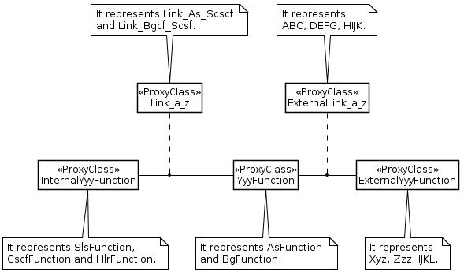
Figure A.2-1: <<ProxyClass>> Notation Example A.2

Annex B (normative):
Attribute properties
In Table B.1 the manager plays the role of consumer and the agent plays the role of producer.
Table B.1: Attribute properties
isInvariant | write | defaultValue | manager shall provide a value when manager requests object creation | Meaning
☑ | ☑ | ☑ | ☑ | Not valid.
☑ | ☑ | ☑ |  | May be set by the manager only during object creation time; if no value is provided by the manager, the default value is used.
☑ | ☑ |  | ☑ | Must be set by the manager during object creation time.
☑ | ☑ |  |  | May be set by the manager only during object creation time; if no value is provided by the manager, the agent must provide a value.
☑ |  | ☑ | ☑ | Not valid.
☑ |  | ☑ |  | Valid but not useful.
☑ |  |  | ☑ | Not valid.
☑ |  |  |  | Must be set by the agent during object creation time.
 | ☑ | ☑ | ☑ | Not valid.
 | ☑ | ☑ |  | May be set by the manager anytime; if no value is provided by the manager at object creation time, it is set to the default value.
 | ☑ |  | ☑ | Must be set by the manager at object creation time and may be changed anytime.
 | ☑ |  |  | May be set by the manager at object creation time and may be changed anytime.
 |  | ☑ | ☑ | Not valid.
 |  | ☑ |  | Must be set by the agent to the default value at object creation time;  may be changed by the agent anytime.
 |  |  | ☑ | Not valid.
 |  |  |  | May be set by the agent at object creation time and may be changed by the agent anytime.

Annex C (normative):
Design patterns

C.1 Intervening Class and Association Class

C.1.1 Concept and Definition
Classes may be related via simple direct associations or via associations with related association classes.
However, in situations where the relationships between a number of classes is complex and especially where the relationships between instances of those classes are themselves interrelated there may be a need to encapsulate the complexity of the relationships within a class that sits between the classes that are to be related. The term “intervening class” is used here to name the pattern that describes this approach. The name “intervening class” is used as the additional class “intervenes” in the relationships between other classes.
The “intervening class” differs from the association class as the intervening class does break the association between the classes where as the association class does not but instead sits to one side. This can be seen in the following figure. A direct association between class A and C appears the same at A and C regardless of the presence or absence of an association class where as in the case of the “intervening class” there are associations between A and the “intervening class” B and C and the “intervening class” B.
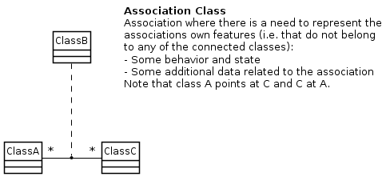
Figure C.1.1-1: Various association forms
The “intervening class” is essentially no different to any other class in that it may encapsulate attributes, complex behaviour etc.
The following figure shows an instance view of both an association class form and an “intervening class” form for a complex interrelationship
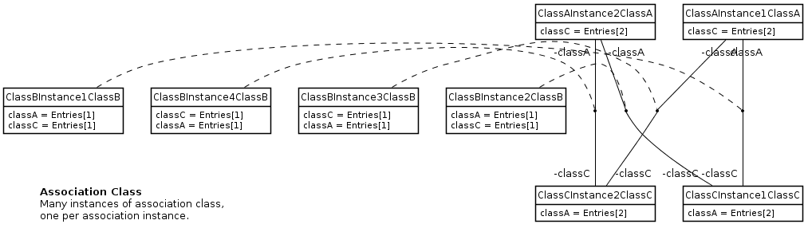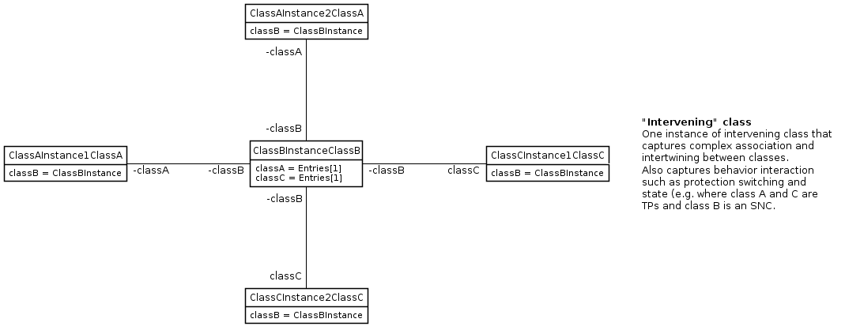
Figure C.1.1-2: Instance view of "intervening class"
The case depicted above does not show interrelationships between the relationships. A practical case from modeling of the relationships between Termination Points in a fixed network does show this relationship interrelationship challenge. In this case the complexity of relationship is between instances of the same class, the Termination Point (TP). The complexity is encapsulated in a SubNetworkConnection (SNC) class.
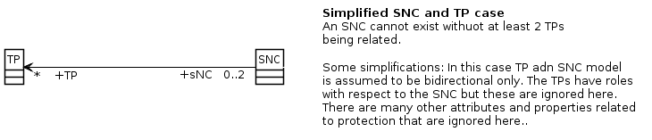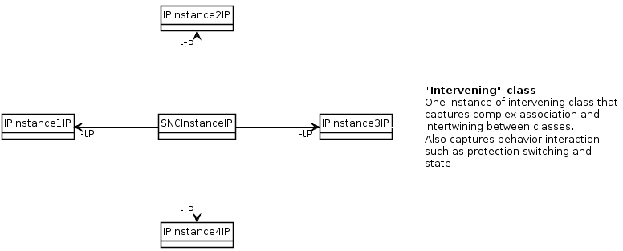
Figure C.1.1-3: SNC intervening in TP-TP relationship
The SNC also encapsulates the complex behaviour of switching and path selection as depicted below.
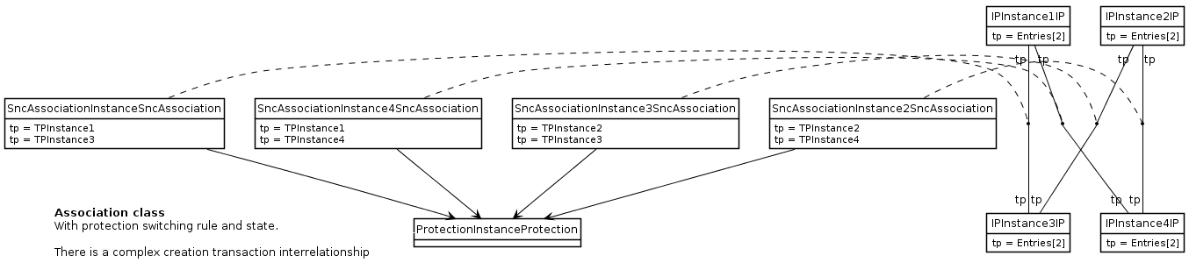
Figure C.1.1-4: Complex relationship interrelationships

C.1.2 Usage in the non-transport domain
The choice of association class pattern or intervening class pattern is on a case-by-case basis.
The transport domain boundary is highlighted in the following figure.
Figure C.1.2-1: Highlighting the boundary between transport and non-transport domains

C.1.3 Usage in the transport domain
The following guidelines must be applied to the models of the “transport domain”.
When considering interrelationships between classes the following guidelines should be applied:
• If considering all current and recognised potential future cases it is expected that the relationship between two specific classes will be 0..1:0..1 then a simple association should be used
– This may benefit from an association class to convey rules and parameters about the association behaviour in complex cases.
• If there is recognised potential for cases currently or in future where there is a 0..*:0..* between two specific classes then intervening classes should be used to encapsulate the groupings etc. so as to convert it to 0..1:n..*.
– Note that the 0..1:n..* association may benefit from an association class to convey rules and parameters about the association behaviour in complex cases but in the instance form this can probably be ignored or folded into the intervening class
• In general it seems appropriate to use an association class when the properties on the relationship instance cannot be obviously or reasonably folded into one of the classes at either end of the association and when there is no interdependency between association instances between a set of instances of the classes.
An example of usage of intervening class is the case of the TP-TP (TerminationPoint) relationship (0..*:0..*) where the SNC (SubNetworkConnection) is added as the intervening class between multiple TPs, i.e. TP-SNC. Note that TP-SNC actually becomes 0..2:n..* due to directionality encapsulation.
Considering the case of the adjacency relationship between PTPs it is known that although the current common cases are 1:1 there are some current and many potential future case of 0..*:0..* and hence a model that has an intervening class, i.e. the TopologicalLink, should be used.
For a degenerate instance cases of 0..*:0..* that happens to be 0..1:0..1 the intervening class pattern should still be used:
- • Using the 0..1:0..1 direct association in this degenerate case brings unnecessary variety to the model and hence to the behaviour of the application (the 0..1:n..* model covers the 0..1:0..1 case with one single code form clearly)
- • An instance of the 0..1:0..1 model may need to be migrated to 0..1:n..* as a result of some change in the network forcing an unnecessary administrative action to transition the model form where as in the 0..1:n..* form requires no essential change.

C.2 Use of “ExternalXyz” class
This subclause will be completed for the next release.

Annex D (informative):
Void

Annex E (normative): <<SupportIOC>> stereotype definition

E.1 Description
It is the descriptor for a set of management capabilities.
The <<SupportIOC>> is an extension of UML class. See Annex [F] for the differences between <<InformationObjectClass>> and <<SupportIOC>>.
See more on UML class in 10.2.1 of [1].

E.2 Example
This sample shows an AlarmList <<SupportIOC>>.
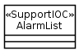
<<SupportIOC>> notation

E.3 Name style
For <<SupportIOC>> name, use the same style as <<InformationObjectClass>> (see subclause 5.3.2).

Annex F (normative):
Application of <<InformationObjectClass>> and <SupportIOC>>
The <<InformationObjectClass>> and <<SupportIOC>> are stereotypes. These two stereotypes serve similar purpose in that each is a named set of network resource properties. However, their applications, in the context of supporting network management over Itf-N or through the use of management services,, can be different. This Annex highlights their similarities and differences of such application.
 | <<InformationObjectClass>> | <<SupportIOC>>
Can it be an abstract class? | Yes | Yes
Can it be a concrete class? | Yes | Yes
Can it inherit from <<InformationObjectClass>>? | Yes | No, except for <<InformationObjectClass>> Top.
Can it inherit from <<SupportIOC>>? | No | Yes
Can it be name-contained by <<InformationObjectClass>>? | Yes | Yes
Can it be name-contained by <<SupportIOC>>? | No | Yes
Can an instance have a DN? | <<InformationObjectClass>> must be a class of a naming-tree meaning all its instances must have a DN. | <<SupportIOC>> may be used by specification author for a class within a naming-tree. If so, it means that all its instances will have a DN.
Can either 1) IRPManager use operations of Basic CM IRP [9] and Bulk CM IRP [10] or 2) MnS consumer use the Provisioning operations [17] and [16] to access the information in an instance? | Either 1) IRPManager can use the Basic CM IRP and Bulk CM IRP operations or 2) MnS consumer can use the provisioning operations to access information of all <<InformationObjectClass>> defined in all NRM [15], in accordance to the qualifier values of the <<InformationObjectClass>>. | Either 1) IRPManager can use the Basic CM IRP and Bulk CM IRP operations to access information of instances of <<SupportIOC>> defined in their respective Interface IRP (i.e. Basic CM IRP or Bulk CM IRP), in accordance to the qualifier values of the <<SupportIOC>> or 2) MnS consumer can use the provisioning operations to access information of instances of <<SupportIOC>> specified in [16] and [17] in accordance to the qualifier values of the <<SupportIOC>>.  Neither 1) IRPManager can use the Basic CM IRP and Bulk CM IRP operations to access information of instances of <<SupportIOC>> not defined in their respective Interface IRP (i.e. Basic CM IRP or Bulk CM IRP) nor 2) MnS consumer can use the Provisioning operations to access information of instances of <<SupportIOC>> not defined in [16] and [17]
Can either 1) IRPManager use operations of Interface IRP, except Basic CM IRP [9] and Bulk CM IRP [10] (e.g. Alarm IRP [11]), or 2) MnS consumer use non Provisioning operations (e.g. fault supervision operations [14] and [16] to access the information? | No | Either 1) IRPManager can use the Interface IRP operations to access information of <<SupportIOC>> defined in their respective Interface IRP, in accordance to qualifier values of the <<SupportIOC>> or 2) . MnS consumer can use the Provisioning operations to access information of instances of <<SupportIOC>> specified in [16] and [17] in accordance to the qualifier values of the <<SupportIOC>>.  Neither 1) IRPManager can not use the Interface IRP operations to access information of <<SupportIOC>> not defined in their respective Interface IRP, nor 2) MnS consumer can not use the Provisioning operations to access information of instances of <<SupportIOC>> not defined in [16] and [17].
Can either IRPManager or MnS consumer receive information via Notification [12] whose objectClass and objectInstance parameters carry the instance DN? | Yes.  The types of notification emitted are shown by the Notification Table associated with the class definition. | Yes if <<SupportIOC>> is a class of a naming-tree.  The types of notification emitted are shown by the Notification Table associated with the class definition.  No if <<SupportIOC>> is not a class of a naming-tree.
Measurement [13] | Measurements can be associated with <<InformationObjectClass>> instances. | Measurements can be associated with <<SupportIOC>> instances if <<SupportIOC>> class is used in a naming-tree.

Annex G(informative):
Change history
Change history
Date | TSG # | TSG Doc. | CR | Rev | Subject/Comment | Old | New
2012-12 |  |  |  |  | New version after approval | 2.0.0 | 11.0.0
2013-01 |  |  |  |  | Fixed layout problems | 11.0.0 | 11.0.1
2013-03 |  |  |  |  | Fixed title of the spec by removing a semi colon | 11.0.1 | 11.0.2
2013-06 | SA#60 | SP-130304 | 001 | - | Model Repertoire introduce CR S5vTMFa354 | 11.0.2 | 11.1.0
2014-09 | SA#65 | SP-140597 | 002 | - | Introduce the agreed result of MSDO JWG Model Alignment work | 11.1.0 | 11.2.0
2014-10 | - | - | - | - | Update to Rel-12 version (MCC) | 11.2.0 | 12.0.0
2016-01 | - | - | - | - | Update to Rel-13 version (MCC) | 12.0.0 | 13.0.0

Change history
Date | Meeting | TDoc | CR | Rev | Cat | Subject/Comment | New version
2016-12 | SA#74 | SP-160855 | 0003 | - | B | Add missing Annex | 14.0.0
2017-04 |  |  |  |  |  | Editorial fixes (MCC) | 14.0.1
2018-06 | SA#80 | SP-180422 | 0007 | - | A | Clarify the use of datatype | 14.1.0
2018-06 | SA#80 | SP-180423 | 0015 | 1 | A | Clarification and removal of text | 14.1.0
2018-06 | - | - | - | - | - | Update to Rel-15 version (MCC) | 15.0.0
2018-12 | SA#82 | SP-181042 | 0016 | 1 | F | Add producer - consumer interaction to Annex B | 15.1.0
2018-12 | SA#82 | SP-181042 | 0017 | 1 | F | Add producer - consumer interaction to Annex F | 15.1.0
2018-12 | SA#82 | SP-181042 | 0018 | 1 | F | Update example of the generalization relationship | 15.1.0
2019-03 | SA#83 | SP-190131 | 0022 | 1 | A | Removal of reference to a temporary joint working group | 15.2.0
2019-06 | SA#84 | SP-190377 | 0033 | 1 | A | Correct style for Definition | 15.3.0

