3GPP TS 28.622 V13.2.0 (2017-03)
Technical Specification
3rd Generation Partnership Project;
Technical Specification Group Services and System Aspects;
Telecommunication management;
Generic Network Resource Model (NRM)
Integration Reference Point (IRP);
Information Service (IS)
(Release 13)


The present document has been developed within the 3rd Generation Partnership Project (3GPP TM) and may be further elaborated for the purposes of 3GPP.
The present document has not been subject to any approval process by the 3GPP Organizational Partners and shall not be implemented.
This Specification is provided for future development work within 3GPP only. The Organizational Partners accept no liability for any use of this Specification.
Specifications and reports for implementation of the 3GPP TM system should be obtained via the 3GPP Organizational Partners' Publications Offices.

Keywords
Generic, NRM, IRP, Converged Management
3GPP
Postal address

3GPP support office address
650 Route des Lucioles - Sophia Antipolis
Valbonne - FRANCE
Tel.: +33 4 92 94 42 00 Fax: +33 4 93 65 47 16
Internet
http://www.3gpp.org
Copyright Notification
No part may be reproduced except as authorized by written permission.
The copyright and the foregoing restriction extend to reproduction in all media.

© 2017, 3GPP Organizational Partners (ARIB, ATIS, CCSA, ETSI, TSDSI, TTA, TTC).
All rights reserved.
UMTS™ is a Trade Mark of ETSI registered for the benefit of its members
3GPP™ is a Trade Mark of ETSI registered for the benefit of its Members and of the 3GPP Organizational Partners
LTE™ is a Trade Mark of ETSI registered for the benefit of its Members and of the 3GPP Organizational Partners
GSM® and the GSM logo are registered and owned by the GSM Association
Contents
Foreword 5
Introduction 5
1 Scope 6
2 References 6
3 Definitions and abbreviations 7
3.1 Definitions 7
3.2 Abbreviations 8
4 Model 9
4.1 Imported information entities and local labels 9
4.2 Class diagrams 9
4.2.1 Relationships 9
4.2.2 Inheritance 11
4.3 Class definitions 11
4.3.1 Any 11
4.3.1.1 Definition 11
4.3.1.2 Attributes 11
4.3.1.3 Attribute constraints 11
4.3.1.4 Notifications 11
4.3.2 IRPAgent 11
4.3.2.1 Definition 11
4.3.2.2 Attributes 12
4.3.2.3 Attribute constraints 12
4.3.2.4 Notifications 12
4.3.3 ManagedElement 12
4.3.3.1 Definition 12
4.3.3.2 Attributes 12
4.3.3.3 Attribute constraints 12
4.3.3.4 Notifications 13
4.3.4 ManagedFunction 13
4.3.4.1 Definition 13
4.3.4.2 Attributes 13
4.3.4.3 Attribute constraints 13
4.3.4.4 Notifications 13
4.3.5 ManagementNode 13
4.3.5.1 Definition 13
4.3.5.2 Attributes 13
4.3.5.3 Attribute constraints 13
4.3.5.4 Notifications 13
4.3.6 MeContext 14
4.3.6.1 Definition 14
4.3.6.2 Attributes 14
4.3.6.3 Attribute constraints 14
4.3.6.4 Notifications 14
4.3.7 SubNetwork 14
4.3.7.1 Definition 14
4.3.7.2 Attributes 15
4.3.7.3 Attribute constraints 15
4.3.7.4 Notifications 15
4.3.8 Top 15
4.3.8.1 Definition 15
4.3.8.2 Attributes 15
4.3.8.3 Attribute constraints 15
4.3.8.4 Notifications 15
4.3.9 VsDataContainer 15
4.3.9.1 Definition 15
4.3.9.2 Attributes 16
4.3.9.3 Attribute constraints 16
4.3.9.4 Notifications 16
4.3.10 Link 16
4.3.10.1 Definition 16
4.3.10.2 Attributes 16
4.3.10.3 Attribute constraints 16
4.3.10.4 Notifications 16
4.3.11 EP_RP 16
4.3.11.1 Definition 16
4.3.11.2 Attributes 17
4.3.11.3 Attribute constraints 17
4.3.11.4 Notifications 17
4.4 Attribute definitions 18
4.4.1 Attribute properties 18
4.4.2 Constraints 19
4.5 Common notifications 20
4.5.1 Alarm notifications 20
4.5.2 Configuration notifications 20
Annex A (informative): Alternate class diagram 21
Annex B (informative): Change history 22

Foreword
This Technical Specification has been produced by the 3rd Generation Partnership Project (3GPP).
The contents of the present document are subject to continuing work within the TSG and may change following formal TSG approval. Should the TSG modify the contents of the present document, it will be re-released by the TSG with an identifying change of release date and an increase in version number as follows:
Version x.y.z
where:
x the first digit:
1 presented to TSG for information;
2 presented to TSG for approval;
3 or greater indicates TSG approved document under change control.
y the second digit is incremented for all changes of substance, i.e. technical enhancements, corrections, updates, etc.
z the third digit is incremented when editorial only changes have been incorporated in the document.

Introduction
The present document is part of a TS-family covering the 3rd Generation Partnership Project; Technical Specification Group Services and System Aspects; Telecommunication management; as identified below:
28.621 Generic Network Resource Model (NRM) Integration Reference Point (IRP); Requirements;
28.622 Generic Network Resource Model (NRM) Integration Reference Point (IRP); Information Service (IS) ;
28.623 Generic Network Resource Model (NRM) Integration Reference Point (IRP); Solution Set (SS) definitions.
The interface Itf-N, defined in 3GPP TS 32.102 [2], is built up by a number of Integration Reference Points (IRPs) and a related Name Convention, which realise the functional capabilities over this interface. The basic structure of the IRPs is defined in 3GPP TS 32.150 [4].
This specification is part of a set that has been developed for converged management solutions.

1 Scope
The present document specifies the Generic network resource information that can be communicated between an IRPAgent and an IRPManager for telecommunication network management purposes, including management of converged networks.
This document specifies the semantics of information object class attributes and relations visible across the reference point in a protocol and technology neutral way. It does not define their syntax and encoding.
This document supports the Federated Network Information Model (FNIM) concept described in [8] in that the relevant Information Object Class (IOC)s defined in this specification are directly or indirectly inherited from those specified in the Umbrella Information Model (UIM) of [9].

2 References
The following documents contain provisions which, through reference in this text, constitute provisions of the present document.
- References are either specific (identified by date of publication, edition number, version number, etc.) or non-specific.
- For a specific reference, subsequent revisions do not apply.
- For a non-specific reference, the latest version applies. In the case of a reference to a 3GPP document (including a GSM document), a non-specific reference implicitly refers to the latest version of that document in the same Release as the present document.
[1] 3GPP TS 32.101: "Telecommunication management; Principles and high level requirements".
[2] 3GPP TS 32.102: "Telecommunication management; Architecture".
[3] 3GPP TS 32.302: "Telecommunication management; Configuration Management (CM); Notification Integration Reference Point (IRP): Information Service (IS)".
[4] 3GPP TS 32.150: "Telecommunication management; Integration Reference Point (IRP) Concept and Definitions".
[5] 3GPP TS 23.003: "Technical Specification Group Core Network and Terminals; Numbering, addressing and identification"
[6] 3GPP TS 32.532: " Telecommunication management; Software Management Integration Reference Point (IRP); Information Service (IS) "
[7] ITU-T Recommendation X.710 (1991): "Common Management Information Service Definition for CCITT Applications".
[8] TS 32.107: "Telecommunication management; Fixed Mobile Convergence (FMC) Federated Network Information Model (FNIM)"
[9] TS 28.620: "Telecommunication management; Fixed Mobile Convergence (FMC) Federated Network Information Model (FNIM) Umbrella Information Model (UIM)"
[10] TS 32.156: "Telecommunication management; Fixed Mobile Convergence (FMC) Model Repertoire"
[11] 3GPP TS 32.111-2: "Telecommunication management; Fault Management; Part 2: Alarm Integration Reference Point (IRP): Information Service (IS)".
[12] 3GPP TS 32.662: "Telecommunication management; Configuration Management (CM); Kernel CM Information Service (IS)".
[13] 3GPP TS 32.300: "Telecommunication management; Configuration Management (CM); Name convention for Managed Objects".
[14] 3GPP TS 32.600: "Telecommunication management; Configuration Management (CM); Concept and high-level requirements".

3 Definitions and abbreviations

3.1 Definitions
For the purposes of the present document, the following terms and definitions apply. For terms and definitions not found here, please refer to 3GPP TS 32.101 [1], 3GPP TS 32.102 [2], 3GPP TS 32.150 [4] and 3GPP TS 32.600 [14].
Association: In general it is used to model relationships between Managed Objects. Associations can be implemented in several ways, such as:
1) name bindings,
2) reference attributes, and
3) association objects.
This IRP stipulates that name containment associations shall be expressed through name bindings, but it does not stipulate the implementation for other types of associations as a general rule. These are specified as separate entities in the object models (UML diagrams). Currently however, all (non-containment) associations are modelled by means of reference attributes of the participating MOs.
Information Object Class (IOC): An IOC represents the management aspect of a Network Resource. It describes the information that can be passed/used in management interfaces. Their representations are technology agnostic software objects. IOC has attributes that represents the various properties of the class of objects. See the term "attribute" defined in [10]. Furthermore, IOC can support operations providing network management services invocable on demand for that class of objects. An IOC may support notifications that report event occurrences relevant for that class of objects. It is modelled using the stereotype "Class" in the UML meta-model. See TS 32.156 [10] for additional information on IOC.
Managed Element (ME): An instance of the IOC ManagedElement.
Managed Object (MO): A MO is an instance of a Managed Object Class (MOC) representing the management aspects of a Network Resource. Its representation is a technology specific software object. It is sometimes called MO instance (MOI). The MOC is a class of such technology specific software objects. An MOC is the same as an IOC except that the former is defined in technology specific terms and the latter is defined in technology agnostic terms. MOCs are used/defined in SS level specifications. IOCs are used/defined in IS level specifications.
Management Information Base (MIB): A MIB is an instance of an NRM and has some values on the defined attributes and associations specific for that instance. In the context of the present document, an MIB consists of:
1) a Name space (describing the MO containment hierarchy in the MIB through Distinguished Names),
2) a number of Managed Objects with their attributes and
3) a number of Associations between these MOs. Also note that TMN (ITU-T Recommendation X.710 [7]) defines a concept of a Management Information Tree (also known as a Naming Tree) that corresponds to the name space (containment hierarchy) portion of this MIB definition. Figure 3.1 depicts the relationships between a Name space and a number of participating MOs (the shown association is of a non-containment type)
Figure 3.1: Relationships between a Name space and a number of participating MOs
Name space: A name space is a collection of names. The IRP name convention (see 3GPP TS 32.300 [13]) restricts the name space to a hierarchical containment structure, including its simplest form - the one-level, flat name space.
All Managed Objects in a MIB shall be included in the corresponding name space and the MIB/name space shall only support a strict hierarchical containment structure (with one root object). A Managed Object that contains another is said to be the superior (parent); the contained Managed Object is referred to as the subordinate (child). The parent of all MOs in a single name space is called a Local Root. The ultimate parent of all MOs of all managed systems is called the Global Root.
Network Resource Model (NRM): A collection of IOCs representing a set of Network Resources under management.

3.2 Abbreviations
For the purposes of the present document, the following abbreviations apply:
AUC Authentication Centre
DN Distinguished Name (see 3GPP TS 32.300 [13])
EM Element Manager
HLR Home Location Register
IOC Information Object Class
IRP Integration Reference Point
ME Managed Element
MIB Management Information Base
MO Managed Object
MOC Managed Object Class
MOI Managed Object Instance
MSC Mobile Services Switching Centre
NR Network Resource
NRM Network Resource Model
RDN Relative Distinguished Name (see 3GPP TS 32.300 [13])
RNC Radio Network Controller
SS Solution Set
TMN Telecommunications Management Network
UML Unified Modelling Language
VLR Visitor Location Register

4 Model

4.1 Imported information entities and local labels
Label reference | Local label
3GPP TS 32.111-2 [11], notification, notifyAckStateChanged | notifyAckStateChanged
3GPP TS 32.662 [12], notification, notifyAttributeValueChanged | notifyAttributeValueChanged
3GPP TS 32.111-2 [11], notification, notifyChangedAlarm | notifyChangedAlarm
3GPP TS 32.111-2 [11], notification, notifyClearedAlarm | notifyClearedAlarm
3GPP TS 32.111-2 [11], notification, notifyComments | notifyComments
3GPP TS 32.111-2 [11], notification, notifyNewAlarm | notifyNewAlarm
3GPP TS 32.662 [12], notification, notifyObjectCreation | notifyObjectCreation
3GPP TS 32.662 [12], notification, notifyObjectDeletion | notifyObjectDeletion
3GPP TS 32.111-2 [11], notification, notifyAlarmListRebuilt | notifyAlarmListRebuilt
3GPP TS 32.111-2 [11], notification, notifyPotentialFaultyAlarmList | notifyPotentialFaultyAlarmList
3GPP TS 32.532 [6], notification, notifyDownloadNESwStatusChanged | notifyDownloadNESwStatusChanged
3GPP TS 32.532 [6], notification, notifyInstallNESwStatusChanged | notifyInstallNESwStatusChanged
3GPP TS 32.532 [6], notification, notifyActivateNESwStatusChanged | notifyActivateNESwStatusChanged
3GPP TS 28.620 [9], IOC, Domain_ | Domain_
3GPP TS 28.620 [9], IOC, ManagedElement_ | ManagedElement_
3GPP TS 28.620 [9], IOC, Function_ | Function_
3GPP TS 28.620 [9], IOC, ManagementSystem_ | ManagementSystem_
3GPP TS 28.620 [9], IOC, TopologicalLink_ | TopologicalLink_
3GPP TS 28.620 [9], IOC, Top_ | Top_

4.2 Class diagrams

4.2.1 Relationships
This clause depicts the set of classes (e.g.IOCs) that encapsulates the information relevant for this IRP. This clause provides the overview of the relationships of relevant classes in UML. Subsequent clauses provide more detailed specification of various aspects of these classes.
The following figure shows the containment/naming hierarchy and the associations of the classes defined in the present document. See Annex A of a class diagram that combines this figure with Figure 1 of [2], the class diagram of UIM.
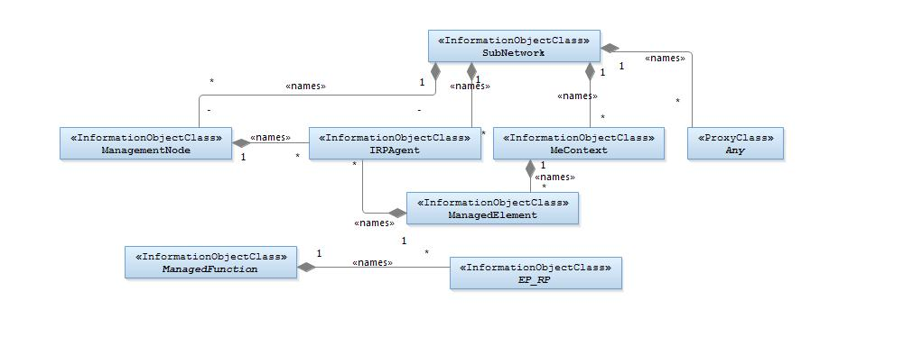
NOTE 1: ManagedElement may be contained either
- in a SubNetwork (since SubNetwork inherits from Domain_ and ManagedElement inherits from ManagedElement_ and Domain_ name-contained ManagedElement_ as observed in the figure of Annex A) or
- in a MeContext instance as observed by the above figure or in the figure of Annex A.
This either-or relation cannot be shown by using an {xor} constraint in the above figure.
ManagedElement may also have no parent instance at all.
NOTE 2: Each instance of the VsDataContainer shall only be contained under one IOC. The VsDataContainer can be contained under IOCs defined in other NRMs.
NOTE 3: If the configuration contains several instances of SubNetwork, exactly one SubNetwork instance shall directly or indirectly contain all the other SubNetwork instances.
NOTE 4: The SubNetwork instance not contained in any other instance of SubNetwork is referred to as "the root SubNetwork instance".
NOTE 5: ManagementNode shall be contained in the root SubNetwork instance.
NOTE 6: If contained in a SubNetwork instance, IRPAgent shall be contained in the root SubNetwork instance.
NOTE 7: For a clarification on the choice of containment of the IRPAgent (since it has three possible parents), see the def. of IRPAgent.

Figure 4.2.1-1: Generic NRM Containment/Naming and Association diagram
Each Managed Object is identified with a Distinguished Name (DN) according to 3GPP TS 32.300 [13] that expresses its containment hierarchy. As an example, the DN of a ManagedElement instance could have a format like:
SubNetwork=Sweden,MeContext =MEC-Gbg-1, ManagedElement=RNC-Gbg-1.
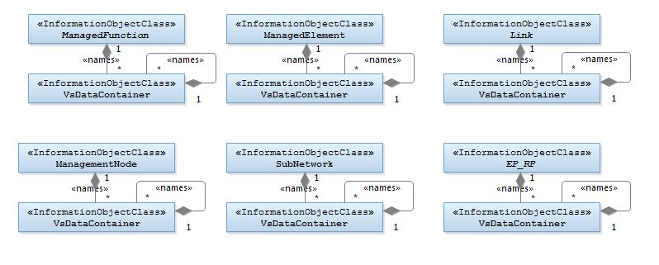

NOTE 8: Each instance of the VsDataContainer shall only be contained under one IOC. The VsDataContainer can be contained under IOCs defined in other NRMs by virtue of inheritance from the GENERIC NRM.

Figure 4.2.1-2: VsDataContainer Containment/Naming and Association in GENERIC NRM diagram
The VsDataContainer is only used for the Bulk CM IRP.

4.2.2 Inheritance

This clause depicts the inheritance relationships.

The following figure shows the inheritance diagram.
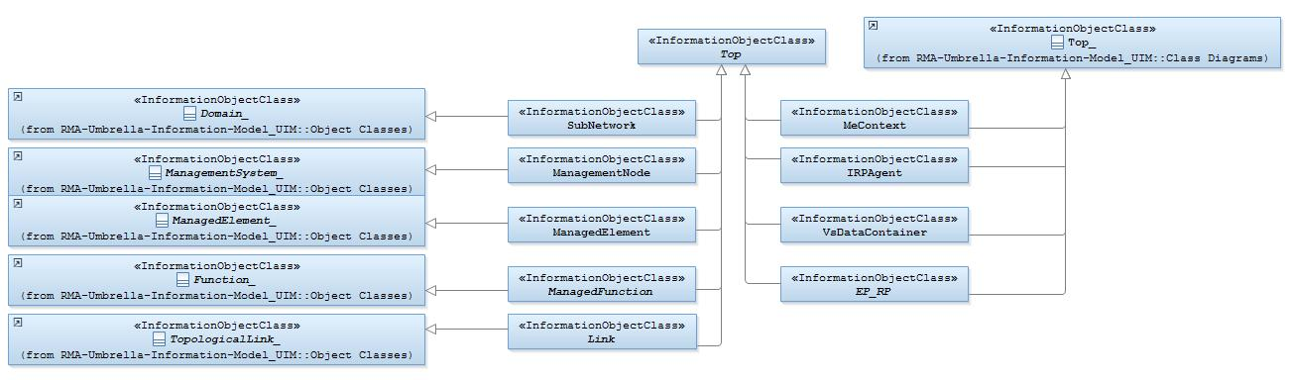

Figure 4.2.2-1: Generic Network Resource Model IRP Inheritance Hierarchy

4.3 Class definitions

4.3.1 Any

4.3.1.1 Definition
This class represents the classes (e.g. IOC) that are not defined in this specification but are or will be defined in other IRP specification(s).

4.3.1.2 Attributes
None

4.3.1.3 Attribute constraints
None

4.3.1.4 Notifications
This class does not support any notification.

4.3.2 IRPAgent

4.3.2.1 Definition
This IOC represents the functionality of an IRPAgent. It shall be present. For a definition of IRPAgent, see 3GPP TS 32.102 [2].
The IRPAgent will be contained under an IOC as follows (only one of the options shall be used):
1) ManagementNode, if the configuration contains a ManagementNode;
2) SubNetwork, if the configuration contains a SubNetwork and no ManagementNode;
3) ManagedElement, if the configuration contains no ManagementNode or SubNetwork.

4.3.2.2 Attributes
Attribute Name | Support Qualifier | isReadable | isWritable | isInvariant | isNotifyable
systemDN | C | M | - | - | M

4.3.2.3 Attribute constraints
None

4.3.2.4 Notifications
The common notifications defined in clause 4.5 are valid for this IOC, without exceptions or additions

4.3.3 ManagedElement

4.3.3.1 Definition
This IOC represents telecommunications equipment or TMN entities within the telecommunications network that performs Managed Element (ME) functions, i.e. provides support and/or service to the subscriber.
An ME communicates with a manager (directly or indirectly) over one or more interfaces for the purpose of being monitored and/or controlled. MEs may or may not additionally perform element management functionality.
An ME contains equipment that may or may not be geographically distributed. An ME is often referred to as a "Network Element".
A ManagedElement may be contained in either a SubNetwork or in a MeContext instance. A single ManagedElement seen over the Itf-N may also exist stand-alone with no parent at all.
The ManagedElement IOC may be used to represent combined ME functionality (as indicated by the managedElementType attribute and the contained instances of different functional IOCs).
Single function ManagedElement IOC instances will have a 1..1 containment relationship to a function IOC instance (in this context a function IOC instance is an instance of an IOC derived from the ManagedFunction IOC). Multiple function ManagedElement instances will have a 1..N containment relationship to function IOC instances.
NOTE: For some specific functional IOCs a 1..N containment relationship is permitted. The specific functional entities are identified in the NRMs that define subclasses of ManagedFunction.

4.3.3.2 Attributes
Attribute Name | Support Qualifier | isReadable | isWritable | isInvariant | isNotifyable
id | M | M | - | M | -
vendorName | M | M | - | - | M
userDefinedState | M | M | M | - | M
swVersion | M | M | - | - | M

4.3.3.3 Attribute constraints
Attribute constrains for dnPrefix: The attribute dnPrefix shall be supported if an instance of ManagedElement is the local root instance of the MIB. Otherwise the attribute shall be absent or carry no information.

4.3.3.4 Notifications
The common notifications defined in clause 4.5 are valid for this IOC. In addition, the following set of notifications is also valid.
Name | Qualifier | Notes
notifyDownloadNESwStatusChanged | See Software Management IRP (3GPP TS 32.532 [6])
notifyInstallNESwStatusChanged | See Software Management IRP (3GPP TS 32.532 [6])
notifyActivateNESwStatusChanged | See Software Management IRP (3GPP TS 32.532 [6])

4.3.4 ManagedFunction

4.3.4.1 Definition
This IOC is provided for sub-classing only. It provides attribute(s) that are common to functional IOCs. Note that a ManagedElement may contain several managed functions. The ManagedFunction may be extended in the future if more common characteristics to functional objects are identified.

Attributes
Attribute Name | Support Qualifier | isReadable | isWritable | isInvariant | isNotifyable
id | M | M | - | M | -

4.3.4.3 Attribute constraints
None

4.3.4.4 Notifications
There is no notification defined.

4.3.5 ManagementNode

4.3.5.1 Definition
This IOC represents a telecommunications management system (EM) within the TMN that contains functionality for managing a number of ManagedElements (MEs). The management system communicates with the MEs directly or indirectly over one or more interfaces for the purpose of monitoring and/or controlling these MEs.
This class has similar characteristics as the ManagedElement. The main difference between these two classes is that the ManagementNode has a special association to the managed elements that it is responsible for managing.

4.3.5.2 Attributes
Attribute Name | Support Qualifier | isReadable | isWritable | isInvariant | isNotifyable
id | M | M | - | M | -
vendorName | M | M | - | - | M
userDefinedState | M | M | M | - | M
locationName | M | M | - | - | M
swVersion | M | M | - | - | M

4.3.5.3 Attribute constraints
None

4.3.5.4 Notifications
The common notifications defined in clause 4.5 are valid for this IOC, without exceptions or additions.

4.3.6 MeContext

4.3.6.1 Definition
This IOC is introduced for naming purposes. It may support creation of unique DNs in scenarios when some MEs have the same RDNs due to the fact that they have been manufacturer pre-configured.
If some MEs have the same RDNs (for the above mentioned reason) and they are contained in the same SubNetwork instance, some measure shall be taken in order to assure the global uniqueness of DNs for all IOC instances under those MEs. One way could be to set different dnPrefix for those NEs, but that would require either that:
a) all LDNs or DNs are locally modified using the new dnPrefix for the upper portion of the DNs, or
b) a mapping (translation) of the old LDNs or DNs to the new DNs every time they are used externally, e.g. in alarm notifications.
As both the two alternatives above may involve unacceptable drawbacks (as the old RDNs for the MEs then would have to be changed or mapped to new values), using MeContext offers a new alternative to resolve the DN creation. Using MeContext as part of the naming tree (and thus the DN) means that the dnPrefix, including a unique MeContext for each ME, may be directly concatenated with the LDNs, without any need to change or map the existing ME RDNs to new values.
MeContext have 0..N instances. It may exist even if no SubNetwork exists. Every instance of MeContext contains exactly one ManagedElement during steady-state operations.

4.3.6.2 Attributes
Attribute Name | Support Qualifier | isReadable | isWritable | isInvariant | isNotifyable
dnPrefix | CM | M | - | - | M

Attribute constraints
Name | Definition
dnPrefix | It shall be supported if an instance of MeContext is the local root instance of the MIB. Otherwise the attribute shall be absent or carry no information.

4.3.6.4 Notifications
The common notifications defined in clause 4.5 are valid for this IOC, without exceptions or additions.

4.3.7 SubNetwork

4.3.7.1 Definition

This IOC represents a set of managed entities as seen over the Itf-N.
There may be zero or more instances of a SubNetwork. It shall be present if either a ManagementNode or multiple ManagedElements are present (i.e. ManagementNode and multiple ManagedElement instances shall have SubNetwork as parent).
The SubNetwork instance not contained in any other instance of SubNetwork is referred to as "the root SubNetwork instance".

4.3.7.2 Attributes
Attribute Name | Support Qualifier | isReadable | isWritable | isInvariant | isNotifyable
id | M | M | - | M | -
setOfMcc | CM | M | - | - | M

4.3.7.3 Attribute constraints
Name | Definition
dnPrefix (inherited from Domain_) | It shall be supported if an instance of SubNetwork is the local root instance of the MIB. Otherwise the attribute shall be absent or carry no information.
setOfMcc | If there is more than one value in setOfMcc of the SubNetwork instance, the support of this attribute setOfMcc is mandatory. Otherwise it is optional.

4.3.7.4 Notifications
The common notifications defined in clause 4.5 are valid for this IOC, without exceptions or additions

4.3.8 Top

4.3.8.1 Definition
This IOC is provided for sub-classing only. All information object classes defined in all TS that claim to be conformant to 32.102 [2] shall inherit from Top.

4.3.8.2 Attributes
Attribute Name | Support Qualifier | isReadable | isWritable | isInvariant | isNotifyable
objectClass | M | M | - | M | M
objectInstance | M | M | - | M | M

4.3.8.3 Attribute constraints
None

4.3.8.4 Notifications
There is no notification defined.

4.3.9 VsDataContainer

4.3.9.1 Definition
The VsDataContainer managed object is a container for vendor specific data. The number of instances of the VsDataContainer can differ from vendor to vendor. This IOC shall only be used by the Bulk CM IRP for all the NRMs.

4.3.9.2 Attributes
Attribute Name | Support Qualifier | isReadable | isWritable | isInvariant | isNotifyable
vsDataType | M | M | - | - | O
vsData | M | M | O | - | O
vsDataFormatVersion | M | M | - | - | O

4.3.9.3 Attribute constraints
None

4.3.9.4 Notifications
Support for notification on the change of attribute value is vendor-specific.

4.3.10 Link

4.3.10.1 Definition
This IOC is provided for sub-classing only. This IOC represents a communication link or reference point between two network entities. The Link IOC does not indicate whether the represented communication link or reference point is a physical or logical entity.
For the subclasses of Link, the following rules apply:
1) The subclass names shall have the form “Link_<X>_<Y>”, where <X> is a string that represents the IOC at one end of the association related to the particular Link subclass, and <Y> is a string that represents the IOC at the other end of the association. For the order of the two strings, <X> shall come alphabetically before <Y>.
2) In case <X> and <Y> are YyyFunction IOCs (inheriting from ManagedFunction and on first level below ManagedElement), the <X> and <Y> strings shall have the same form as the legal values of the managedElementType attribute (see clause 4.5.1), e.g. “Auc”. Otherwise <X> and <Y> shall be the full IOC names.
Thus, two valid examples of Link subclass names would be: Link_As_Cscf and Link_Mrfc_Mrfp.

4.3.10.2 Attributes
Attribute Name | Support Qualifier | isReadable | isWritable | isInvariant | isNotifyable
id | M | M | - | M | -
userLabel | M | M | M | - | M
linkType | O | M | - | - | M
protocolVersion | O | M | - | - | M

4.3.10.3 Attribute constraints
Name | Definition
aEnd and zEnd (inherited from TopologicalLink_) | The property multiplicity is 1.

4.3.10.4 Notifications
The common notifications defined in subclause 4.5 are valid for this IOC, without exceptions or additions

4.3.11 EP_RP

4.3.11.1 Definition
This IOC is provided for sub-classing only. This IOC represents an end point of a link used across a reference point between two network entities.
The detailed subclassed IOC, e.g. EP_X2, will be defined in E-UTRAN NRM IRP, by inheriting from this EP_RP.
For naming the subclasses of EP_RP, the following rules shall apply:
- The name of the subclassed IOC shall have the form “EP_<rp>”, where <rp> is a string that represents the name of the reference point.
Thus, two valid examples of EP_RP subclassed IOC names would be: EP_S1 and EP_X2.

4.3.11.2 Attributes
Attribute Name | Support Qualifier | isReadable | isWritable | isInvariant | isNotifyable
farEndEntity | O | M | - | - | M
userLabel | O | M | M | - | M

4.3.11.3 Attribute constraints
None

4.3.11.4 Notifications
This class does not support any notification.

4.4 Attribute definitions

4.4.1 Attribute properties
The following table defines the properties of attributes specified in the present document.
Attribute Name | Documentation and Allowed Values | Properties
farEndEntity | The value of this attribute shall be the Distinguished Name of the far end network entity to which the reference point is related.  As an example, with EP_Iucs, if the instance of EP_Iucs is contained by one RncFunction instance, the farEndEntity is the Distinguished Name of the MscServerFunction instance to which this Iucs reference point is related.  allowedValues: N/A | type: DN  multiplicity: 0..1  isOrdered: N/A  isUnique: N/A  defaultValue: No default value  isNullable: False
id | An attribute whose "name+value" can be used as an RDN when naming an instance of the object class. This RDN uniquely identifies the object instance within the scope of its containing (parent) object instance. | type: DN  multiplicity: 1  isOrdered: N/A  isUnique: N/A  defaultValue: None  allowedValues: N/A  isNullable: False
linkType | This attribute defines the type of the link.  allowedValues: Signalling, Bearer, OAM&P, Other or multiple combinations of this type. | type: String  multiplicity: 0..*  isOrdered: F  isUnique: T  defaultValue: No default value  isNullable: False
locationName | The physical location of this entity (e.g. an address).  allowedValues: N/A | type: String  multiplicity: 0..1  isOrdered: N/A  isUnique: N/A  defaultValue: No default value  isNullable: False
objectClass | An attribute which captures the name of the class from which the object instance is an occurrence of.  allowedValues: N/A | type: String  multiplicity: 1  isOrdered: N/A  isUnique: N/A  defaultValue: No default value  isNullable: False
objectInstance | An information which captures the Distinguished Name of any object.  allowedValues: N/A | type: String  multiplicity: 1  isOrdered: N/A  isUnique: N/A  defaultValue: No default value  isNullable: False
protocolVersion | Versions(s) and additional descriptive information for the protocol(s) used for the associated communication link. Syntax and semantic is not specified.  allowedValues: N/A | type: String  multiplicity: 0..*  isOrdered: F  isUnique: T  defaultValue: no default value  isNullable: False
setOfMcc | Set of Mobile Country Code (MCC). The MCC uniquely identifies the country of domicile of the mobile subscriber. MCC is part of the IMSI (TS 23.003 [5])  This list contains all the MCC values in subordinate object instances to this SubNetwork instance.  allowedValues: See clause 2.3 of TS 23.003 [5] for MCC allocation principles. | type: Integer  multiplicity: 1..*  isOrdered: F  isUnique: T  defaultValue: No default value  isNullable: False
swVersion | The software version of the ManagementNode or ManagedElement (this is used for determining which version of the vendor specific information is valid for the ManagementNode or ManagedElement).  allowedValues: N/A | type: String  multiplicity: 0..1  isOrdered: N/A  isUnique: N/A  defaultValue: No default value  isNullable: False
systemDN | The Distinguished Name (DN) of IRPAgent. Defined in 3GPP TS 32.300.  allowedValues: N/A | type: DN  multiplicity: 0..1  isOrdered: N/A  isUnique: N/A  defaultValue: No default value  isNullable: False
userDefinedState | An operator defined state for operator specific usage.  allowedValues: N/A | type: String  multiplicity: 0..1  isOrdered: N/A  isUnique: N/A  defaultValue: No default value  isNullable: False
userLabel | A user-friendly (and user assignable) name of this object.  allowedValues: N/A | type: String  multiplicity: 0..1  isOrdered: N/A  isUnique: N/A  defaultValue: No default value  isNullable: False
vendorName | The name of the vendor.  allowedValues: N/A | type: String  multiplicity: 0..1  isOrdered: N/A  isUnique: N/A  defaultValue: No default value  isNullable: False
vsData | Vendor specific attributes of the type vsDataType. The attribute definitions including constraints (value ranges, data types, etc.) are specified in a vendor specific data format file.  allowedValues: -- | type: --  multiplicity: --  isOrdered: --  isUnique: --  defaultValue: --  isNullable: False
vsDataFormatVersion | Name of the data format file, including version.  allowedValues: N/A | type: String  multiplicity: 1  isOrdered: N/A  isUnique: N/A  defaultValue: No default value  isNullable: False
vsDataType | Type of vendor specific data contained by this instance, e.g. relation specific algorithm parameters, cell specific parameters for power control or re-selection or a timer. The type itself is also vendor specific.  allowedValues: N/A | type: String  multiplicity: 1  isOrdered: N/A  isUnique: N/A  defaultValue: No default value  isNullable: False

4.4.2 Constraints
None

4.5 Common notifications

4.5.1 Alarm notifications
This clause presents a list of notifications, defined in [11], that IRPManager can receive. The notification header attribute objectClass/objectInstance, defined in [3], would capture the DN of an instance of an IOC defined in this IRP specification.
Name | Qualifier | Notes
notifyAckStateChanged | See Alarm IRP (3GPP TS 32.111-2 [11])
notifyChangedAlarm | See Alarm IRP (3GPP TS 32.111-2 [11])
notifyClearedAlarm | See Alarm IRP (3GPP TS 32.111-2 [11])
notifyNewAlarm | See Alarm IRP (3GPP TS 32.111-2 [11])
notifyComments | See Alarm IRP (3GPP TS 32.111-2 [11])
notifyAlarmListRebuilt | See Alarm IRP (3GPP TS 32.111-2 [11])
notifyPotentialFaultyAlarmList | See Alarm IRP (3GPP TS 32.111-2 [11])

Configuration notifications
This clause presents a list of notifications, defined in [12], that IRPManager can receive. The notification header attribute objectClass/objectInstance, defined in [3], would capture the DN of an instance of an IOC defined in this IRP specification.
Name | Qualifier | Notes
notifyAttributeValueChange | O
notifyObjectCreation | O
notifyObjectDeletion | O

Annex A (informative): Alternate class diagram
This class diagram combines the Figure 4.2.1-1 of this document with Figure 1 of [9], the class diagram of UIM.
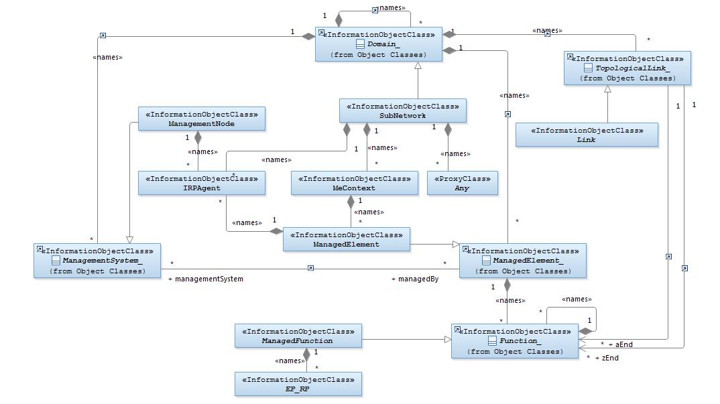
Figure A-1: Alternate class diagram

Annex B (informative):
Change history

Change history
Date | TSG # | TSG Doc. | CR | Rev | Subject/Comment | Old | New
2012-12 |  |  |  |  | New version after approval | 2.0.0 | 11.0.0
2012-02 |  |  |  |  | MCC update of TOC | 11.0.0 | 11.0.1
2014-06 | SA#64 | SP-140332 | 001 | - | Correction of reference | 11.0.1 | 11.1.0
2014-06 | SA#64 | SP-140358 | 002 | - | Remove the feature support statements | 11.0.1 | 11.1.0
2014-09 | SA#65 |  |  |  | Upgrade to Rel-12 | 11.1.0 | 12.0.0
2015-12 | SA#70 | SP-150691 | 005 | 1 | Add missing id attribute for 28.622 | 12.0.0 | 12.1.0
2016-01 |  |  |  |  | Upgrade to Rel-13 (MCC) | 12.1.0 | 13.0.0

Change history
Date | Meeting | TDoc | CR | Rev | Cat | Subject/Comment | New version
2016-12 | SA#74 | SP-160853 | 0010 | - | A | Clarification on the need to show VsDataContainer self-containing itself several times | 13.1.0
2017-03 | SA#75 | SP-170139 | 0012 | 2 | A | Clarify notification triggered by VsDataContainer change | 13.2.0

