

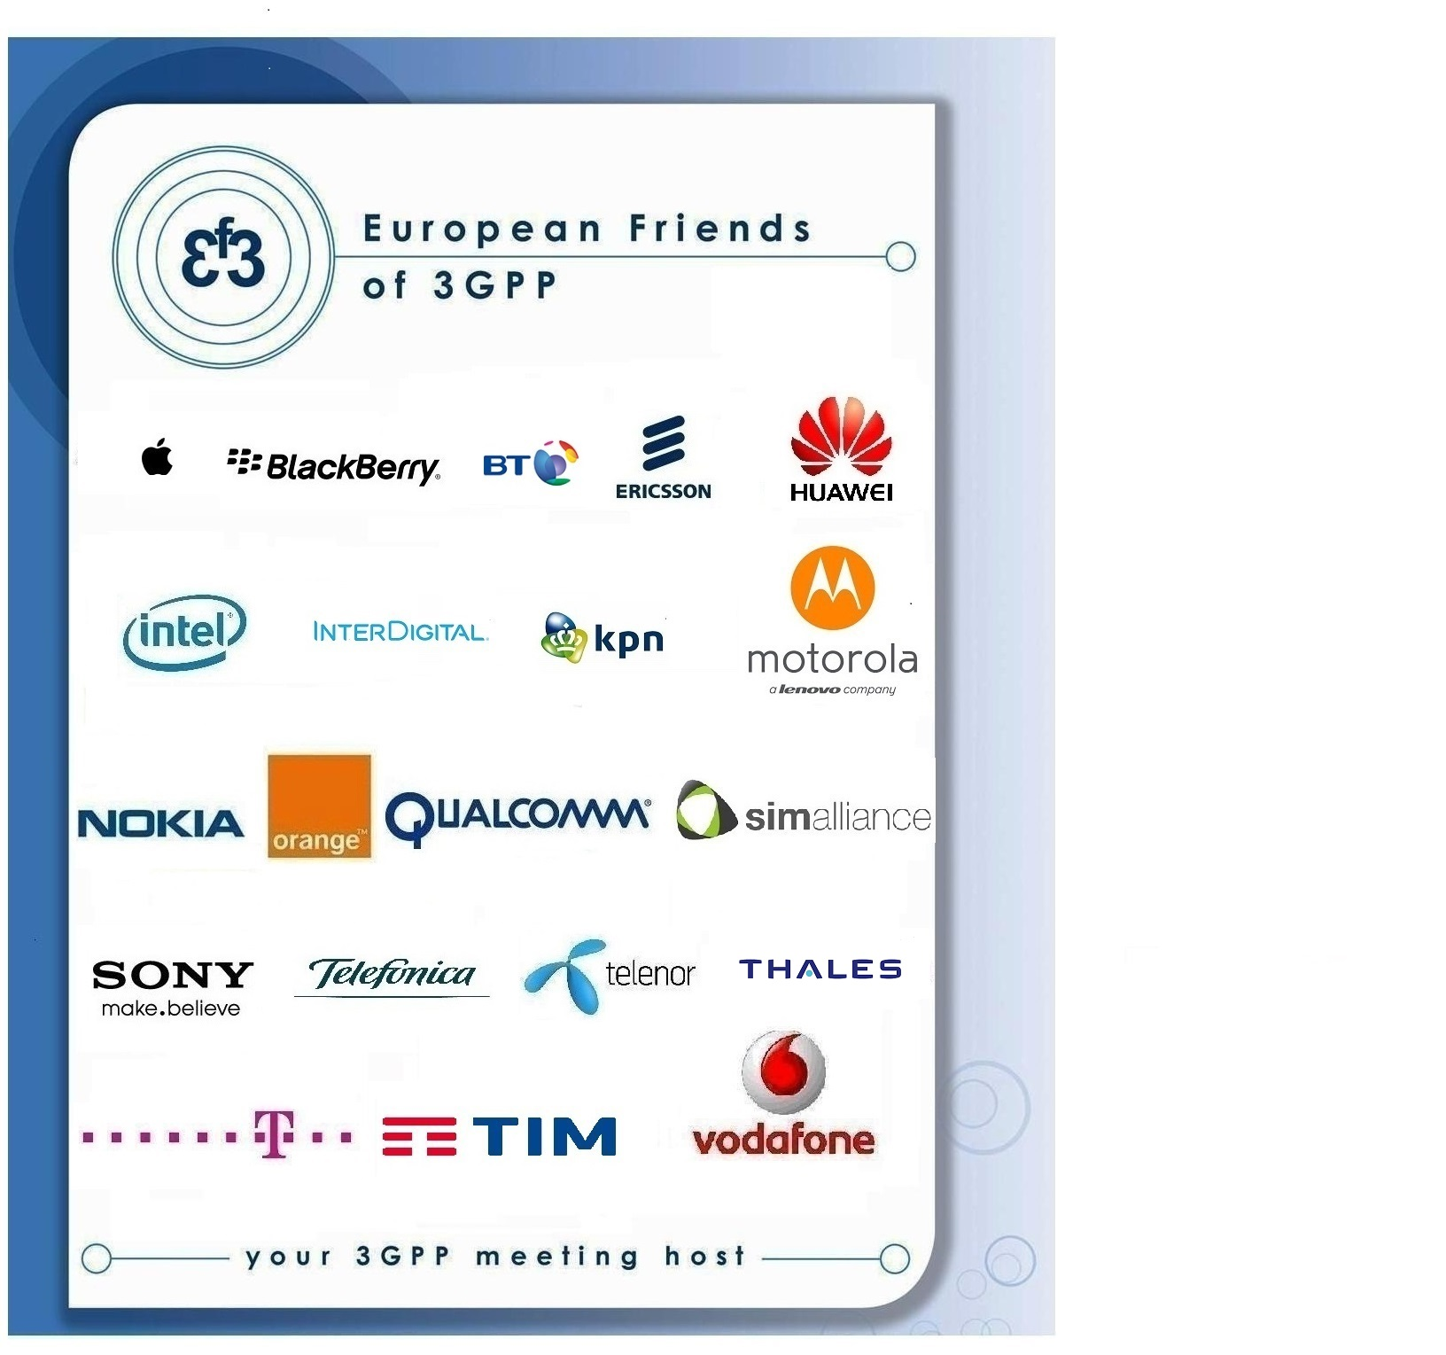

Have the pleasure of inviting you to the 3GPP SA4 on VR stream
in Roma

TITLE | TYPE | DATES | LOCATION | CTRY
3GPPSA4-on VR Stream | AH | 8 Jul 2018 | Roma | IT

Sophia Antipolis, 16 May 2018

3GPP SA4 on VR Stream
On Sunday 8 July 2018 in Roma

Dear Delegate,

The European Friends of 3GPP, Apple, BlackBerry, Deutsche Telekom, Ericsson, Huawei, Intel, InterDigital, KPN, Motorola, Nokia, Orange, Qualcomm, SIMAlliance, Sony, Telefonica, Telenor, Thales, TIM, Vodafone have the pleasure of inviting you to the above-mentioned meeting.

Meeting Venue
Eurostars Roma Aeterna Hotel  Via Casilina, 125 ROMA, Italia  Tel: +390670603  info@eurostarsromaaeterna.com  WEB SITE  BOOKING DEADLINE: 27th MAY, 2018  Bedroom rates:  Standard double for single use at 105€ including breakfast, internet and taxes*  Standard twin/double room at 115€ including breakfast, internet and taxes*  Individual payment & cancellation :  Reservation can be cancelled without charge until 31 days prior to arrival. From 30 days prior to arrival reservation becomes non-refundable and in case of cancellation or no show credit card will be charged for 100% of the amount.  *City tax is not included  Hotel booking form attached | Radisson Blu hotel Lietuva  Konstitucijos pr. 20, LT-09308 Vilnius Lithuania  info.lietuva.vilnius@radissonblu.com  web site  Single room @99€ and Double room @109€  (B&B, VAT, Fitness center & internet included)  Hotel cut-off date, 21st May 2018, | Radisson Blu hotel Lietuva  Konstitucijos pr. 20, LT-09308 Vilnius Lithuania  info.lietuva.vilnius@radissonblu.com  web site  Single room @99€ and Double room @109€  (B&B, VAT, Fitness center & internet included)  Hotel cut-off date, 21st May 2018,
Meeting Registration
Please register for the meetings online at: on-line registration
.

You might find the hotel cancellation policy unreasonable. If you need to cancel your room, on a reasonable basis, please contact contact@eurofriends3.org.

A quality meeting form will be launched after the meeting.

We look forward to seeing you all in Roma.

Yours sincerely,
the European Friends of 3GPP.

Accommodation
EF3 is not responsible for reservation confirmations, cancelled or changed reservations or no-shows. Please contact the hotel directly to make any changes. Please make your own booking filling in the hotel registration form. You might find the hotel cancellation policy unreasonable. If you need to cancel your room, on a reasonable basis, please contact contact@eurofriends3.org.

WLAN: There will be a wireless LAN.

Transportation from the airport to the hotel
Rome's central train station, Termini, is a 20-minute walk (15 minutes by bus).
Tuscolana train station, where you can get the train to Fiumicino regional airport, is a 15-minute walk (10 minutes by bus). The hotel is in front of the Ponte Casilino train station, on the Roma-Giardinetti train line and the metro stations Piazza Vittorio and Termini.
The closest bus station is only 30 metres from the hotel. The tram stop is 200 metres from the hotel.
Directions from:
Roma Fiumicino Airport:
•By Leonardo Express train, which departs every 30 minutes to Termini station
Roma Ciampino Airport:
•With the bus company Terravision or Sit shuttle bus to Termini station
Termini station:
• Bus 105 to Ponte Casilino bus stop
• Tram 5 or 14 to the stop Piazzale Prenestino (200 metres from the hotel)
The hotel can organise transfers to and from the airport upon request.

Host Contacts
For any questions about anything relating to the meeting please contact: contact@eurofriends3.org

Visa letter

****VISA LETTER****
 Delegates needing a visa in order to attend a meeting hosted by EF3 should make their hotel booking where the meeting will take place. As soon as they book their room please ask the hotel to provide you with a personal letter.
We would like to invite you to fill-in your own invitation letter which contains all your personal information. Please follow these steps:
- Please download the visa application letter template at
http://www.3gpp.org/delegates-corner#outil_sommaire
(under meeting document templates, “visa application letter template”)
- Please update the letter accordingly
- Please send your letter to contact@eurofriends3.org for signature
Deadline to apply: 27th May, 2018.



Booking Form

ETSI 3GPP SA4#99

Guest name:

Room Type:

Arrival date:

Departure date:

PREFERENTIAL RATES FOR THE DATE: 7th JULY 2018

DOUBLE FOR SINGLE USE B&B: 105 EUROS
DOUBLE /TWIN ROOM B&B: 115 EUROS

PREFERENTIAL RATES FOR THE DATES: 8th – 13TH JULY 2018

DOUBLE FOR SINGLE USE B&B: 95 EUROS
DOUBLE /TWIN ROOM B&B: 105 EUROS
CITY TAX (not incl.): 6 euros per person per night

DEADLINE TO RECEIVE BOOKING FORMS: 27TH May 2018
Booking form should be sent by email to: reservations@eurostarsromaaeterna.com
Hotel will confirm the reservation with booking number.

Reservation can be cancelled without charge until 31 days prior to arrival.
From 30 days prior to arrival reservation becomes non refundable and in case of cancellation or no show credit card will be charged for 100% of the amount.

Credit Card details to be completed and signed by the cardholder:
□ VISA □ MASTERCARD □ AMERICAN EXPRESS

Cardholder’s name___________________________________________________________________

Credit Card number______________________________________

Expiration date_________________

Telephone number_________________________________________________________

Email___________________________________________________________________

Cardholder’s signature_____________________________________________

This e-mail and any files transmitted with it are CONFIDENTIAL and intended solely for the use of the individual or entity to who they are addressed. If you have received this message by mistake, we request you to notify to the sender and please, be sure to erase it.

