Source: HUAWEI
Title: [FS_AVATAR] Further input about 2D avatar
Spec: FS_AVATAR PD 0.2.0
Agenda item: 9.6
Document for: Discussion and agreement

1. Introduction
In last SA4#127 meeting, 2D avatar was introduced by S4-240056 and agreed to be incorporated into the latest PD v0.2.0. During the previous discussion, it was suggested that further clarification of 2D avatar should be provided to better understand the target use cases and user experience as well as the differences between 2D avatar and 3D avatar.
2. Reason for Change
The contribution proposes to update the 2D avatar descriptions to address the above issues.
3. Proposal
It is proposed to agree on the following changes to the FS_AVATAR PD 0.2.0.

* * * First Change * * * *

3.4 Existing 2D Avatar Representation

3.4.1 Introduction
A 2D avatar (or a 2D digital human) is a graphic representation of a digital human in the two-dimensional space. This representation has no depth and is usually created and viewed from a fixed point of view. See the relevant ITU-T definitions quoted below for the ease of reference:
- Digital Human: A computer application that integrates the technologies of computer graphics, computer vision, intelligent speech and natural language processing, which could be used for digital content generation and human-computer interaction to help improve content production efficiency and user experience. [7]
- 2D Digital Human: A digital human whose figure is a planar image and whose graphic content only contains information about horizontal and vertical dimensions. [8]
In general, the 2D avatar can share the common framework and procedure with the 3D avatar, while it has some unique features as below:
- AI-based modelling: It doesn't require the building of a 3D mesh topology as the base model. Instead, a 2D avatar base model can be generated through the AI training against a Deep Neural Network (DNN).
- Simple animation: A 2D avatar can be driven directly from the users’ input of video, audio or text. It doesn’t need to first derive the animation data from the input media, nor to have the 3D rendering process later.
- Flexible deployment: A 2D avatar may be deployed over either NPU or GPU resources for the model generation (training) and animation (inference) due to its nature of AI-based modelling.

Since a 2D avatar doesn't have a 3D base model that can generate significant body movements and provide free viewports, it can only provide limited viewport (usually fixed) and gestures of the character. This makes it hard to support motional use cases like VR games. Nevertheless, the 2D avatar can be quite suitable for the cases where the position and posture of the avatar is relatively fixed such as RTC.
Detailed information about 2D avatar use cases, technical insights and the comparison with 3D avatar can be found in the following clauses.

3.4.2 2D Avatar Use Cases
The 2D avatar is suitable for planar display and simple interaction scenarios which does not require multi-view viewing. The 2D avatar has already been used in the following scenarios:
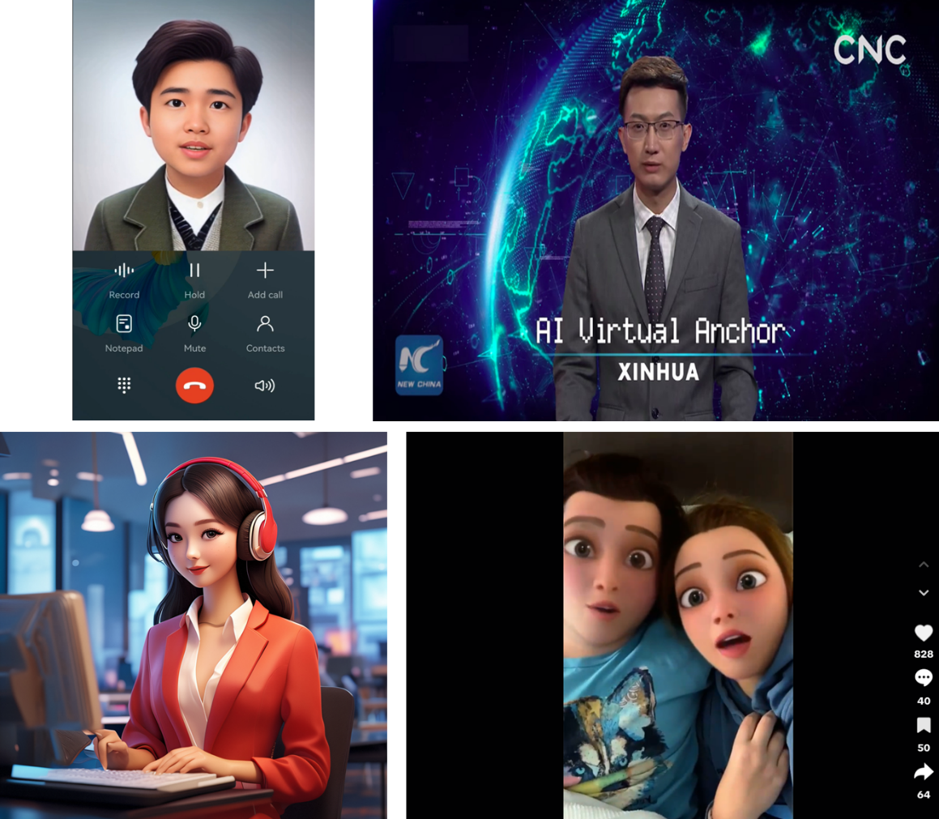

Figure 3.4.2-1. 2D Avatar scenarios (top-left: Avatar call, top-right: Virtual anchor, bottom-left: Virtual customer service, bottom-right: Social media)
- Avatar call: The 2D avatar can be introduced to upgrade the user experience of a traditional voice or video call. The 2D avatar can be animated by the user’s voice or captured video in real-time and displayed on the screen of the peer user. This service can increase the fun of the real-time communication and protect the user’s privacy in the meantime. An example for avatar call is shown at the top-left of Figure 3.4.2-1.
- Virtual anchor/E-commerce: 2D Avatar can be used as virtual anchor for news broadcasting or shopping/touring guide to introduce product items or place of interests. The 2D avatar can be animated by the user’s voice, video or text scripts, which can be fed in real-time or pre-recorded. This service can enable 7*24 online service while relieving the burden of human labours. An example for 2D avatar virtual anchor [16] is shown at the top-right of Figure 3.4.2-1.
- Virtual customer service: When a user dials the customer service number, the 2D avatar of customer service agent can be displayed on the user’s screen instead of the real agent person. The 2D avatar can provide simple interaction following instructions of a human agent or driven by AI. This service can improve the friendliness of the customer service and provide the possibility of 7*24 online service when the human agent is not available. An example for 2D avatar customer service is shown at the bottom-left of Figure 3.4.2-1.
- Social media: In social media scenario, cartoon-styled 2D avatars animated by the user's body action or facial expression can be used as the personalized/customized figure in the user generated contents to protect user’s privacy and increase the attractiveness. This service has been widely used to in social media sharing such as short videos. An example of 2D avatar short video [17] is shown at the bottom-right of Figure 3.4.2-1.

3.4.3 2D Avatar base model generation
The process of 2D Avatar base model generation is to train a DNN model through a supervised learning algorithm. The result DNN model is the base model for a 2D Avatar. The training process is depicted in Figure 3.4.3-1.

Figure 3.4.3-1. 2D Avatar base model generation process (training)

The training process of a 2D Avatar takes three inputs as listed in Table 3.4.3-1:
- Reference image/video: provides the baseline reference of the 2D Avatar representation in the form of a picture or a video.
- Ground truth video: It is the target output video of the 2D Avatar to be trained against. The reference image/video should have the same character as in the ground truth video but not exactly the same appearance at the same time. For example, the lip shape or the facial expression can be different between the reference image/video and the ground truth at a certain time point.
- Driving input: It can be video, audio or text depending on the target use cases (i.e., which type media is going to be used for avatar animation at the inference stage).
The relationship between the reference image/video, driving input, and the ground truth are the following:
- If the driving input is audio, the ground truth is the video where the character in the reference image/video is talking as recorded in the audio [9].
- If the driving input is video, the ground truth is the video where the character in the reference image/video makes the same action [10]. (In this case, the character in the driving input is usually different from the ones in the reference image/video and the ground truth video for the use case of “face swap”.)
- If the driving input is text, the ground truth is the video where the character in the reference image/video is talking the text content [11].
A typical DNN used for the 2D Avatar has the encoder-decoder architecture. The encoder part is used to map the input to the embedding space, and the decoder part is utilized to map the embeddings to the image space so as to generate the target 2D avatar video. A pre-processing function may be introduced to perform cropping, resizing, and normalization on the reference image/video and the driving input data before injecting them into the DNN. It can be implemented inside or outside of the DNN. The loss function defines a measurement of the difference between the generated video and the ground truth video. The output of the loss function is used to perform the backpropagation to update the DNN parameters.
Upon the training process completion, the converged DNN results as the base model of the 2D Avatar. The base model can be stored in an exchangeable format such as .pth (PyTorch [12]), .onnx (ONNX [13]), .trt (TensorRT [14]) or mindir (MindSpore [15]) files.
Considering different levels of generalization capabilities, 2D Avatar base models can be categorized in two groups:
- Robust model: It provides good generalization capability that can support the animation of different target 2D avatar characters (designated by different reference images/videos).
- Personalized model: It is good at the animation of a particular target 2D avatar character but not others. A personalized model may be a fine-tuned model from a robust model.
The cost of training a robust model is generally higher than that of a personalized model, since the former takes much more input training data and training time for different avatar characters. Based on the state-of-the-art implementations and typical hardware conditions, a robust model could be trained within a day, while a personalized model could be trained less than one hour.

Table 3.4.3-1. Training input data for 2D Avatar base model generation
Training input data | Description | Requirements
Reference image/video | The baseline reference of the 2D avatar character to be trained. | The character in the reference image/video is the same as the one in the ground truth video, while the character’s actions (e.g. mouth movements or facial expressions) are generally different at the same point in time. It can be a picture or a video.
Driving input | The media content (video, audio, or text) to drive the animation of the 2D avatar character out of the DNN. | The actions in the driving input are consistent with the ones in the ground truth video (e.g. the syllables of speaking match the mouth shape).
Ground truth video | The training target of the 2D avatar. | The character in the ground truth video is consistent with the reference image/video, and the character’s action is consistent with the one in the driving input.

3.4.4 2D Avatar animation
The process of 2D Avatar animation is to generate the 2D video representation of the avatar through the inference process of the DNN base model driven by the input video, audio or text from the user. The inference process is depicted in Figure 3.4.4-1.

Figure 3.4.4-1. 2D Avatar animation process (inference)

The inference process takes two inputs as listed in Table 3.4.4-1:
- Reference image/video: It is used to specify the target avatar character to be driven. For example, a user can upload or pick from the repository a cartoon (or lifelike) character in the form of a short video in advance as the reference video.
- Driving input: It may be the audio or video stream coming from the user during a real-time call or being pre-recorded. It can also be a text stream converted from audio signals.
The generated video from the DNN is essentially the animated 2D Avatar, which can be further encapsulated, streamed and played with any existing video codecs (e.g. H.264/H.265) and deliver protocols (e.g. RTP).
Existing technologies can support real-time generation of 2D Avatars with considerable concurrency. For example, one typical GPU card with 65 TFLOPS computing power could support 16 concurrent 2D Avatar animations at the frame rate of 25 fps.

Table 3.4.4-1. Inference input data for 2D Avatar animation
Inference input data | Description | Requirements
Reference image/video | It’s used to designate the target avatar character that the user expects to animate. | It can be a static picture or a video that provided or selected by the user before the animation happens.
Driving input | The media content (video, audio, or text) to drive the animation of the 2D avatar character out of the DNN. | It can come from the user during a real-time call or can be pre-recorded, or converted.

The following embedded video clip gives an exemplary demo of the 2D avatar animation driven by audio:
Figure 3.4.4-2. 2D Avatar animation example

3.4.5 The Comparison between 2D Avatar and 3D Avatar
The 2D avatar and the 3D avatar have differences shown in the following table:
Table 3.4.5-1. The comparison between 2D Avatar and 3D Avatar
 | 2D Avatar | 3D Avatar
User Experience | Support only fixed viewport and limited body movement (e.g. pre-defined gestures synchronized with mouth/facial shaping).  Stationary placement in a scene.  Despite of its limitation of viewport and movement, a 2D avatar representation can still provide a 3D-like appearance and rich facial expressions. | Support multiple/free viewports, and flexible movement and placement in three-dimensional space.
Service Scenarios | Real-time communications: e.g. avatar call, virtual customer service, chat bots.  Social media: e.g. short video, vlog  Virtual anchor/E-commerce: e.g. news broadcasting, shopping guide, commercial livestreaming.  Localized mobile metaverse (limited/ stationary cases) | In addition to those service scenarios supported by 2D avatar, 3D avatar has its advantage to support the cases that require free-view change and 3D interactions such as VR gaming, e-sports and full metaverse interaction.
Computational Requirement | No need of 3D modelling and rendering.  Instead, it uses AI training and inference process. | Require 3D modelling and rendering,  or AI training and inference in the case of INR (Implicit Neural Representations) 3D avatars.
Base Model | Neural network based AI model (e.g. ONNX format) | 3D mesh or point cloud model (e.g. glTF format),  or neural network-based AI model in some cases of INR model such as NeRF.
Customization/ Personalization | No need to rebuild the base model.  Achieved by replacing the reference image/video for the customized/personalized character. The reference image/video can be simply copied or be generated by a light-weight AI model from the user’s personal image/video. | Need to rebuild the base model for the customized/personalized character by re-constructing the 3D mesh model via the user’s video/3D capturing,  or re-train an AI base model using a personalized INR.
Animation | Can be directly driven by video, audio or text.  A reference image/video may be provided as additional input for the purpose of customization/personalization. | For the case of video, audio and text driven 3D avatar, animation data needs to be first derived from the input video/audio/text signals using certain algorithms.  For more precise and realistic representations, 3D avatar may be driven by capturing key points of actions and facial expressions using specialized sensors or motion capture equipments.
3D Rendering | Not needed. | Required.  Camera information is need for viewport rendering.
Deployment | NPU or GPU | Mainly GPU

In summary, the 2D avatar can cover popular service scenarios, but has limitations in terms of viewports and body movements which are required for intensive 3D interaction scenarios. Although the 2D avatar may choose different technical approaches at certain aspects or omit some procedures (e.g. rendering), it can share the same basic framework with the 3D avatar and is close to the variant of INR 3D avatar.

* * * Second Change * * * *

8 References
[1] Ekman, P., & Friesen, W.V. (1978). Facial action coding system: a technique for the measurement of facial movement.
[2] Ekman, P., Friesen, W. V., & Hager, J. C. (2002). Facial Action Coding System.
[3] G. A. Abrantes and F. Pereira, "MPEG-4 facial animation technology: survey, implementation, and results," in IEEE Transactions on Circuits and Systems for Video Technology, vol. 9, no. 2, pp. 290-305, March 1999, doi: 10.1109/76.752096.
[4] 3GPP TR 21.905: "Vocabulary for 3GPP Specifications".
[5] 3GPP TR 22.856: “Feasibility Study on Localized Mobile Metaverse Services”
[6] ISO/IEC 23090-14:2023, Information Technology – Coded Representation of Immersive Media – Part 14: MPEG Scene Description.
[7] ITU-T F.748.14 (03/2022), "Requirements and evaluation methods of non-interactive 2D real-person digital human application system".
[8] ITU-T F.748.15 (03/2022), "Framework and metrics for digital human application system".
[9] Zhou Y, Han X, Shechtman E, et al. Makelttalk: speaker-aware talking-head animation[J]. ACM Transactions On Graphics (TOG), 2020, 39(6): 1-15.
[10] Zhao J, Zhang H. Thin-plate spline motion model for image animation[C]//Proceedings of the IEEE/CVF Conference on Computer Vision and Pattern Recognition. 2022: 3657-3666.
[11] Liu, Jinglin, et al. "Parallel and High-Fidelity Text-to-Lip Generation." Proceedings of the AAAI Conference on Artificial Intelligence. Vol. 36. No. 2. 2022.
[12] PyTorch, https://pytorch.org/
[13] ONNX, https://onnx.ai/
[14] TensorRT, https://developer.nvidia.com/tensorrt
[15] mindspore, https://www.mindspore.cn
[16] https://www.theverge.com/2018/11/8/18074806/ai-news-anchor-china-xinhua-digital-composite
[17] https://www.tiktok.com/@chriscanbefunny/video/6902602432811961605
* * * End of Changes * * * *

